1. A = load 'wordcount.txt' as (line:chararray);

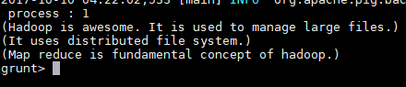

1. B = foreach A generate TOKENIZE(line) as tokens;

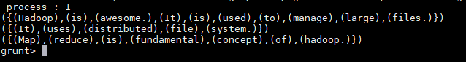

1. C = foreach B generate flatten(tokens) as words;

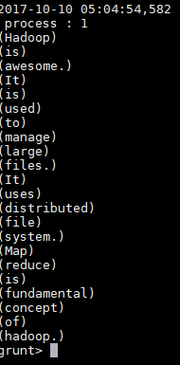

1. D = group C by words;

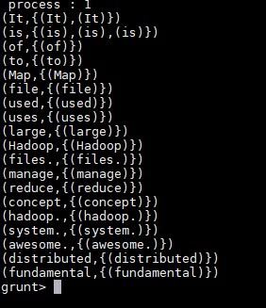

1. E = foreach D generate group, COUNT(C);

