Use the simple Pig built-in functions to form two lists of 5 randomly selected Pokémons with some parameters set by the management.

Load the data:

Load_Data = LOAD 'Pokemon.csv' USING PigStorage(',') AS(Sno:int,Name:chararray,Type1:chararray,Type2:chararray,Total:int,HP:int,Attack:int,Defense:int,SpAtk:int,SpDef:int,Speed:int);

Dump Load_Data;

1. Find the list of players that have been selected in the qualifying round (DEFENCE>55).

selected_list = FILTER Load_Data BY Defense>55;

The dataset is filtered, and hence out of all the 800 Pokémons, only 544 are eligible to take part in the tournament. In order to get the count, refer the next problem statement.

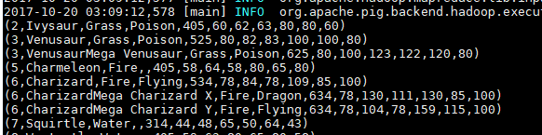

1. State the number of players taking part in the competition after getting selected in the qualifying round.

gourp_selcted_list = Group selected_list All;

count_selcted_list = foreach gourp_selcted_list GENERATE COUNT(selected_list);

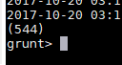

1. Using random() generate random numbers for each Pokémon on the selected list.

random_include1 = foreach selected_list GENERATE RANDOM(),Name,Type1,Type2,Total,HP,Attack,Defense,SpAtk,SpDef,Speed;

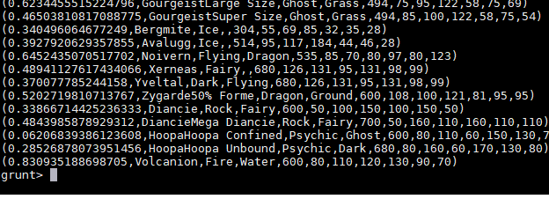

1. Arrange the new list in a descending order according to a column randomly.

random1_desending = ORDER random_include1 BY $0 DESC;

1. Now on a new relation again associate random numbers for each Pokémon and arrange in descending order according to column random.

random_include2 = foreach selected_list GENERATE RANDOM(),Name,Type1,Type2,Total,HP,Attack,Defense,SpAtk,SpDef,Speed;

random2_desending = ORDER random_include2 BY $0 DESC;

1. From the two different descending lists of random Pokémons, select the top 5 Pokémons for 2 different players.

limit_data_random1_desending = LIMIT random1_desending 5;

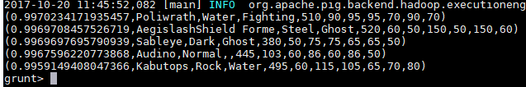

limit_data_random2_desending = LIMIT random2_desending 5 ;

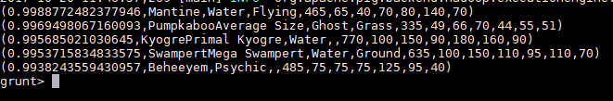

1. Store the data on a local drive to announce for the final match. By the name player1 and player2 (only show the NAME and HP).

filter_only_name1 = foreach limit_data_random1_desending Generate ($1,HP);

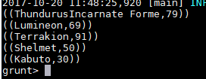

filter_only_name2 = foreach limit_data_random2_desending Generate ($1,HP);

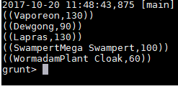

STORE limit_data_random1_desending INTO ‘player1.txt’;

STORE limit_data_random2_desending INTO ‘player2.txt’;

