**Problem Statement**

*Write a hive UDF that implements functionality of string concat_ws(string SEP, array<string>).*

*This UDF will accept two arguments, one string and one array of string.*

*It will return a single string where all the elements of the array are separated by the SEP.*

**Solution:**

Below is the dataset

1 Nikita Java,Oracle,ASP

2 Radhika Oracle,Perl

3 Bhakti Ruby,Java

1. Create table having one array column

create table student(id string,name string,skills array<string>) row format delimited fields terminated by '\t' collection items terminated by ',';

1. Load the data

load data local inpath '/home/acadgild/nikidir/arraydataset.txt' overwrite into table student;

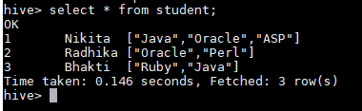

1. Create UDF fuction class.

**package** udf;

**import** java.util.List;

**import** org.apache.hadoop.hive.ql.exec.UDF;

**import** org.apache.hadoop.io.Text;

**public** **class** ConcatString **extends** UDF

{

**public** String evaluate (String sep, List<Text> str) {

**if** (sep == **null** || str==**null** || str.get(0)==**null**) {

**return** **null**;

}

String concat=**null**;

**for**(Text s:str)

{

**if**(concat!=**null**)

concat=concat+sep+s.toString();

**else**

concat=s.toString();

}

**return** concat;

}

}

1. Use the jar, store the function, and use it.

use acadgild_db;

add jar A2_udf.jar;

CREATE TEMPORARY FUNCTION concatString AS 'udf.ConcatString';

select id,concatString('-',skills) from student;

