**Transactions in Hive**

* Before creating a Hive table that supports transactions, the transaction features present in Hive needs to be turned on, as by default they are turned off.

set hive.support.concurrency = true;

set hive.enforce.bucketing = true;

set hive.exec.dynamic.partition.mode = nonstrict;

set hive.txn.manager = org.apache.hadoop.hive.ql.lockmgr.DbTxnManager;

set hive.compactor.initiator.on = true;

set hive.compactor.worker.threads = 5;

* Creating a Table That Supports Hive Transactions

**CREATE TABLE college(clg_id int,clg_name string,clg_loc string) clustered by (clg_id) into 5 buckets stored as orc TBLPROPERTIES('transactional'='true');**

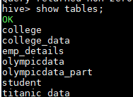

* Inserting Data into a Hive Table

**INSERT INTO table college values(1,'nec','nlr'),(2,'vit','vlr'),(3,'srm','chen'),(4,'lpu','del'),(5,'stanford','uk'),(6,'JNTUA','atp'),(7,'cambridge','us');**

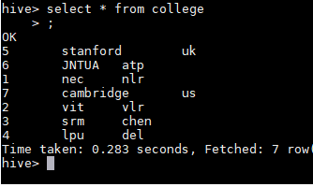

* Updating the Data in Hive Table

UPDATE college set clg_id = 8 where clg_id = 7;

This will fail because clg_id column is bucketed.



**UPDATE college set clg_name = 'IIT' where clg_id = 6;**

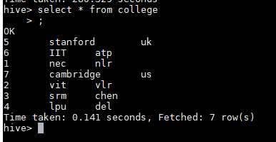

* Deleting a Row from Hive Table

**delete from college where clg_id=5;**

