Kristine Bernadette H. Guerra
CS4A – MACHINE 2

LAB 7 – FINALS
Activity 1
Model Selection
- Train multiple models (Logistic Regression, SVM, Random Forest) on the same dataset.
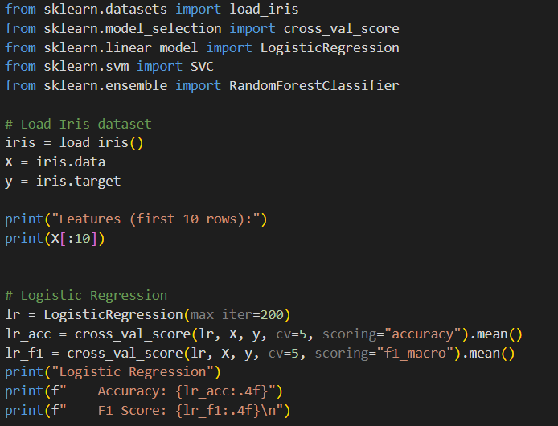
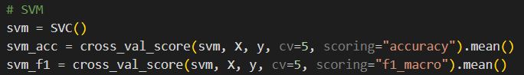
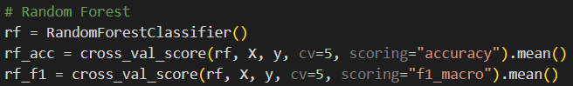

- Evaluate each model using cross-validation metrics (accuracy, F1 score).
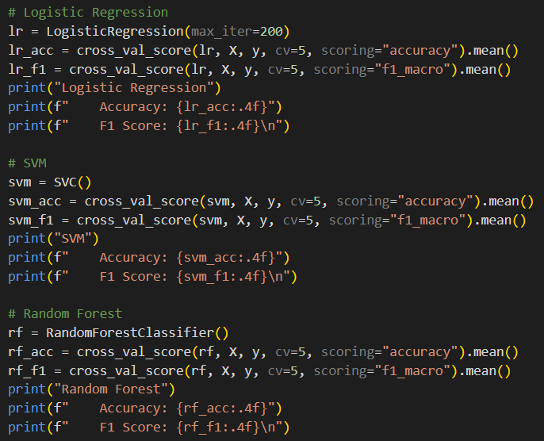
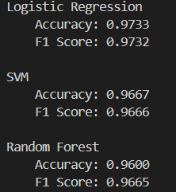
- Choose the best model based on the results.
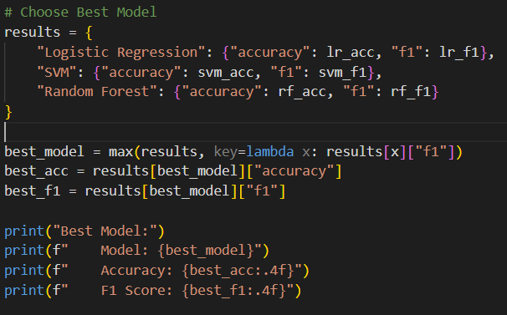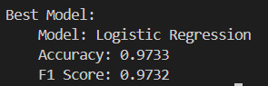
Activity 2
Implementing Cross-Validation
- Load a dataset (e.g., Breast Cancer dataset).
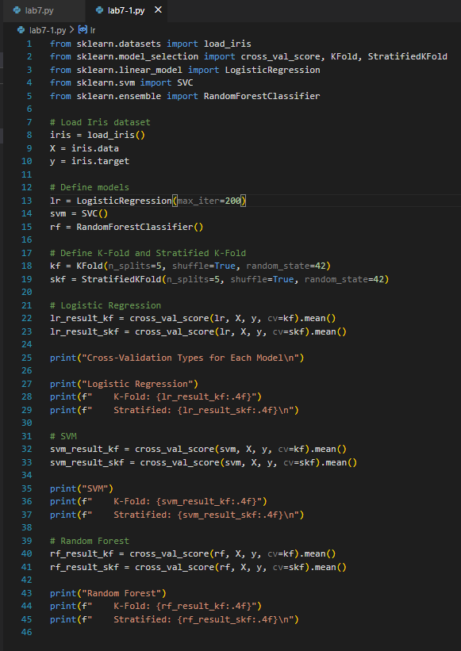
- Apply k-fold and stratified k-fold cross-validation on a classification model (e.g., Logistic Regression).

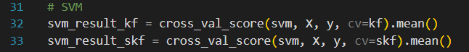
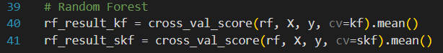

- Compare cross-validation results.
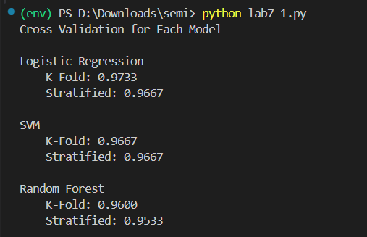

Logistic Regression achieved the highest accuracy with 0.9733 in K-Fold and 0.9667 in Stratified K-Fold, showing slightly varying performance depending on the data split. SVM was consistent across both methods with 0.9667 accuracy, indicating stable performance. Random Forest scored slightly lower at 0.9600 in K-Fold. Overall, Logistic Regression is the most accurate, while SVM provides the most stable results.

