Q1
Let s be a set of strings then (s+)* is equal to___

- S+
- S*
- (S+)+
- None of these
Q2
In TG there may exist more than one path for certain string.
- True
- False
- Depends on the language
- None of these
Q3
Pumping Lemma II says that length(x) + length(y) should be

- Less than number of states
- Less than or equal to number of states
- Greater than number of states
- Greater than or equal to number of states
Q4
Consider the following sequence.
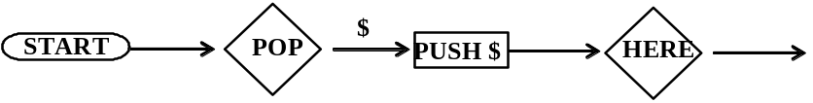

- The PDA must not begin with the sequence
- The PDA may begin with the sequence
- The PDA must begin with the sequence
- The PDA may not begin with the sequence
Q5
For every CFGs we can make corresponding:
- FA
- TG
- PDA
- Regular Grammar
Q6
A Total Language Tree has

- All languages over ∑
- All strings over ∑
- All words of all languages over ∑
- All words of one language over ∑
Q7
A regular language:
(a) Must be finite
(b) Must be infinite
(c) Can be finite or infinite
(d) Must be finite and cannot be infinite
Q8
If a language can be expressed by a regular expression, then its complement cannot be expressed by a regular expression. This statement is:

- True
- False
- Depends on language
- None of the given optios
Q9
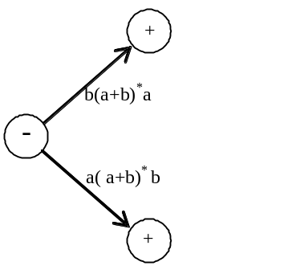
- Begins and ends with different letters
- Begins and ends with same letters
- Have length greater than 1
- None of these
Q10
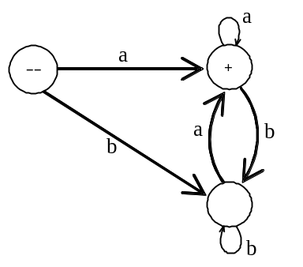
- Ending in a
- Starting with a
- Ending & starting with same letter.
- All of these
Q11
Let A = {0, 1}. The number of possible strings of length ‘n’ that can be formed by the elements of the set A is
- n!
- n²
- n^{m}
- 2^{n}
Q12
Which of the following are regular?
- String of odd number of zeroes
- Set of all palindromes made up of 0’s and 1’s
- String of 0’s whose length is a prime number
- All of these
Q13
Which of the following pairs of regular expressions are not equivalent?
- (ab)* and a*b*
- x(xx)* and (xx)*x
- x⁺ and x*x⁺
- All of these
Q14
If L is a regular language then :
- It must have some Regular expression
- it must have an equivalent Non-regular language
- It should be possible to represent this language through Moore Machine
- All of these.
Q15
Choose the incorrect (FALSE) statement
- A Mealy machine generates no language as such
- All of these
- A Mealy machine has no terminal state
- For a given input string, length of the output string generated by a Moore machine is not more than the length of the output string generated by that of a Mealy machine
Q16
Pumping lemma is generally used for proving
- A given grammar is infinite
- A given grammar is not regular
- Whether two given regular expressions are equivalent
- None of these
Q17
There exist more than one derivations of a certain word in ambiguous grammer.
- True
- False
- Depend on language
- None of the give option
Q18
Regular languages are closed under Union and Concatenation.
- True
- False
- Depends on language
- Depends on alphabets of language.
Q19
Choose the incorrect statement:
- (a+b)*aa(a+b)* generates Regular language.
- The set of B, consisting of all strings made up of only a’s and b’s having equal number of a’s and b’s defines a regular language
- Every language that can be expressed by FA can also be expressed by RE
- None of these
Q20
We can also represent an FA using different states e.g. Accept state, Reject state, Read State etc.
This _____________ state behaves as final state of an FA.
- Accept
- Reject
- Pop
- Push
Q21
CFG given below
S → bS|Sb|aa
represents language __________

- b*aa
- aab*
- b*aab*
- b*(aa)*b*
Q22
Converting the given "CFG in CNF", is the first rule of _____
- CNK algorithm
- CYK algorithm
- CKY algorithm
- KYC algorithm
Q23
Can a turing machine contain just a single state?
- Yes
- Yes when the reject state is not compulsory
- No
- Yes but only in the limited situations.
Q24
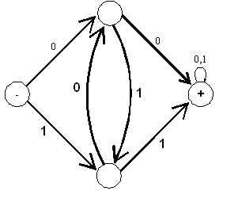
RE for the above given FA is __________________.

- (0+1)* (00) (0+1)* +(0+1)*(11) (0+1)* OR (0+1)* (00 + 11) (0+1)*
- (0+1)* (00)* (0+1)* +(0+1)*(11)*(0+1)*
- (0+1) (00 + 11) (0+1)
- (0+1)* (00 + 11)* (0+1)*
Q25
In drawing FA3 (which is equal to FA1 + FA2), a state will be declared final if
- It corresponds to any of the final state in FA1 and FA2
- It corresponds to final states of both FA1 and FA2
- Depends on language
- None of the given
Q26
If the given CFG contains a production of the form S→Λ, then __________
- The corresponding CFL is not empty.
- The corresponding CFL is empty.
- The corresponding CFL is not empty if the language is regular
- The corresponding CFL is empty and non regular.
Q27
To determine whether a string is generated by the given CFG __________
- CYK algorithm is used
- CIK algorithm is used
- CNK algorithm is used
- CNM algorithm is used
Q28
CYK algorithm was invented by John Cocke and later was published by ____
- Talik Khon and Daniel H
- Tandao Kasami and Daniel H
- Tandao Dagger and Daniel H
- None of these
Q29

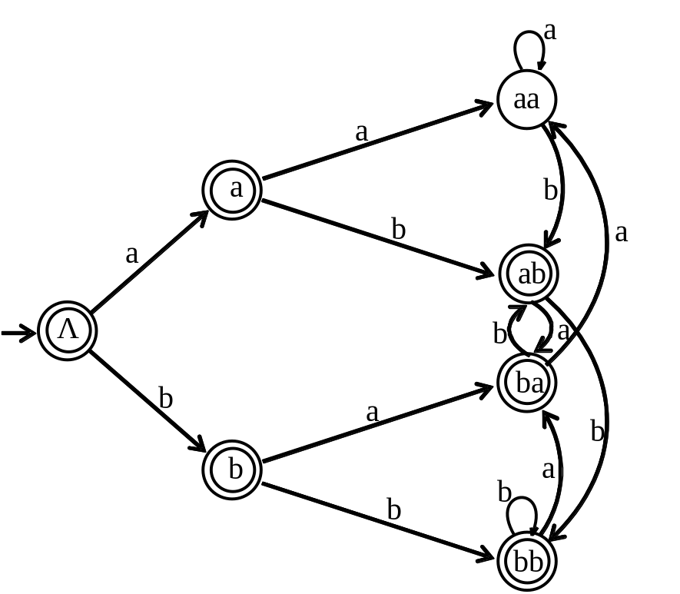
Above given FA is drawn using
- Graph structure
- Tree structure
- It is not a Finite Automaton
- None of these
Q30
Which of the following statement is correct?
- The length of output string is greater than length of input string in moore machine.
- The length of output string is greater than length of input string in mealy machine.
- The length of output string is equal to length of input string in moore machine.
- The length of output string is less than length of input string in mealy machine.
Q31
From three strings given below, identify palindrom: [1]

Λ , abb , babb.

Q32
Define Ambiguous tree? [1]

Q33
What type of language, the following RE generates: [2]

( a + b )*baba( a + b )*

Q34
What are problems that are considered in decidability? [2]

Q35
How to accommodate NULL string if it is part of language while converting from CFG to CNF and building FA from CFG? [3]

Q36
Explain the following with help of diagram:

1) Start State
2) Reject State

TIP: using different combinations of these states along with other states, is one of the ways to draw FA. [3]

Q37
Determine the CFG corresponding to the following FA. [3]
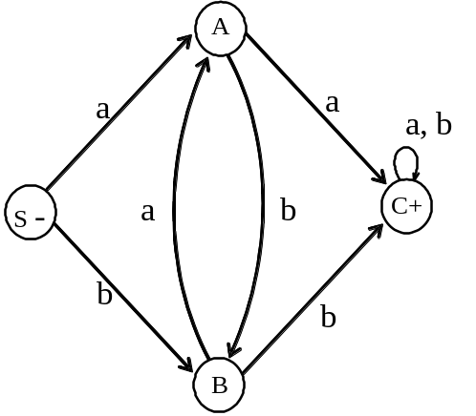

Q38
How to accommodate NULL string if it is part of language while converting from CFG to CNF and in building PDA of CFG? [5]

Q39
What is the difference between "Semiword" and "Word" also give an example of each? [5]

Q40
What is the difference between Context free languages and regular languages? [10]

Q41
Given CFG (Context Free Grammar) [10]
S→ aBa | bAb
A→ aba | bAa | B
B→ ab | bba
Convert above CFG into CNF (Chomsky Normal Form). Show all steps.

