Q1
Who invented the Turing machine?
- Alan Mathison Turing
- N. P. Completeness
- E. Post
- None of these
Q2
Consider the following TM

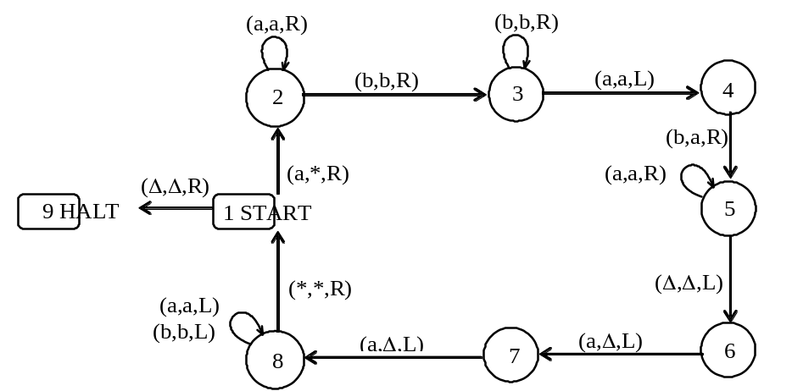

Which of the following is true
- The string aaabbbaaa can be observed to be accepted by the above TM. It can also be observed that the above TM accepts the non-CFL {a b c}.
- The string aaabbbaaa can be observed to be accepted by the above TM. It can also be observed that the above TM accepts the non-CFL {a^{n}b^{n}a^{n}}.
- The string bbbaaabbb can be observed to be accepted by the above TM. It can also be observed that the above TM accepts the non-CFL {a^{n}b^{n}a^{n}}.
- The string abbbaaabb can be observed to be accepted by the above TM. It can also be observed that the above TM accepts the non-CFL {a^{n}b^{n}a^{n}}.
Q3
Can a turing machine's head ever be in the same location in two successive steps?
- Yes
- Yes but only in finite languages
- No
(d)Yes but only in infinite langauges
Q4:
PALINDROME is proved to be regular language by using
- FA
- TG
- Pumping Lemma
- PDA

Q5:
A CFG is said to be ambiguous if there exists one word of its language that cannot be generated by different production trees.
- True
- False
- Depend on language
- None of the given
Q6:
Every regular expression can be expressed as CFG but every CFG cannot be expressed as a regular expression. This statement is:
- True
- False
- Depends on the language
- None of the given options
Q7:
If R is regular language and Q is any language (regular/ nonregular), then Pref(Q in R) is ______
- Regular
- Non-Regular
- Finite
- Infinite

Q8:
One GTG can generate more than one language”. This statement is _______
- True
- False
- Depends on alphabet
- None of these
Q9:
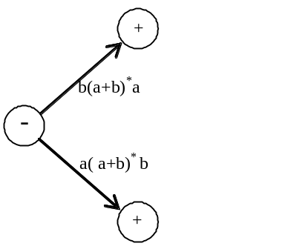
- Begins and ends with different letters
- Begins and ends with same letters
- Have length greater than 1
- None of these
Q10:
Even-palindrome is a ______ language
- non-regular
- regular
- egular but infinite
- none of the given
Q11:
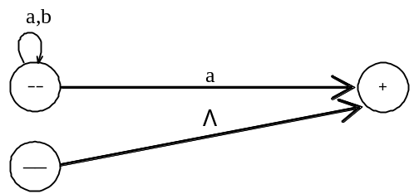
- (a + b)*a
- Λ + (a + b)*a
- Λ + (a + b)*a*
- None of these
Q12:
Every FA should be __________
- Deterministic
- Non- Deterministic
- Deterministic & Non- Deterministic
- None of these
Q13:
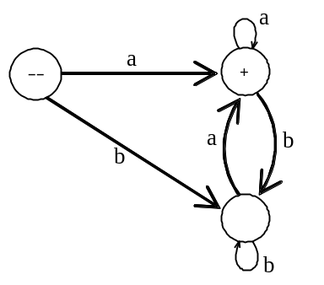
- Ending in a
- Starting with a
- Ending & starting with same letter.
- All of these
Q14:
An FSM can be considered as TM
- Of finite tape length, rewinding capability and unidirectional tape movement
- Of finite tape length, without rewinding capability and unidirectional tape movement
- Of finite tape length, without rewinding capability and bidirectional tape movement
- Of finite tape length, rewinding capability and bidirectional tape movement
Q15:
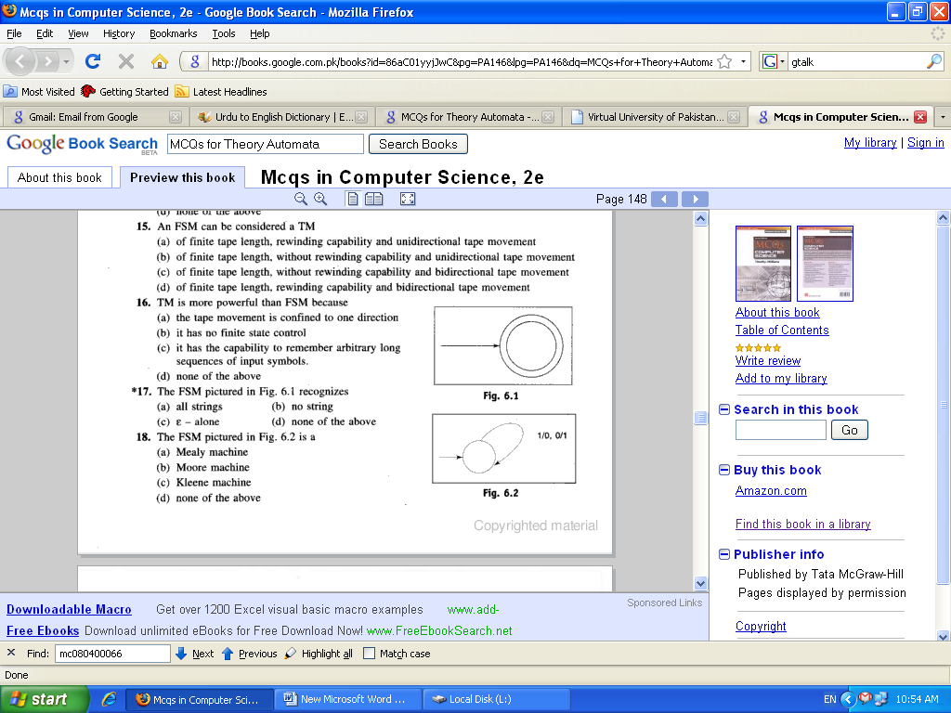

- Mealy machine
- Moore machine
- Kleene machine
- None of these
Q16:
An alphabet of Σ is valid if
- No letter of Σ appears in middle of any other letter
- No letter of Σ appears at end of any other letter
- No letter of Σ appears at start of any other letter
- All of above
Q16:

The product of two regular languages is _____
- Regular Language
- Non-Regular Language
- Depend on alphabets
- None of these
Q17
Pumping lemma is generally used for proving
- A given grammar is infinite
- A given grammar is not regular
- Whether two given regular expressions are equivalent
- None of these
Q18
Left hand side of a production in CFG may consists of:
- One terminal
- More than one terminal
- One non-terminal
- Terminals and non-terminals
Q19
We can also represent an FA using different states e.g. Accept state, Reject state, Read State etc.
This _____________ state behaves as final state of an FA.
- Accept
- Reject
- Pop
- Push
Q20
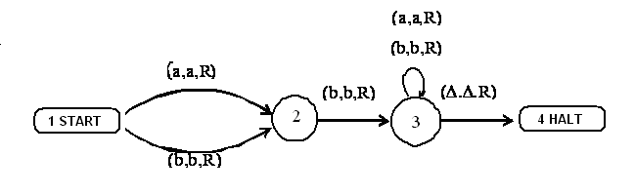

The above machine is a/anTG ___________
- Finite Automata
- Turing machine
- FA
- TG
Q21
Can a turing machine contain just a single state?
- Yes
- Yes when the reject state is not compulsory
- No
- Yes but only in the limited situations
Q22
Which of the following statement is false?

1) The turing machine is similar to a finite automaton but with an unlimited and unrestricted memory
2) A Turing machine is a much more accurate model of a general purpose computer

- Statement 1
- Statemetn 2
- Both satements (1 & 2) are false
- Both statments (1&2) are true
Q23
(a + b)*b is RE for the following language
"The language defined over Σ={a,b} having words not ending in a"
- True
- False
Q24
If the given CFG contains a production of the form S→Λ, then __________
- The corresponding CFL is not empty.
- The corresponding CFL is empty.
- The corresponding CFL is not empty if the language is regular
- The corresponding CFL is empty and non regular.
Q25

Examin the following CFG and select the correct choice

S→AB, A →BSB, B→CC

C→SS

A→a|b

C →b|bb

- abb is a word in the corresponding CFL.
- abb is not the word of corresponding CFL.
- any word can be accept from the corresponding CFL.
- None of the given.
Q26
The process of finding the derivation of word generated by particular grammar is called_____
- Processing
- Parsing
- Programming
- Planing
Q27
There are different parsing techniques, containing ________
- Top down parsing
- Bottom up parsing
- Parsing technique for particular grammar of arithmetic expression
- All of these
Q28
The language all words (made up of a’s and b’s) with at least two a’s can be described by the regular expression.
- (a+b)* a (a+b)* a (a+b)*
- (a+b)* ab* a(a+b)*
- b*ab* a(a+b)*
- All of these
Q29
Regular language can be expressed by _____
- Regular expression only
- Finite automata only
- Regular expression & Finite automata
- Regular Language can not be expressed by FA OR RE
Q30
Is it correct that the regular expression can not be used for simulating sequential circuits?

Q31
What is the alphabet of the language represented by following CFG ?
S → SS
S → a
S → b
S → ^

Q32
How can you determine that any two FAs can generate the equivalint language?

Q33
What is meant by "conversion form" of a PDA ?

Q34
Find Pref (Q in R) for: [3]
Q = {01, 10, 11, 011}
R = {10011, 100100, 01010, 0111, 010100, 01011}

Q35
Give Regular Expression (RE) for the following FA: [3]
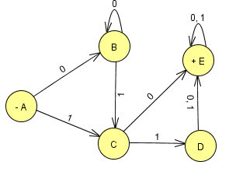
Note: No need to follow the state elimination method. Simply follow the paths and write RE

Q36
What are the Joints of PDA? [3]

Q37
Derive any two words of length 4 from the given CFG. Write the corresponding RE as Well
S→XaaX, X→aX|bX|Λ. [5]

Q38
Build an NFA equivalent to FA1 U FA2, where FA1, FA2 are given below. [5]

FA1
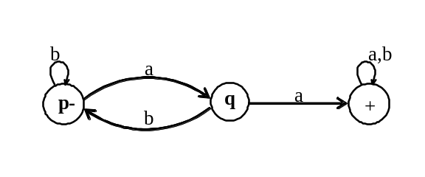
FA2
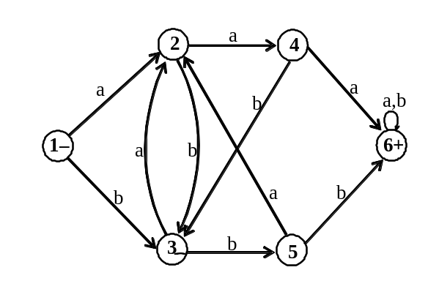

Q39
Draw the corresponding Mealy Machine for the following table: [10]
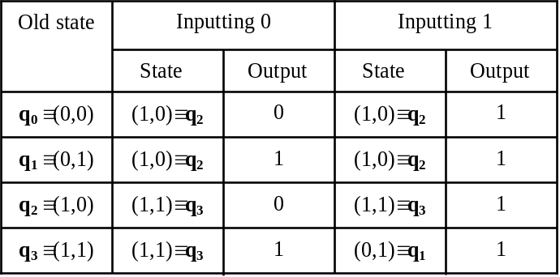

Note: Use MS Office or Paint for drawing the picture.

Q40
Draw the FA corresponding to the following PDA: [10]

