PSY101 (Short Notes, Terms, MCQ’s) - Midterm

INTRODUCTION:

German philosopher and physiologist Wilhelm Wundt set the foundations of modern psychology in 1879, by establishing the first psychology laboratory in Leipzig, Germany.

“Psychology is the scientific study of behavior and mental processes …. Human or Animal”

Psychologists study animals’ behavior too; to better understand and predict human behavior, the study of animal behavior becomes essential at times, especially because some researches cannot be carried out with humans due to safety reasons or ethical issues

Main goals of psychology are:
a) Observation,
b) Description,
c) Understanding,
d) Explanation,
e) Prediction, and
f) Control of human behavior and mental processes.

Psychology is a science that uses scientific method for gathering knowledge and information.

Scientific method is a systematic and organized series of steps that scientists adopt for exploring any phenomenon in order to obtain accurate and consistent results.
Steps involved in Scientific method: observation, description, control, and replication

“Psychology has a long past, but only a short history.”(Hermann Ebbinghaus, 1908)

Trephining was a procedure whereby a hole was drilled into the skull of a mental patient.
This was done in order to let the evil spirits or demons escape from the sufferer’s body.

In 1590, Rudolf Goeckel used the term “psychology”.
This word is the combination of two Greek words “ psyche” and “ logos”, the former means the “ soul” and the later “ discursive knowledge”. Thus literally, psychology means the science of soul.

Aristotle gave a very important place to soul in human life. Life has no meaning without soul.

Psychology was also defined as the “science of mind”.

Psychology has also been defined as the science of consciousness defined by Wilhelm Wundt

Modern physiologists and Watson, the founder of the behaviorist school of thought, defined psychology as a science of behavior, both of animals and humans

The new scientific psychology is a fusion of two psychologies, i.e., philosopher’s psychology and the sensory psychology. So basically Psychology emerged from Philosophy

POPULAR AREAS OF PSYCHOLOGY:

Clinical Psychology
A branch of psychology concerned with the study, diagnosis, and treatment of abnormal behavior.
It is the oldest as well as the most well known branch of psychology.

Industrial / Organizational Psychology
A branch of psychology that studies the psychology in action at the workplace, including productivity, job satisfaction, and decision-making

Health Psychology
The branch of psychology that explores the relationship of psychological factors and physical illness or disease

Consumer Psychology
A branch of psychology that studies and explains our buying habits and our effects of advertising a buying behavior. Mainly dealt with the likes and dislikes and preferences of people.

Environmental Psychology
A branch of psychology, that focuses upon the relationship between people and their physical environment.

Sport Psychology
The branch of psychology that studies the psychological variables that have an impact upon the sportspersons’ performance; e.g. how stress can affect sport performance, how morale can be boosted, the impact of crowd behavior etc.

Forensic Psychology
The branch of psychology that investigates legal issues and psychological variables involved in criminal behavior.

http://vustudents.ning.com/

THE GREEK PHILOSOPHERS:

HIPPOCRATES (460-377 B.C.)
Hippocrates was a physician, Regarded as the “Father of Medicine”
He postulated a theory of “humors” that account for the basic human activity.

PLATO (427-347 B.C.)
He was the first person in history to produce a great all- embracing system of philosophy.
He developed the theory of knowledge, theory of conduct, theory of state, and the theory of universe.
According to Plato, the soul has three parts or components, which he calls reason, spirit, and appetite.
According to Plato, when a person moves from believing to thinking, he moves from the visible world to the intelligible world, from the realm of opinion to the realm of knowledge.
Plato believed that thinking gives us knowledge of truth.
ARISTOTLE (384-322 B.C.)
He was not only a philosopher in the modern sense but he was a man of universal learning.
There was no branch of knowledge, which did not receive his attention except, mathematics.
It is to him that we owe the first systematic treatment of psychology.
His method was two- fold, both inductive and deductive.
He introduced:
• The first theory of learning
• Succession of ideas
• The theory that ideas are generated in consciousness based on four principles:
Contiguity, Similarity, Contrast, Succession

SOCRATES (469- 399)
For him, soul was the essential man.
For him, soul was the capacity for intelligence and character.
It was man’s conscious personality. The activity of soul is to know and to direct a person’s daily conduct.
The man’s greatest concern should be the proper care of his soul so as to make the soul as good as possible.

ALCAMEON: (500 BC)
A physician, who performed the first dissection
He was interested in philosophy and directed his attention to understanding perception
He believed that sensations and thoughts occur in the brain.
ALCAMEON was known as “father of Greek medicine”
He was the first to take anatomical dissection for research purposes and also the first vivisectionist.

THE MUSLIM INFLUENCE:

The period which was called Europe’s Dark Age was the period when Muslim philosophy, science, and knowledge flourished.

Muslims presented the “humane concept” of mental treatment. Muslim thinkers and philosophers established the first mental hospital in Spain

Types of Soul: Man is a compound of body and soul.
Soul is of two types:
Rooh-e –Rabbani: The part of the soul that makes it possible for man to make a connection with God.
Rooh-e-Haewani: Man possesses ‘Nafs’ or the soul. It is the force with the help of which man fulfills all his desires.
Levels of ‘Nafs’: Nafs is divided into three levels:
Nafs-e- Mutmaina: At this stage, the body and soul are in complete harmony. There is no conflict between good and bad and man is satisfied physically, mentally and spiritually.
Nafs-e- Liwama/Nafs-e-Natiqua: At this stage, the conflict between good and bad starts, both positive and negative forces clash with each other. Man is in a state of “do” and “don’t”.
Nafs-e- Ammaraa: A t this stage, negative forces have a complete control over the individual. It is the animal tendency of man. All bad habits and wrong doings are due to this Nafs e.g. greed, pride, anger, lust, hatred etc
AL-FARABI (870-950 AD)
• Philosopher and poet
• According to him, Man is composed of two elements; body and soul
• Believed in dualistic nature of Man
• He was of the view that there exists no relationship between body and soul

IBNE- MUSKAVIA (930-1030 AD)
• “Man is a compound of body and soul”
• ‘Rooh’ is the main factor that controls our actions and maintains them
• If ‘soul’ rules over the body then person remains mentally healthy but if body rules over the soul then the person becomes mentally ill

IBN-E-SINA/AVICENNA (980-1037 AD)
• A physician, scientist and a philosopher
• Considered as the great physicians of ‘Middle Ages’
• Gave importance to the ‘sentiments’ of the individual
• He said,” When man is away from God’s love, he is also away from man’s love”
According to him, there are three kinds of mind:
• Vegetable Mind
• Animal Mind
• Human Mind

IMAM-GHAZALI (1058-1111 AD)
• Believed that ‘self’ which is called ‘Qalb’ is the essence of Man.
• It is spiritual entity residing in human body which controls the organic & physical functions of an individual
• ‘Self’ is the center of personality from which all the psychological phenomena originate
• He classified the behavioral mal-adjustments into the bodily and spiritual disorders

According to IMAM-GHAZALI, there are SIX powers of “Self”:
• Anger
• Impulse
• Apprehension
• Intellect
• Appetite
• Will
Anger is the ‘beastly power’ and ‘intellect’ is the 'Devine power’.
His method of treatment is called “contradictory treatment” i.e., illiteracy is treated with literacy.
The therapist was named ’Sheikh’ and patient called ‘Mureed’.
IBNE ARABI (1165-1240 AD)
Believed in the idea of “WAHDAT- UL WAJOOD” which means that Man is the part of God himself
Because Man is created by God, so for mental health, it is essential that he should perish himself in the
“ZAAT” of God
MUJADAD ALFSANI (1564-1625 AD)
• Supported the idea of “WAHADT -UL-SHAHOOD” means “REFLECTION OF GOD” which means that the God’s reflection can be seen in the things, which have been created by God.
• A person who is complete in his self and a follower of Shariat and Tareequat is mentally healthy.
SHAH WALI ULLAH (1703-1762 AD)
• Mentioned about two forces:
I. Beastly Force or Baheemi
II. Ar-Rabbani or Devine.
• Both are contradictory forces and are always struggling. This struggle is called “TAJAZUB”.
• When there is no struggle between these forces, then the individual’s condition is called “ISTALLAH” (mentally healthy and well balanced).
• But when they are struggling and have conflict, then it is called “ALLAHIE TAJAZUB”
(Tendency towards mental illness)

RAPID DEVELOPMENTS SINCE 17TH CENTURY A.D

RENE DESCARTES (1596-1650 AD)
• His most important work was his attempt to resolve the mind- body problem, an issue that had been controversial for centuries.
• He saw human body as a piece of machinery; difficult and complicated.
• Mind-Body “Interactive Dualism”: mind and body are separate entities influencing each other
• Nerves are hollow tubes through which “Animal Spirits” conduct “Impulses”

FRANZ JOSEPH GALL (1758-1828 AD)
• Known for his work on phrenology
• He postulated the idea that particular psychic functions are represented by particular areas of the brain.
• Intelligence, moral character and other personality characteristics can be distinguished by the shape of, and the number of bumps on, a person’s skull.
JOHN LOCKE (1632-1704 AD)
His major contribution to psychology was an essay concerning human understanding, which appeared in 1690 and was the conclusion of some 20 years of study and thought; it was later considered as the formal beginning of English/British Empiricism.
His primary question was how the mind acquires knowledge?
Locke, gave the concept of “Tabula Rasa”; People are born in this world with empty minds i.e.”Tabula Rasa” or a blank slate. The ideas and memories are imprinted on our minds as a result of experience.

http://vustudents.ning.com/

SCHOOLS OF THOUGHT

STRUCTURALISM
Focused on studying the conscious experience by looking into its individual parts or elements
Analyze consciousness into basic elements and study how they are related.
A method used to study the ‘structure of the mind’ was called “INTROSPECTION” (Self-observation of one’s own conscious experiences)

FUNCTIONALISM
Focused on what the mind does and how it does.
Investigate the function, or purpose of consciousness rather than its structure.
This school founded by the American psychologist William James, became prominent in the1900s.
Emphasized “function” rather than “Structure” of human consciousness i.e., what the mind does
John Dewey: Famous American educator. One of the key founders of “Functionalism”

GESTALT PSYCHOLOGY
Focused on studying the whole experience of a person rather than breaking it into individual components
‘The whole is different than the sum of its parts’
In contrast to the structuralist approach of breaking down conscious experience into elements, or focusing upon the structure, the Gestalt emphasized the significance of studying any phenomenon in its overall form.
The word gestalt means “Configuration”
Three German psychologists Max Wertheimer, Kurt Koffka and Wolfgang Kohler were regarded as the founders of gestalt school

BIOLOGICAL MODEL
The psychological model that views behavior from the perspective of biological functioning
The role of brain, genes, neurotransmitters, endocrine glands etc

PSYCHODYNAMIC MODEL
Focuses on the unconscious forces that drive/ motivate human behavior
This approach concentrates on belief that behavior is motivated by the inner forces over which individuals have little control. It was founded by the Viennese physician Sigmund Freud in early 1900s.

COGNITIVE MODEL
The psychological model that focuses on how people know, understands, and thinks about the world.
Cognition: The mental processes involved in acquiring, processing, storing & using information
Cognition means “the known”, “knowledge”, or “the process of knowing”

BEHAVIORAL MODEL
Focuses on studying the behavior that is observable and overt
The behaviorists relate overt behaviors (responses) to observable events in the environment (stimulus)
John B. Watson was the first person to advocate the behavioral approach.

HUMANISTIC MODEL
The psychological model that suggests that people are in control of their lives
Humanistic perspective emphasizes the unique qualities of humans especially their freedom & their potential for personal growth. Humanists take an optimistic view of human nature

GENERAL INFORMATION ABOUT PSYCHOLOGIST:

James Mckeen Cattell: Known for his work on individual differences and “Mental Tests”

Emil Kraeplin: Postulated a physical cause of mental illness, in 1883, he gave first classification system of mental disorders

Hugo Munsterberg: First to apply psychology to industry and law

Edward B. Tichener:
Known as the formal founder of Structuralism
American psychologist, English by birth, which spent his most productive years in Cornell University, New York
He believed that we can study perception, emotions and ideas through introspection, by reducing them to their elementary parts
There are four elements in the sensation of taste: sweet, sour, salty and bitter
Ideas and images are related.

Max Wertheimer: The founder of Gestalt psychology, born in Prague in 1880

Phi phenomenon = When two lights are in close proximity to each other, flashing alternately, they appear to be one light moving back and forth; therefore the whole was different from the separate parts; movement perceived whereas it never occurred

We perceive experiences in a way that calls for the simplest explanation, even though reality may be entirely different; this is Gestalt Law of Minimum Principle.

Kurt Koffka
Wrote the famous “Principles of Gestalt Psychology” (1935)
Talked about geographical versus behavioral environment

Wolfgang Kohler
Gave the concept of “insight” and “transposition”, as a result of his observations of a caged chimpanzee and experiments with chickens
• Insight = spontaneous restructuring of the situation
• Transposition = generalization of knowledge from one situation to another
• Kohler also talked about Isomorphism; changes in the brain structure yield changes in experiences

Galen (129-199 A.D): Born to Greek parents in Asia Minor. Known for anatomical studies on animals and observations of human body functions
Julien Offroy De La Mettrie (1709-1751 Ad): French priest turned physician
Cabanis: French physician
Philippe Pinel (1745-1826 Ad): French physician
Wilhelm Griesinger (1817 – 1868 Ad): German psychiatrist
Paul Broca (1824-1880): French surgeon and anthropologist, Discovered speech center in brain
Emil Kraepelin (1856-1926 Ad): German psychiatrist. Stressed the likely physical cause of mental illness

Charles Darwin: (1809-1882 Ad): British scientist, Author of the revolutionary “The Origin of Species” (1859), gave the concept of “Survival of the Fittest”

IMPORTANT TOPICS & TERMS

Neurotransmitters: The synapse of the neuron releases special chemicals called “neurotransmitters”
Neurotransmitters and Their Role:
• Acetylcholine: Learning, Memory and Muscle control
• Dopamine: Motor activity, Coordination, Emotion and Memory
• Epinephrine: Emotion, Stress
• GABA (Gamma-Amino Butyric Acid): Anxiety, Arousal, Learning
• Serotonin: Sensory Processing, Sleep, Arousal
• Glutamate: Anxiety, Mood

“Pharmacology is the science of the study of drugs to treat a wide range of less severe psychological disorders”
- Narcosis: The word “Narcosis” is derived from the Greek word meaning, “be numb”
- Chemotherapy: It is the type of therapy that treats mental and behavioral disorders with drugs and chemicals
Tranquilizers: Drugs that produce soothing and calming effects
Energizers: They are used with the sufferers of depression who are not helped by sedatives

THE PSYCHODYNAMIC APPROACH/ MODEL: The approach that concentrated on the unconscious forces that drive our behavior; belief that the inner forces over which individuals have little control motivate behavior.

Founded by Sigmund Freud
- He was founder of psychoanalysis.
- Austrian physician, neurologist, psychologist.
- In 1895: wrote “Studies on Hysteria”

Structure of Consciousness
Conscious: Contains thoughts and feelings of which one is immediately aware
Subconscious: Mind level below the level of conscious awareness
Preconscious: Part of the sub conscious that can be accessed by deliberate choice
Unconscious: Part of the sub conscious that cannot be accessed directly although impulses, ideas, and feelings may permeate out through other sources e.g. dreams, slips of tongue etc.
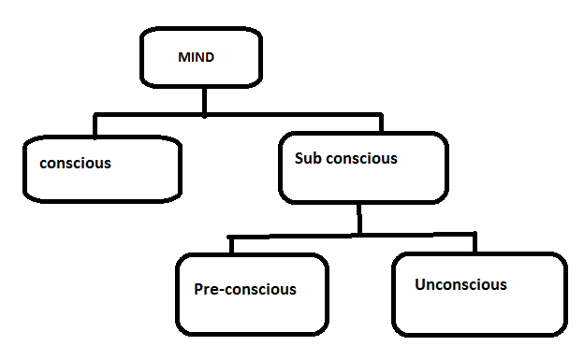

Sources of motivation

Psychodynamic Model of Personality Is a three-part structure of the mind; Id, ego and super ego.

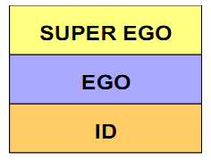
Id
At birth, the entire mind consists of only id. It consists of pure, unadulterated, instinctual energy and exists entirely on the unconscious level. It is the source of basic drives; operates under the ‘pleasure principle’ i.e., it wants immediate gratification of needs.

The id has two means of satisfying bodily needs, reflex action and wish fulfillment.

Reflex action is responding automatically to a source of irritation .e.g. an infant may sneeze in response to an irritant in the nose. In such case, reflex action is effective in reducing tension. Coughing and blinking are other examples of reflex action.

Wish- fulfillment is more complicated. It is the illusion of an image of an object or event that is capable of satisfying a biological need e.g. a hungry person thinks of food- related objects.

Ego
Mediates the link of the self with the outside world, “Real World”, as well as between the id and superego; operates under the demands of the environment. The ego comes into existence in order to bring the person into contact with experiences that will truly satisfy his/ her needs. When the person is hungry, the ego finds food, when the person is thirsty, the ego finds liquid. The ego goes through reality testing to find appropriate objects.
http://vustudents.ning.com/

Super Ego
There is a third component of personality that makes things much more complicated, i.e. super ego. It is governed by the moral constraints. It develops from the internalized patterns of reward and punishment that the young child experiences i.e. Depending on the values of the parents, certain things the child does or says are rewarded and encouraged and others not liked are punished or discouraged.

Anxiety
• An emotional state experienced as a result of felt threat to the self
• Anxiety arises when ego cannot cope too much of:
i. Demands of the id
ii. Demands of the ego
iii. External danger
• In order to protect itself against anxiety and threat, ego uses defense mechanism

DEFENSE MECHANISMS
i. Repression: Blocking unpleasant/unacceptable thoughts by pushing them into the unconscious e.g. forgetting events of the painful childhood.
ii. Regression: Reverting back to a stage that was satisfying e.g. a boss showing temper tantrums like a child; or acting like a baby.
iii. Displacement: Redirecting the expression of unwanted desires or impulses to a substitute rather than the actual target e.g. beating children when a wife cannot express anger toward husband.
iv. Rationalization: In order to justify one’s behavior, one develops a socially acceptable explanation or reasoning e.g. going for a second marriage saying that the first wife was quarrelsome.
v. Denial: Refusing to acknowledge or accept anxiety provoking thoughts or impulses e.g. being a heavy smoker but saying ‘I am an occasional smoker’.
vi. Projection: Attributing unwanted thoughts and impulses to others e.g. a person takes bribe and blames the organization for paying him not enough salary.
vii. Sublimation: Converting unwanted impulses into socially approved thoughts, feelings and actions e.g. disliking the in-laws but behaving in a very friendly manner.

Psychotherapy: Psychoanalysis
• An intensive, long-term psychotherapeutic procedure.
• Requires long sessions over extended periods----- may be years.
• Better suited to intelligent individuals.
• Involves a special relationship between the therapist and the patient.
• Target: To explore unconscious motivation, conflicts, desires.
• Goal: Establishing intra psychic harmony by developing awareness of the role of the id, reducing over compliance with super ego, and by strengthening the ego.
• Understanding of ‘repression’: The therapy gives central importance to the understanding of the manner in which the person uses repression for handling conflict.

Stimulus: A physical energy source that has an effect on a sense organ, thus producing a response
Response: The action, behavior, or reaction triggered by a stimulus.
Environment: External factors, variables, conditions, influences, or circumstance affecting one’s development or behavior.
Variable: A behavior, factor, setting, or event that can change / vary in amount or kind.
Learning: A relatively permanent change in behavior that takes place as a result of practice and/or experience.

Shaping: Successive approximations of a required/desired response are reinforced until that response is fully learnt
Stages in Shaping:
- Acquisition: Initially the response rate following reinforcement may be slow but at one stage it increases to the maximum.
- Extinction: If reinforcement is withheld the response rate decreases and finally no response is shown.

Shaping Can Best Be Used For:
• Learning alphabets, vocabulary, mathematical tables, or a new language.
• Learning to play a musical Instrument.
• Appropriate classroom behavior.
• Training mentally handicapped children.

STEPS OF SCIENTIFIC METHOD IN PSYCHOLOGY
1. Identifying the research problem: The research problem can be identified in many ways, including personal interest, brainstorming, scientific developments, knowledge etc.

2. Review of the related literature: In order to see how others approached the same or similar issues.

3. Formulation of hypotheses: A hypothesis is a speculative statement about the relationship between two or more variables. Reviewing the related research articles helps one formulate various hypotheses.

4. Designing and conducting the research: After reviewing the related literature and making hypotheses, the research is conducted by using different strategies such as Questionnaires, mail interviews, telephonic interviews, face to face interviews etc.

5. Analysis of data: After collecting information, the data will be tabulated with the help of statistical methods and computation in order to see whether the finding prove or disprove the hypotheses.

6. Drawing conclusions: Conclusions are drawn after the statistical analysis of data. On the basis of this, a decision is made about the rejection or acceptance of the hypothesis.

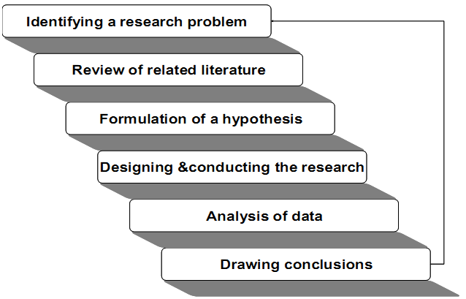

RESEARCH METHODS IN PSYCHOLOGY:
1. Observation: Systematic observation is used. Phenomenon of interest is observed, studied, and the observations are recorded. The recorded observations are analyzed. Conclusions are drawn on the basis of analysis. Types of observation: Observation without Intervention, Observation with Intervention

2. Correlation Research: A method used for identifying predictive relationships among naturally occurring variables

3. Surveys: Surveys are used when quick information is required in limited time e.g. opinion polls, product preference
Sources of data/information in Surveys
• Questionnaires: in person, mailed, internet
• Interviews: personal, telephonic
• Newspaper Surveys

Five Steps involve in conducting the Survey:
Conceiving the problem: The purpose of the study. How is the information to be used? What kind of information to be gathered etc
Designing the instrument: There are numerous ways by which information can be gathered from the general public such as mailed questionnaires, telephonic interviews, through internet etc
Sampling the population: With this procedure, each age, sex, income, religious and ethnic group in the population will be proportionately represented in the sample
Conducting interviews: Experiments have shown that females are the best interviewers: at least 21 years of age, who like people, who are unbiased, who are good listeners, who have some college education, and who are fairly familiar with the section they are working in.
Interpreting the results: When all the findings are carried out properly, there is always a chance of misinterpreting the results. Errors in questionnaires, statistical methods, and investigator’s own subjectivity can easily bias the results. So be careful about that.

4. Unobtrusive Measures of Behavior: Indirect ways of data collection, The person/s who are the focus of interest may not be present at the time of investigation.
5. Content Analysis: The analysis may cover contents of live human behavior, books, journals, magazines, poetry, drama, movies, folktales, TV programs, school textbooks and curricula, advertisements etc
6. Focus Groups: A variety of interviews conducted in a group setting
7. Meta Analysis: A statistics based method
http://vustudents.ning.com/

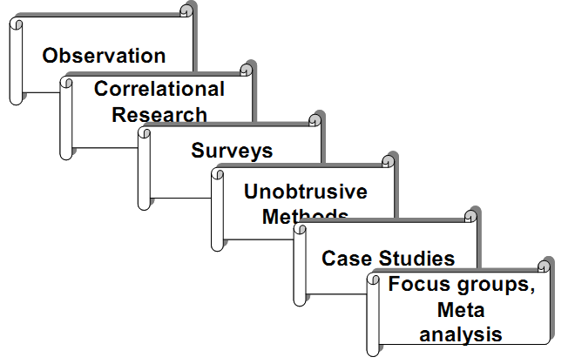
Development: “The process of growth and differentiation”
Developmental Psychology: The branch of psychology that studies how growth and physiological/ psychological/ social changes take place over the life span

Nature versus Nurture
• Nature means hereditary influences.
• Nurture refers to environmental influences, in child development.

Limitations of Nature-Nurture Research:
• Ethical considerations in research with humans
• Not all animal research can be applied to humans

Genes: parts of chromosome that are the transmitters of inheritance.
Genes may be dominant or recessive; a dominant gene means that its characteristics will dominate those of the recessive one e.g. if father has brown eyes and mother has black eyes, and if the father’s genes dominate then the baby will have brown eyes.
- The zygote contains 23 pairs of chromosomes
- Deoxyribonucleic Acid (DNA)

Prenatal Stages:
Embryo: A developed zygote with a heart, a brain and other organs.
Fetus: A developing child; 9 weeks after conception till birth.

Genotype: genetic composition of a person.
Phenotype: observable characteristics.

Alleles: This difference in color is due to the fact that genes come in alternative forms called “Alleles” (alternative forms of a gene).
When alleles are identical, a person is homozygous for a trait;
When alleles are dissimilar the person is heterozygous.

Anthropologists: Focus on, and measure, how cognition develops in different cultures.
Sociologists: study how cognitions are acquired and used in various groups and institutional settings.
Computer scientists: Target to create ‘artificial intelligence’.

Biological Bases of Behavior

The Nervous system: The system that controls and regulates the structure and function of the brain, spinal cord, nerves, and the nerve cells; it maintains coordination between the nervous system and the rest of the bodily systems

Endocrine Glands: These glands form the body’s “slow” chemical communication system; a set of ductless glands that secrete hormones (special chemicals) into the bloodstream”

Central Nervous System (CNS): The system that controls and regulates the structure and function of the brain, spinal cord, nerves, and the nerve cells; it maintains coordination between the nervous system and the rest of the bodily systems.
Peripheral Nervous System (PNS): Consists of the spinal and cranial nerves; these connect the CNS to the rest of the body. PNS connects the body’s sensory receptors to the CNS, and the CNS to the muscles and glands.

Neuron: A nervous system cell is constituted in such a way that it is specialized in receiving, processing, and/or transmitting information to other cells.

The Brain
• The center of the nervous system.
• The vital organ that is responsible for the functions of seeing, hearing, smelling, tasting, thinking, feeling, remembering, speaking, dreaming, information processing, and a lot more.

Structure of Brain
• The deeply grooved structure lies safely and securely in our skull.
• The average adult human brain weighs 1.3 to 1.4 kg (approx. 3 pounds).
• If you look at it from the outside the brain is pinkish gray in color; soft, spongy, and mottled.
• The brain contains billions of nerve cells (neurons) and trillions of "support cells".

The brain is made of three main parts:
a. Fore brain
b. Mid brain
c. Hind brain

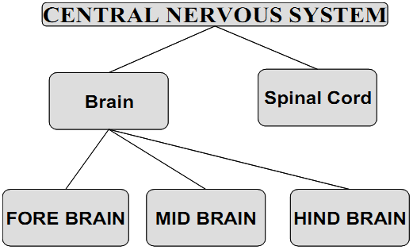

Electroencephalogram (EEG): An apparatus/machine that measure records and displays electrical activity within the brain of a person.
Magnetic Resonance Imaging (MRI): The scan produces a powerful magnetic field to provide a computer generated, detailed image of the structure of the brain.
Super Conducting Quantum Interference Device (SQUID): a scan sensitive to minute changes in the magnetic field occurring when neurons are firing.
Positron Emission Tomography (PET): a scan showing biochemical activity within the brain at any given moment.

Cerebellum:
• "Cerebellum" comes from the Latin word for "little brain”. The cerebellum is located behind the brain stem.
• It carries 10% of the weight of the brain.
• It contains as many neurons as in the rest of the brain.
• Its function is to coordinate body movements i.e. coordination, maintenance of posture & balance.

Cerebrum: Largest part of the human brain, associated with higher brain functions such as thought and action.

Cerebrospinal Fluid (CSF):
A clear, colorless fluid covering the entire surface of central nervous system

Endocrine system is a collection of glands that produce hormones that regulate body's growth, metabolism, and sexual development and function. The hormones are released into the bloodstream and transported to tissues and organs throughout the body.
Endocrine glands are known as the “Managers of Human Body”

Sensation: Sensation is a process that makes possible, and facilitates our contact with reality. ‘To sense’ means to become aware of something.
The five senses:
• Vision
• Hearing/ Auditory sense or Audition; also associated with maintenance of bodily balance
• Smell/ Olfaction
• Taste
• The skin sensations/ Kinesthetic sense; touch, pressure, temperature, and pain

VISION:
The Human Eye:
Cornea: A transparent external surface, five-layered membrane that covers both the pupil and the iris.
Sclera: Outer walls of the eye are formed by a hard, white substance called ‘sclera’, hence sclerotic coat that covers 5/6th of the surface of the eye.

Pupil: A dark, adjustable opening in the center of the eye through which the light enters. It changes its size as the amount of light entering the eye varies

Iris: Around the pupil of the eye, there is a ring of muscle tissue that controls the size of the pupil opening, through its contraction and expansion

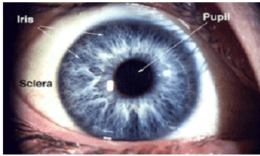

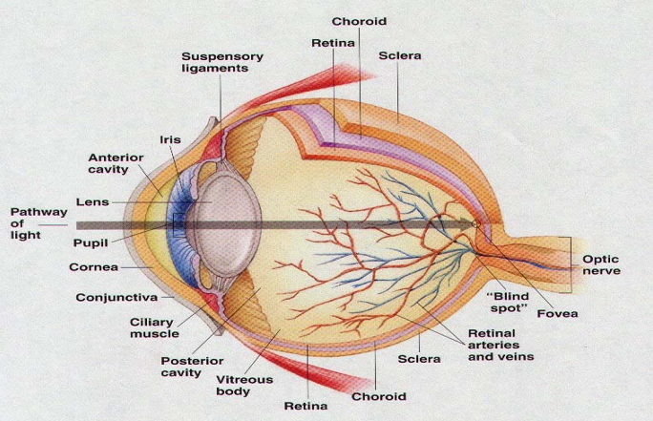

Lens: The transparent part of the eye that is located behind the pupil that changes it shape in order to focus images on the retina. The lens changes its own thickness in order to focus image properly on retina__ this ability of the lens is called “accommodation”

Eye has three important layers or chambers:
i. Anterior layer that lies between the cornea and iris
ii. Posterior layer that lies between iris and lens
iii. Vitreous layer that lies between the lens and the retina

HEARING:
Ear is regarded as the organ of hearing.
Some Interesting Facts about Hearing:
• Animals have the capability of hearing more sounds than humans
• Dolphins have the best sense of hearing among all animals
• When people go up high in the mountains, the changes in pressure cause the ear to pop
• Babies can get ear aches because of the milk deposit in the Eustachian tube, which helps the bacteria to grow there and may cause problems later in life
• Children can hear more noises than adults, as their ears are more sensitive than that of adults
• Ear aches result when too much fluid causes pressure in the eardrum__ often occur due to allergies, virus or some sort of infection

The Human Ear: Anatomy/ Structure:

The primary apparatus of hearing i.e., the ear is divided into three parts

1. The outer ear: The outer ear serves the function of collecting the sound waves from the environment to the internal portions of the ear. It is shaped like a reverse megaphone

Auditory Canal: When sound waves originate from the vibrating object, they then pass through the auditory canal, which is a tube like passage through which the sound travels to the inner part of the ear or “ the eardrum”.

Eardrum:
• The part of the ear that starts vibrating when sound waves strike/ hit it.
• Its intensity of vibration is dependent on how intense the sound waves are___ the more intense the sound, the more intensely it vibrates.
• These vibrations are then transmitted to the “middle ear”.

2. The middle ear:
• A tiny chamber between the eardrum and cochlea containing three bones---- the hammer, the anvil, and the stirrup, which transmit vibrations to the oval window
• These three bones have only one function, i.e. to convey/ transmit the message to the inner ear.
Oval Window:
• A membrane between the middle and the inner ear that increases the strength of the stimulus (vibration) while transmitting them.
• Serves as the amplifier so that tiny or hiss voices could be heard, which otherwise may remain unnoticed.

3. The inner ear:
The innermost region/ part of the ear that contains important structures such as cochlea, semi circular canals and vestibular sacs, and that changes/ transforms the sound waves into the neural impulse.

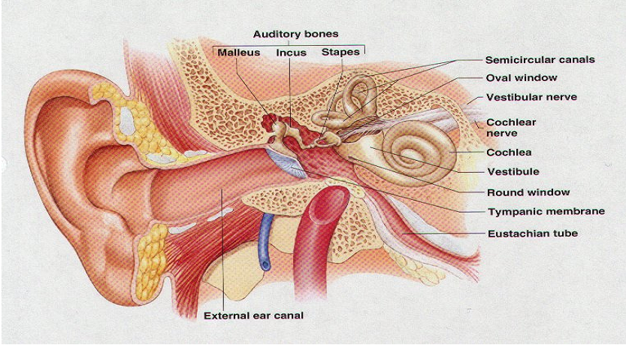

Frequency: Is the prominent feature/ characteristic of sound and refers to the number of complete wave lengths that occur or pass a point in each second.

Pitch: Primarily related with the frequency and refers to the quality of sound that is being produced by the frequency of the sound wave; expressed in cycles per second.

Timbre: Quality of sound determined by the complexity of sound waves

http://vustudents.ning.com/
PERCEPTION
Perception: The ability to process or use information coming/received from the senses.
Gestalt Laws of Perceptual Organization
The Law of Closure: It is the perceptual tendency to fill in the gaps and completing the line; enables us to perceive the disconnected parts as the whole object.

The Law of Proximity: Close or nearer objects are perceived as coherent and related.

Law of Continuity/Good Continuation: Tendency to group the stimuli into smooth and continuous patterns or parts.


Law of Similarity: Tendency to perceive objects, patterns or stimuli as groups, which are similar in appearance
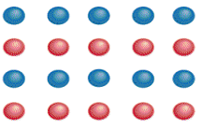
Law of Simplicity: People intuitively prefer the simplest, most stable, straightforward, and basic form of possible organizations.
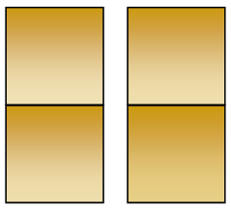
Law of Common Fate: It is the tendency to group together the objects that move together, or seem to move together, and in the same direction.
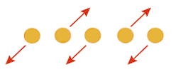
Law of Enclosure/ Connectivity: It is our perceptual tendency to perceive features/ patterns, such as dots or objects as a single unit when uniform and link; lines, dots, areas, objects etc are perceived as single or same unit when combined or linked.
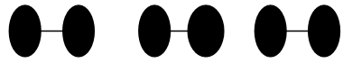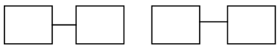

Feature Analysis: The process of perceiving a shape, pattern, object, or scene by attending to the individual elements making it up.
Steps in Feature Analysis:
a. Identify the feature, shape of any object, of which the image falls on the retina.
b. Combine/ gather object in some form/pattern so that some sort of representation can be formed.
c. In the final stage, we identify/ compare each component/element/ object with the help of past experiences or memories.

Depth Perception:
Depth perception is he perceptual tendency/ ability to see objects in three dimensions, although the image that falls on the retina of the eye is two-dimensional; thus enabling us to perceive distance.

“Depth Perception” is the skill to perceive depth and distance e.g. we are able to judge the distance of the incoming car, height of the cliff or of a roof top, size of an object, weight of a sand bag etc, in a glance, just by having a look at it.

This sort of perception is largely due to the fact that we have two eyes which are slightly distant from each other, so the brain integrates the two slightly different images and combines them into one consolidated view; However the differences in images or ‘Binocular Disparity’ is not ignored by the brain. Eleanor Gibson and Richard Walk discovered these phenomena in 1960 by using the miniature cliff with a drop- off covered by sturdy glass.

Motion Parallax: The change in the position of the retinal image with the side-to-side movement of the head; providing a cue to the distance.
Occurs when objects are at different distances and we are also moving at different rates when in motion.
A binocular cue for depth perception that illustrates, that when we assume that the two objects are of same size, the one that produces a relatively smaller image will be perceived as distant

Selective Attention:
Perceptual process in which the person chooses the stimulus which he is interested in; paying attention to only the stimulus of interest

Dichotic Listening:
• A procedure in which individual wears earphones in which different messages are sent to each ear at the same time.
• After hearing the stimuli, the individual is asked to reproduce them aloud as it comes to one ear: “shadowing”.
• In this process, individual can easily identify the talking person as man or woman and whether change in voices takes place during the message or not.

Form-Perception:
• A perceptual phenomenon in which we perceive the shape, form or pattern of any object___ give name to objects as house, tree, table, chair etc
Mainly it involves two important principles:
• Figure- ground relationship
• Contours
Figure- Ground Relationship:
Our perceptual tendency to see objects with the foreground as well as the background___ the object is being recognized with respect to its back ground e.g. Black board and chalk, painting against the wall etc. It is a vise- versa relationship i.e., figure cannot be observed without a ground and ground cannot be recognized without having a figure.
Contours:
Perceptual phenomenon in which we are able to maintain a difference of the form from its background due to the perception of contours e.g. In observing the paper, which has two colors, white and black__ there is no contour at all. But as it becomes lighter rather than becoming dark, a person can simply identify the difference. And when the difference is much apparent, we simply divide into two parts as light and dark and skip different shades as lighter or darker____ where brightness changes suddenly, we perceive contours.

Motion Perception: Motion simply means the relative/ progressive change in the position of the person in space with time. Objects cannot be perceived fully when in motion. It is also difficult due to the fact that our eyes cannot follow the moving object with great precision and efficiency all the time.

Relative Motion: While looking at moving automobiles, the ones that are nearer seem to be moving more rapidly than those at a moderate distance, and those that are more distant seem to be moving along. Relative motion can also be interpreted through experience, when one can fairly tell the speed of a train or a bus by noticing outside the window as to how rapidly the nearby objects are passing.

Radical Motion: A movement directly towards or away from the observer. Continuous and radical motion is being perceived when the retinal image continuously changes. The change in size of the retinal image gives the perception of motion.

Perceptual Constancy: A perceptual tendency to perceive object as unchanging in size, shape, color, lightness etc., even though changes in illumination and retinal image do take place
Lightness Constancy: object’s lightness or brightness remains the same in spite of changes in illumination.
Color Constancy: color of the object remains the same in spite of changes in lighting conditions
Shape Constancy: Means the shape of the object remains the same in spite of some changes in its orientation.
Size Constancy: refers to our ability or tendency to perceive objects as remaining of the same size despite having distance from the observer

Visual Illusion
Also known as optical illusion. Illusion is misperception, or false perception.
It is when the physical stimulus constantly and persistently produces error in perception
Muller- Lyer Illusion: The visual illusion in which the two lines of the same lengths appear different because of the change in position of arrows at each end of two lines__ arrows pointing out appear shorter than the arrows pointing inwards.
Causes of Illusions
- Sensory deficits and defects
- Readiness and expectation
- Atmospheric variables
- Effect of drugs
- Artistic manipulation
http://vustudents.ning.com/

Consciousness: The awareness of the sensations, thoughts, feelings and emotions, events, and surroundings that are experienced by a person.
Varied States of Consciousness
• Sleep
• Dreaming
• Hypnosis and Meditation
• Drug induced states

Sleep
• A state of total or partial unawareness ranging from slight wakefulness to light tranquility, to nearly total detachment from the external world.
• Sleep is the time of rest and rejuvenation for the body.
• The muscles and the nerves relax.
• The body recharges its energy for the hours of work to come the next day.
• Sleep Stages: Stage-1, Stage-2, Stage-3, Stage-4
REM: Rapid Eye Movement Sleep
• Occurs during stage-1 sleep
• Eyes move back and fort
• Sleep is very deep and the major muscles seem as if paralyzed
• Difficult to wake up the person during REM sleep.
• Usually people dream during REM.
• It is thought that eyes move back and forth during REM because they are following the action-taking place in dreams.
• REM sleep plays an important part in a person’s life, both physical and psychological, as the body needs a certain amount of REM sleep.
• Experiments have shown that people whose REM sleep was interrupted and disturbed by being awakened, exhibit a rebound effect.

Sleep Deprivation Effects:
• Sleep deprivation in humans as well as animals has adverse effects although temporary
• Sleep deprivation affects all faculties, mental and physical: causes fatigue, and irritability; concentration and logical thinking are adversely affected.
• Reaction time is slowed.
• Sleep Deprivation may have serious consequences in case of academic performance, automobile driving, and certain professions requiring sharp alertness of mind and body.

Sleep Disorders
Sleep related problems ranging from inability to sleep, to difficulty falling to sleep, to interrupted sleep, to feeling sleepy even when one has had enough hours of deep sleep; Generally known by the name of Insomnia, sleep disorders include sleep walking and sleep talking as well.
Causes of Sleep Disorders
• Stress
• Preoccupation (concern or fear etc.)
• Mental illness
• Noise pollution
• Digestive problems
• Physical illness
• Drug abuse and medication
• High caffeine intake and many other

Practical Steps for Getting Rid of Most Sleep Problems
• Avoid taking sleeping pills.
• Fix a place/room where you will go to sleep every night, and do not do anything else over there.
• Keep television away from your sleeping place, and if it is there NEVER EVER watch an interesting movie or program at sleep time.
• Develop a habit of reading at bedtime, but NEVER EVER read an interesting or exciting book.
• If you are in your bed and still can’t go to sleep, then get out of the bed and take a round around the house and come back. Develop a habit of rising early in the morning every day, at the same time.
• Do not change your sleep time.
• Learn some relaxation exercises.
• Avoid caffeine.
• Avoid heavy meals at night, and eat your dinner about two hours before bedtime.
• A glass of warm milk helps quite often.

Dreams and Sleeping
• Dreams are mental experiences during sleep.
• Every body dreams though they may forget the contents.

Dreams in Freudian Approach: Dreams reflect unconscious needs, desires, and impulses.

Dreams have two levels of dream content: manifest and latent.
Manifest content: The obvious, apparent part: what a dream appears to be to the dreamer.
Latent content: The dream’s true meaning, which is usually disguised or distorted by dream work.
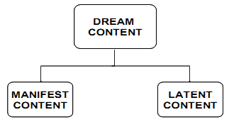

Hypnosis
• A condition in which the person is in a highly suggestible state.
• Following a number of instructions by the hypnotist, the person enters a trance and follows the suggestions or further instructions without resistance.
• The instructions are followed even after the person is out of the trance.
• However, a hypnotic state does not mean total loss of will; people may not follow instructions that clash with their moral/ethical ideology.
• It is primarily a varied state of consciousness in which one is not fully awake.

Why Do People Go For Hypnosis?
People may choose hypnosis as a therapy for various reasons:, e.g. for:
• Quitting smoking
• Quitting alcohol
• Pain management
• Assertiveness training/overcoming shyness
• Improving sport performance
• Treatment of psychological problems (fears/ phobias)
• Eating Disorders
• Recalling events

How Effective Is Hypnosis? There is no conclusive evidence available in this regard.
Meditation
• The person learns (after instruction) to refocus attention and to concentrate in such a way that he/she is totally detached from all the unwanted stimulation for as long as he/she desires.
• For focusing attention a word, syllable, or sound may be repeated e.g. the way we do in transcendental meditation (TM).
• In some forms of meditation some object e.g. a marble, crystal, candle flame, or picture may be used
• The main idea is to concentrate.

Physiological changes due to meditation
• Decreased heart rate
• Lowered blood pressure
• Lessened oxygen usage
• Changed brainwave pattern

How does meditation affect?
• It gives a heightened feeling of relief and relaxation.
• Concentration is sharper.
• Insight is improved and problem solving better.
• It has a positive effect on health, and in some studies longevity has been found to be associated with prolonged practice of TM.

Drug Induced States: Changes in consciousness due to use/abuse of different drugs.
Psychoactive drugs:
• Drugs that affect behavior and mental processes including cognitions, emotions and perceptions.
• More deep rooted and adverse effects are caused by the addictive drugs; drugs causing dependence.

Effects of Drugs
• Withdrawal effects
• Overdose effects

Categories of Drugs
• Stimulants
• Depressants
• Narcotics
• Hallucinogens

Why do people take drugs?
- Addiction
- Role modeling
- Peer pressure
- Stress/ Relaxation
- Thrill/Excitement/Experimenting

Learning: A relatively permanent change in behavior that takes place as a result of practice and/or experience.
Learning usually refers to improved performance, acquisition of skills, and a positive change in behavior; however the change may also be negative in nature

There are varieties of learning:
I. Verbal learning: Basically man is a verbal learner who learns about the environment through experiences
ii. Motor learning: It involves the practical application of the learned phenomena. e.g. learning the skills like playing football, tennis, cricket etc; or the training of technicians whose motor skills need to be highly efficient.
iii. Problem solving: Problem solving tasks usually involves trial and error and primarily includes verbal processes. While doing the problem-solving task, individual learns many responses that can be helpful for him in different situations

OPERANT CONDITIONING:
Operant conditioning forms an association between a behavior and a consequence

Consequences of Behavior:

Reinforcement: Increasing the probability that preceding behavior will be repeated through a stimulus.
Positive Rein forcer: A stimulus whose introduction brings about an increase in the preceding response.
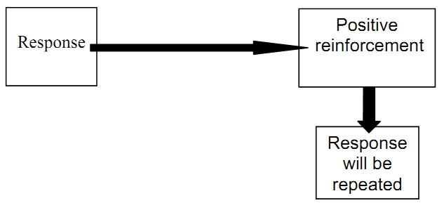
Negative Rein forcer: A stimulus whose removal reinforces and leads to a higher chance that the response bringing about this removal will be repeated.
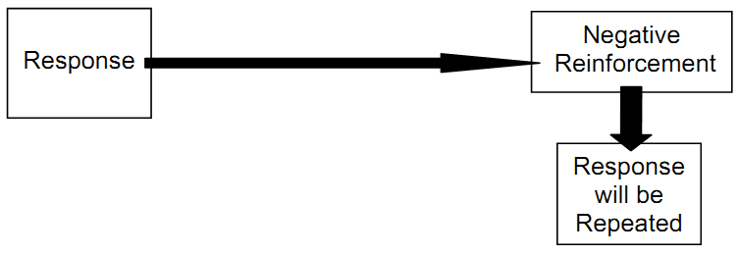

Punishment: An unpleasant or painful stimulus whose introduction following a certain behavior decreases likelihood that the behavior will occur again.
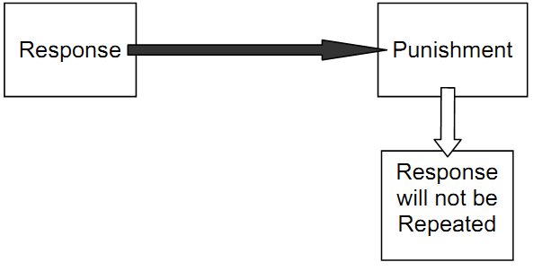
No reinforcement: This also deters or stops a behavior from being repeated.
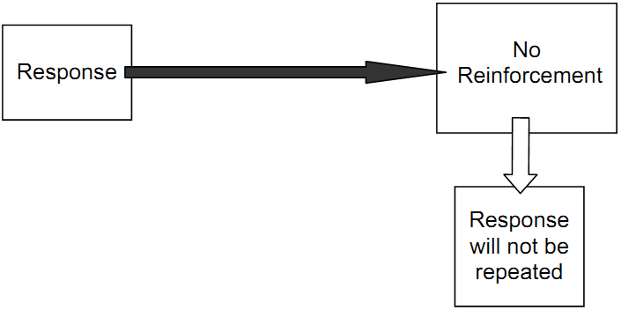
Applications of Operant Conditioning in Everyday Life
• Child rearing
• Classroom management
• Teaching of skills
• Animal taming
• Advertising

PSY101- Introduction to Psychology (Midterm MCQ’s)

Laws of perceptual organization were proposed by which of the following school of thought?
► Functionalism
► Structuralism
► Gestalt school
► Behaviorism
http://vustudents.ning.com/

Today psychology is considered as the scientific study of which of the followings?
► Mind
► Conscious experiences
► Behavior and mental processes
► Soul

Who among the followings is known as “father of Greek medicines”?
► Socrates
► Plato
► Aristotle
► Alcameon

Who among the followings gave the concept of Insight?
► Max Wertheimer
► Wolfgang Kohler
► James Rowland Angell
► James Mckeen Cattell

Who among the followings regarded as the “Father of Medicine”?
► Hippocrates
► Kraepelin
► Plato
► Socrates

Who among the followings is the author of the book “The Origin of Species”?
► Emil Kraepelin
► Paul Broca
► Wilhelm Griesinger
► Charles Darwin

Which of the following is incorrect about insulin-shock therapy?
► In this therapy the comma is caused because of a reduction in blood sugar level.
► It has found to be effective with schizophrenics, addicts etc., if used with psychotherapy.
► It was developed by Paul Broca who was a French surgeon and anthropologist
► It is used to cure psychological disorders by administrating insulin.

Which of the following can increase the likelihood of occurrence of a behavior?
► Extinction
► Reinforcement
► Punishment
► Insight

Identify where we stop reinforcement and behavior extinguishes.
► Generalization
► Extinction
► Spontaneous recovery
► Shaping

Which of the following law is given by Thorndike that all responses followed by satisfaction are stamped into an individual and he learns those responses?
► Law of exercise
► Law of effect
► Law of insight
► Law of belongingness

Which perspective of psychology emerged out of a desire to understand the conscious mind, free will, human dignity, and the capacity for self-reflection and growth?
► Humanistic
► Behavioral
► Gestalt
► Psychodynamic

Which of the following process is suggested by Bandura that help human behavior to learn?
► Intention
► Observation
► Insight
► Reinforcement

Fatima is using newspaper records to study the rate of crime during the past 20 years. Which type of method is she utilizing?
► Participant Observation
► Structured Observation
► Field experiments
► Archival data

Gene that only influences the expression of a trait when paired with an identical gene is known as what?
► Dominant
► Mutated
► Recombinant
► Recessive

Which of the following is the correct order for Piaget's four stages of development?
► Preoperational, sensory-motor, concrete operations, formal operation
► Concrete operations, preoperational, sensory-motor, formal operation
► Sensory-motor, preoperational, concrete operations, formal operation
► Preoperational, concrete operations, sensory-motor, formal operation

Which of the following is a scan showing biochemical activity within the brain at any given moment?
► CAT
► MRI
► EEG
► PET

Which of the following statement best describes “Hormones”?
► The male gonads
► Chemicals found in the synaptic vesicles, which when released have an effect on the next cell
► Chemicals released into the bloodstream by the endocrine glands
► The female gonads

What do we call thyroid enlargement?
► Vitamin deficiency goiter
► Calcium deficiency goiter
► Protein deficiency goiter
► Iodine deficiency goiter

Which part of the eye is a muscle that regulates the size of the pupil?
► Retina
► Sclera
► Iris
► Lens

Which type of hearing problem can be reduced with ordinary hearing aids?
► Central deafness
► Auditory pathway deafness
► Conduction deafness
► Sensory-neural deafness

In Watson’s experiment, when little Albet was being conditioned to the fear of a rat, afterwards he used to be afraid of cotton balls as well. This concept is known as what?
► Stimulus generalization
► Extinction
► Spontaneous recovery
► Higher order conditioning

When Pavlov presented the bell (CS) continuously without the presentation of the meat powder (US), the dog's salivation decreased. This process is known as what?
► Stimulus generalization
► Spontaneous recovery
► Extinction
► Reinforcement

A child overcomes her fear of snakes by observing another child repeatedly handle snakes. This is an example of which of the followings?
► Cognition therapy
► Systematic desensitization
► Modeling
► Contingency contracting

Cognitive approach emphasizes on all of the followings EXCEPT:
► Feelings
► Thoughts
► Thinking
► Genetic makeup

A child learns that whenever he eats all of his dinner; he will get a cookie for dessert. This type of learning is best example of which of the following?
► Operant conditioning
► Classical conditioning
► Biofeedback theory
► Social learning theory

After every third wicket taken by an individual of the Pakistan cricket team, the coach rewards the player. What schedule of reinforcement is being used?
► Fixed ratio schedule
► Variable ratio schedule
► Variable interval schedule
► Fixed interval schedule

An employee receives a reward every 45 minutes. In which type of reinforcement schedule organism is reinforced after pre fixed time of intervals?
► Fixed Ratio Schedule
► Variable Ratio Schedule
► Variable Interval Schedule
► Fixed Interval Schedule

The brain and the spinal cord comprise which of the following nervous systems?
a) Central nervous system
b) Peripheral nervous system
c) Autonomic nervous system
d) Sympathetic nervous system

The lobe of the cerebral cortex responsible for motor control and higher mental processes is known as the____________.
a) Occipital lobe
b) Temporal lobe
c) Parietal lobe
d) Frontal lobe

The band of muscles behind the cornea that gives the eye its color and controls the size of the pupil is known as the _________.
a) Sclera
b) Iris
c) Pupil
d) Cornea

The _______ theory suggests color vision depends on red-green, blue-yellow, and black-white processes in the brain. It suggests that the receptor cells are linked in pairs and they work in opposition to each other.
a) Figure-ground
b) Trichromatic
c) Photopigment
d) Opponent-process

Which of the following glands abnormal secretion result in a condition called “cretinism”?
a) Parathyroid gland
b) Thyroid gland
c) Pancreas
d) Gonads

What is conduction deafness?
a) Hearing loss due to failure of the auditory nerve
b) Hearing loss due to problems with the bones of the middle ear
c) Hearing loss due to failure of the visual nerve
d) Hearing loss due to problems with the bones of the outer ear

Who will be interested to study how cognitions are acquired and used in various groups and institutional settings?
a) Anthropologists
b) Computer scientist
c) Sociologists
d) Geeks

___________ refers to the degree of stability or change across the life span.
a) Temporal aspects
b) Situational aspects
c) Environmental aspects
d) Spatial aspects

Who developed REBT (Rational Emotive Behavior Therapy)?
a) George Kelly
b) John Dollard
c) Albert Ellis
d) Neal Miller

In which of the following stage, OEDIPUS COMPLEX is observed?
a) Oral stage
b) Anal stage
c) Phallic stage
d) Genital stage

A child who gives many answers in response to a question resorts to the process of ______________.
a. Convergent thinking
b. Latent thinking
c. Divergent thinking
d. Critical thinking

A type of thinking which is aimed at solving problems or creating something new is called:
a. Creative thinking
b. Autistic thinking
c. Directed thinking
d. Symbolic thinking

Which one of the following best supports the heuristic approach of problem solving?
a. Trying different responses until one works
b. Following a rule that guarantees a solution to a specific type of problem
c. Applying solutions that were previously successful with other problems similar in underlying structure
d. Employing rules of thumb suggested by our experience that are often used to solve problems

Which one of the following is not a secondary/learnt motive?
a. Achievement
b. Power
c. Hunger
d. Curiosity

__________are enduring dimensions of personality characteristics that differentiate a person from others
a. Behaviour
b. Personality
c. Traits
d. All of the given options

In _________ defense mechanism, a person reverts back to a stage that was satisfying.
a. Sublimation
b. Repression
c. Denial
d. Regression

Hunger, thirst and sleep are the________________.
a. Learnt motives
b. Primary motives hunger, thirst, need for sleep, air, excretion
c. Social motives
d. None of the given options

A correlation is a numerical measure of the__________.
a) Unintended changes in participant’s behavior due to cues from the experimenter.
b) Behaviors of participants of different ages compared at a given time.
c) Behaviors of participants followed and periodically assed over time.
d) Strength of relationship between two variables.

An adjustment in the lens shape in order to keep images in sharp focus is called:
a) lens-image inversion
b) top-down processing
c) Accommodation
d) Optical adaptation

A researcher stops people at the mall and asks them questions about their attitude toward gun control. Which research technique is being used?
a) Survey
b) Experiment
c) Naturalistic observation
d) Case study

As Saadia is walking across the campus, a car swerves toward her. Her heart beat races and sweat breaks out as she jumps out of harm’s way. This mobilization of energy is due to the action of Saadia’s __________ system:
a) Sympathetic
b) Para sympathetic
c) Somatic nervous
d) Skeleton nervous

What two categories of dream content did Sigmund Frued described?
a) Latent and manifest
b) Poetic and realistic
c) Delusional and hallucinatory
d) Literal and symbolic

In survey research method:
a) Existing data are examined
b) A control group is necessary
c) New data is generated
d) A sample of people are asked questions

A psychologist with a ______________ perspective focuses on how people know, understand, and think about the world:
a) Psychodynamic
b) Behavioral
c) Humanistic
d) Cognitive

The change that an experimenter deliberately produces in a situation is called:
a) The experimental manipulation
b) Randomization
c) Replication
d) The control group

The proper sequence of structures that sound passes when it enters the ear is the following:
a) Oval window, eardrum, stirrup, cochlea
b) Cochlea, stirrup, eardrum, oval window
c) Stirrup, eardrum, oval window, cochlea
d) Eardrum, stirrup, oval window, cochlea

The endocrine system is a______________ communication network that sends messages throughout the nervous system via the bloodstream:
a) Photo
b) Neural
c) Electrical
d) Chemical

Which memory system provides us with a very brief representation of all the stimuli present at a particular moment?
Sensory memory
Short-term memory
Long-term memory
Primary memory

_________of the following perspectives would be associated with free will.
Behavioral
Psychodynamic
Biological
Humanistic

In the statement “Critical thinking requires reasoned judgments,” the word reasoned means___________
Giving it a lot of thought
Seeing one side of an argument very clearly
Focusing on opinion
Logical and well thought out

Critical thinking means making judgments based on ________________.
Emotion
Authority and expertise
Keeping a closed mind
Reason and logical evaluation

The behavioral treatment approaches assume that abnormal behavior is ____________.
Learned
A function of dysfunctional cognitions
A consequence of restricted growth potential
The result of a biological dysfunction

What is one similarity shared by clinical psychologists and psychiatrists?
They diagnose and treat people experiencing behavioral and emotional problems.
They have the same training experiences after college
They view abnormal behaviors as arising from the same causes.
They obtain the same graduate degree

Galton considered intelligence to be _____________________.
a. Not heritable
b. Similar between most people
c. A property of our nervous system or hereditary
d. The product of social differences

If a man experiences chest pains while at a department store, and later experiences anxiety attacks when visiting department stores, this can be explained by what type of learning?
a. Operant
b. Classical conditioning
c. Observational
d. Vicarious

Social phobia is characterized by _____.
a. A fear of people
b. A fear of rejection
c. A fear of social situations
d. A fear of social isolation

Who was the founder of REBT?
a. Allbert Ellis
b. Aron beck
c. Albert Einstein
d. Aron Feldr

Which one is NOT a type of schizophrenia?
a. Disorganized type
b. Catatonic type
c. Paranoid type
d. Differentiated type

Name the concept when there is a feeling of integration between the self and ideal self.
a. Empathy
b. Respect
c. Congruence
d. Genuineness

____________Is a defense mechanism which refuses to acknowledge or accept anxiety provoking thoughts or impulses.
i) Displacement
ii) Denial
iii) Projection
iv) None of the above

Structures of consciousness, according to psychodynamic approach, are conscious, subconscious, __________ and unconscious.
i) Super conscious
ii) Hyperconscious
iii) Non conscious
iv) None of the above

The therapy based upon __________ theory is too time consuming and therefore expensive.
i. Psychodynamic
ii. Psycho social
iii. Trait
iv. None of the above

__________ described personality in terms of two major dimensions.
i. Cattell
ii. Eysenik
iii. Adler
iv. None of the above

TAT is a __________.
i) Self Report Inventory
ii) Projection Test
iii) Perception Test
iv) None of the above

__________ was the first to use the term “Mental Test” for devices used to measure intelligence.
i) Galton
ii) Cattell
iii) Thorndike
iv) None of the above

Binet and Simon were________ scientists. They were the first to measure intelligence formally.
i) German
ii) American
iii) French
iv) None of the above

Cole and Hass gave the idea of __________.
i) Social Intelligence
ii) Moral Intelligence
iii) Emotional Intelligence
iv) None of the above

__________ has a dual function. Its functions are both arousing and alarming.
v) S.N.S
vi) P.N.S
vii) A.N.S (Automatic Nervous System)
viii) None of the above

J.B. Watson talked about three main emotions anger, love and __________.
v) Disgust
vi) Fear
vii) Sadness
viii) None of the above
According to Piaget, children’s thinking develops through two simultaneous processes. Identify them.
a. Assimilation and accommodation
b. Assimilation and mental representation
c. Mental representation and equilibrium
d. Equilibrium and accommodation

Which of the following statement best describe Erik Erikson?
a. He was an id psychologist
b. He developed a theory based on social rather than sexual relationships
c. He described archetypes
d. He gave the concept of basic anxiety

Which of the followings are the branch-like structures that receive messages from other neurons?
a. Nerve bundles
b. Axons
c. Dendrites
d. Synapses

The peripheral nervous system consists of __________________.
a. The spinal cord and autonomic system
b. All nerves in the brain and the spinal cord
c. The brain and the autonomic system
d. All the nerve cells that are not in the brain and spinal cord

The fovea is made up of what?
a. All cones and no rods Fovea: The very sensitive and important part of the retina that aids in focusing; it is the area of best vision
b. Mostly cones with some rods
c. All rods and no cones
d. Mostly rods with some cones

What are the hammer, anvil, and stirrup?
a. Types of sound that most people can detect
b. Tiny bones located in the middle ear
c. Types of cones on the retina
d. Words often used by audiologists in testing for hearing difficulties
Which of the following is not one of the Gestalt principles?
a. Figure and ground
b. Proximity
c. Synchronicity
d. Closure

Which of the following statement best describes the concept of an illusion?
a. It is due to the action of the rods versus the cones in the retina
b. Corresponds directly to something that you dreamed
c. It is the same thing as a vision
d. It is a perception that does not correspond to reality

All of the following statements concern with the concept of learning EXCEPT:
a. Learning is relatively permanent
b. Learning involves experiences
c. Learning is another word for physical growth
d. Learning involves changes in behavior

Drugs that speed up the functioning of the nervous system are called ________________.
Stimulants
Psychogenics
Narcotics - Create a feeling of relaxation, and alleviate anxiety and pain
Depressants - Slowed down nervous system

According to Sigmund Freud, the important underlying meaning of our dreams is found in the _____.
Manifest content
Deep content
Latent content
Subliminal content

Freud’s psychoanalytic theory of dreaming states that __________________.
The purpose of dreaming is to express unconscious wishes, thoughts, and conflicts
Dreaming is a by-product of a process of eliminating or strengthening neural connections
The purpose of dreaming is to resolve current concerns and problems
There is no purpose to dreaming; dreams occur because of random brain stem signals

4. Daydreaming, meditation, intoxication, sleep, and hypnosis are all types of ______.
Altered states of consciousness
Waking consciousness
Self-awareness
Self-absorption

5. The branchlike structures that receive messages from other neurons are called _____.
Nerve bundles
Dendrites
Axons
Synapses

The idea that learning occurs and is stored up, even when behaviors are not reinforced, is called ______.
Innate learning
Insight
Placebo learning
Latent learning

In operant conditioning, _____________ is necessary to create the association between the stimulus and the voluntary response.
The law of negative effect
A long time delay
Conditional emotional linkages
Reinforcement

Receptor cells in the retina responsible for color vision are ______.
Cones - Retinal receptors, cone- shaped and light sensitive, concentrated near the center of retina.
Concerned with sharp focusing, fine details and color sensation;

Rods - Retinal receptors which are long, cylindrical, and light sensitive; that can only detect black, white and gray; they functions well in dim light, and are largely insensitive to color and small details__ functions when cones do not respond
Bipolar cells
Ganglion cells

The branch of psychology that studies cognition, and related areas issues are called_____________.
1. Forensic psychology
2. Cognitive psychology
3. Counseling psychology
4. Clinical psychology

Dr. Usman studies the diagnosis, causes, treatments, and prevention of mental illnesses. Which type of psychologist is Dr. Usman?
· a) Clinical psychologist
b) Developmental psychologist
c) Forensic psychologist
d) Health psychologist

Which one of the following models believes that behavior is motivated by inner forces over which individuals have little control?
a) Cognitive model
· b) Psychodynamic model
c) Humanistic model
d) Behavioral model

Which one of the following schools of thought focused on what the mind does and how it does?
a) Structuralism
· b) Functionalism
c) Gestalt
d) Behaviorist

Which one of the following drugs is a stimulant?
· a) Nicotine
b) Lorazepam
c) Barbiturates
d) LSD

Tahir often experiences intense feelings of anger and frustration. In order to cope with these feeling, he enrolls in a kickboxing class as an outlet for his emotions. Tahir's actions are an example of which type of defense mechanism?
a) Projection
b) Displacement
c) Repression
d) Sublimation

Which type of learning process did Burrhus Frederic Skinner describe?
a) Classical Conditioning
b) Modeling
c) Observational Learning
d) Operant Conditioning

______________ refers to genetic composition of a person.
a) Genotype
b) Phenotype
c) Monotype
d) None of the given options

In a correlational study, when one variable goes up as another goes down is known as a _________.
a) Positive Correlation
b) No Correlation
c) Negative Correlation
d) Illusory Correlation

A researcher accessed information on the Internet from a series of surveys of women that was conducted during the 1970s and 1980s. The data were analyzed to examine changes in attitudes and behaviors over time. Which of the following method was used?
a) Participant observation
b) Case study
· c) Archival data
d) Field experiments

A researcher wants to study the effects of violence displayed in movies on children behavior. In this research violence displayed in movies is the _________ variable as it is manipulated by the experimenter.
· a) Independent
b) Dependent
c) Confounding
d) All of the given options

John B. Watson believed that psychology should involve the study of _________.
a. Consciousness
b. The brain
c. The mind
d. Behavior

A(n) _________________ is a measure of how strongly two variables are related to one another.
a. Independent variable
· Correlation
b. Experimental effect
c. Dependent variable

A variable that the experimenter manipulates is called a(n) _____________.
a. Control condition
· Independent variable
b. Coefficient of correlation
c. Dependent variable

Observing behavior as it happens in real-life natural settings without imposing laboratory controls is known as the ______.
a · Naturalistic observation method
b. Experimental method
c. Psychometric approach
d. Survey method

Who claimed that behavior is affected by positive reinforcement?
a · B. F. Skinner
b. Sigmund Freud
c. William James
d. Wilhelm Wundt

A detailed description of a particular individual being studied or treated is called _____
a. A single-blind study
b. A representative sample
c. A naturalistic observation
d· A case study

The psychodynamic perspective was based on the work of ________________.
a.Freud
b. Watson
c. Gestalt
d. Wundt

Who was an early proponent of functionalism?
a. Wilhelm Wundt
b. Ivan Pavlov
c. William James
d. Max Wertheimer

Which of the following terms do NOT belong together?
a. Natural selection; functionalism
b. Psychoanalysis; unconscious conflict
c. Structuralism; observable behavior
d. Gestalt; whole

“The whole is greater than the sum of the parts” is a statement associated with the perspective of ____
a. Introspection
b. Gestalt psychologists
c. Psychoanalysis
d. Functionalism

A branch of psychology that studies the psychology in action at the workplace is known as which of the following?
Clinical psychology
Forensic psychology
Health psychology
Industrial / Organizational Psychology

Which of the followings model focuses on how people know, understand and think about the world?
Cognitive model
Behavioral model
Humanistic model
Psychodynamic model

Which of the following school of thought gave emphasis on the structure of consciousness?
Behaviorism
Functionalism
Structuralism
Gestalt school of thought

Which of the following system is a chemical communication network that sends messages through out the nervous system via the bloodstream?
Endocrine
Neuron
Electrical
Central

During which stage of development, the Oedipal and Electra complex takes place?
The Latency Period
The Anal Stage
The Oral Stage
The Phallic Stage

Which of the following will happen where we stop the reinforcement and the behavior will be extinguished?
Generalization
Extinction
Spontaneous recovery
Shaping

Identify who among the following developed his system of psychotherapy called Client Centered Therapy
Alfred Adler
William. H. Sheldon
Albert Ellis
Carl Rogers

The recording of the behavior of people or animals in their natural environments, with little or no intervention by the researcher is known as what?
Experimental research
Naturalistic observation
Manipulative research
Laboratory observation

When a detailed description of a particular individual is gathered, this sort of data collection is known as
A single-blind study
A representative sample
A naturalistic observation
A case study

The branch of psychology that studies how physiological and social changes take place over the lifespan is known as what?
Forensic Psychology
Developmental Psychology
Clinical Psychology
Social Psychology

___________ focuses on the unconscious forces that drive or motivate human behavior.
- Psychodynamic model
- Functionalism
- Structuralism
- Gestalt psychology

The process of constructing comparable, exposure and comparison groups is called ____
- Time series design
- Prospective design
- Retrospective design
- Matching

______ gave the concept that human capacity for learning the language is innate.
- Jean Piaget
- Noam chomsky
- Stanley schacter
- Tolman

_______, a French surgeon and anthropologist, discovered speech centre in brain.
- Paul Broca
- Philippe Pinel
- Galen
- Cabanis

Psychology is defined as the science of:
- Sensation and perception.
- Experience and mental illness.
- Culture and group dynamics.
- Behavior and mental processes.

Who is considered the "father of psychology" by his establishment of the first psychology lab?
Wilhelm Wundt
William James
Sigmund Freud
E. B. Tichener
Which of the following is considered the founder of the psychodynamic perspective in psychology?
Wilhelm Wundt
William James
Sigmund Freud
E. B. Tichener

The behaviorists believed:
Psychology should emphasize the study of healthy people.
Psychology should only study observable and objectively described acts
Psychology should study the self examination of inner ideas and experiences.
All of the above.

The psychological school of thought that stressed the whole or complete view of a situation was:
Structuralism.
Functionalism
Behaviorism
Gestalt

According to this Psychological school of thought, to understand human behavior and thought, one must understand the unconscious mind and the key events that happened early in life that influence the unconscious mind. What is this school of thought?
Psychoanalysis.
Functionalism
Behaviorism
Gestalt

Manifest content of a dream is:
The obvious and apparent part
Hidden content.
Conscious part of dream.
Overt part of dream.

Who established the first psychology lab in the United States?
G. Stanley Hall
William James
Francis Cecil Sumner
Mary Whiton Calkins

Edward Titchener used a method for studying the mind that became very popular during the Structuralist period. The method, called _____ required trained participants to report their conscious mental experiences to the investigator. For example, if a person was angry, they would report all of their experiences during the time they were angry.
Empiricism
Functionalism
Contemplation
Introspection.

________ is the school of thought in where psychology is defined as the study of the structure of the mind.
Functionalism.
Behaviorism.
· Structuralism.
All of the above.

Which of the following is the ability to use logic, past experience, and learn information for mental processing?
Reasoning
Research
Thinking
Perception

Who suggested that most human behavior is learned by Observation?
Albert Bandura
Gordon Allport
George Alexander Kelly
William H. Sheldon

Which of the following is NOT a type of learning?
Verbal learning
Problem solving
Motor learning
Synchronicity

In which of the following type of learning; person’s own association, experiences and relations with the phenomenon has been involved?
Verbal learning
Problem solving
Motor learning
Audio learning

Cognitive approach emphasizes on all of the followings EXCEPT:
Thoughts
Feelings
Thinking
Genetic makeup

Which of the following is a rule; if it is applied, ensures the solution to the problem?
Heuristics
Algorithms
Both heuristics and algorithms
Logrithm

Which component has been called the outward expression of our emotions?
Behavioral - Behavioral Component
Physiological
Cognitive
None of the given options

Which one of the following processes is not the part of cognition?
Imagery
Thinking
Problem solving
Motivation

Critical thinking means making judgments about world based on which of the following?
Emotion
Authority and expertise
Keeping a close mind
Reason and logical evaluation

Which one of the following is not the primary motive?
Hunger hunger, thirst, need for sleep, air, excretion (Primary Motives)
Air
Warmth and cold
Achievement

In the theory of classical conditioning the acronym CR stands for which of the following?
Conditional reinforcement
Conditioned response
Contingent reflex
Contingent reflection

Which of the following is not one of the types of concepts?
Artificial concepts Concepts that have a unique set of traits and features
Natural concepts Known, familiar and relatively simple concepts that have rather loose features to define and explain them
Prolonged concepts
Prototype concepts Prototypes are used to define and explain objects and ideas that cannot be defined in a clear-cut and straightforward manner

If reinforcement is withheld the response rate of the child declines and finally no response is shown by the child, this will be an example of which of the following?
Reward
Shaping
Extinction
Acquisition

Who among the following gave the Cognitive Appraisal Theory of emotions?
Richard Solomon and John Corbit
Richard Lazarus
Albert Ellis
Cannon-Bard

All of the following statements concern with the concept of learning EXCEPT:
Learning is relatively permanent
Learning involves experiences
Learning is another word for physical growth
Learning involves changes in behavior

Which of the following is a desire, instinct or need that speeds up our behavior towards some goal?
Motivation
Learning
Vulnerability
Tendency

Human behavior is determined by the environment. This was proposed by which of the followings?
Behaviorists
Humanists
Psychoanalysts
Cognitivists

Which of the following is a rule; if it is applied, ensures the solution to the problem?
Heuristics
Algorithms
Both heuristics and algorithms
Logrithm

A Skinner box is most likely to be used in research on _____________.
Classical conditioning
Cognitive learning
Operant conditioning
Vicarious learning

Who amongst the following used apes in his experiments for knowing the use of insight by animals in problem solving?
J. B. Watson
B. F. Skinners
Wolfgang Kohler
Jean Piaget

Skinners used which of the following technique that means start reinforcing a behavior that is the first toward final behavior and then gradually reinforce successively closer approximations to the final behavior.
Shaping
Assertion
Modeling
Aversive

Learning to play a Piano is an example of which of the following?
Shaping
Classical conditioning
Learning by insight
Generalization

A child overcomes her fear of snakes by observing another child repeatedly handle snakes. This is an example of which of the followings?
Cognition therapy
Systematic desensitization
Modeling
Contingency contracting

In which of the following type of learning, an association is formed between a behavior and a consequence?
Classical conditioning
Operant conditioning
Modeling
Observational learning

Which of the following psychologist would argue that a criminal engages in unlawful behavior because he grew up around older boys who engaged in criminal activities?
Behaviorist
Psychoanalytic
Functionalist
Structuralist

The rate at which food converts into energy and then is expended by the body is known as what?
Metabolism
Deuteranopia
Calcitonin
Oxytocin

Secondary motives are also known as which of the following?
Psycho-social motives
Biological motives
Psychological motives
Emotional motives

Who among the following talked about the “cognitive maps”?
Tolman
Skinner
Thorndike
Maslow

Which of the following is the main contribution of Kohler in the Gestalt School?
Learning by Insight
Learning by Imitation
Learning by Trial and Error
Learning by Conditioning

Organized bodies of information stored in memory are called what?
Norms
Cognitions
Schema
Traits

A German psychologist Wolfgang Kohler was one of the first psychologists who observed which of the following phenomenon?
Insight
Deductive reasoning
Inductive Thinking
Trial and error

All of the followings are the features of Unconscious EXCEPT:
Instinctual drives
Perception
Desires
Infantile wishes

Which part of brain controls positive emotions?
The left hemisphere - Positive emotion
Limbic system
The right hemisphere - Negative emotion
Cerebrum

With regard to the types of concepts; which of the following concept is known, familiar and relatively simple concept?
Artificial
Natural
Prototypes
Prolonged

The mind level below the level of conscious awareness is known as_____________.
Pre conscious - Part of the sub conscious that can be accessed by deliberate choice
Sub conscious
Unconscious - Part of the sub conscious that cannot be accessed directly, although impulses, ideas, and feelings may permeate out
through other sources e.g. dreams, slips of tongue etc.
Conscious - Contains thoughts and feelings which one is immediately aware of

Which one of the following is not a secondary/learnt motive?
Achievement
Power
Hunger Primary Motive
Curiosity

Which branch of psychology studies cognition, related areas and issues?
Thinking psychology
Experimental psychology
Developmental psychology
Cognitive psychology

According to Jung, which of the following is the energy for personal growth and development?
Archetypes
Superiority complex
Libido
Neurotic needs

A rectangle has two opposite sides equal, if it is not the case, then it is not a rectangle. This is an example of which of the following type of concept?
Artificial
Prototypes
Natural
Prolonged

All of the followings are the features of Unconscious EXCEPT:
Instinctual drives
Perception
Desires
Infantile wishes

Hunger, thirst and sleep are what?
Learnt motives
Primary motives
Social motives
None of the given options

The ABC model suggests that an attitude has three components. Which of the following is not one of them?
Affect
Perception
Behavior
Cognition

According to “Theory of Emotions” given by Albert Ellis, emotions do not result from a single cause but originate from different ways. In this regard, all of the followings were identifies by Albert Ellis EXCEPT:
Sensory- motor
Bio-chemical stimulation
Reflex action
Cognitive and thinking processes

All of the followings are the methods of assessing personality EXCEPT:
Interview
Observation and behavioral assessment
Psychological tests
Positron Emission Tomography (PET) a scan showing biochemical activity within the brain at any given moment

In which of the following need a person has a tendency to seek impact, control, or influence over others?
Arousal
Achievement
Affiliation
Power

Learning approaches are primarily based upon the principles of all of the followings EXCEPT:
Classical Conditioning
Operant Conditioning
Gestalt Principle
Cognitive Learning

Which part of brain helps in expression through tone of voice and by controlling facial expression?
The left hemisphere
Limbic system
The right hemisphere
Cerebrum

Which of the following approach’s main assumption is that “Human beings are capable of shaping their own destiny”?
Psychoanalytic
Behavioral
Humanistic
Existential

Who gave the theory of “humors”?
Hippocrates
Plato
Socrates
Kraepelin

Concepts that have unique sets of traits and features, easy to define and elaborate are known as what?
Artificial concepts
Natural concepts
Prolonged concepts
Prototype concepts

Relaxation exercises and meditation are the examples of what?
Mental images
Schema
Concepts
Ideas

