CS432: Network Modeling and Simulation
Assignment No. 01
Student ID: Bc240201904

Tasks:

a) Role of Network Modeling and Simulation in Analyzing Network Performance
Network modeling and simulation play a vital role in evaluating how a network will behave before its actual deployment. By creating a virtual model of the network, engineers can test different configurations, protocols, and traffic conditions without the cost of physical implementation. It helps in identifying potential bottlenecks, delays, and packet losses. Simulation tools like OMNET++ allow visualization of packet flow, making it easier to understand system behavior and improve design decisions for better performance and reliability.
b) Difference Between Analytical Modeling and Simulation-Based Modeling
Analytical Modeling | Simulation-Based Modeling
Analytical modeling uses mathematical formulas and equations to represent network behavior. It provides quick results but often relies on assumptions that may not reflect real-world conditions | Simulation-based modeling, on the other hand, involves creating a virtual environment where network components and traffic are modeled in detail. It provides more realistic results by mimicking actual network operations.
For example, using queuing theory to calculate average delay in a network is an analytical approach. | For example, using OMNET++ to simulate packet transmission between routers under varying traffic loads is a simulation-based approach.

c) Basic Network Simulation Scenario
1. Network Topology:
A simple network consisting of:
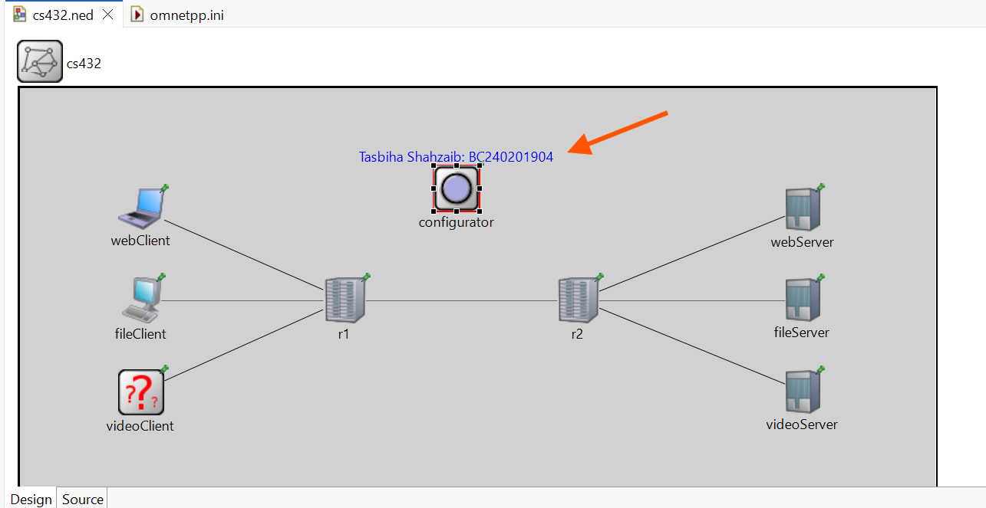2. Traffic Types:
- Web traffic (HTTP requests)
- File transfer (FTP)
- Video streaming (continuous data packets)
3. Performance Metrics:

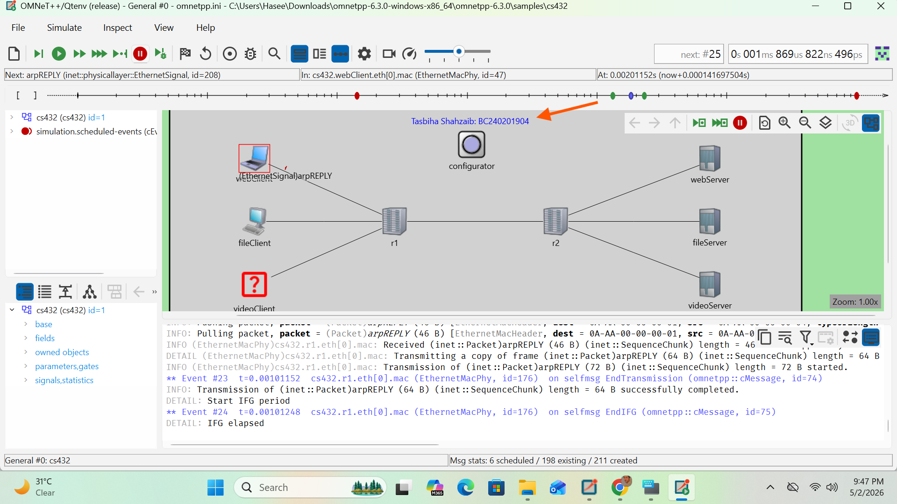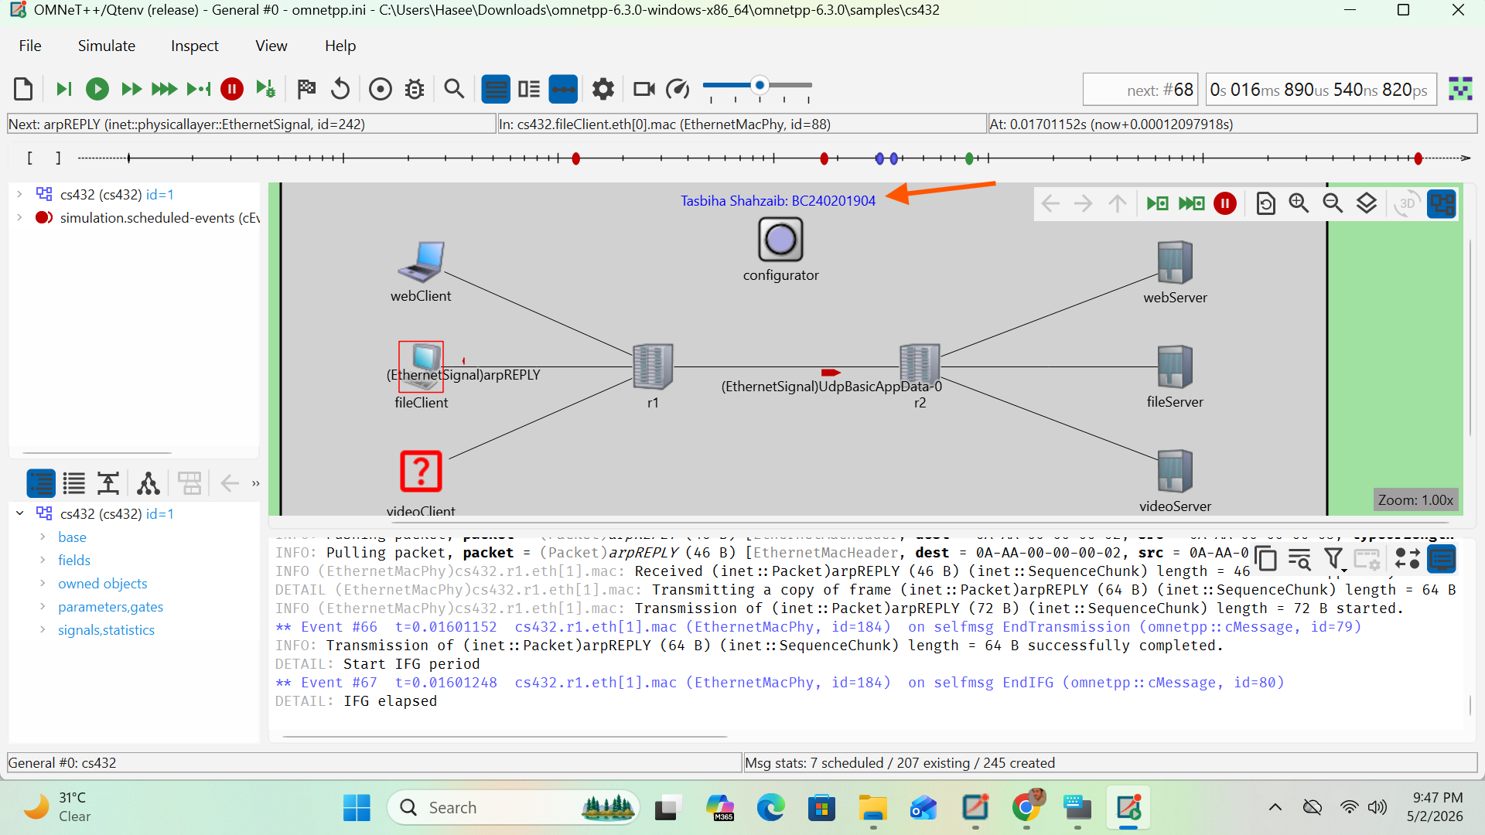d) Effect of Bandwidth and Packet Size on Network Performance
Bandwidth determines how much data can be transmitted over a network in a given time. Increasing bandwidth generally improves network performance by allowing more data to pass through, reducing congestion and delays. Conversely, low bandwidth can cause bottlenecks and increase packet loss.
Packet size also affects performance. Larger packets reduce overhead because fewer headers are needed, improving efficiency. However, if a large packet is lost, it must be retransmitted, increasing delay. Smaller packets are more reliable in unstable networks but create more overhead, which can reduce overall efficiency.

Thus, an optimal balance between bandwidth and packet size is necessary for efficient network performance.
e) One Limitation of Network Simulation
One major limitation of network simulation is that it may not perfectly reflect real-world conditions. Simulations depend on predefined models and assumptions, which might not include all environmental factors such as hardware failures, unpredictable traffic spikes, or human errors. As a result, the simulation outcomes may differ from actual network performance after deployment.

