We can express the application of vertical shifts this way:
Formally: For any function f(x), the function g(x) = f(x) + c has a graph that is the same as f(x), shifted c units vertically. If c is positive, the graph is shifted up. If c is negative, the graph is shifted down.
Informally: Adding a positive number after the x outside the parentheses shifts the graph up, adding a negative (or subtracting) shifts the graph down.
We can express the application of horizontal shifts this way:
A horizontal shift is the result of adding a constant term to the function inside the parentheses. A positive term results in a shift to the left and a negative term in a shift to the right.

A vertical shift is the result of adding a constant term to the value of a function. A positive term results in an upward shift, and a negative term in a downward shift.

Formally: given a function f(x), and a constant a > 0, the function g(x) = f(x - a) represents a horizontal shift a units to the right from f(x). The function h(x) = f(x + a) represents a horizontal shift a units to the left.
Example:
What must be done to the graph of y = x² to convert it into the graphs of y = x² - 3, and y = x² + 4?
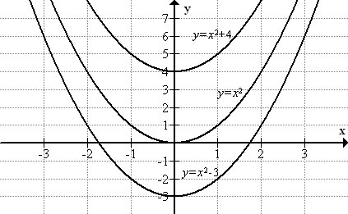

Example:
Use the parent function f(x) = x² to graph f(x) = x² + 3.

The function f(x) = x² is a parabola with the vertex at (0, 0).
Adding outside the parenthesis shifts the graph vertically.
Therefore, f(x) = x² + 3 will be a parabola with the vertex 3 units up.
