Question No 1:
A small project consists of the following activities whose time estimates are given below:
Part (a) Construct a network diagram which shows the relationship between the activities and their predecessors. b) Calculate the following
Solution:
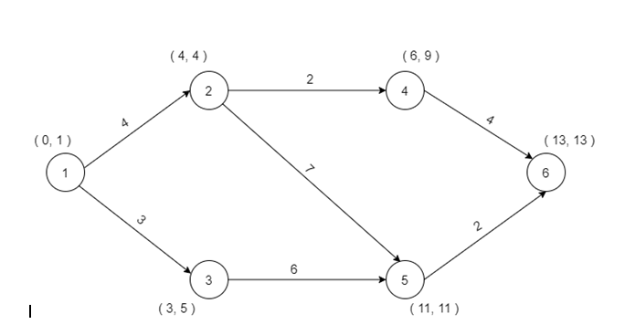
Part (b)
:Calculate the following time estimates for each activity.
➢ Earliest Start Time(EST)
➢ Earliest Finish Time (EFT)
➢ Latest Start Time (LST)
➢ Latest Finish Time (LFT)
➢ Total float for each activity
Solution:

Activity | Duration  (D) | EST | EFT(EST)+(D) | EST(EST)-(D) | LFT | TF(LFT-EFT)  OR(LST-EST)
1-2 | 4 | 0 | 4 | 0 | 4 | 0
1-3 | 3 | 0 | 3 | 2 | 5 | 2
2-4 | 2 | 4 | 6 | 7 | 9 | 3
2-5 | 7 | 4 | 11 | 4 | 11 | 0
3-5 | 6 | 3 | 9 | 5 | 11 | 2
4-6 | 4 | 6 | 10 | 9 | 13 | 3
5-6 | 2 | 11 | 13 | 11 | 13 | 0

