MIDTERM EXAMINATION
Fall 2009
MTH202- Discrete Mathematics

Question No: 1 ( Marks: 1 ) - Please choose one

The inverse of given relation R = {(1,1),(1,2),(1,4),(3,4),(4,1)} is

► {(1,1),(2,1),(4,1),(2,3)}

► {(1,1),(1,2),(4,1),( 4,3),(1,4)}

► {(1,1),(2,1),(4,1),(4,3),(1,4)}

Question No: 2 ( Marks: 1 ) - Please choose one

Symmetric and antisymmetric are

► Negative of each other

► Both are same

► Not negative of each other

Question No: 3 ( Marks: 1 ) - Please choose one

Let A = {a, b, c} and
R = {(a, c), (b, b), (c, a)} be a relation on A. Is R

► Transitive

► Reflexive

► Symmetric

► Transitive and Reflexive

Question No: 4 ( Marks: 1 ) - Please choose one

Let A= {1, 2, 3, 4} and R = {(1, 1), (2, 2), (3, 3),(4,4)} then

► R is symmetric.

► R is anti symmetric.

► R is transitive.

► R is reflexive.

► All given options are true

Question No: 5 ( Marks: 1 ) - Please choose one
The contrapositive of the conditional statement p  q is

► ~p  ~q

► q p

► ~q ~p

► None of these

Question No: 6 ( Marks: 1 ) - Please choose one

In Boolean addition 1+1=

► 2

► 1

► 0

Question No: 7 ( Marks: 1 ) - Please choose one
The negation of “Today is Friday” is

► Today is Saturday

► Today is not Friday

► Today is Thursday

Question No: 8 ( Marks: 1 ) - Please choose one

The same element can never appear twice in a set.

► True

► False

Question No: 9 ( Marks: 1 ) - Please choose one

If f(x)=2x+1, 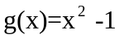 then fg(x)=

► 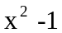

► 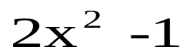

► 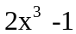

Question No: 10 ( Marks: 1 ) - Please choose one
The statement p q  ~p  q  ~(p  ~q)
describes

► Commutative Law

► Implication Laws

► Exportation Law

► Equivalence

Question No: 11 ( Marks: 1 ) - Please choose one

If two sets are not equal, then one must be a subset of the other

► True

► False

Question No: 12 ( Marks: 1 ) - Please choose one

If f and g are two one-to-one functions then their composition that is gof is

► Not one-to-one

► Onto

► One-to-one

► Onto and one-to-one

Question No: 13 ( Marks: 1 ) - Please choose one

If a set contains exactly m distinct elements where m denotes some non negative integer then the set is .

► Finite

► Infinite

► None of these

Question No: 14 ( Marks: 1 ) - Please choose one

If f(4) = 1 and g(1) = 4 then fog(1) =

► 3

► 1

► 4

Question No: 15 ( Marks: 1 ) - Please choose one
If (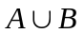) = A, then (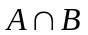) = B

► True

► False

► Cannot be determined

Question No: 16 ( Marks: 1 ) - Please choose one

The total number of elements in a set is called

► Strength

► Cardinality

► Finite

Question No: 17 ( Marks: 1 ) - Please choose one

If f(x) = x and g(x)=-2x then (f+g)x =

► 3x

► 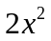

► –x

Question No: 18 ( Marks: 1 ) - Please choose one
Associative law of Intersection for three sets

► A  (B  C) = (A  B)  C

► A (B C) = (A B) C

► A  (B  C) = (A  B)  (A  B)

► None of these

Question No: 19 ( Marks: 1 ) - Please choose one

Which term of the sequence 4,1,-2,… is -77

► 26

► 27

► 28

Question No: 20 ( Marks: 1 ) - Please choose one

If a set A has 5 elements then power set of A. P(S) contains elements. Which are?

► 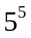

► 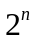

► 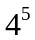

► 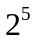

Question No: 21 ( Marks: 1 ) - Please choose one

A collection of rules indicating how to form new set objects from those already known to be in the set is called

► Base

► Restriction

► Recursion

Question No: 22 ( Marks: 1 ) - Please choose one

is

► Arithmetic series
Arithmetic series

► Geometric series

► Arithmetic sequence

► Geometric sequence

Question No: 23 ( Marks: 1 ) - Please choose one
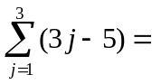

► 4

► 3

► -2

Question No: 24 ( Marks: 1 ) - Please choose one

The product of the positive integers from 1 to n is called

► Multiplication

► n factorial

► Geometric sequence

Question No: 25 ( Marks: 3 )

Consider the geometric progression 5/7, 5/49, 5/343, …
- Identify r
- Find the nth term of this progression
- If the above progression is to be added up to infinite terms then what could be the sum?
Answer:-
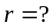
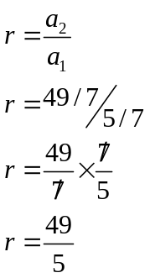

nth term=?
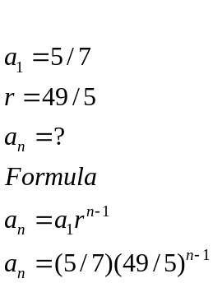
Sum=?
As 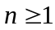 
So, formula is:-
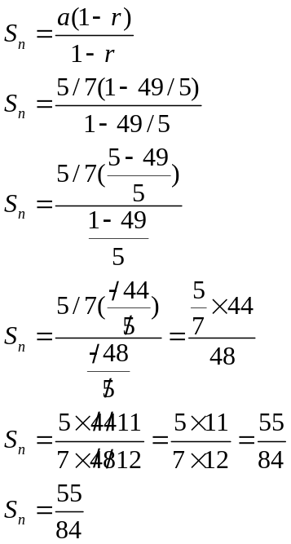
Question No: 26 ( Marks: 5 )

Determine whether the following statement is tautology or not (use truth table)
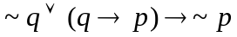

p | q | ~p | ~q | 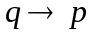 | ~q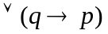
1 | 1 | 0 | 0 | 1 | 1 | 0
1 | 0 | 0 | 1 | 1 | 1 | 0
0 | 1 | 1 | 0 | 0 | 0 | 1
0 | 0 | 1 | 1 | 1 | 1 | 1
Hence, it is not a tautology as there are two false.

Question No: 27 ( Marks: 10 )

Write an input/output table for the circuit:

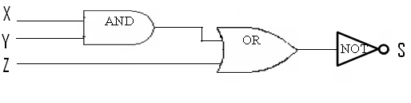
Input signals are:

X = 1
Y = 0
Z = 0
X | Y | Z | X^Y | (X^Y) Z | ~[(X^Y) Z]
1 | 0 | 0 | 0 | 0 | 1

