Math202 Midterm Subjective Paper

- Q: Suppose that a connected planar simple graph has 15 edges. If a plane drawing of this graph has 7 faces, how many vertices does this graph have?
- Answer: Given, Edges = v =15 Faces = f = 7 Vertices = v =? According to Euler Formula, we know that, f= e – v +2 Putting values, we get 7 = 15 – v + 2 7 = 17 – v Simplifying v =1 7-7 =10
- Q: How many ordered selections of two elements can be made from the set {0,1,2,3}?
- Answer: The order selection of two elements from 4 is as P(4,2) = 4!/(4-2)! = (4.3.2.1)/2! = 12
- Q: Find a non-isomorphic tree with five vertices.
- ANS: There are three non-isomorphic trees with five vertices as shown (where every tree with five vertices has 5-1=4 edges).
- Q: Define a predicate?
- ANS: Let the declarative statement: “x is greater than 3”. We denote this declarative statement by P(x) where x is the variable, P is the predicate “is greater than 3”. The declarative statement P(x) is said to be the value of the propositional function P at x.
- Q: There are 25 people who work in an office together. Four of these people are selected to attend four different conferences. The first person selected will go to a conference in New York, the second will go to Chicago, the third to San Francisco, and the fourth to Miami. How many such selections are possible?
- Ans = 12650
- Q: Prove that every integer is a rational number?
- ANS: Every integer is a rational number, since each integer n can be written in the form n/1. For example 5 = 5/1 and thus 5 is a rational number. However, numbers like 1/2, 45454737/2424242, and -3/7 are also rational; since they are fractions whose numerator and denominator are integers.
- Q: Draw a graph with six vertices, five edges that is not a tree.
- ANS: Here is the graph with six vertices, five edges that is not a tree Q: Let A and B be events with P (A) = ½ , P(B)=1/3 and P (A ∩B) = ¼ Find P (B|A) Ans = P(A ∩ B) = P(A) P(B|A) P(B|A)= P(A ∩ B)/ P(A) = 0.5
- Q: What are Complementary Graphs?
- Answer: Complementary Graph of a simple graph(G) is denoted by the (G bar ) and has as many vertices as G but two vertices are adjacent in complementary Graph by an edge if and only if these two vertices are not adjacent in G .
- Q: What is chromatic number?
- ANS: While coloring a graph you can color a vertex which is choosing a new color for it or by the same color which you have used for the vertices which are not adjacent with this vertex. It means that while coloring a graph you may have different number of colors used for this purpose. But the least number of colors which are being used during the coloring of Graphs is known as the Chromatic number
- Q: What is Tauology?
- A: A tautology is a statement form that is always true regardless of the truth values of the statement variables. i.e. If you want to prove that (p v q) is tautology, you have to show that all values of statement (p v q) are true regardless of the values of p and q.If all the values of the statement (p v q) is not true then this statement is not tautology.
- Q: what is the basic difference b/w sequences and series
- ANS: A sequence is just a list of elements .In sequence we write the terms of sequence as a list (separated by comma's). e.g 2,3,4,5,6,7,8,9,... ( in this we have terms 2,3,4,5,6,7,8,9 and so on).we write these in form of list separated by comma's. And the sum of the terms of a sequence forms a series. e.g we have sequence 1,2,3,4,5,6,7 Now the series is sum of terms of sequence as 1+2+3+4+5+6+7.
- Q: How to use conditional probability
- Answer: Dear student In Conditional probability we put some condition on an event to be occur. e.g. A pair of dice is tossed. Find the probability that one of the dice is 2 if the sum is 6. If we have to find the probability that one of the dice is 2, then it is the case of simple probability. Here we put a condition that sum is six. Now A = { 2 appears in at least one die} E = {sum is 6 } Here E = { (1,5), (2, 4), (3, 3), (4, 2), (5, 1) } Here two order pairs ( 2, 4 ) and ( 4, 2) satisfies the A. (i.e. belongs to A) Now A (intersection) B= { (2,4), (4,2)} Now by formula P(A/E) = P(A (intersection) E)/ P(E) = 2/5
- Question: What is the difference between yes and allowed in graphs.
- Answer: Allowed mean that specific property can be occurs in that case but yes mean that specific property always occurs in that case. e.g. In Walk you may start and end at same point and may not be (allowed). But in Closed Walk you have to start and end at same point (yes).
- Q: What is improper subset.
- Answer: Let A and B be sets. A is proper subset of B, if, and only if, every element of A is in B but there is at least on element if B that is not in A. Now A is improper subset of B, if and only if, every element of A is in B and there is no element in B which is not in A. e.g. A= { 1, 2 , 3, 4} B= { 2, 1, 4, 3} Now A is improper subset of B. Because every element of A is in B and there is no element in B which is not in A
- Q: Is Pie an irrational number?
- Answer: Pi π is an irrational number as its exact value has an infinite decimal expansion: Its decimal expansion never ends and does not repeat. The numerical value of π truncated to 50 decimal places is:3.14159 26535 89793 23846 26433 83279 50288 41971 69399 37510
- Q: How empty set become a subset of every set.
- Answer: If A & B are two sets, A is called a subset of B, if, and only if, every element of A is also an element of B. Now we prove that empty set is subset of any other set by a contra positive statement( of above statement) i.e. If there is any element in the the set A that is not in the set B then A is not a subset of B. Now if A={} and B={1,3,4,5} Then you cannot find an element which is in A but not in B. So A is subset of B.
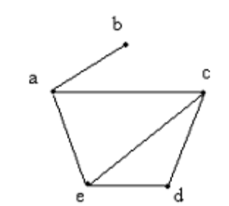
sum the series upto nth term 1^2,3^2,5^2.... (5marks)
find the 8th term of G.P (i forgot the values ) (2marks)
find function (f-g)(x) (2marks)
a set a=(1,2,3) and relation was given and we have to find R(bar
Find the sum of the infinite G.P.
Exclusive OR is logically equivalent to:
Ans: (p ∨ q) ∧ (∼p ∨ ~q)
An argument is valid if _______ of its premises implies conclision.
ANs: Conjunction
One question was related to matrix. I was asked to draw matrix of RoS, and then was supposed to take it's transpose.
There was question, in which a Relation was given and I had to check whether it is an equivalence relation or not.
Q.No 1
A circuit with two input signals and one output signal is called
NOT-gate (or inverter)
AND- gate
None of these
Q.No3
1 then (2f - 1g)x=+2x2 −If f(x)= x+1 and g(x)=
Q.N04
The statement “It is not raining if and only if roads are dry” is logically equivalent to
If roads are dry then it is not raining.
Roads are dry if and only if it is not raining
If it is not raining then roads are dry
None Of these.

Q.No9
If f(x) = x and g(x)=-2x then (f+g)x =
3x
–x
Q.No10
Let the real valued functions f and g be defined by
f(x) = 2x + 1 and g(x) = x2 – 1
Obtain the expression for fg(x)
Q.No11
Let A={1,5,9} and B={6,7}
Then find Cartesian product from A to B and from B to A. Is both are equal or not Also Justify.
Find the sum of the infinite G.P.
Exclusive OR is logically equivalent to:
Ans: (p ∨ q) ∧ (∼p ∨ ~q)
An argument is valid if _______ of its premises implies conclision.
ANs: Conjunction
One question was about fog.
One question was related to matrix. I was asked to draw matrix of RoS, and then was supposed to take it's transpose.
There was question, in which a Relation was given and I had to check whether it is an equivalence relation or not.
Determine the matrix of the following?
Find the Infinite G.P of 2,2^1/2,1?
Explain gof is one to one if and only if g(x) is one to one function?
F(x) =2x+3 and g(x)=3x-1 find fog and gof composition?
Let R be the relation from A to B asR={(1,1),(2,2),(3,3),(4,5),(4,4)}
Explain it is reflexive or not?and also find its ordered pair?
Let A ={ 1,2,3,4} find the binary relation of AxA and R is {(1,1),(2,2),(3,3),(4,4),(2,1),(2,3)}
Find is it equivalent or not?

MIDTERM EXAMINATION
Spring 2012
MTH202- Discrete Mathematics

Subjective:

Qs.No1: 5marks

Find the 36th term of the Arithmetic sequence if 3rd term is 7 and 8th term is 17.

Qs.No2: 5marks

If the function is f(x) = 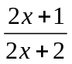 is it onto?
Qs.No3: 3marks

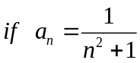 Find the 1st 4 term of the series.

Qs.No4: 3marks

If f(x) = 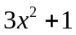 and g(x) = 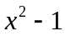 then find gog(x) =?

Qs.No5: 2 marks

If set A= {1, 2, 3, 4} and B= {2, 3, 1}
R = { (1,1),(1,2),(2,2),(1,3),(3,3)
S= {(1, 1), (1, 3), (3, 3)}
Find 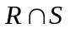=?
Subjective part:

Question No: (Marks: 2)
Let a and b be integers. Suppose a function Q is defined recursively as follows:
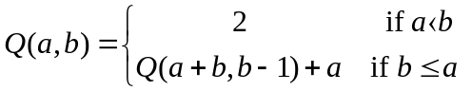

Find the value of Q (5, 2)

Question No: (Marks: 3)
Let a and b be integers. Suppose a function Q is defined recursively as follows:
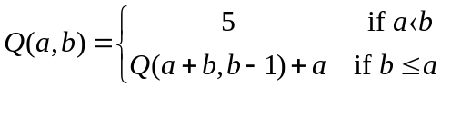

➔1 qs is from sequence lecture # 19 5marks
Find the … term of geometric sequence
Kuch is tra ke he tha qs

➔1 qs me show krna tha k function symmetric reflexive or transitive hay? 5marks
Function simple he tha.
Qs.No1: 5marks

Find the 36th term of the Arithmetic sequence if 3rd term is 7 and 8th term is 17.

Qs.No2: 5marks

If the function is f(x) = is it onto?
Qs.No3: 3marks

Find the 1st 4 term of the series.

Qs.No4: 3marks

If f(x) = and g(x) = then find gog(x) =?

Qs.No5: 2 marks

If set A= {1, 2, 3, 4} and B= {2, 3, 1}
R = { (1,1),(1,2),(2,2),(1,3),(3,3)
S= {(1, 1), (1, 3), (3, 3)}
Find =?
MTH202 MID TERM PAPER SPRING 2012

Question (2 Marks)
If 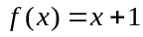 and 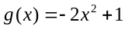 then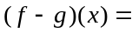

Question (2 Marks)
If 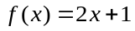, 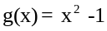 then 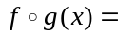
www.vustudents.ning.com

Question (2 Marks)
Let a and b be integers. Suppose a function Q is defined recursively as follows:

Question (3 Marks)
Suppose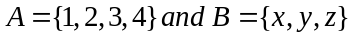 are two sets and R is a relation from A to B as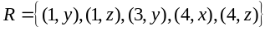 then determine the matrix representation of the R.

Question (3 Marks)
If 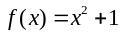 and 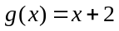 then find 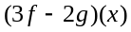

Question (5 Marks)
Let R₁ and R₂ be the relations on a set given by
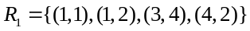
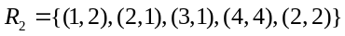
Find the ordered pairs of 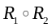 and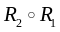.

Question (5 Marks)

Find the 36th term of the arithmetic sequence whose 3rd term is 7 and 8th term is 17

SUMMER 2007
MTH202 - DISCRETE MATHEMATICS (Session - 1 )

Question No: 6 ( Marks: 8 )

Test the following argument for validity:
Logic is difficult or not many students like logic.
If Mathematics is easy, then logic is not difficult.
Therefore,
Mathematics is not easy or logic is difficult.
Question No: 7 ( Marks: 9 )
Let A = {a, b, c, d} and define the null relation  and universal relation A A on A. Test these
relations for reflexive, symmetric and transitive properties.
Question No: 8 ( Marks: 4 )
Let f and g be the functions from the set of integers to the set of integers defined by f(x) = 2 x +
3 and g(x) = 3 x + 2 .What is the composition of f and g ? What is the composition of g and f?
Question No: 9 ( Marks: 9 )
If the 5th element of an arithmetic sequence is -16 and the 20th term is -46.
Then find 10th term.
( Note: Use the proper formula of sequence)
Question No: 10 ( Marks: 5 )
Show that the sequence 0,1,3,7,...2n − 1,..., for n  0, satisfies the recurrence relation
Ck = 2Ck − 1 + 1,
for all integers k  0

