MIDTERM EXAMINATION

MTH501- Linear Algebra (MCQ’s File)

Question No: 1

If for a linear transformation the equation T(x )= 0 has only the trivial solution then T is

► one-to-one
► onto

Question No: 2

Which one of the following is an matrix?

► 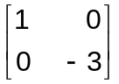
► 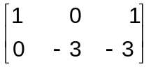
► 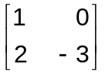
► 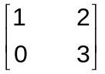

Question No: 3

Let 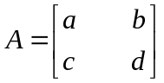and let k be a scalar .A formula that relates det kA to k and det A is

► det kA= k det A

► det kA = det (k+A)

► det k A = k² det A

► det kA = det A

Question No:

The equation x = p + t v describes a line

► through v parallel to p

► through p parallel to v
► through origin parallel to p

Question No: 5
Determine which of the following sets of vectors are linearly dependent.

► 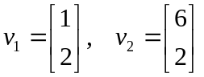
► 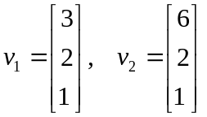
► 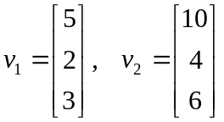

Question No: 6

Every linear transformation is a matrix transformation

► True
► False

Question No: 7

A null space is a vector space.

► True
► False

Question No: 8

If two row interchanges are made in succession, then the new determinant

► equals to the old determinant

► equals to -1 times the old determinant

Question No: 9

The determinant of A is the product of the pivots in any echelon form U of A , multiplied by (-1)^{r} , Where r is

► the number of rows of A

► the number of row interchanges made during row reduction from A to U
► the number of rows of U

► the number of row interchanges made during row reduction U to A

Question No: 10

If A is invertible, then det(A)det(A⁻¹)=1.

► True
► False

Question No: 11

A square matrix 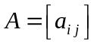 is lower triangular if and only if 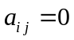 for

► 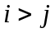
► 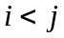
► 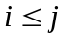
► 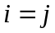

Question No: 12

The product of upper triangular matrices is

► lower triangular matrix

► upper triangular matrix
► diagonal matrix

Question No: 13

The matrix multiplication is associative
► True
► False

Question No: 14

We can add the matrices of ______________.
► same order
► same number of columns.
► same number of rows
► different order

Question No: 15

By solving system of equations with iterative method, we stop the process when the entries in two successive iterations are ________.
► repeat
► large difference
► different
► Same
Question No: 16

Jacobi’s Method is ____________ converges to solution than Gauss Siedal Method.
► slow
► fast
► better

Question No: 17

A system of linear equations is said to be homogeneous if it can be written in the form ______________.

► AX = B
► AX = 0
► AB = X
► X = A⁻¹

Question No: 18

The row reduction algorithm applies only to augmented matrices for a linear system.

► True
► False

Question No: 19
Whenever a system has no free variable, the solution set contains many solutions.

► True
► False

Question No: 20

Which of the following is not a linear equation?

► 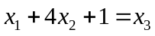
► 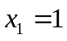
► 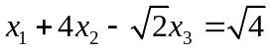
► 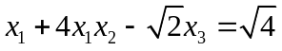

Question No: 21

If a system of equations is solved using the Gauss-Seidel method, then which of the following is the most appropriate answer about the matrix M that is derived from the coefficient matrix ?
Select correct option:

All of its entries on the diagonal must be zero.
All of its entries below the diagonal must be zero.
All of its entries above the diagonal must be zero.
All of its entries below and above the diagonal must be zero.

Question No: 22

The determinant of a diagonal matrix is the product of the diagonal elements.
Select correct option:

- TRUE
- FALSE

Question No: 23

By using determinants, we can easily check that the solution of the given system of linear equation exits and it is unique.

- FALSE
- TRUE

Question No: 24

A matrix A and its transpose have the same determinant.

- TRUE
- FALSE

Question No: 25

If both the Jacobi and Gauss-Seidel sequences converge for the solution of Ax=b, for any initial x(0), then which of the following is true about both the solutions?

- No solution
- Unique solution
- Different solutions
- Infinitely many solutions

Question No: 26

The value of the determinant of a square matrix remains unchanged if we multiply each element of a row or a column by some scalar.

- TRUE
- FALSE

Question No: 27

How many different permutations are there in the set of integers {1,2,3}?

- 2
- 4
- 6
- 8

Question No: 28

If A is n x n matrix and det (A) = 2 then det (5A) = ________.

- 10
- 32
- 5
- 8

Question No: 29

Every vector space has at least two subspaces; one is itself and the second is:

- multiplication of vectors
- addition of vectors
- subspace {0}
- scalar multiplication of vectors

Question No: 30
If one row of A is multiplied by k to produce B, then which of the following condition is true?

Select correct option:

- det(AB) = (detA)(detB)
- detB = k detA
- detB = – detA
- detB = detA

