www.virtualinspire.com
MIDTERM EXAMINATION
Spring 2010
CS101- Introduction to Computing (Session - 4)
Ref No: 1341114
Time: 60 min
Marks: 38
Student Info
StudentID:
Center: | OPKST
ExamDate: | 5/26/2010 12:00:00 AM

For Teacher's Use Only
Q No. | 1 | 2 | 3 | 4 | 5 | 6 | 7 | 8 | Total
Marks
Q No. | 9 | 10 | 11 | 12 | 13 | 14 | 15 | 16
Marks
Q No. | 17 | 18 | 19 | 20 | 21 | 22 | 23
Marks

Question No: 1 ( Marks: 1 ) - Please choose one
Ada, Countess of Lovelace developed first:
► Computer
► Website
► Computer Program
► Analytical engine

Question No: 2 ( Marks: 1 ) - Please choose one
Charles Babbage was a/an
► Mathematician
► Computer Scientist
► Physician
► Analyst

Question No: 3 ( Marks: 1 ) - Please choose one
Detailed plan, specifying the required resources and expected deliverables, is done in ________ phase.

► Planning
► User Requirements
► Design
► Developer Specification

Question No: 4 ( Marks: 1 ) - Please choose one
A computer program that facilitates the communication between the computer and a peripheral device is called___________________

► Operating system
► Utilities
► Language Translator
► Device Drives

Question No: 5 ( Marks: 1 ) - Please choose one
To start an ordered list from 20 instead of 1, we will write

► <OL begin = “20">
► <OL initiate = “20">

► <OL start = “20">
► <OL from = “20">

Question No: 6 ( Marks: 1 ) - Please choose one
_________ is the best known builder for supercomputers.
► Sun
► Cray Research
► Microsoft
► Apple

Question No: 7 ( Marks: 1 ) - Please choose one
Using COLSPAN, number of rows of the current cell should extend itself
► Upward
► Downward
► Both Upward and Downward
► None of the given choices

Question No: 8 ( Marks: 1 ) - Please choose one
Interactive forms are always placed between ___ tag-set
► TITLE
► HEAD
► BODY
► HTML

Question No: 9 ( Marks: 1 ) - Please choose one
_________ manages the HW and SW resources ( memory, disk drives etc) of the computer system, often invisibly.
► Explorer.exe
► System Files
► Operating System
► Application Software

Question No: 10 ( Marks: 1 ) - Please choose one
Speakers fall into the hardware category.
► True
► False

Question No: 11 ( Marks: 1 ) - Please choose one
______________ software directly interacts with the hardware.

► Application software

► System software

► Dynamic software

► Distributed software

Question No: 12 ( Marks: 1 ) - Please choose one
In spreadsheet, which of the following function is used to solve the equation
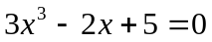?
► =COUNTIF
► =GoalSeek
► None of the above
► =Sum

Question No: 13 ( Marks: 1 ) - Please choose one
_______ is known as the best feature in word processing.
► Cut
► Copy
► Paste
► Undo

Question No: 14 ( Marks: 1 ) - Please choose one
In java script objects may have___________ properties.
► Single

► Several

► Multiple
► All of the given options

Question No: 15 ( Marks: 1 ) - Please choose one
_________ are great for showing parts of a whole that are generally expressed in percentages.

► Line Charts

► Pie Charts

► Bar Charts

► None of the options described

Question No: 16 ( Marks: 1 ) - Please choose one
Small Computer System Interface is
► Slower and harder to configure then serial and parallel ports

► Faster then USB

► Both first choices

► Slower then USB but Faster then serial and parallel

Question No: 17 ( Marks: 2 )
Write the major types of softwares with examples?

Question No: 18 ( Marks: 2 )
What is the major difference between paragraph <p> and Line Break <BR> tags?

Question No: 19 ( Marks: 2 )
Why PASCAL was designed and what is the problem with PASCAL?

Question No: 20 ( Marks: 3 )
What are the key requirements of E-commerce Software?

Question No: 21 ( Marks: 3 )
Write down the pseudo code for the following flow chart.
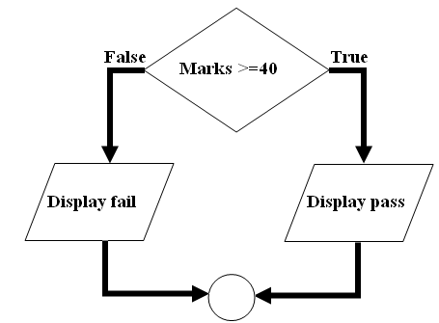

Question No: 22 ( Marks: 5 )
(a) Write down two positive features of client-side scripting.
(b) Discuss two deficiencies of JavaScript.

Question No: 23 ( Marks: 5 )
What are the key features of a word processor?
www.virtualinspire.com

