CS607P Current Papers
1. Which of the following are key components of the expert system?
- Knowledge base
- interference
- hybrid
- knowledge base and interference
2. __command remove the facts.
- Retract
3. Who published 8 queen problem?
- Max bezzel
4. DFS is __ efficient and BFS is ___ efficient.
- Space and time
5. The _ attribute allows the specified of minimum and maximum numeric values.
- Range
- limit
- slot
- value
6. Correct statement list fact ranging from 1 to 9
- Clips>(fact 1 9)
- clip>(fact 1 to 9)
7. What is complexity of DFS algorithm?
- B^2,
- b^b
- b,
- b^m
8. __ allows user to integrated their program with clips and use some of the more sophisticated feature in clips.
- Basic programming language
- XML
- HTML
- API
9. Window contains the variable that you create or import into matlab.
- Workspace
- System
- comman
10. __ Provide a number of slot attributes that can be specified when deftemplate slots are def
- Xml
- Html
- Clips
- C++
11. __ is a forward chaining rule based programming language written in C that also provide procedural and OOP facilities
- Html
- Java
- Xml
- Clips
12. ___ many solution are there for 8 queens on 8*8 board
- 91
- 22
- 92
- 93
13. Queue data structure is used in BFS
14. Father of AI is__________?
jhon McCarthy
1)The objective programming language provided with clips called
- ASP. NET
- Object oriented programming
- COOL
- OOP database

2) A person wants to reach some place from vertax A to vertex Z it break tracks to reach the desired vertex is reefered as___
  - BFS
  - DFS
  - Trim's algorithm
  - Kruskal's algorithm

3) BFS is commonly Application used in which the following
4)In general how many lines a node it's visited
1. Once
2. Twice
3. Thrice
4. Equivalent to the number of In-degree of node

5) C language is a __ programming language useful for an expert system
1. Rule based
2. Web based
3. Structure based
4. Strom based

6) The____ attributes allows the specific with minimum and maximum numbers of values that can be stored in multi slot
1. Cardinality
2. Tuple
3. Attributes
4. Slots

7) In clips IDE, def function is compromised of ____elements

8) ___ is an interpret the values in the input vector and assigns value of the output vector
1. Logic
2. Vector
3. Fuzzy
4. Rules

9) The set generated using infinite membership function is called ___
1. Boolean set
2. Crips set.
3. Fuzzy set
4. Monotime set

10) What is output of a=[1 0 2] ; b=[3 0 7]; c= a. *b ;
[3 0 14]
11) ___is the process of driving and logical conclusion from given facts,
1. Representation
2. Executive
3. Reasoning
4. Planing

12) ___ is the process by which the fuzzy sets the represent the output of each rules combine into a single fuzzy set
1. Composition
2. Association
3. Aggregation
4. Membership function

13) DFS is __efficient and BFS is ____ efficient
1. time, space
2. time, time
3. Space, space
4. Space, time
14) what is the return type of the angels function in the matlab ?
Select the correct option
- Degree

- Radians

- Vectors

- Matrics

15) in clips ide , defunction coparised of ----- elements ?

Select the correct option
- Three

- Five

- Four

- Two

16) --- is a. set that uses binary value ranging from smallest value ?

- Madulus

- Salience

- Agenda

- Rule

Identify the correct statement to list facts numbers 1 to 9.
A. clips> (facts 1 9)
B. clips> (facts 1 to 9)
C. clips> (facts 9)
D. clips> (facts 1)
MATLAB software is used for _______.
A. Video editing
B. Design analysis
C. Mathematical work
D. Software testing
The ________ command starts executing a CLIPS program.
A. Clear
B. exit
C. run
D. Retract
The (clear) command in CLIPS IDE is used to ________.
A. remove facts only
B. remove rules only
C. remove both facts and rules
D. remove errors
Variables in CLIPS are always written in a question mark _________followed by a symbolic field name.
A. #
B. $
C. :
D. ?
_______________sums up to formulate the possible moves in 4x4 only
, 8x8 and . NXN queens problem.
A. Recursive Call
B. Revers Call

Subjective Part

Question: Write the program in CLIPS IDE that will save the facts about stationary products (at least 3 products). You are required to make fact list of items. After loading the facts in working memory use the facts command to see the index of product facts. Remove fact 3 by using the relevant command and again use the facts command to see the index of remaining product facts.
Answer
CLIPS> (assert (Pen) (Pencil) (Notebook))
<Fact-3>
CLIPS> (facts)
f-0 (Pen)
f-1 (Pencil)
f-2 (Notebook)
For a total of 3 fact.
CLIPS> (retract 2)
CLIPS> (facts)
f-0 (Pen)
f-1 (Pencil)
For a total of 1 fact.
CLIPS> (exit)

Question: In MATLAB, in Quick Access Toolbar name of Global tabs.
“Quick Access Toolbar” consisting of three tabs namely “HOME”, “PLOTS” and “APPS”. These are called Global Tabs.

Question: Write name of MATLAB of windows.
- Command window allows commands to be executed are written and results from the executed commands are also displayed.
- Workspace window displays the variables to be used.the variables used for analysis are displayed.
- Current folder window displays the files displayed and the researcher can access same.

Question: "Considering the basic functions of CLIPS, narrate the code for each of the mentioned below instruction set in CLIPS IDE simple syntax. (No output required)"
- (* 5 (+ 2 (* 1 3) 2))
- (- 11 (/ 7 5))
- (+ 12 (- 5 6))
- To add 1, 2, 3
- To multiply (* 2 6 0 1)

Answers :
- CLIPS> (* 5 (+ 2 (* 1 3) 2))
(printout t (* 5 (+ 2 (* 1 3) 2)) crlf)

- CLIPS> (- 11 (/ 7 5))
(printout t (- 11 (/ 7 5)) crlf)

- CLIPS> (+ 12 (- 5 6))
(printout t (+ 12 (- 5 6)) crlf)

- CLIPS> (+ 1 2 3)
(printout t (+ 1 2 3) crlf)

- CLIPS> (* 2 6 0 1)
(printout t (* 2 6 0 1) crlf)

CLIPS code likhein 5 * 25 karne ke liye
clips
CopyEdit
(deftemplate result
(slot value))

(defrule multiply
=>
(assert (result (value (* 5 25)))))

4 Functions of CLIPS:
- (exit) – run
- (clear)– Data structures define karta hai
- (Assert)– Facts ko add karta hai
- (Retract) – Facts ko remove karta hai

Explain Depth First Search algorithm and illustrate with an example.
Answer
Depth-First Search (DFS) is an algorithm for traversing or searching tree or graph data structures. Depth First Search dives into a tree deeper and deeper to fine the goal state. The algorithm starts at the root node and explores as far as possible along each branch before backtracking.
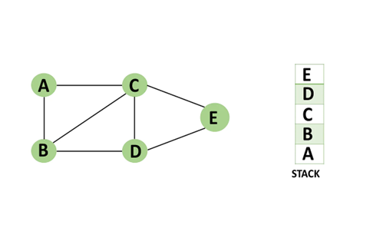
Extra memory, usually a stack, is needed to keep track of the nodes discovered so far along a specified branch which helps in backtracking of the graph.

QUESTION: Write a program in CLIPS define facts template using deftemplate keyword
Supplier (Sup_ID,
Sup_Name,
Sup_No)
Also create or add two facts of this template.
Answers:

(deftemplate Supplier
(slot Sup_ID)
(slot Sup_Name)
(slot Sup_No))

(deffacts suppliers
(Supplier (Sup_ID 1) (Sup_Name "John") (Sup_No "S1"))
(Supplier (Sup_ID 2) (Sup_Name "Jane") (Sup_No "S2")))

(reset)
(assert (Supplier (Sup_ID 3) (Sup_Name "Bob") (Sup_No "S3")))
(agenda)
(facts)

In this example, we define a Supplier template with three slots: Sup_ID, Sup_Name, and Sup_No. We then define two initial facts using the deffacts construct. We also assert a new fact using the assert command. Finally, we display the agenda and the facts.

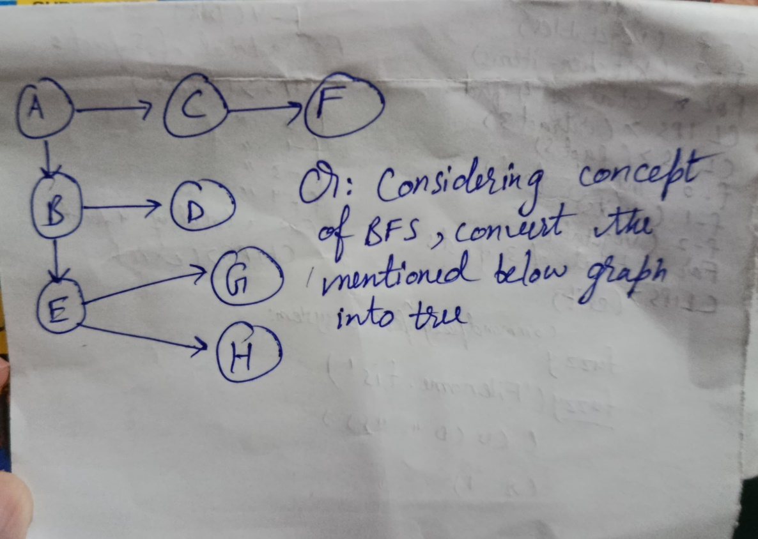
H
G
E
D
F
A
B
C

Cs607P 10feb 11:30
Objective max conceptual tha files say bht he kam they
Long :
1: Vertices aur edges given they tree ka btana tha k connection kitnay hai
2: bfs explain with the example of tree
3: clips code student ka template bhe banayein aur do attributes enter karein aur facts show karwayein
4: clips code grocery product ka tha
5: matlab ki window types just names
6: 8 queen ka tha kuch ajeeb sa smjh nhi aaya

Cs 607p Today paper
Timing: 11.30
Date: 31-1-2025

Objective: labs+ conceptual 5 Sy 6 bs files Sy Thi.

Subjective:

1. BFS ko explain krna tha or diagram draw krni thi.
2. DFS ko explain krna tha or diagram bnani thi.
3. Clip ID KY bary mn do question thy.
4. Ik clip KY related program write krna tha.
5. Ik fuzzy fact ky related koi ajeeb SA question tha sai Sy yaad ni.

Best of luck.
Cs 607p Today paper
Timing: 11.30
Date: 31-1-2025

Objective: labs+ conceptual 5 Sy 6 bs files Sy Thi.

Subjective:

1. BFS ko explain krna tha or diagram draw krni thi.
2. DFS ko explain krna tha or diagram bnani thi.
3. Clip ID KY bary mn do question thy.
4. Ik clip KY related program write krna tha.
5. Ik fuzzy fact ky related koi ajeeb SA question tha sai Sy yaad ni.

Best of luck.

Assalam-O-Alaikum..
Cs607p today's paper 0215
MCQ's :
Files ki thi ar lab bhe tou general concept clear tha clips ar matlab ka tou axhy ho gy :
Q :
*DFS ki traversal ki detail lekhni thi example k sth
*Graph sy tree bnana tha
*Grocery Product k related tha k fact bno ar 3 product add karo phir fact smd sy index show karwany thy phir fact 3 ko delete karna tha phir facts list show karwani thi
*Defrule ka proper define karna tha construct lekhna tha
*Aik queen wala tha kch attacking position k related

Today cs607p paper time 9:45am
Mcqs Vu topper file say thay kuch aur baqi lab 1 to 16 reading men say thay aur long 6 thay jin Men say 4 karnay thay
Qno 1 explain BFS with example
Qno 2 AK program tha clips wala
Qno 3 queen ka concept batana tha
Qno 4 Function of clips
Qno 5 ak program tha
Qno 6 DFS Kay related tha vertices batanay thay

Cs607p papar
Mcqs Kuch prince alvi ki file se thy ur Kuch conceptual thy but easy thy
Q1: DFS ka khud tree bana k usko explain krna tha
Q2:bfs graph given tha tree banana tha
Q3:MATLAB ki windows kitni h name lekhe
Q4: MATLAB ki global tab kitni h name lekhy
Q5: clips code lekhe 5 *25 krny k leye
Q6: Aik queen Wala tha Jo me ne choice pe chorh deya
Paper easy tha Alhamdulillah
Best of luck.....
Regards: khanum shehzadi

Cs607p mcqs slides say thay long sudo code likna tha factroial find krnay ka in CLIPS may bfs complete step with example q2 dfs complete step with example q3 clips ka code likhna tha three item add krnay tha pher last item delete krna tha q4 MTLAB tool bar ki batanay thay or

