Paper 1 (spring 2010)

Paper1
FINALTERM EXAMINATION
Spring 2010
MTH301- Calculus II
Ref No: xxxxxxx
Time: 90 min
Marks: 60

Question No: 2 ( Marks: 1 ) - Please choose one

All axis are negative in ----------- octant

► Second

► Fourth

► Seventh

► Eight

Question No: 3 ( Marks: 1 ) - Please choose one

In three dimensional space, intersection of two surfaces is a --------------

► Plane

► Sphere

► Curve

► None of these

Question No: 4 ( Marks: 1 ) - Please choose one

For a function 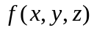, the equation 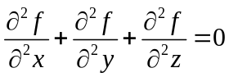 is known as -------------

► Gauss Equation

► Euler’s equation

► Laplace’s Equation

► Stoke's Equation

Question No: 5 ( Marks: 1 ) - Please choose one

Is the function 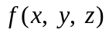 continuous at origin? If not, why?
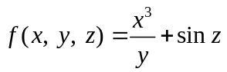

► is continuous at origin

► 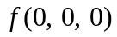 is not defined

► is defined but 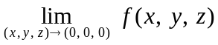 does not exist

► is defined and exists but these two numbers are not equal.

Question No: 6 ( Marks: 1 ) - Please choose one

Match the following vector-valued function with its graph.
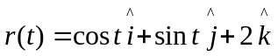 and 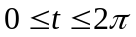

► 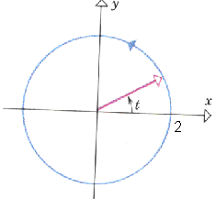

► 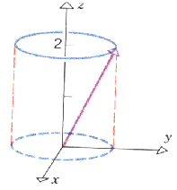

► 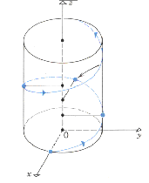

► 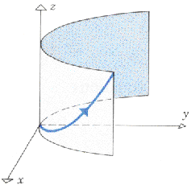

Question No: 7 ( Marks: 1 ) - Please choose one

Match the following vector-valued function with its graph.
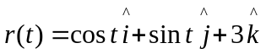 and

►

►

►

► 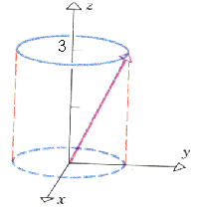

Question No: 8 ( Marks: 1 ) - Please choose one

Match the vector-valued function with its graph.
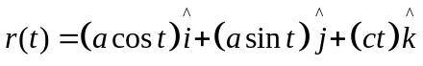 where a and c are positive constants and

►

►

► 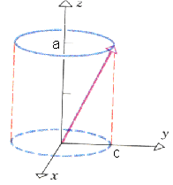

► 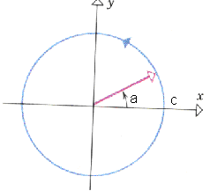

Question No: 9 ( Marks: 1 ) - Please choose one

What is the derivative of following vector-valued function?
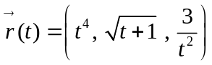

► 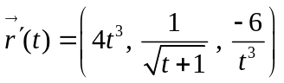

► 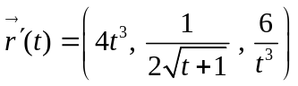

► 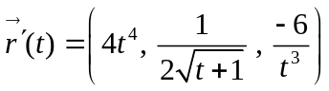

► 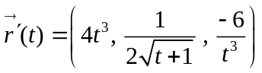

Question No: 10 ( Marks: 1 ) - Please choose one

What is the derivative of following vector-valued function?
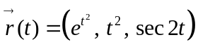

► 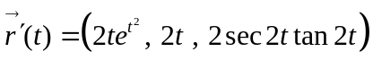

► 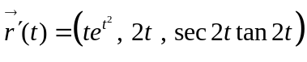

► 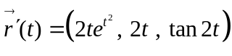

► 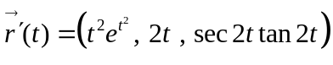

Question No: 11 ( Marks: 1 ) - Please choose one

The following differential is exact
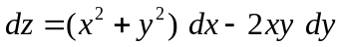

► True

► False
Question No: 12 ( Marks: 1 ) - Please choose one

Which one of the following is correct Wallis Sine formula when is even and ?

► 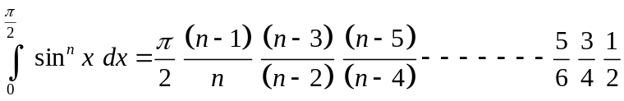

► 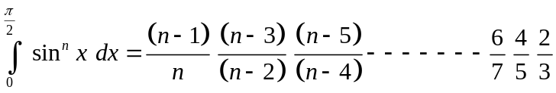

► 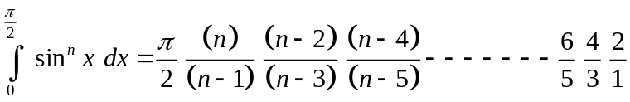

► 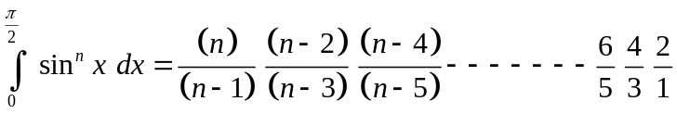

Question No: 13 ( Marks: 1 ) - Please choose one

If , then the equation, in polar co-ordinates, of the form 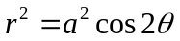 represent which of the following family of curves?

► Leminscate

► Cardiods

► Rose curves

► Spiral

Question No: 14 ( Marks: 1 ) - Please choose one

Which of the following condition must be satisfied for a vector field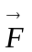 to be a conservative vector field?

► 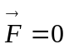

► 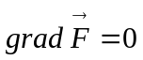

► 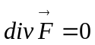

► 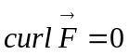

Question No: 15 ( Marks: 1 ) - Please choose one

Match the following periodic function with its graph.
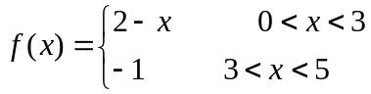

► 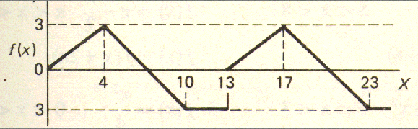

► 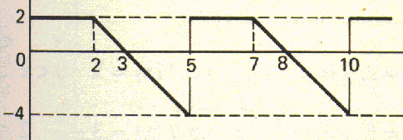

► 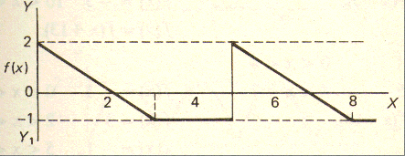

► 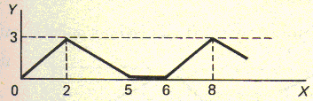

Question No: 16 ( Marks: 1 ) - Please choose one

Match the following periodic function with its graph.
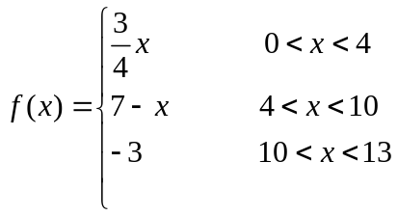

►

►

►

►

Question No: 17 ( Marks: 1 ) - Please choose one

What is the period of periodic function whose graph is as below?
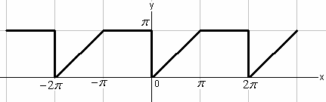

►

►

► 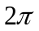

► 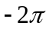

Question No: 18 ( Marks: 1 ) - Please choose one

Let denotes the Laplace Transform.
If 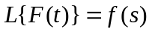where is a constant, then which of the following equation holds?

► 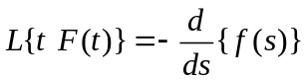

► 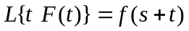

► 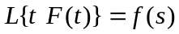

► 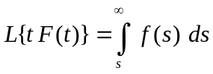

Question No: 19 ( Marks: 1 ) - Please choose one

The function 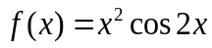 is -------------

► Neither even nor odd

► Odd function

► Even function

Question No: 21 ( Marks: 1 ) - Please choose one

Let the function 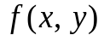 has continuous second-order partial derivatives 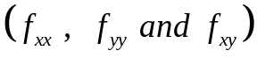 in some circle centered at a critical point 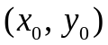and let 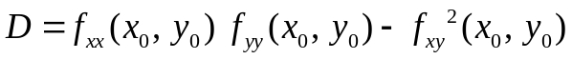

If 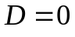 then ---------------

► 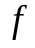 has relative maximum at

► has relative minimum at

► has saddle point at

► No conclusion can be drawn.

Question No: 22 ( Marks: 1 ) - Please choose one

The path of integration of a line integral must be -------------

► straight and single-valued

► continuous and single-valued

► straight and multiple-valued

► continuous and multiple-valued

Question No: 24 ( Marks: 1 ) - Please choose one

What is the Laplace Inverse Transform of 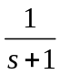

► 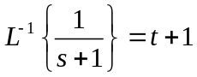

► 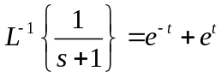

► 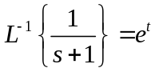

► 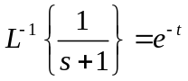

Question No: 25 ( Marks: 1 ) - Please choose one

Evaluate the line integral 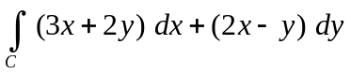 where C is the line segment from (0, 0) to (2, 0).

► 6

► -6

► 0

► Do not exist

Question No: 26 ( Marks: 1 ) - Please choose one

Evaluate the line integral 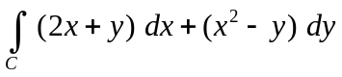 where C is the line segment from (0, 0) to (0, 2).

► -4

► -2

► 0

► 2

Question No: 27 ( Marks: 1 ) - Please choose one

Curl of vector function is always a --------------

► Scalar

► Vector

Question No: 28 ( Marks: 1 ) - Please choose one

If p is the period of a function then that function is said to be periodic if 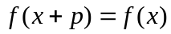, _______________

► For all values of x in the domain of f

► For positive values of x in the domain of f

► For negative values of x in the domain of f

Question No: 29 ( Marks: 1 ) - Please choose one

Which of the following is geometrical representation of the equation 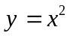, in three dimensional space?

► Parabola

► Straight line

► Half cylinder

► Cone

Question No: 30 ( Marks: 1 ) - Please choose one

If a = 1 ,then the equation, in polar co-ordinates of the form r = a θ represents which of the following curve?

► cardioid

► circle

► rose curve

► archimedian spiral

Question No: 33 ( Marks: 2 )

Find Laplace Transform of the function 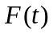if 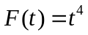

Question No: 34 ( Marks: 3 )

What is the arc-length of the curve 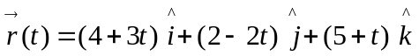 when 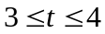?

Question No: 35 ( Marks: 3 )

Determine the Fourier co-efficient 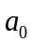of the periodic function defined below:

Question No: 36 ( Marks: 3 )

Define the periodic function whose graph is shown below.

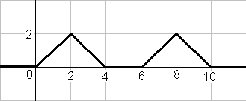

Question No: 37 ( Marks: 5 )

Evaluate the following line integral which is independent of path.
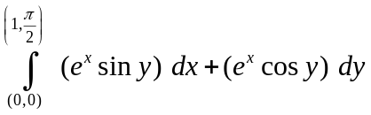

Question No: 38 ( Marks: 5 )

Determine the fourier co-efficient of the following function.
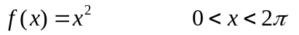

Question No: 39 ( Marks: 5 )

Determine whether the following vector field is conservative or not.
