MIDTERM EXAMINATION
Spring 2009
MTH101- Calculus And Analytical Geometry (Session - 1)

Question No: 1 ( Marks: 1 ) - Please choose one
The set {…,-4,-3,-2,-1,0,1,2,3,4,..} is know as set of …………..

► Natural numbers
► Integers

► Whole numbers
► None of these

Question No: 2 ( Marks: 1 ) - Please choose one
The domain of the function
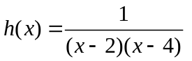 is

► 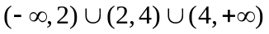
► 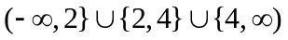
► 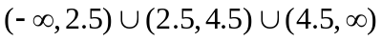
► All of these are incorrect

Question No: 3 ( Marks: 1 ) - Please choose one
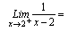

► 1
► -1
► 0
►

Question No: 4 ( Marks: 1 ) - Please choose one
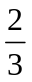 is

► An even number
► None of these
► A natural number
► A complex number

Question No: 5 ( Marks: 1 ) - Please choose one
The set of rational number is a subset of

► Integers
► Natural numbers
► Odd integers
► Real number

Question No: 6 ( Marks: 1 ) - Please choose one
If n-5 is an even integer, what is the next larger consecutive even integer?

► n-7
► n-3
► n-2

► n-4

Question No: 7 ( Marks: 1 ) - Please choose one
If a function satisfies the conditions

f(c) is defined
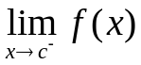 Exists
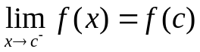
Then the function is said to be

► Continuous at c
► Continuous from left at c
► Continuous from right at c
► None of these

Question No: 8 ( Marks: 1 ) - Please choose one
Tan(x) is continuous every where except at points

► 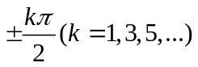
► 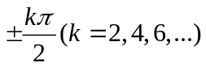
► 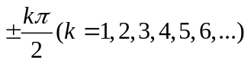
► None of these

Question No: 9 ( Marks: 1 ) - Please choose one
A line
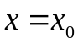 is called ------------ for the graph of a function 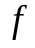 if 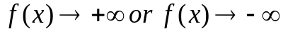 as approaches  from the right or from the left

► Horizontal asymptotes
► None of these
► Vertical asymptotes

Question No: 10 ( Marks: 1 ) - Please choose one
--------- theorem states that “if f(x )is continuous in a closed interval [a,b] and C is any number between f(a) And f(b) Inclusive ,Then there is at least one number x in the interval [a,b] uch that f(x) =C”

► Value theorem
► Intermediate value theorem
► Euler’s theorem
► None of these

Question No: 11 ( Marks: 1 ) - Please choose one
Let L₁ and L₂ be non vertical lines with slopes m₁ and m₂ ,respectively Both the lines are perpendicular if and only if

► 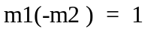
► 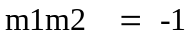
► 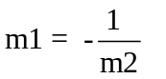
► All of these

Question No: 12 ( Marks: 1 ) - Please choose one
The equation of line of the form
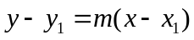 is known as

► Slope intercept form
► Point-slope form
► Two points form
► Intercepts form

Question No: 13 ( Marks: 1 ) - Please choose one
Polynomials are always …………………. Function

► Continuous
► Discontinuous

Question No: 14 ( Marks: 1 ) - Please choose one
The solution of the inequality
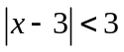 is

► (-1,7)
► (1,7)
► (1,-7)
► None of these

Question No: 15 ( Marks: 1 ) - Please choose one
The solution set of the inequality
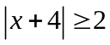 is

► 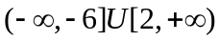
► None of these
► 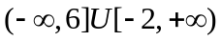
► 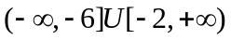

Question No: 16 ( Marks: 1 ) - Please choose one
The centre and the radius of the circle
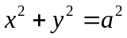 is

► (1,1),a
► (0,0),1
► None of these
► (0,0) ,a

Question No: 17 ( Marks: 1 ) - Please choose one
The centre and the radius of the circle
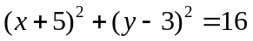 is

► (-5,3) ,4
► (5,-3),16
► (5,-3),4
► None of these

Question No: 18 ( Marks: 1 ) - Please choose one
Consider two function
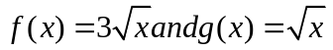 what is true about these functions

► 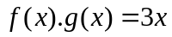
► 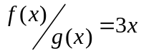
► 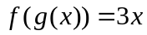
► None of these

Question No: 19 ( Marks: 1 ) - Please choose one
Consider two function
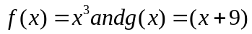 then 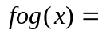

► 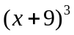
► 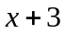
► 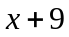
► None of these

Question No: 20 ( Marks: 1 ) - Please choose one
The formula
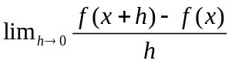 is called ……………….. with respect to x of the function f

► Derivative
► Slope
► Tangent
► None of these

Question No: 21 ( Marks: 2 )
Find the distance between A₁ (4, 6) and A₂ (10, 4) using the distance formula.

Question No: 22 ( Marks: 3 )
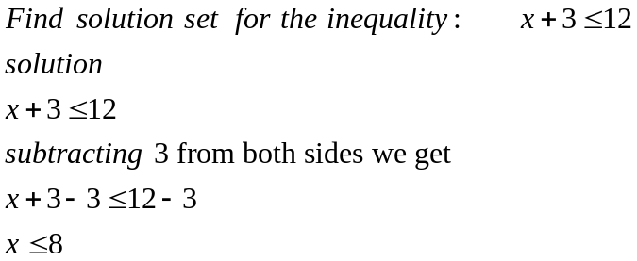

Question No: 23 ( Marks: 5 )
Determine whether or not
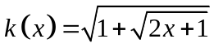 at  is continuous?

Question No: 24 ( Marks: 10 )
Express the given function in piecewise form without using absolute values

g(x) = |x| + |x-1|
g(x) = |x + x-1|
g(x) = |2x-1|

