PSYP631-Summer 2024 Practical
House-Tree-Person (HTP) Test Report

Introduction:

We administered the House-Tree-Person (HTP) test to Ali, a 35-year-old male project manager in a technology firm. Ali is married and lives with his wife, Tania, and their two children, Zain (8 years old) and Fatima (5 years old). The family resides in a suburban area in a medium-sized house with a well-maintained garden. Ali is known for his strong work ethic and dedication to both his career and family.

Family Background:

Ali was raised in a loving, close-knit household. Allah Dita and Gulzar, his parents, are both retired educators who have been together for more than 40 years. Sadia, Ali's younger sister, works as a self-employed graphic designer. The family has always valued education and close family ties highly. Ali's mother, Gulzar, stressed the value of emotional intelligence and nourishing connections, while his father, Allah Dita, was especially significant in developing in him a sense of responsibility and dedication.

Ali's personal relationships with his family are solid. He has been married for 10 years to Tania, his wife, since they first met in college. They value spending time with their families and take an active role in their kids' activities. Ali makes it a priority in his life to balance work and family obligations, even in the face of the pressures of his profession.

Test Administration:

Ali was advised that the HTP test would not be utilized for any clinical diagnosis and was only being administered for educational purposes. The exam was given in a casual office environment to guarantee comfort and reduce distractions. Ali was given a pencil and a blank piece of paper and instructed to draw a person, a tree, and a home. Beyond this request, he received no more instructions or cues.

Ali seemed assured and focused while he was drawing. He worked carefully and methodically on each drawing, demonstrating his attention to detail and sense of purpose. We noted all we could about his actions, including any hesitancy or shifts in attitude.

Instructions:

- Ali was informed that this test was solely for illustrative purposes and not for any clinical diagnosis
- Ali was expected to draw without hesitation or censorship and in detail
- The fact that there are no further instructions or prompts were given.

Behavioral Observation:

The client showed signs of cooperation and engagement during the test administration. He maintained clear eye contact and displayed a variety of facial expressions, including concern, thought, and brief grins. Ali demonstrated a sincere desire to comprehend the goal of the exam.
Description of Drawings:

- House:

- Appearance: Ali's drawing features a large rectangular base with a pitched roof. The house is centrally positioned on the page. The drawing includes a prominent chimney, a large central door with a doorknob, and two square windows, each with crossbars. The front yard is depicted with a line.

- Details: The house has clean, well-defined lines, and the additional elements like the yard sides are neatly drawn. There are no extraneous details that do not contribute to the structure of the house.

- Tree:

- Appearance: The tree is drawn with a thick trunk and a rounded, bushy canopy. It is positioned on the left side of the page and occupies a substantial portion of it. The canopy is represented by overlapping ovals, and the tree lacks visible branches and roots.

- Details: The shading within the canopy is minimal, and there is no ground line or depiction of roots, making the drawing appear somewhat simplified.

- Person:

- Appearance: The person is drawn with a large circular head and a small rectangular body. Facial features include two small dots for eyes, a dot for a nose, and a curved line for a smiling mouth. The hair is represented by a few straight lines. The limbs are stick-like, with straight lines for arms and legs.

- Details: The person is relatively small compared to the house and tree, and is placed slightly to the right of center on the page. There are no additional details such as clothing or accessories.

Interpretation:
- House:

- Placement: The central placement of the house suggests a balanced and stable view of Ali’s home life and security. It indicates that he sees his domestic environment as a central part of his life.
- Chimney: The presence of a chimney, without excessive emphasis, suggests that Ali feels a sense of warmth and intimacy within his home environment. There is no indication of significant conflict with male figures.
- Door: The large, open door indicates a strong need for communication and warmth from the external world. It suggests that Ali is open to others and values accessibility.
- Front Yard: The Yard line implies that Ali has a nurturing disposition and appreciates beauty and order in his environment.

- Tree:

- Size and Shape: The thick trunk and rounded canopy indicate that Ali perceives himself as strong and stable. The lack of visible branches and roots might suggest a simplified self-concept or a focus on core aspects of his personality.
- Position: The left-side positioning of the tree could reflect internal self-reflections or past influences that impact his self-view.
- Details: The absence of roots or a ground line may indicate some level of emotional instability or repressed emotions.

- Person:

- Head: The large head suggests that Ali has a rich inner life and is preoccupied with thoughts and ideas. This may reflect a strong intellectual or emotional focus.
- Body and Limbs: The small body and stick-like limbs may indicate feelings of inadequacy or a tendency to control external circumstances rather than feeling secure in oneself.
- Facial Features: The smiling face suggests a generally positive self-view and comfort in social interactions.
- Position: The smaller size of the person compared to the house and tree might indicate feelings of being overshadowed or less central in his life.
Conclusion:
The HTP test administration revealed illuminating details about Ali's character and emotional condition. The pictures imply that he has a healthy, loving, and balanced perspective on interpersonal connections in his family life. Though it also suggests possible emotional repressions or feelings of inadequacy, the self-representation in the tree and figure drawings shows a solid self-view.
Managing any biases in the study and ensuring correct and objective interpretation of the drawings were challenges. The usefulness of the HTP test as a tool for examining underlying psychological themes and perceptions was highlighted by this real-world experience. It also emphasized how crucial it is to combine HTP findings with those from other evaluation techniques in order to get a thorough picture of the person.

Note: Attached to this report are scanned images of Ali’s drawings for visual reference.
Attachments:
- Drawing 1: House
- Drawing 2: Tree
- Drawing 3: Person

Drawing 1: Home
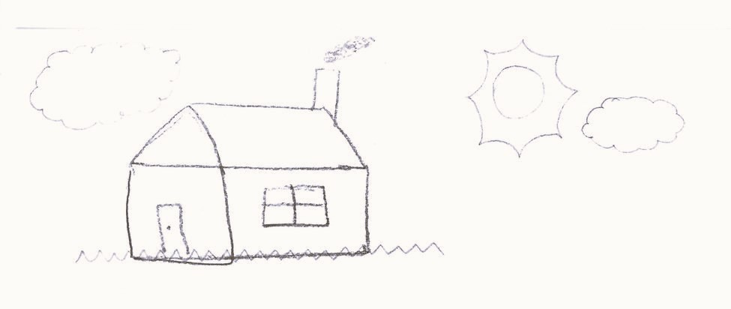

Drawing 2: Tree
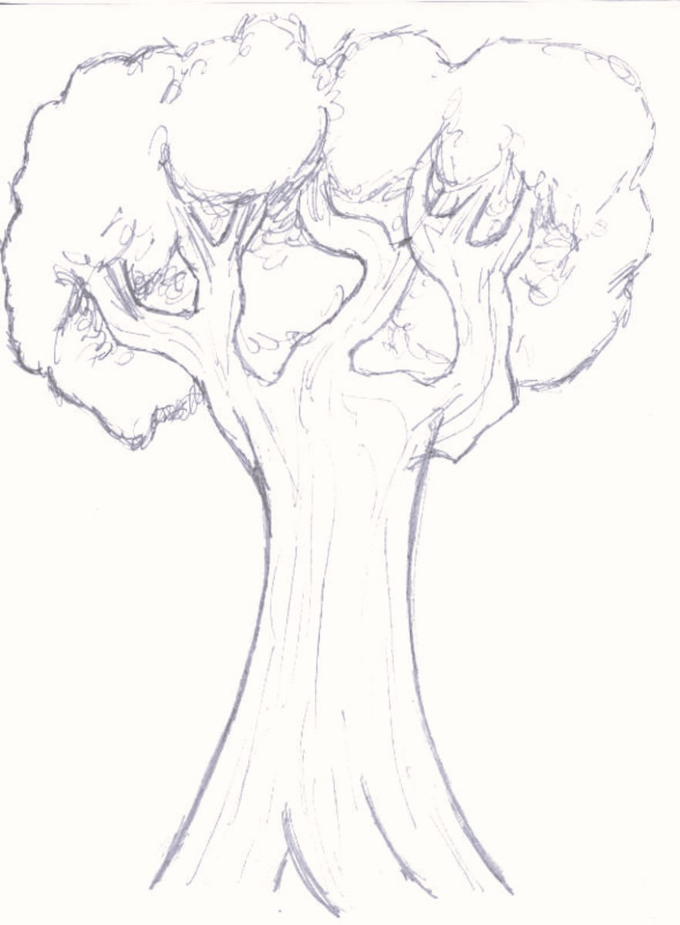
Drawing 3: Person


