Q1
The average which is defined as the reciprocal of the arithmetic mean is called:
- G.M
- H.M
- Mode
- Median
Q2
Which one of the following measure is not used in ‘five number summery’:
- 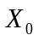
- 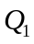
- 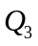
- 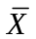
Q3
The conditional probability P (A\B) is:

(a) 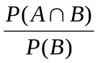
(b) 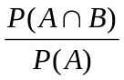
(c) 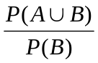
(d) 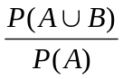
Q4.
The value of χ²can never be :
- Zero
- Less than 1
- Greater than 1
- Negative
Q5.
The curve of the F- distribution depends upon:
- Degrees of freedom
- Sample size
- Mean
- Variance
Q6
The variance of the chi-square distribution is
(a) 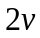
(b) 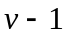
(c) 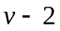
(d)
Q7
The test statistic used in analysis of variance procedure follow the ....... distribution.:
- χ²
- T
- T
- F
Q8
The variance of t-distribution, for >2, is always:
- Greater than zero
- Less than one
- Equal to one
- Greater than one
Q9
Interval estimation and confidence interval are:
- Same
- Different
- Opposite
- Independent
Q10
For a particular hypothesis test, 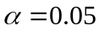and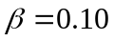. The power of test is equal to:
- 0.14
- 0.90
- 0.95
- 0.25
Q11
Two continuous r.v.’s X and Y are said to be independent if and only if :
- f(x,y)= g(x) h(y)
- f(x,y) ╪ g(x) h(y)
- f(x,y)> g(x) h(y)
- f(x,y)<g(x) h(y)
Q12
For unknown population variance and small n which of the formula will be used to find confidence interval for 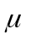:
- 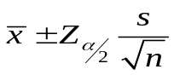
- 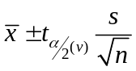
- 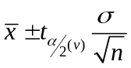
none of these

For large samples, to estimate the population mean which limits will be used:
- 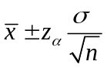
- 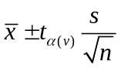

Q14
The combined distribution of more than two random variables is:
- Univariate distribution
- Joint distribution
- Marginal distribution
- Bivariate distribution
Q15
When f (x, y) is bivariate probability density function of continuous r.v.'s X and Y, then
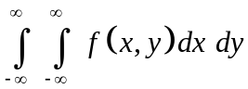 is equal to:
- 1
- 0
- -1
Q16
A normal population distribution is needed from the following test statistic:

- Chi-squared
- Standard error of the mean
- Variance estimation
- Kendall's rank coefficient
Q17
When we find the probability of an event happening by subtracting the probability of the event not happening from 1, we are using:
- The general rule of addition.
- The special rule of multiplication
- The complement rule
- Subjective probability
Q18
The F- test statistic in one-way ANOVA is:
- SSW / SSE
- MSW / MSE
- SSE / SSW
- MSE / MSW
Q19
Which branch of statistics deals with the techniques that are used to organize, summarize, and present the data?
- Advance statistics
- Probability statistics
- Descriptive statistics
- Inferential statistics
Q20
Which one of the following is an example of compressed data?
- Data array
- Frequency distribution
- Histogram
- Ogive
Q21
What is meant by large sample? Marks: 1
Q22
Why we call the standard deviation of the sample statistic as standard error of the statistic? Marks: 2
Q23
What is t-test-statistic for testing of paired observation? Marks: 3
Q24
Write down the three possible forms of 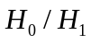hypothesis. Marks: 3
Q25
From the given table find P(X = 0 | Y = 1);

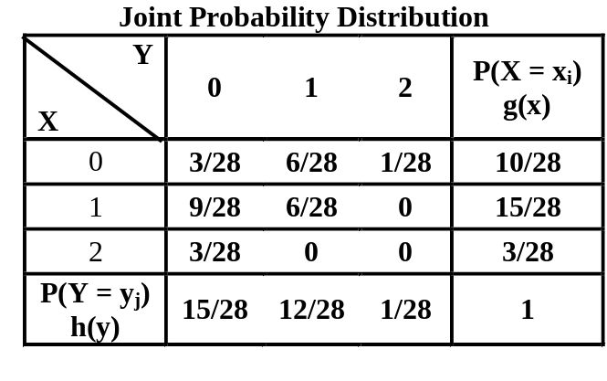

Marks: 3
Q26
Why we use Stem and leaf plot in data sorting? Marks: 3
Q27
Describe the 'standard error' in sampling distribution of proportions. Marks: 5
Q28
In an examination, 24 candidates offered Statistics. If the probability of passing the subject is, find the mean and variance of the distribution. Marks: 5
Q29
Write down short note on chi- square test of independence. Marks: 5
Q30
Nine individual are chosen at random from a normal population and their weights in Kg are found to be 63, 64, 66, 67, 67, 68, 69, 69, 70 with mean weight 67 and standard deviation 2.345. Test the hypotheses that the mean weight of the population is 66 Kg, using 5% level of significance. Marks: 10

