ACC501 Quiz No- 3 Fall 2014
Question # 1 of 20 ( Start time: 02:01:09 AM ) Total Marks: 1
In how many years, an amount will be doubled at a discount rate of 8 percent?
Answer: Cannot be determined without more information
In MACRS property classes, 7-year class includes which of the following ?
Answer:Most industrial equipment\
Which of the following measures the present value of an investment per dollar invested?
Answer:Net Present Value (NPV)
Which of the following statements is(are) CORRECT regarding a bond?
A bond is an evidence of debt issued by a corporation or a governmental body.
A bond represents a loan made by investors to the issuer.
When a corporation wishes to borrow from public on a long term basis, it does so by issuing or selling bonds.
All of the given options Answer:
The most important item that can be extracted from financial statements is the actual __________ of the firm.
Answer:????
What will be the value of a Rs. 1,000 face-value bond with an 8% coupon rate at 8% required rate of return?
Answer: More than its face value
Which of the following is the amount of time required for an investment to generate cash flows sufficient to recover its initial cost?
Answer:Payback period
A ___________ is an agent who arranges security transactions among investors.
Answer:Broker
Which of the following represents the linear relation between Net Present Value (NPV) and Profitability Index (PI)?
Answer:If Profitability Index > 1, NPV is Positive (+)
Which of the given is treated as financial asset?
Answer:Corporate bond
If a firm has a ROA of 8 percent, sales of Rs. 100,000, and total assets of Rs. 75,000. What is the profit margin?
Answer:????
Which of the following is a series of constant cash flows that occur at the end of each period for some fixed number of periods?
Answer:???
If the dividend for a share is growing at a steady rate then which of the following formula(s) can be used to find the dividend in two periods?
Answer: D2 = D1 x (1 + g )
Mr. A has just recently started a business by investing a capital of Rs. 500,000. He will be the only owner of the business and also enjoy all the profits of the business. Which type of business is being employed by Mr. A?
Answer: Sole-proprietorship
The principal amount of a bond at issue is called:
Answer:Par value
Which one of the following is NOT a liquidity ratio?
Answer: Cash Coverage Ratio
In which of the following type of annuity, cash flows occur at the beginning of each period?
Answer:Annuity due
Which of the following set of cash flows represent the change in the firm’s total cash flow that occurs as direct result of accepting the project ?
Answer:Relevant Cash Flows
XYZ Company has a ROE of 12 percent and a dividend payout ratio of 40 percent. What is the firm’s maximum sustainable rate of growth?
Answer:???

ACC501 Quiz No 3 Fall 2014
Quiz Start Time: 02:01 PM
Time Left 64
sec(s)
Question # 6 of 20 ( Start time: 02:07:57 PM ) Total Marks: 1
If the dividend for a share is growing at a steady rate then which of the following formula(s) can be used to find the dividend in two periods?
Select correct option:
D2 = D1 x (1 + g )
D2 = Do x ( 1 + g )2
D2 = Do x ( 1 + g )2
All of the given options

If a firm is allowed to miss a coupon payment on a bond in a year in which it reports an operating loss, the bond is most likely a(n) _______ bond.

Select correct option:
Income
Zero coupon
Floating-rate
Put
Which of the following is the amount of cash we would get if we actually sell
an asset?
Select correct option:
Market Value
Book Value
Intrinsic Value
None of the given options

Quiz Start Time: 02:01 PM
Time Left 28
sec(s)
Question # 7 of 20 ( Start time: 02:09:01 PM ) Total Marks: 1
Which of the following process can be defined as the process of generating earnings from previous earnings?
Select correct option:
Discounting
Compounding
Factorization
None of the given options

Quiz Start Time: 02:01 PM
Time Left 72
sec(s)
Question # 8 of 20 ( Start time: 02:10:30 PM ) Total Marks: 1
Which of the following refers to a conflict of interest between principal and agent?
Select correct option:
Management conflict
Interest conflict
Agency problem
None of the given option

Quiz Start Time: 02:01 PM
Time Left 64
sec(s)
Question # 10 of 20 ( Start time: 02:12:30 PM ) Total Marks: 1
Which of the following best represents the term “Financing”?
Select correct option:
It means raising money to acquire something.
It is an object that provides services.
It is trade license to trade securities on behalf of investors.
It represents an ownership interest.

Quiz Start Time: 02:01 PM
Time Left 64
sec(s)
Question # 11 of 20 ( Start time: 02:13:11 PM ) Total Marks: 1
Which of the following term refers to the difference between the present value of cash inflows and the present value of cash outflows?
Select correct option:
Net Present Value (NPV)
Average Accounting Return (AAR)
Internal Rate of Return (IRR)
Profitability Index (PI)

Quiz Start Time: 02:01 PM
Time Left 65
sec(s)
Question # 12 of 20 ( Start time: 02:13:48 PM ) Total Marks: 1
How much must be deposited at 10% each of the next 15 years to have Rs. 14297.62?
Select correct option:
Rs. 225
Rs. 341
Rs. 410(nt sure )
Rs. 450

Quiz Start Time: 02:01 PM
Time Left 62
sec(s)
Question # 13 of 20 ( Start time: 02:15:07 PM ) Total Marks: 1
Which of the following is a measure of accounting profit relative to the book value?
Select correct option:
Net Present Value
Profitability Index
Internal Rate of Return
Average Accounting Return

Quiz Start Time: 02:01 PM
Time Left 49
sec(s)
Question # 15 of 20 ( Start time: 02:16:33 PM ) Total Marks: 1
Which of the following set of ratios is used to assess a business's ability to generate earnings as compared to its expenses and other relevant costs incurred during a specific period of time?
Select correct option:
Liquidity Ratios
Leverage Ratios
Profitability Ratios
Market Value Ratios

Quiz Start Time: 02:01 PM
Time Left 61
sec(s)
Question # 16 of 20 ( Start time: 02:17:30 PM ) Total Marks: 1
Sumi Inc. has just paid a dividend of Rs. 7 per share. The dividend of this company grows at a steady rate of 5% per year. What will be the dividend in 5 years?
Select correct option:
Rs. 4.41
Rs. 6.12
Rs. 7.35
Rs. 8.93

Quiz Start Time: 02:01 PM
Time Left 60
sec(s)
Question # 17 of 20 ( Start time: 02:18:10 PM ) Total Marks: 1
Which of the given is treated as financial asset?
Select correct option:
Corporate bond
Machinery
Inventory
Factory building

Quiz Start Time: 02:01 PM
Time Left 61
sec(s)
Question # 18 of 20 ( Start time: 02:18:51 PM ) Total Marks: 1
Which of the following comes under the head of accounting criteria for capital budgeting decision?
Select correct option:
Payback Period
Net Present Value
Profitability Index
Average Accounting Return

Quiz Start Time: 02:01 PM
Time Left 63
sec(s)
Question # 19 of 20 ( Start time: 02:19:33 PM ) Total Marks: 1
A given rate is quoted as 9 percent APR, but the EAR is 9.38 percent. What is the compounding period?
Select correct option:
Semiannually
Quarterly
Monthly
Daily

Quiz Start Time: 02:01 PM
Time Left 46
sec(s)
Question # 20 of 20 ( Start time: 02:20:10 PM ) Total Marks: 1
Which of the following represents the linear relation between Net Present Value (NPV) and Profitability Index (PI)?
Select correct option:
If Profitability Index > 1, NPV is Negative (-)
If Profitability Index < 1, NPV is Positive (+)
If Profitability Index > 1, NPV is Positive (+)

If Profitability Index > 1, NPV is Zero (0)

ACC501 Midterm Solved Quiz No-3 Fall 2014
Top of Form


MC120200251 : Muhammad Bilal  Quiz Start Time: 11:47 PM
  Time Left | 68  sec(s)

Question # 1 of 20 ( Start time: 11:47:19 PM ) | Total Marks: 1
Which of the following comes under the head of discounted cash flow criteria for capital budgeting decisions?
Select correct option:
 | 
 | 
 | 
 | 




MC120200251 : Muhammad Bilal  Quiz Start Time: 11:47 PM
  Time Left | 15  sec(s)

Question # 2 of 20 ( Start time: 11:48:01 PM ) | Total Marks: 1
What will be the value of a Rs. 1,000 face-value bond with an 8% coupon rate at 8% required rate of return?
Select correct option:






MC120200251 : Muhammad Bilal  Quiz Start Time: 11:47 PM
  Time Left | 71  sec(s)

Question # 3 of 20 ( Start time: 11:49:26 PM ) | Total Marks: 1
Which of the following is the amount of time required for an investment to generate cash flows sufficient to recover its initial cost?
Select correct option:






MC120200251 : Muhammad Bilal  Quiz Start Time: 11:47 PM
  Time Left | 66  sec(s)

Question # 4 of 20 ( Start time: 11:50:06 PM ) | Total Marks: 1
Which of the following statement is TRUE regarding debt?
Select correct option:

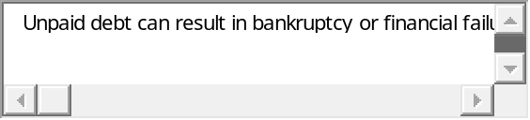

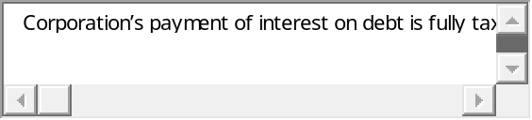


MC120200251 : Muhammad Bilal  Quiz Start Time: 11:47 PM
  Time Left | 74  sec(s)

Question # 5 of 20 ( Start time: 11:50:41 PM ) | Total Marks: 1
The coupon rate of a floating-rate bond is capped and upper and lower rates are called:
Select correct option:






MC120200251 : Muhammad Bilal  Quiz Start Time: 11:47 PM
  Time Left | 31  sec(s)

Question # 6 of 20 ( Start time: 11:51:11 PM ) | Total Marks: 1
Which of the following is the most significant financial advantage of corporate form?
Select correct option:






MC120200251 : Muhammad Bilal  Quiz Start Time: 11:47 PM
  Time Left | 75  sec(s)

Question # 7 of 20 ( Start time: 11:52:22 PM ) | Total Marks: 1
Which of the following is subcategory (ies) of finance department?
Select correct option:


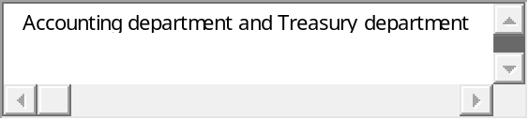


MC120200251 : Muhammad Bilal  Quiz Start Time: 11:47 PM
  Time Left | 89  sec(s)

Question # 8 of 20 ( Start time: 11:53:46 PM ) | Total Marks: 1
What will be the cash inflow if we have sales of Rs. 400,000 and accounts receivable are decreased by Rs. 70,000 ?
Select correct option:
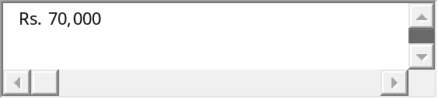
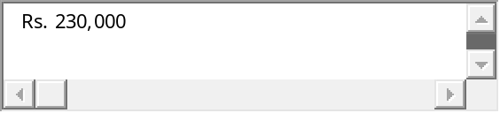1000%
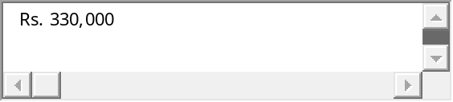
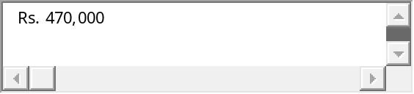


MC120200251 : Muhammad Bilal  Quiz Start Time: 11:47 PM
  Time Left | 88  sec(s)

Question # 9 of 20 ( Start time: 11:54:21 PM ) | Total Marks: 1
Expectation of a ______ inflation rate will push long term interest rates ______ than short term rates reflected by an upward term structure.
Select correct option:


100%


MC120200251 : Muhammad Bilal  Quiz Start Time: 11:47 PM
  Time Left | 73  sec(s)

Question # 10 of 20 ( Start time: 11:54:51 PM ) | Total Marks: 1
Which of the following is NOT an internal use of financial statements information?
Select correct option:

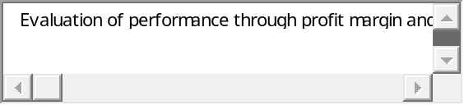



MC120200251 : Muhammad Bilal  Quiz Start Time: 11:47 PM
  Time Left | 68  sec(s)

Question # 11 of 20 ( Start time: 11:55:11 PM ) | Total Marks: 1
In MACRS property classes, 7-year class includes which of the following ?
Select correct option:






MC120200251 : Muhammad Bilal  Quiz Start Time: 11:47 PM
  Time Left | 71  sec(s)

Question # 12 of 20 ( Start time: 11:55:37 PM ) | Total Marks: 1
Which of the following ratios is NOT from the set of Asset Management Ratios?
Select correct option:






MC120200251 : Muhammad Bilal  Quiz Start Time: 11:47 PM
  Time Left | 68  sec(s)

Question # 13 of 20 ( Start time: 11:55:59 PM ) | Total Marks: 1
The most common application of term “Finance” involves raising money to acquire_________.
Select correct option:



100%


MC120200251 : Muhammad Bilal  Quiz Start Time: 11:47 PM
  Time Left | 89  sec(s)

Question # 14 of 20 ( Start time: 11:57:09 PM ) | Total Marks: 1
Which of the following is an example of positive covenant?
Select correct option:
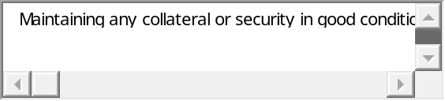100%

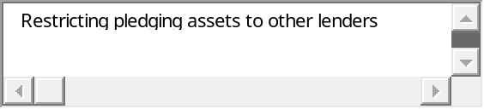



MC120200251 : Muhammad Bilal  Quiz Start Time: 11:47 PM
  Time Left | 69  sec(s)

Question # 15 of 20 ( Start time: 11:58:40 PM ) | Total Marks: 1
____________ shows the sources from which cash has been generated and how it has been spent during a period of time?
Select correct option:






MC120200251 : Muhammad Bilal  Quiz Start Time: 11:47 PM
  Time Left | 89  sec(s)

Question # 16 of 20 ( Start time: 11:59:09 PM ) | Total Marks: 1
Which of the following item provides the important function of shielding part of income from taxes?
Select correct option:


100%


MC120200251 : Muhammad Bilal  Quiz Start Time: 11:47 PM
  Time Left | 88  sec(s)

Question # 17 of 20 ( Start time: 11:59:32 PM ) | Total Marks: 1
How much must be deposited at 10% each of the next 15 years to have Rs. 14297.62?
Select correct option:


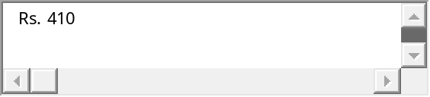
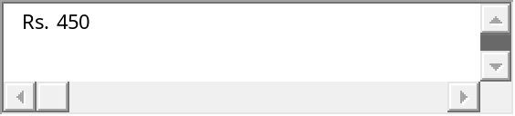


MC120200251 : Muhammad Bilal  Quiz Start Time: 11:47 PM
  Time Left | 73  sec(s)

Question # 18 of 20 ( Start time: 11:59:55 PM ) | Total Marks: 1
Which of the following is a characteristic of preferred stock?
Select correct option:
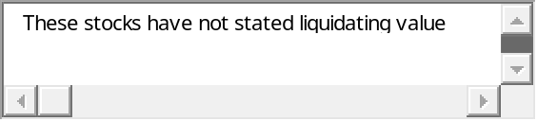
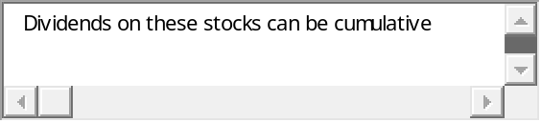




MC120200251 : Muhammad Bilal  Quiz Start Time: 11:47 PM
  Time Left | 89  sec(s)

Question # 19 of 20 ( Start time: 12:00:25 AM ) | Total Marks: 1
JJ Inc. has a 4 percent return on total assets of Rs. 500,000 and a net profit margin of 5 percent. Total sales for JJ Inc. would be :
Select correct option:



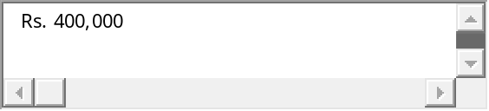100%


MC120200251 : Muhammad Bilal  Quiz Start Time: 11:47 PM
  Time Left | 88  sec(s)

Question # 20 of 20 ( Start time: 12:00:49 AM ) | Total Marks: 1
Which one of the following costs refers to the cash flows that could be generated from an asset the firm already owns provided it is not used for the project in question ?
Select correct option:





