Final term solved past paper 2017
vu zoologist
1. What are the processes of the ecosystem influenced by landscape structure? 2
A landscape is a heterogeneous area composed of several ecosystems. The ecosystems making up a landscape generally form a mosaic of visually distinctive patches. These patches are called landscape elements.
Landscape structure influences processes such as the flow of energy, materials, and species between the ecosystems within a landscape. Landscape ecologists have proposed that landscape structure, especially the size, number, and isolation of habitat patches, can influence the movement of organisms between potentially suitable habitats. The group of subpopulations living on such habitat patches make up a metapopulation.
for Examples;
The source of water for lakes in a Wisconsin lake district is determined by their positions in the landscape, which in turn determine their hydrologic and chemical responses to drought.
2. Write four reasons which relatively have incomplete fossil record. 2
The fossil record is relatively incomplete for several reasons:
Soft tissues are rarely preserved
Movement of the earth's crust has obliterated and/or covered many fossils
Fossilization takes place only in certain types of habitats and favorable environments
Paleontologists have not dug up every place on earth
3. Define Hardy-Weinberg principle. 2
One of the most fundamental concepts in population genetics, the Hardy-Weinberg principle, states that “in a population mating at random in the absence of evolutionary forces, allele frequencies will remain constant.”
For a population in Hardy-Weinberg equilibrium in a situation where there are only two alleles at a particular locus, p + q = 1.0. The frequency of genotypes in a population in Hardy-Weinberg equilibrium can be calculated as (p + q)² = (p + q) x (p + q) = p² + 2pq + q² = 1.0.
The conditions necessary to maintain constent allele frequencies in a population are:
random mating,
no mutations,
large population size,
no immigration, and
equal survival and reproductive rates for all genotypes.

4. How nutrient enrichment says the human is altering the aquatic and terrestrial ecosystem.? 3
Nutrient enrichment by humans
Vegetative controls appear to be less important in cold and/or dry environments. Nutrient loss by stream ecosystems is highly pulsed and associated with disturbance by flooding. Nutrient enrichment by humans is altering aquatic and terrestrial ecosystems. Nitrate concentration and export by the earth's major rivers correlate directly with human population density. Human disturbance also increases export of phosphorus from aquatic catchments. Nutrient enrichment appears to be reducing the diversity of plants and fungi in terrestrial ecosystems. Land managers around the world use nutrient loading models to predict and manage the impact of land use on aquatic ecosystems.
5. Define and explain optical foraging theory 3
Optimal foraging theory
Optimal foraging theory attempts to model how organisms feed as an optimizin process.
Evolutionary ecologists predict that if organisms have limited access to energy, natural selection is likely to favor individuals that are more effective at acquiring energy and nutrients. Many animals select food in a way that appears to maximize the rate at which they capture energy.
Plants appear to allocate energy to roots versus shoots in a way that increases their rate of intake of the resources that limit their growth. Plants in environments with abundant nutrients but little light tend to invest more energy in the growth of stems and leaves and less in roots. In environments rich in light but poor in nutrients, plants tend to invest more energy in the growth of roots.
6. Lyell’s Mistake on natural selection. 3
Lyell’s mistake
As a part of his general resistance to direction/ substantial change in geology, Lyell maintained there was no real direction of change in the fossil record either. This was greeted with pretty general astonishment, but Lyell claimed the apparent changes were just due to our having bad (misleading) samples…more mammals would soon appear in older formations, etc., as we extend our fossil collections. Within ten years (1840) it was clear that this was completely untenable.
7.Species diversity and species richness.
Species diversity
Species diversity is a measure of community complexity.
It is a function of both the number of different species in the community (species richness) and their relative abundances (species evenness). Larger numbers of species and more even abundances of species lead to higher species diversity. For example:A forest community with 20 different kinds of trees would have greater species diversity than a forest community with only 5 kinds of trees (assuming that the tree species were even in abundance in both cases).
A forest community with 20 different kinds of trees in even abundances would have greater species diversity than a forest community with the same number of species in very uneven abundances. In general, ecologists think that more diverse ecological communities are more stable (that is, more able to recover after a disturbance) than less diverse communities. However, the diversity-stability relationship isn't a universal rule, and there are some cases where other factors (besides species diversity) are more important in determining community and ecosystem stability superscript.
Species richness
Species richness is the number of different species in a particular community.
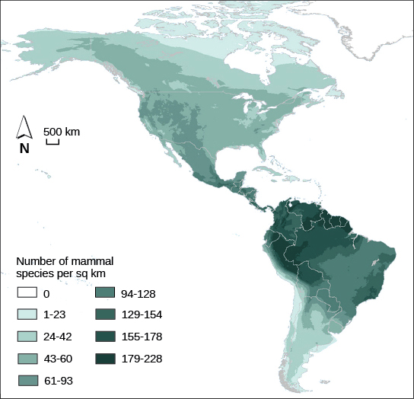
If we found 30 species in one community, and 300 species in another, the second community would have much higher species richness than the first. Communities with the highest species richness tend to be found in areas near the equator, which have lots of solar energy (supporting high primary productivity), warm temperatures, large amounts of rainfall, and little seasonal change. Communities with the lowest species richness lie near the poles, which get less solar energy and are colder, drier, and less amenable to life. This pattern is illustrated below for mammalian species richness (species richness calculated only for mammal species, not for all species). Many other factors in addition to latitude can also affect a community's species-richness.
Map shows the spatial distribution of mammal species richness in North and South America. The highest number of mammal species, 179-228 per square kilometer, occurs in the Amazon region of South America. Species richness is generally highest in tropical latitudes, and then decreases to the north and south, with zero species in the Arctic regions

8.Mutualistic relationship.
Mutualism
Mutualism, interactions between individuals that benefit both partners, is a common phenomenon in nature that has apparently made important contributions to the evolutionary history of life and continues to make key contributions to the ecological integrity of the biosphere.
Mutualisms types
Mutualisms can be divided into those that are facultative, where species can live without their mutualistic partners, and obligate, where species are so dependent on the mutualistic relationship that they cannot
live without their mutualistic partners
Examples
Plants benefit from mutualistic partnerships with a wide variety of bacteria, fungi, and animals. Mutualism provides benefits to plants ranging from nitrogen fixation and enhanced nutrient and water uptake to pollination and seed dispersal.
Mycorrhiza
Ninety percent of terrestrial plants form mutualistic relationships with mycorrhizal fungi, which make substantial contributions to plant performance. Mycorrhizae, which are mostly either vesicular-arbuscular mycorrhizae or ectomycorrhizae, are important in increasing plant access to water, nitrogen, phosphorus, and other nutrients. In return for these nutrients, mycorrhizae receive energy-rich root exudates. Experiments have shown that the mutualistic balance sheet between plants and mycorrhizal fungi can be altered by the availability of nutrients. Plant-ant protection mutualisms are found in both tropical and temperate environments.

9. Community structure define.2
Community structure is essentially the composition of a community, including the number of species in that community and their relative numbers^1​1​​start superscript, 1, end superscript. It can also be interpreted more broadly, to include all of the patterns of interaction between these different Species.
10.Effect of exotic predators on food web. 5
Exotic predators and the structure of food webs
Exotic predators can collapse and simplify the structure of food webs. Introduced fishes have devastated the native fishes of Lake Atitlan and Gatun Lake in Central America.
Examples
The influence of the Nile perch on the fish community of Lake Victoria is enmeshed with massive changes in the lake's ecosystem. Introduction of the Nile perch is rapidly reducing the species-rich
fish fauna of Lake Victoria to a community dominated by a handful of species.
Humans
Humans have acted as keystone species in communities. People have long manipulated food webs both as a consequence of their own feeding activities and by introducing or deleting species from existing food webs. In addition, many of these manipulations have been focused on keystone species. Hunters in tropical rain forests have been responsible for removing keystone animal species from large areas of the rain forests of Central and South America. Chinese farmers have used ants as keystone predators to control pests in citrus orchards for over 1,700 years.

11.Genomic sequence 5 mark

12.How to documented genetic history in genome 3 mark\
An organism’s evolutionary history is documented in its genome
- Comparing nucleic acids or other molecules to infer relatedness is a valuable tool for tracing organisms’ evolutionary history
- DNA that codes for rRNA changes relatively slowly and is useful for investigating branching points hundreds of millions of years ago
- mtDNA evolves rapidly and can be used to explore recent evolutionary events

13.Human evolution according to muslimisam 10 mark
PPT-46: HUMAN EVOLUTION
- Humans are too complex to be "understood" by any one field. Thus we will look at a few major steps in evolution and some of the things affecting human evolution.
- Humans are members of the order Primates which consists of about 180 species (there are 17 different orders of mammals which diverged 80-65 million years ago). Primates are a relatively old order of mammals. Most of the synapomorphies of this order are associated with an arboreal way of life: flexible digits, forward facing eyes, vision as a primary sense.
- These traits may have played a role in the evolution of brain size in the lineage leading to humans. Humans are a member of the family Hominidae which is believed to have diverged about 5 million years before the present (mybp) from the other members of the Old world monkeys. At least 20 mybp the Hominoids split off from the other old world monkeys. The dates are rough and get changed now and then.
Relationship of humans to African apes
Relationship of humans to African apes ( chimps, gorillas) and orangutan DNA hybridization indicates that apes are our closest relatives. Human/chimp/gorilla relationships not proven but chimps are most likely our closest relatives. The molecular clock says ~ 5 million years ago the human-chimp line split.
While Chimp and gorilla have knuckle walking , the humans posses many traits associated with bipedality: vertebral column, shape of pelvis, angle of femur, foramen magnum at base of skull. Bipedality seems to be a major "innovation" which allowed humans to enter a new "adaptive zone". The first human (Australopithecus afarensis) seems to have an angle between the femur and tibia (Upper and lower leg) that is intermediate to that of humans and gorillas.
The evolution of modern humans from our hominid ancestor is commonly considered as having involved four major steps:
- evolving terrestriality,
- bipedalism,
- a large brain (encephalization)
- civilization.
There are (and have been) several competing hypotheses that have acknowledged these four steps, but put them in a different sequence during human evolution.
Origin of Homo sapiens: Australopithecus afarensis = first bipedal hominid, found in east Africa about 3.0-3.2 MYBP. Later forms became more slender (= "gracile"). Homo habilis and H. erectus (~1.5mybp) came later. The evolution of bipedalism may have freed the hands for us in other functions: carrying, tool use. The trends in the evolution of tool use (more types, more specific tasks, different types of materials, more efficient use of materials) seems to follow (lead??) the evolution of increase cranial capacity. These both seem to increase noticeably about 2 mybp.

14.Write the phly of ambiotic protozoans and write mode of locomotion 3 mark
PPT No 22: Features of protists
Characteristics of Protist
- Eukarotic
- Unicellular
- 3 Main groups of protists; Protozoans, algae & fungus-like

- Protozoans: Animal like protists
Grouped by movement
- pseudopods
- cilia
- flagella
- parastites - no movement
Protozoan Characteristics
- No cell wall
- Free-living or parasitic
- Consumers
- Habitat – aquatic (ponds,lakes, oceans)
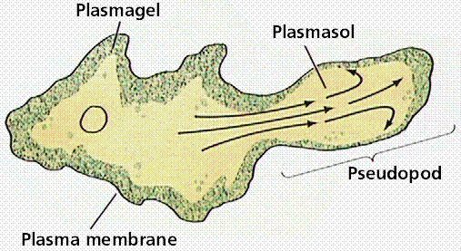
- Examples: amoeba, paramecium, dinoflagellates

- Example 1: - amoebas
- shapeless, aquatic
- Pseudopods in Amoebas

How Amoebas Eat ?
Feeding structures-
- food vacuole
- digestive enzymeswq
- diffusion
Getting Rid of Waste
Contracting vacole
– collect excess water from inside the cell and gets rid of it.
Reproduction of Amoeba
asexual reproduction
    - Binary fission
Dysentery (an illness)
- Inflammation of the large intestine
- Diarreha and vomiting
- Caused by an amoeba
15.What intermediate hypothesis suggests?
The intermediate disturbance hypothesis suggests that communities with a medium (intermediate) level of disturbance may have greater species diversity than communities with very frequent or very rare disturbances.

