FINALTERM EXAMINATION
Fall 2009
MTH301- Calculus II
Time: 120 min
Marks: 80

Question No: 1 ( Marks: 1 ) - Please choose one
A group of workers can do a piece of work in 40 days. However as 10 of them were absent it took 50 days to complete the work. How many people actually worked on the job to complete it?
► 35
► 40
► 25
► 50

Question No: 2 ( Marks: 1 ) - Please choose one
After the merchant buys merchandise, it is sold at a higher price called the _______
► Sale price

► Revenue discount

► Selling price
► Cost price

Question No: 3 ( Marks: 1 ) - Please choose one
Find x if 3x + 7 – x = 17.
► 5
► 4
► 12
► -5

Question No: 4 ( Marks: 1 ) - Please choose one
If Sale Price = Rs. 3810 and Original Price = Rs. 7270 then the Markdown Rate is equal to
► 47.59 %
► 45.57 %
► 43.53 %
► 48.9 %

Question No: 5 ( Marks: 1 ) - Please choose one
Amount of discount is obtained as
► Percentage of Discount x List Price

► Percentage of Discount / List Price

► Percentage of Discount - List Price

► None of these

Question No: 6 ( Marks: 1 ) - Please choose one
If for the next 8 years you save Rs. 20,000 per six months then how much will you have accumulated at the end of 8 years. Payments are to be made at the end of each annuity period, assume an interest of 8% compounded quarterly?
Which function can give you correct answer of above question?

► FV(0.08, 8, 20000, 0,0)
► FV(0.08, 8, 20000, 0, 1)
► FV(0.08/2, 8*4, 20000, 0, 0)
► PV(0.08/2, 8*4, 20000, 0, 0)

Question No: 7 ( Marks: 1 ) - Please choose one
Which of the following is the system of linear equations?
       ► 4 x + 6 y = 9
       ► 3 x² + 5 y² = 7 , x + y = 8
       ► 5 x + 7 y = 12, 2 x + 8 y = 10
       ► 2 x ² – 5 x + 7 = 0

Question No: 8 ( Marks: 1 ) - Please choose one
Break Even point is a point at which neither a profit nor ----- is made.

       ► Gain
       ► Loss
       ► Sale
       ► cost

Question No: 9 ( Marks: 1 ) - Please choose one
Net loss = Number of unit’s sale below BEP in unit’s × ……………per unit.

► FC
► VC
► CM
► S

Question No: 10 ( Marks: 1 ) - Please choose one
All formula in Excel start with
► +
► =
► -
► %

Question No: 11 ( Marks: 1 ) - Please choose one
Product: 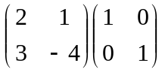=

► 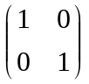
► 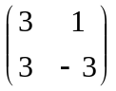
► 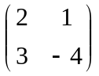
► 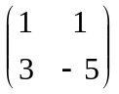

Question No: 12 ( Marks: 1 ) - Please choose one
VDB returns the depreciation of an asset for

► Zero period

► One period

► Two period

► Any arbitrary period

Question No: 13 ( Marks: 1 ) - Please choose one
After marketing analysis, the Contribution Margin in rupees provided that
variable cost = Rs.400 & expected sale price is Rs.800 is

► 2
► 1/2

► -400

► 400

Question No: 14 ( Marks: 1 ) - Please choose one
If A= [a b c] is a matrix then in order to find AB, the number of columns B must have are

► 3
► 1
► 2
► any non zero number

Question No: 15 ( Marks: 1 ) - Please choose one
There is an investment of _________ of basic salary on behalf of the employee in Provident Fund
► 1/11th
► 2/11th
► 3/11th
► 5/11th

Question No: 16 ( Marks: 1 ) - Please choose one
In classroom, there are 18 boys and 20 girls, then ratio of girls to boys is
       ►  9 to 12
       ► 18 to 20
       ► 10 to 9
       ► 9 to10

Question No: 17 ( Marks: 1 ) - Please choose one
If there is a change of -30% in the price of an item, what does the negative sign show?
► The price is decreasing.
► The price has low rate of change.
► None of the above.
► The price is increasing.

Question No: 18 ( Marks: 1 ) - Please choose one
If 15% discount is offered on a list price (L) of an item then its new price (L₁) will be…….

► L₁ = L – (L × 15%)
► L₁ = L + (L × 15%)
► L₁ = (L × 15%) - L
► L₁ = L× (L - 15%)

Question No: 19 ( Marks: 1 ) - Please choose one
Sum of all the amounts in column C that are on or after 13/08/07in column B can be found by using
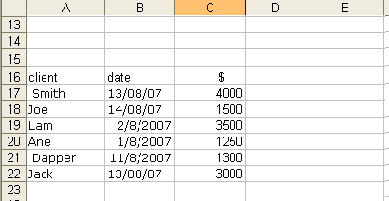
► =DSUM(B17:B22,">=13/08/07",C17:C22)

► =DSUM(B17:B22,” date",C17:C22)

► =SUMIF(B17:B22,">=13/08/07",C17:C22)
► =SUMIF(C17:C22,">=13/08/07",B17:B22)

Question No: 20 ( Marks: 1 ) - Please choose one
If a company made £80 million profits one year and £100 million the next year, the percentage change in its profits was ..........

► -0.2%

► 0.2%

► -25%

► 25%

Question No: 1 ( Marks: 1 ) - Please choose one
Which of the following number is associated to each point on a co-ordinate line?
► An integer
► A real number
► A rational number
► A natural number

Question No: 2 ( Marks: 1 ) - Please choose one
If 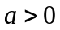, then the parabola 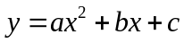opens in which of the following direction?
► Positive - direction 
► Negative - direction
► Positive - direction
► Negative - direction

Question No: 3 ( Marks: 1 ) - Please choose one
Rectangular co-ordinate of a point is 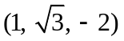. What is its spherical co-ordinate?
       ► 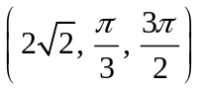
       ► 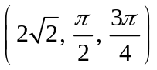
       ► 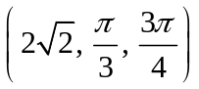
       ► 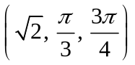

Question No: 4 ( Marks: 1 ) - Please choose one
If a function is not defined at some point, then its limit ----------- exist at that point.

       ► Always
       ► Never
       ► May

Question No: 5 ( Marks: 1 ) - Please choose one
Suppose 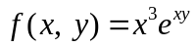. Which one of the statements is correct?

       ► 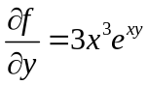
       ► 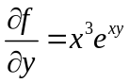
       ► 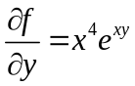
       ► 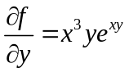

Question No: 6 ( Marks: 1 ) - Please choose one
If 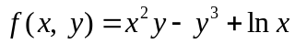
then 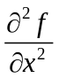=

       ► 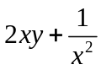
       ► 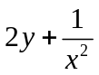
       ► 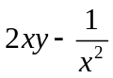
       ► 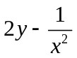

Question No: 7 ( Marks: 1 ) - Please choose one
Suppose . Which one of the following is true?

       ► 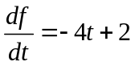
       ► 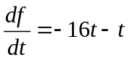
       ► 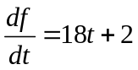
       ► 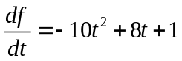

Question No: 8 ( Marks: 1 ) - Please choose one
Is the function 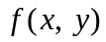 continuous at origin? If not, why?
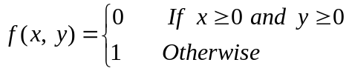
       ►  is continuous at origin
       ► 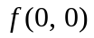 is not defined
       ►  is defined but 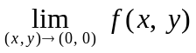 does not exist
       ►  is defined and exists but these two numbers are not equal.

Question No: 9 ( Marks: 1 ) - Please choose one
What is the relation between the direction of gradient at any point on the surface to the tangent plane at that point ?
       ► parallel
       ► perpendicular
       ► opposite direction
       ► No relation between them.

Question No: 10 ( Marks: 1 ) - Please choose one
Two surfaces are said to intersect orthogonally if their normals at every point common to them are ----------
► perpendicular
► parallel
► in opposite direction

Question No: 11 ( Marks: 1 ) - Please choose one
By Extreme Value Theorem, if a function 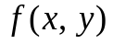 is continuous on a closed and bounded set R, then has both ---------------- on R.
► Absolute maximum and absolute minimum value
► Relative maximum and relative minimum value

Question No: 12 ( Marks: 1 ) - Please choose one
Let the function has continuous second-order partial derivatives 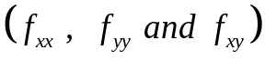 in some circle centered at a critical point 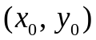and let 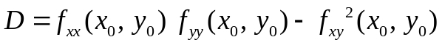

If 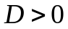 and 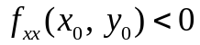 then 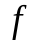 has ---------------
► Relative maximum at
► Relative minimum at
► Saddle point at
► No conclusion can be drawn.

Question No: 13 ( Marks: 1 ) - Please choose one
Let the function has continuous second-order partial derivatives in some circle centered at a critical point and let

If 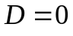 then ---------------
► 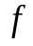 has relative maximum at
► has relative minimum at
► has saddle point at
► No conclusion can be drawn.

Question No: 14 ( Marks: 1 ) - Please choose one
The function 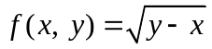 is continuous in the region --------- and discontinuous elsewhere.

► 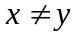
► 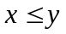
► 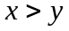

Question No: 15 ( Marks: 1 ) - Please choose one
Plane is an example of ---------------------
► Curve
► Surface
► Sphere
► Cone

Question No: 16 ( Marks: 1 ) - Please choose one
If 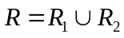 , where 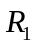 and 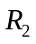 are no overlapping regions then
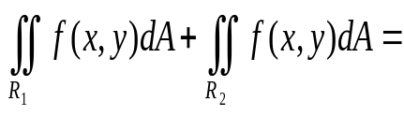

► 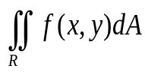
► 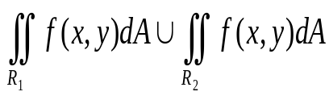
► 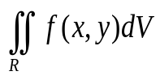
► 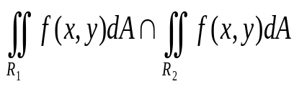

Question No: 17 ( Marks: 1 ) - Please choose one
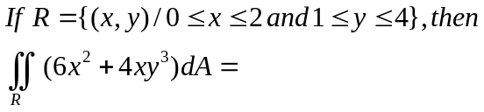

► 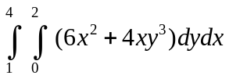
► 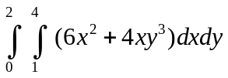
► 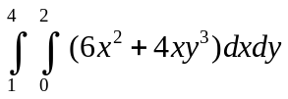
► 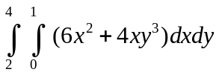

Question No: 18 ( Marks: 1 ) - Please choose one
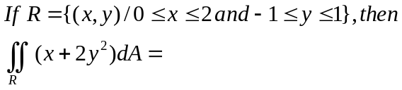

► 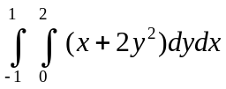
► 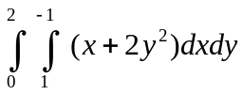
► 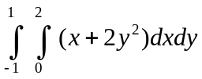
► 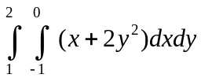

Question No: 19 ( Marks: 1 ) - Please choose one
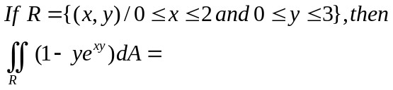

► 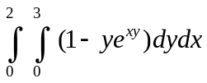
► 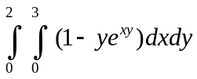
► 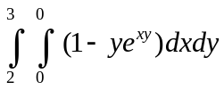
► 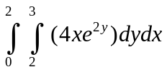

Question No: 20 ( Marks: 1 ) - Please choose one
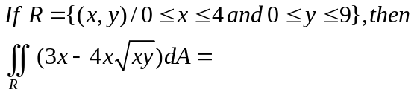

► 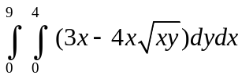
► 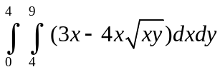
► 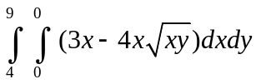
► 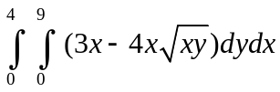

Question No: 1 ( Marks: 1 ) - Please choose one

is an example of -----------

► Irrational numbers

► Rational numbers

► Integers

► Natural numbers

Question No: 2 ( Marks: 1 ) - Please choose one

Straight line is a special kind of ----------------

► Surface

► Curve

► Plane

► Parabola

Question No: 3 ( Marks: 1 ) - Please choose one

An ordered triple corresponds to ----------- in three dimensional space.

► A unique point

► A point in each octant

► Three points

► Infinite number of points

Question No: 4 ( Marks: 1 ) - Please choose one

The angles which a line makes with positive x ,y and z-axis are known as ------------

► Direction cosines

► Direction ratios

► Direction angles

Question No: 5 ( Marks: 1 ) - Please choose one

Is the function continuous at origin? If not, why?
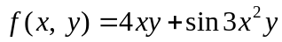

► is continuous at origin

► is not defined

► is defined but does not exist

► is defined and exists but these two numbers are not equal.

Question No: 6 ( Marks: 1 ) - Please choose one

Match the following vector-valued function with its graph.
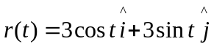 and 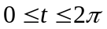

► 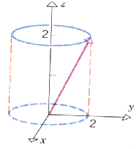

► 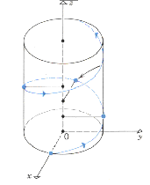

► 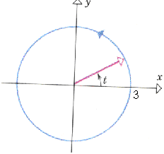

► 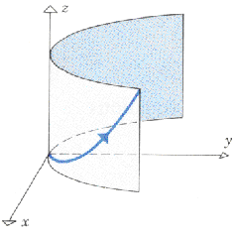

Question No: 7 ( Marks: 1 ) - Please choose one

Match the following vector-valued function with its graph.
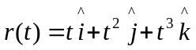 and 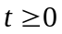

►

►

►

► 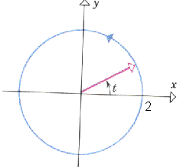

Question No: 8 ( Marks: 1 ) - Please choose one

What are the parametric equations that correspond to the following vector equation?
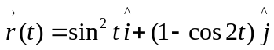

► 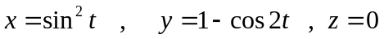

► 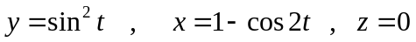

► 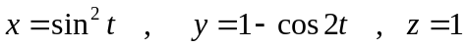

► 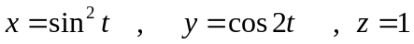

Question No: 9 ( Marks: 1 ) - Please choose one

Is the following vector-valued function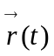 continuous at ? If not, why?
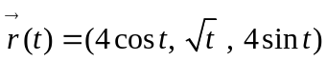

► 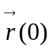is not defined

► is defined but 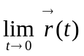 does not exist

► is defined and exists but these two numbers are not equal.

► 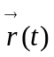is continuous at

Question No: 10 ( Marks: 1 ) - Please choose one

What is the derivative of following vector-valued function?
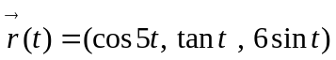

► 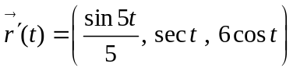

► 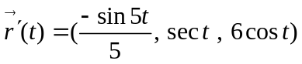

► 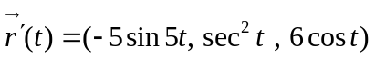

► 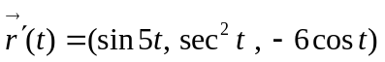

Question No: 11 ( Marks: 1 ) - Please choose one

The following differential is exact
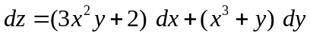

► True

► False

Question No: 12 ( Marks: 1 ) - Please choose one

The following differential is exact
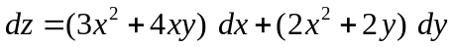

► True

► False

Question No: 13 ( Marks: 1 ) - Please choose one

Which one of the following is correct Wallis Sine formula when is odd and 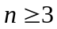?

► 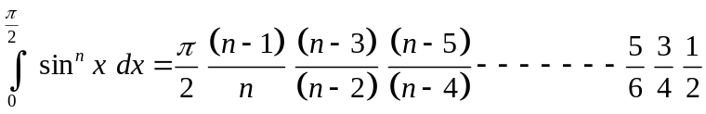

► 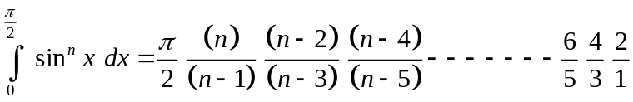

► 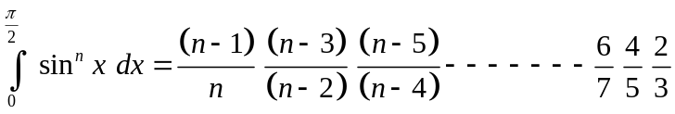

► 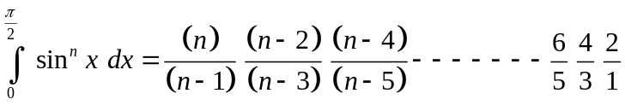

Question No: 14 ( Marks: 1 ) - Please choose one

Which of the following is correct?

► 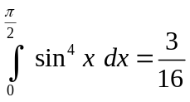

► 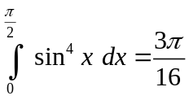

► 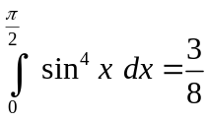

► 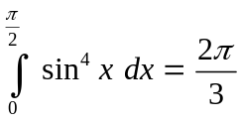

Question No: 15 ( Marks: 1 ) - Please choose one

Match the following equation in polar co-ordinates with its graph.
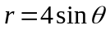

► 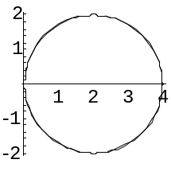

► 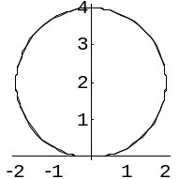

► 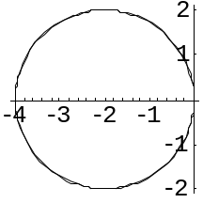

► 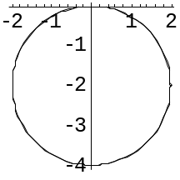

Question No: 16 ( Marks: 1 ) - Please choose one

If the equation of a curve, in polar co-ordinates, remains unchanged after replacing 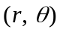by 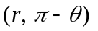then the curve is said to be symmetric about which of the following?

► Initial line

► y-axis

► Pole

Question No: 17 ( Marks: 1 ) - Please choose one

What is the period of a periodic function defined by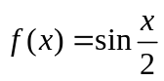?

► 

►

► 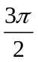

► 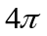

Question No: 18 ( Marks: 1 ) - Please choose one

Match the following periodic function with its graph.
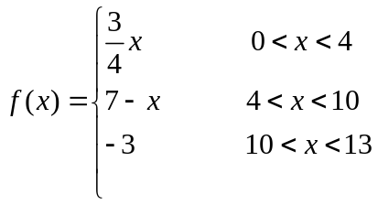

► 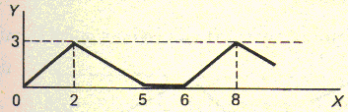

► 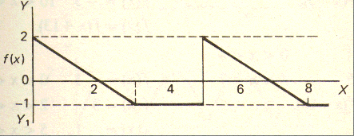

► 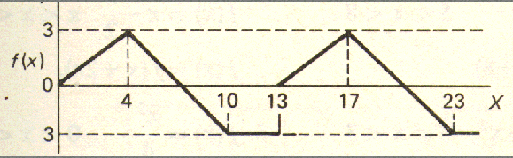

► 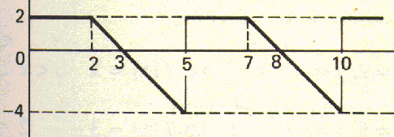

Question No: 19 ( Marks: 1 ) - Please choose one

What is the period of periodic function whose graph is as below?

► 2

► 3

► 4

► 5

Question No: 20 ( Marks: 1 ) - Please choose one

What is the period of periodic function whose graph is as below?
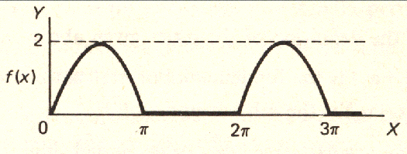

► 0

► 2

►

► 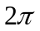

Question No: 21 ( Marks: 1 ) - Please choose one

Polar co-ordinates of a point are 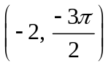. Which of the following is another possible polar co-ordinates representation of this point?

► 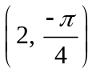

► 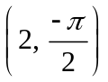

► 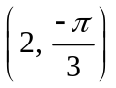

► 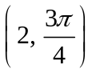

Question No: 22 ( Marks: 1 ) - Please choose one

The function 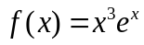 is -------------

► Even function

► Odd function

► Neither even nor odd

Question No: 23 ( Marks: 1 ) - Please choose one

The graph of an even function is symmetrical about ---------------

► x-axis

► y-axis

► origin

Question No: 24 ( Marks: 1 ) - Please choose one

At which point the vertex of parabola, represented by the equation 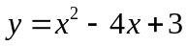, occurs?

► 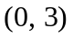

► 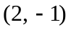

► 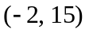

► 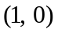

Question No: 25 ( Marks: 1 ) - Please choose one

The equation 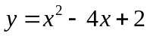 represents a parabola. Find a point at which the vertex of given parabola occurs?

► 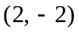

► 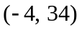

► 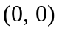

► 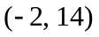

Question No: 26 ( Marks: 1 ) - Please choose one

Is the function continuous at origin? If not, why?
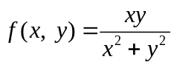

► is continuous at origin

► does not exist

► is defined and exists but these two numbers are not equal.

Question No: 27 ( Marks: 1 ) - Please choose one

Sign of line integral is reversed when -----------

► path of integration is divided into parts.

► path of integration is parallel to y-axis.

► direction of path of integration is reversed.

► path of integration is parallel to x-axis.

Question No: 28 ( Marks: 1 ) - Please choose one

What is Laplace transform of a function F(t)?

(s is a constant)

► 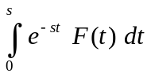

► 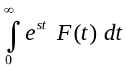

► 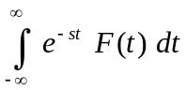

► 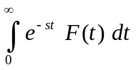

Question No: 29 ( Marks: 1 ) - Please choose one

What is the value of 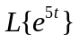if denotes laplace transform?

► 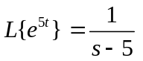

► 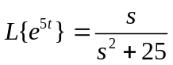

► 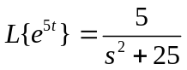

► 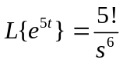

Question No: 30 ( Marks: 1 ) - Please choose one

What is the Laplace Inverse Transform of 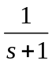

► 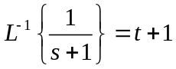

► 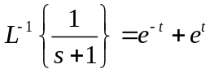

► 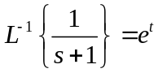

► 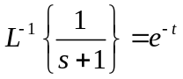

Question No: 31 ( Marks: 1 ) - Please choose one

What is Laplace Inverse Transform of 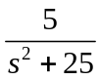

► 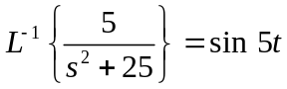

► 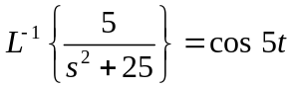

► 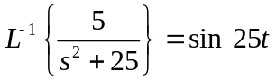

► 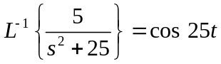

Question No: 32 ( Marks: 1 ) - Please choose one

What is 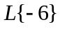if denotes Laplace Transform?

► 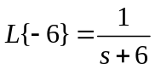

► 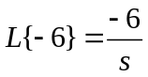

► 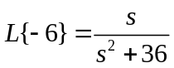

► 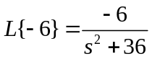

Question No: 33 ( Marks: 1 ) - Please choose one

Evaluate the line integral 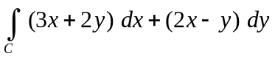 where C is the line segment from (0, 0) to (2, 0).

► 6

► -6

► 0

► Do not exist

Question No: 34 ( Marks: 1 ) - Please choose one

Evaluate the line integral 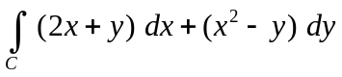 where C is the line segment from (0, 0) to (0, 2).

► -4

► -2

► 0

► 2

Question No: 35 ( Marks: 1 ) - Please choose one

Plane is an example of ---------------------

► Curve

► Surface

► Sphere

► Cone

Question No: 36 ( Marks: 1 ) - Please choose one

►

►

►

►

Question No: 37 ( Marks: 1 ) - Please choose one

To evaluate the line integral, the integrand is expressed in terms of x, y, z with

► 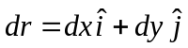

► 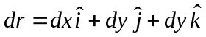

► 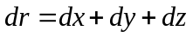

► 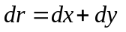

Question No: 38 ( Marks: 1 ) - Please choose one

Match the following equation in polar co-ordinates with its graph.
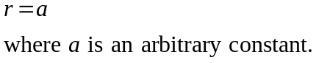

► 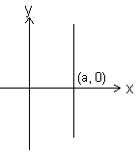

► 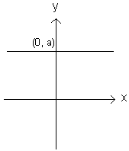

► 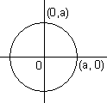

► 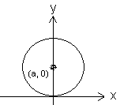

Question No: 39 ( Marks: 1 ) - Please choose one

Which of the following is true for a periodic function whose graph is as below?
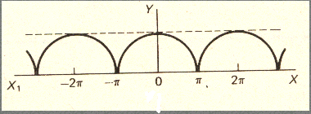

► Even function

► Odd function

► Neither even nor odd function

Question No: 40 ( Marks: 1 ) - Please choose one

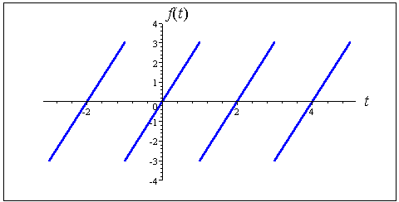

The graph of “saw tooth wave” given above is --------------

► An odd function

► An even function

► Neither even nor odd

Question No: 1 ( Marks: 2 ) - Please choose one
Laplace transform of ‘t ‘ is

 | ► | 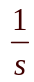
 | ► | 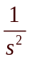
 | ► | 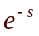
 | ► | 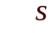

Question No: 2 ( Marks: 2 ) - Please choose one
Symmetric equation for the line through (1,3,5) and (2,-2,3) is

 | ► | 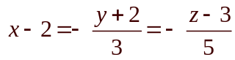
 | ► | 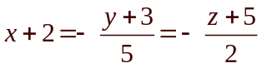
 | ► | 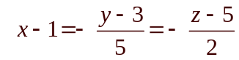
 | ► | 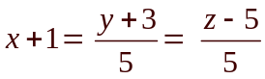

Question No: 3 ( Marks: 1 ) - Please choose one
The level curves of f(x, y) = y Cscx are parabolas.
 | ► | True.
 | ► | False.

Question No: 4 ( Marks: 1 ) - Please choose one
The equation 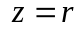 is written in

 | ► | Rectangular coordinates
 | ► | Cylindrical coordinates
 | ► | Spherical coordinates
 | ► | None of the above

