http://www.vusr.net
2 marks
How can we calculate notion of availability in statistical measurement?
What would you understand by the term “Software refactoring”?
What is meant by 90-10% rule in time-boxing?

What does mean by the term “Software Reengineering”?
How can quality of design is measured quantitatively?
3 marks
Subtasks have interdependencies based on their sequence, Give an example of subtask interdependcies?
What would this model depict?
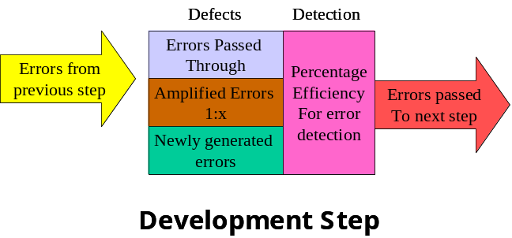

What would you understand by following code segment?

for (i=0; i < N-1; i++) {
min = i;
for (j = i; j < N; j++)
if (a[j] < a[min]) min = j;
temp = a[i];
a[i] = a[min];
a[min] = temp;
}

What is the guideline for organizations so that they will not depend on single individuals for there growth?

On what basis, a legacy sytem is assessed that whether it should be maintained or discarded. Explain it briefly.
5 marks
What is the difference between code and design re-structuring?
Give some recommendation to make a Walkthrough to be effective?
The software processes are usually ad-hoc and usually chaotic at
Level1
5
3
2
In order to plan and run a project successfully, a project manager needs NOT to worry about the following issue
Product Quality
Cost estimation
Name of company
Risk Assessment
In ____________a team is structured loosely and depends on individual initiative of the team members

Random paradiagm
Closed
Synchronous
Open

