MTH401 Current final term Spring 2011 complete paper with MCQ’s

The annihilator operator of the function 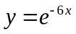 is
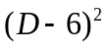
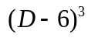
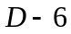
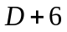

After converting the given differential equation 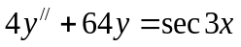 into standard form, the function f(x) is
(Sec3x)/4
(Sec3x)/64
None of them
Secx

Wronskian of the function 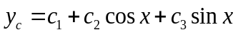 is
0
1
2
3

In the infinite series of (x-a) which can be written as 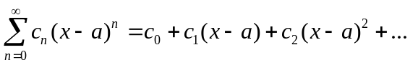 the number a is called the
Radius of power series
Centre of power series
Base of power series
None of them

Suppose that a power series 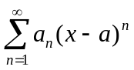is represented by a function “f”whose domain is the interval of the convergence of the power series. That function “f” is continuous, differentiable and integrable on

(a + R, a - R)
(R -a, R + a)
(a - R, a + R)
None of them

The interval of convergence for the function secx is

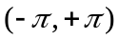
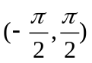
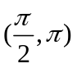
None of them

The solution of the linear first order differential equation 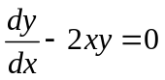is
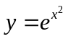
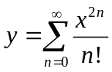
Both &
None of them

The quantity 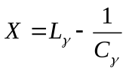is called
Reactance of circuit
Impedance of circuit
Quasi of circuit
None of them

For the equation of free damped motion 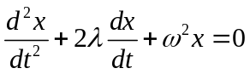 the roots are 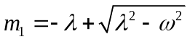 & 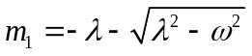 If 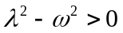then system is said to be
Under damped
Over damped
Critically damped
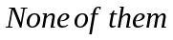

The time interval between two successive maxima of 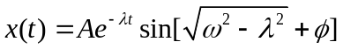is called
Phase period
Quasi-period
Both the period
None of them

The given differential equation 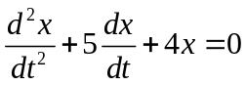 is
Over damped
Critically damped
Under damped
None of them

The standard unit for measurement of inductance is
Volt
Ohms
Henry
None of them

Which of the rule in matrices under multiplication does not hold true?
Commutative law
Associative law
Identity law
None of them

If 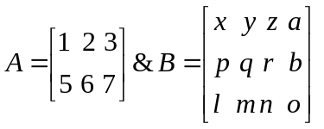then the order of 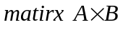is

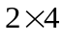
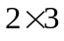
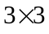
None of them

The given system without the use of matrices 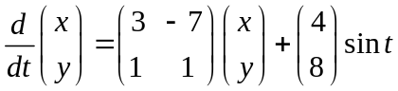 is
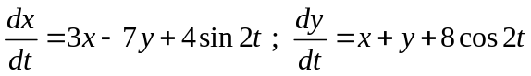
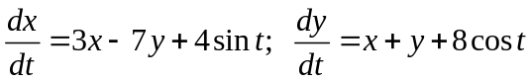
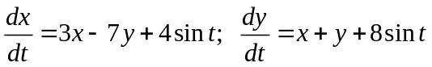
None of them

Suppose that {X₁, X₂, X₃,…, X_{n}} is a set of n solutions vectors on an interval I, of a homogeneous system X/=AX. The set is said to be a fundamental set of solutions of the system on the interval I if the solution vectors are

Linearly dependent
Linearly independent
Homogeneous
None of them

The coefficient matrix of the following homogeneous system of differential equation 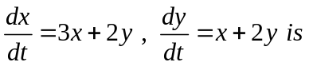
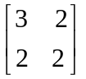
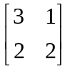
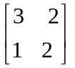
None of them

The matrix 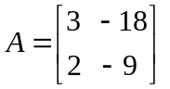has an eigen value of multiplicity

1
2
3
4

The matrix 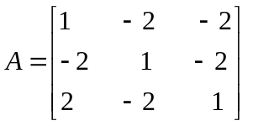has eigen values 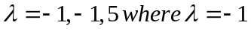is a
Single root of A

triple root of A
double root of A
None of them

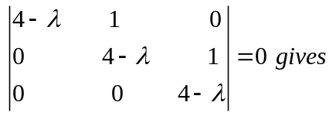
= 4 of multiplicity of 1
= 4 of multiplicity of 2
= 4 of multiplicity of 3
None of them

For the system of differential equations 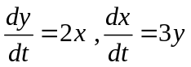the independent variable(s) is (are)

x, t
y, t
x, y
t

If L denote the linear differential operators with constant coefficients, then 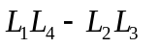 represents the

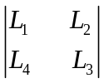
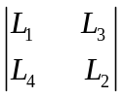
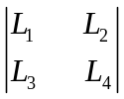
None of them

Wronskian of x,x² is
x
x²
x³
0

The general solution of differential equation 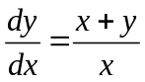.is given by

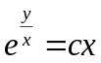
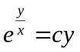
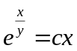
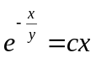

The form of the exact solution to
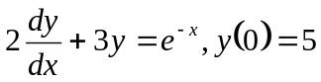
is

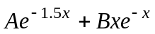
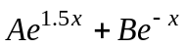
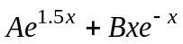
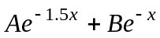

If m and n are non negative integers and 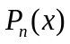 is a Legendre’s polynomial then

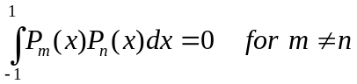
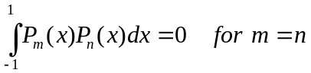
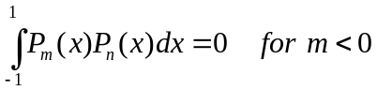
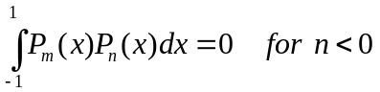

If A is a square matrix and its determinant is zero, then
A is singular matrix.
A is non singular matrix.
A is scalar matrix.
A is diagonal matrix.

An electronic component of an electronic circuit that has the ability to store charge and opposes any change of voltage in the circuit is called

Inductor
Resistor
Capacitor
None of them

Operator method is the method of the solution of a system of linear homogeneous or linear non-homogeneous differential equations which is based on the process of systematic elimination of the

Dependent variables
Independent variable
Choice variable
None of them
Any linear differential equation of the form is called
Homogeneous equation
Polar equation
Equi-dimensioanl equation
None of them

For eigen values 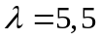 of a matirx 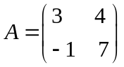,there exists ......... eigen vectors.

infinite
one
two
three

Ordinary points of 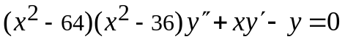 are
0,1
8,-8
6,-6
None of others.

A singular point 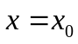of the given equation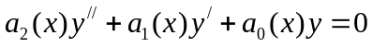 is said to be a regular singular point if
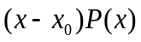is analytic at x₀

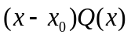is analytic at x₀
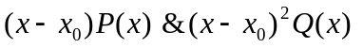are analytic at x₀
None of them

Singular points of the equation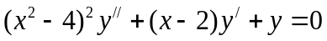 are
x= -2, 2
None of them
x =2
x = - 2

The matrix 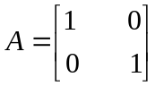has ..............
Real and unequal value
Repeated & real eigen value
Complex eigen value
None of them

Let be an eigen value of a non zero square matrix A. Then the equation 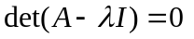is called
Trivial equation
Characteristics equation
Non-trivial equation
None of them

If y₁=x² is solution of the differential equation, then formula for finding Second solution
of 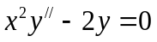 is

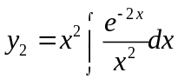
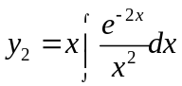
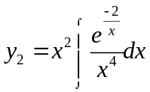
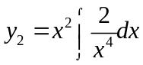

For ------.
9
-9
10
-10

A differential equation 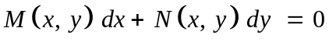 is said to be an exact if -----.

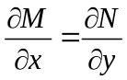
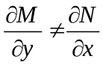
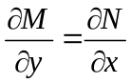
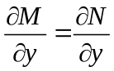

The integrating factor of the differential equation 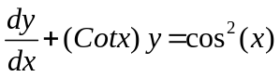 is ------------

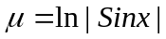
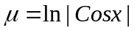
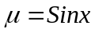
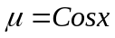

2 Marks

Give two examples of Bessel’s Differential Equation?

Define matrix and give condition of multiplication of two matrices.

Find Wronskain of two vectors 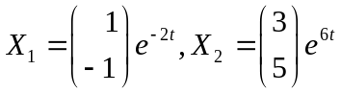.

What is half life of a substance?

Marks 3

Write the differential equation 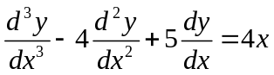in the form L(y) = g(x) where L is a differential operator with constant coefficients

Why we take 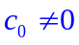 in Frobenius method?

Write the homogenous system of differential equations
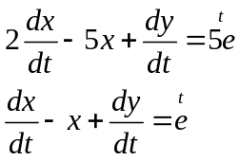
in decoupled form.

Find eigen vector of

A=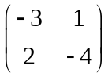,corresponding eigen value 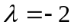.

Marks 5

Deduce the Special Case of Logistic Equation “Epidemic spread”?

Find 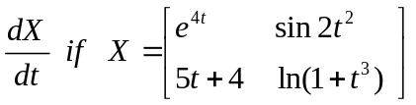

State the procedure to solve a differential equation by using Frobenius Theorem.

Write down the system of differential equations

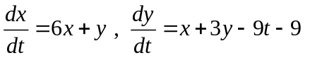
in form of 

