For any subspace W of a vector space V, which one is not the axiom for subspace.

0 must be in W.
For all u, v in W and u – v must be in W.
For all u, v in W and u.v must be in W.
For any scalar k and u in W then k.u in W.

Which one is not the axiom for vector space?
0 + u = u
0.u = u
1.u = u
u + v = v + u

The Gauss-Seidel method is applicable to strictly diagonally dominant matrix.
TRUE
FALSE

By using determinants, we can easily check that the solution of the given system of linear equation exits and it is unique.

At what condition det(AB)=(detA)(detB) is possible?
When A and B are n x n matrices
When A is a row matrix
When A and B are m x n matrices
When B is a column matrix

For any 3x3 matrix A where det (A) = 3, then det (2A) = ________.
24
20
15
6

If a multiple of one row of a square matrix A is added to another row to produce a matrix B, then which of the following condition is true?
detB = detA
detB = k detA
detA detB = 0
detA detB = detA

The Jacobi’s method is a method of solving a matrix equation on a matrix that has no zeros along its main diagonal.
TRUE
FALSE

While using the Cramer’s rule, if determinant D = 0, and other determinant is not zero then how many solutions are there?
Many solutions
No solution
Two solutions
One solution

Which of the following is all permutations of {1,2}?
(1,2,2,1)

Question # 1 of 10 ( Start time: 09:52:17 PM ) Total Marks: 1
By using determinants, we can easily check that the solution of the given system of linear equation exits and it is unique.
Select correct option:
FALSE
TRUE

Question # 2 of 10 ( Start time: 09:53:11 PM ) Total Marks: 1
If a multiple of one row of a square matrix A is added to another row to produce a matrix B, then which of the following condition is true?
Select correct option:
detB = k detA
detB = detA
detA detB = 0
detA detB = detA
Question # 3 of 10 ( Start time: 09:54:09 PM ) Total Marks: 1
At what condition the Cramer’s formula is valid for linear systems?
Select correct option:
When matrix is n x n
When det(A) is equal to zero
When matrix is m x n
When det(A) in not equal to zero
Question # 4 of 10 ( Start time: 09:54:44 PM ) Total Marks: 1
A matrix has not the same determinant if we add a multiple of a column to another column.
Select correct option:
TRUE
FALSE
Question # 5 of 10 ( Start time: 09:55:30 PM ) Total Marks: 1
The Jacobi’s method is a method of solving a matrix equation on a matrix that has no zeros along its main diagonal.
Select correct option:
TRUE
FALSE
Question # 6 of 10 ( Start time: 09:56:10 PM ) Total Marks: 1
Which of the following is the volume of the parallelepiped determined by the columns of A where A is a 3 x 3 matrix?
Select correct option:
|det A|
[A]
det A
A^(-1) ,that is inverse of A
Question # 7 of 10 ( Start time: 09:57:25 PM ) Total Marks: 1
For any 3x3 matrix A where det (A) = 3, then det (2A) = ________.
Select correct option:
24
20
15
6
Question # 8 of 10 ( Start time: 09:58:24 PM ) Total Marks: 1
Which one is not the axiom for vector space?
Select correct option:
0 + u = u
0.u = u
1.u = u
u + v = v + u
2
Question # 9 of 10 ( Start time: 09:58:58 PM ) Total Marks: 1
Which of the following is NOT the axiom for vector space where u, v, w in V are set of vectors and l, m, n are scalars?
Select correct option:
u + (v + w) = (u + v) + w
u.v =v.u
l (u + v)= l u + l v
(l +m) u= I u+ m u
Question # 10 of 10 ( Start time: 09:59:48 PM ) Total Marks: 1
If two rows or columns of a square matrix are identical, then det (A)wil be _______.
Select correct option:
zero
non zero
one
positive

Question # 1 of 10 ( Start time: 10:30:38 PM ) Total Marks: 1
If A is strictly diagonally dominant, then A is _________.
Select correct option:
invertible
singular
symmetric
scalar
Question # 2 of 10 ( Start time: 10:31:17 PM ) Total Marks: 1
The Gauss-Seidel method is applicable to strictly diagonally dominant matrix.
Select correct option:
TRUE
FALSE
Question # 3 of 10 ( Start time: 10:32:00 PM ) Total Marks: 1
If the absolute value of each diagonal entry exceeds the sum of the absolute values of the other entries in the same row then a matrix A is called:
Select correct option:
invertible
strictly diagonally dominant
diagonally
scalar
Question # 4 of 10 ( Start time: 10:33:26 PM ) Total Marks: 1
The Jacobi’s method is a method of solving a matrix equation on a matrix that has no zeros along its main diagonal.
Select correct option:
TRUE
FALSE
Question # 5 of 10 ( Start time: 10:33:52 PM ) Total Marks: 1
Which one is not the axiom for vector space?
Select correct option:
0 + u = u
0.u = u
1.u = u
u + v = v + u
Question # 6 of 10 ( Start time: 10:34:16 PM ) Total Marks: 1
Let W = {(x, y) such that x, y in R and x = y}. Is W a vector subspace of plane.
Select correct option:
YES
NO
Question # 7 of 10 ( Start time: 10:34:58 PM ) Total Marks: 1
If A is a triangular matrix, then det(A) is the product of the entries on the ________.
Select correct option:
main diagonal of A
first two rows of A
diagonal of A
first two columns of A
Question # 8 of 10 ( Start time: 10:35:59 PM ) Total Marks: 1
By using determinants, we can easily check that the solution of the given system of linear equation exits and it is unique.
Select correct option:
FALSE
TRUE
Question # 9 of 10 ( Start time: 10:36:55 PM ) Total Marks: 1
If a matrix A is invertible than adj(A) is also invertible.
Select correct option:
TRUE
FALSE
Question # 10 of 10 ( Start time: 10:37:57 PM ) Total Marks: 1
If all the entries of a row or a column of a square matrix are zero, then det (A) will be _____________.
Select correct option:
zero
infinity
one
non zero

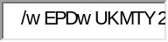

BC090201047 : Muhmmad Asif  Quiz Start Time: 08:32 PM
  Time Left | 57  sec(s)

Question # 3 of 10 ( Start time: 08:34:27 PM ) | Total Marks: 1
A matrix A and its transpose have the same determinant.
Select correct option:
 | 
 | 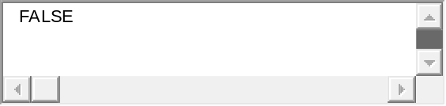



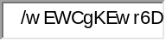
BC090201047 : Muhmmad Asif  Quiz Start Time: 08:32 PM
  Time Left | 48  sec(s)

Question # 5 of 10 ( Start time: 08:36:08 PM ) | Total Marks: 1
If a system of equations is solved using the Jacobi’s method , then which of the following is the most appropriate answer about the matrix M that is derived from the coefficient matrix ?
Select correct option:

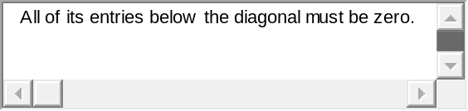
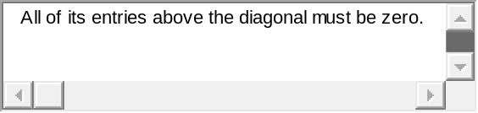


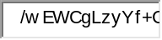
BC090201047 : Muhmmad Asif  Quiz Start Time: 08:32 PM
  Time Left | 66  sec(s)

Question # 6 of 10 ( Start time: 08:37:37 PM ) | Total Marks: 1
If A is a square matrix, then the Minor of entry ith row and jth column is to be the determinant of the sub matrix that remains when the ith row and jth column of A are:
Select correct option:


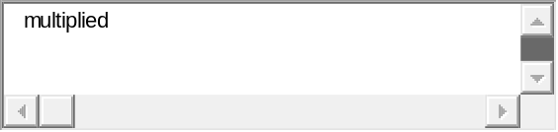

BC090201047 : Muhmmad Asif  Quiz Start Time: 08:32 PM
  Time Left | 36  sec(s)

Question # 7 of 10 ( Start time: 08:38:54 PM ) | Total Marks: 1
If M=[3] then which of the following is the determinant of the matrix M?
Select correct option:

For which of the matrix, the Gauss-Seidel method is applicable


BC090201047 : Muhmmad Asif  Quiz Start Time: 08:32 PM
  Time Left | 71  sec(s)

Question # 9 of 10 ( Start time: 08:41:21 PM ) | Total Marks: 1
Which of the following is all permutations of {1,2}?
Select correct option:
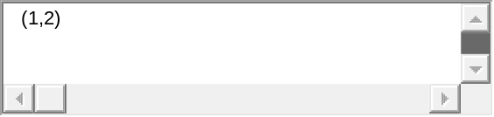
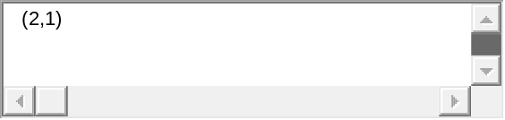
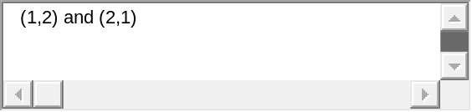


BC090201047 : Muhmmad Asif  Quiz Start Time: 08:32 PM
  Time Left | 56  sec(s)

Question # 10 of 10 ( Start time: 08:42:29 PM ) | Total Marks: 1
If M is a square matrix having two rows equal then which of the following about the determinant of the matrix is true?
Select correct option:
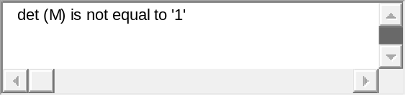
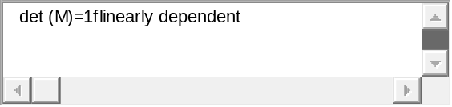
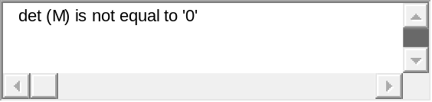
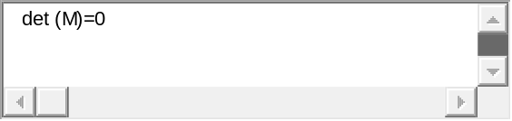

Quiz Start Time: 05:46 PM
  Time Left | 37  sec(s)

Question # 1 of 10 ( Start time: 05:46:20 PM )
If a system of equations is solved using the Gauss-Seidel method, then which of the following is the most appropriate answer about the matrix M that is derived from the coefficient matrix ?
Select correct option:

true

Quiz Start Time: 05:46 PM
  Time Left | 81  sec(s)

Question # 3 of 10 ( Start time: 05:48:07 PM )
Let W = {(1, y) such that y in R}. Is W a vector subspace of plane.
Select correct option:

 true

Quiz Start Time: 05:46 PM
  Time Left | 89  sec(s)

Question # 4 of 10 ( Start time: 05:48:39 PM )
Which of the following is the volume of the parallelepiped determined by the columns of A where A is a 3 x 3 matrix?
Select correct option:
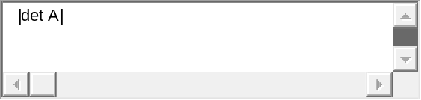 true

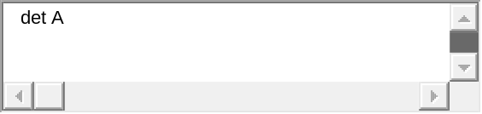
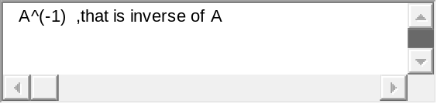

Quiz Start Time: 05:46 PM
  Time Left | 89  sec(s)

Question # 5 of 10 ( Start time: 05:50:05 PM )
At what condition the Cramer’s rule fails?
Select correct option:
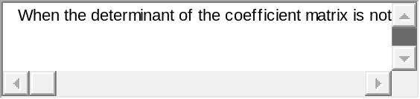

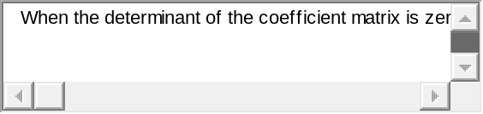 true
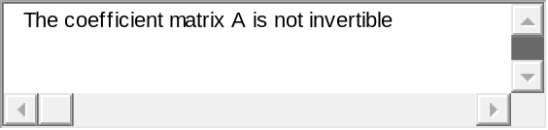

Quiz Start Time: 05:46 PM
  Time Left | 74  sec(s)

Question # 6 of 10 ( Start time: 05:50:21 PM )
All the lines those passes through origin are not the subspace of a plane.
Select correct option:
true

Quiz Start Time: 05:46 PM
  Time Left | 79  sec(s)

Question # 7 of 10 ( Start time: 05:50:55 PM )
A matrix A and its transpose have the same determinant.
Select correct option:
true

Quiz Start Time: 05:46 PM
  Time Left | 83  sec(s)

Question # 8 of 10 ( Start time: 05:51:08 PM )
Cramer’s rule is a formula for solving systems of equations by __________.
Select correct option:
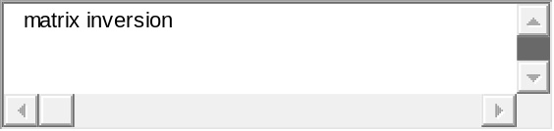
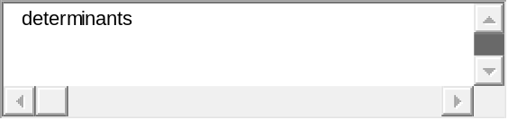 true
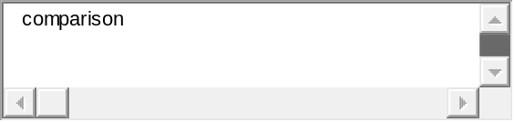
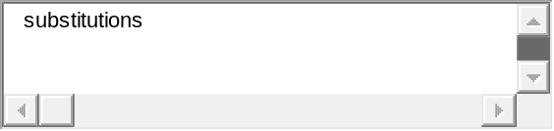

Quiz Start Time: 05:46 PM
  Time Left | 83  sec(s)

Question # 9 of 10 ( Start time: 05:51:30 PM )
If a system of equations is solved using the Jacobi’s method , then which of the following is the most appropriate answer about the matrix M that is derived from the coefficient matrix ?
Select correct option:

Quiz Start Time: 05:46 PM
  Time Left | 87  sec(s)

Question # 10 of 10 ( Start time: 05:52:59 PM )
Which of the following is all permutations of {1,2}?
Select correct option:
true

Consider a system of linear equations A x =b where A is a3 ×3 matrix having 3 pivot positions, then which
statement is false about the system Ax =b
(a) System has unique solution.
(b) Rank of the matrix is 3.
(c) There is only one free variable in solution of that system.
(d) The associated homogeneous system Ax =0 has only trivial system.

If a finite set S of non zero vectors span a vector space V, then some subset of S is a basis for V.
1. True
2. false

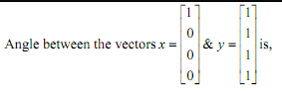
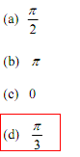

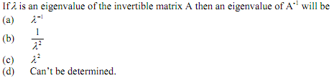
D

If rank of a3 x 5 matrix is 3 then dimension of its Null space is
(a) 0
(b) 3
(c) 2
(d) We can’t say anything

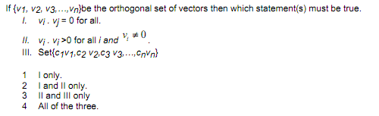
1

If matrix A has zero as an eigenvalue then which statement(s) about A must be true.
I. Matrix A is not invertible.
II. Matrix A will also have an eigenvalue 2.
III. Matrix is diagonalizable.

1 II and III only.
2 I only. (true)
3 II and III only.
4 All three.

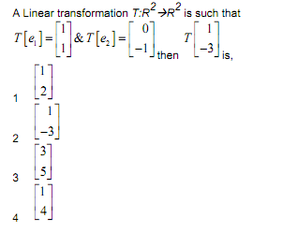

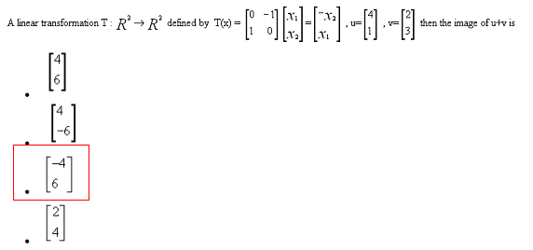

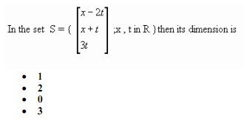
- 1
- 2
- 0
- 3

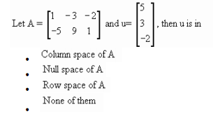

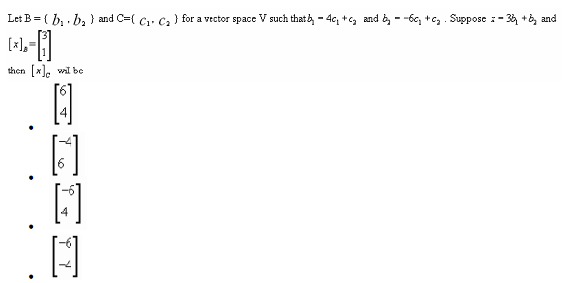

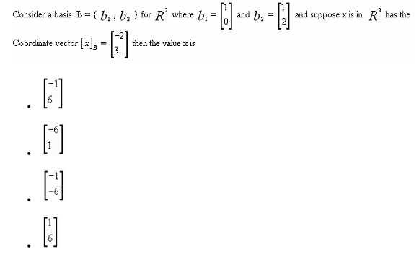

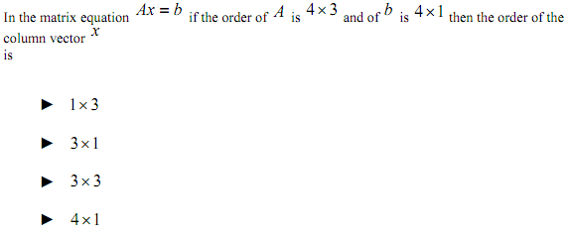
1 x 3
3 x 1
3 x 3
4 x 1

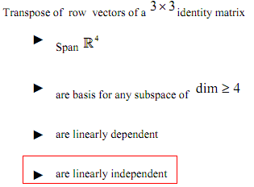

Determinant of a non-invertible(singular) matrix always

► vanish
► unity

► non zero negative

► non zero positive

Rank of a zero matrix of any order is
► zero

► three

► four

► nine

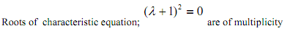
► Zero

► One

► Two

► Three

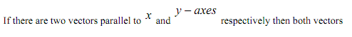
► Are orthogonal

►Having their inner product zero

► Can span a subspace while both passing through the origin

► All above statements are equivalent

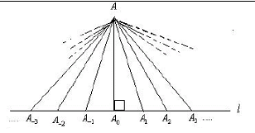

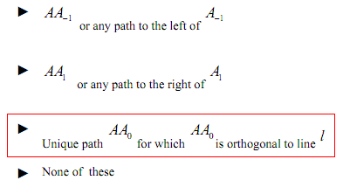

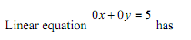
► Infinite many solutions

► Empty solution

► Unique, non-trivial solution

► Unique, trivial solution

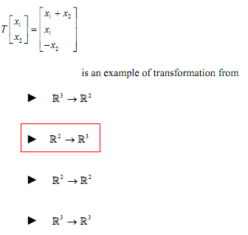

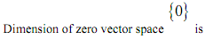
► Not defined

►One

► Zero

► Arbitrary

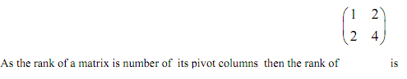

► 4

► 2

► 1
► Inconclusive

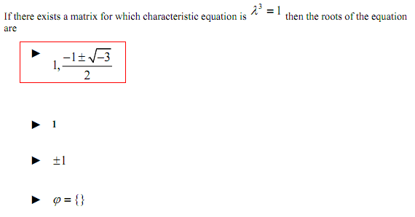

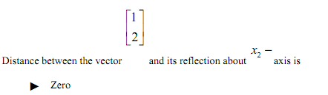
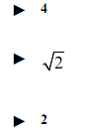

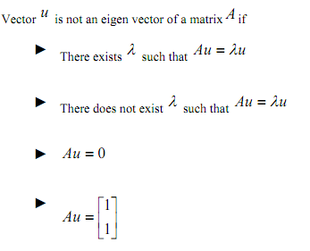

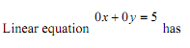
► Infinite many solutions

► Empty solution

► Unique, non-trivial solution

► Unique, trivial solution

Question No: 1 ( Marks: 2 ) - Please choose one
The characteristics polynomial for the matrix A= is
►

►

►

►

Question No: 2 ( Marks: 2 ) - Please choose one
Let A=PA then what will be where A= , D=
 | ►
 | ►
 | ►
 | ► | None of the other

Question No: 3 ( Marks: 2 ) - Please choose one
The origin of the dynamical system =A for the matrix A= is

 | ► | Attractor
 | ► | Repellor
 | ► | Saddle point
 | ► | None of them

Question No: 4 ( Marks: 2 ) - Please choose one
The distance between the vectors u=(7,1) and v=(3,2)is

►

►

►

►

Question No: 5 ( Marks: 2 ) - Please choose one
The vectors , , are
 | ► | Parallel
 | ► | Orthogonal
 | ► | Not Orthogonal
 | ► | Not parallel

Question No: 1 ( Marks: 1 ) - Please choose one

Reduced echelon form of the matrix is

►

►

►

►

Question No: 2 ( Marks: 1 ) - Please choose one

A matrix that results from applying a single elementary row operation to an identity matrix is called

► Invertible matrix

► Singular matrix

► Scalar matrix

► Elementary matrix

Question No: 3 ( Marks: 1 ) - Please choose one

For an n×n matrix (A^{t})^{t} =

► A^{t}

► A

► A⁻¹

► (A⁻¹)⁻¹

Question No: 4 ( Marks: 1 ) - Please choose one

What is the largest possible number of pivots a 4×6 matrix can have?

► 4 (true)

► 6

► 10

► 0

Question No: 5 ( Marks: 1 ) - Please choose one

The characteristic polynomial of a 5×5 matrix is ,the eigenvalues are

► 0,-5, 9

► 0,0,0,5,9

► 0,0,0,-5,9 (true)

► 0,0,5,-9

Question No: 6 ( Marks: 1 ) - Please choose one

Find the characteristic equation of the given matrix

►

►

►

►

Question No: 7 ( Marks: 1 ) - Please choose one

A is diagonalizable if Where

► D is any matrix and P is an invertible matrix

► D is a diagonal matrix and P is any matrix

► D is a diagonal matrix and P is invertible matrix

► D is a invertible matrix and P is any matrix

Question No: 8 ( Marks: 1 ) - Please choose one

The inverse of an invertible lower triangular matrix is

► lower triangular matrix

► upper triangular matrix

► diagonal matrix

Question No: 9 ( Marks: 1 ) - Please choose one

If P is a parallelepiped in R³, then
{volume of T (P)} = |detA|. {volume of P}

► Where T is determined by a matrix A

► Where T is determined by a matrix A

► Where T is determined by a matrix A

► Where T is determined by a matrix A

Question No: 10 ( Marks: 1 ) - Please choose one

Let A be a matrix of rank then row space of A has dimension

►

►

►

►

Question No: 11 ( Marks: 1 ) - Please choose one

The dimension of the vector space is

► 4

► 3

► 5

► 1

Question No: 12 ( Marks: 1 ) - Please choose one

Let .For the weighted Euclidean inner product

► 2

► -2

► 3

► -3

Question No: 13 ( Marks: 1 ) - Please choose one

Let A be matrix whose entries are real. If is an eigenvalue of A with x a corresponding eigenvector in , then

►

►

►

►

Question No: 14 ( Marks: 1 ) - Please choose one

Suppose that has eigenvalues 2 and 0.5 .Then origin is a

► Saddle point

► Repellor

► Attractor

Question No: 15 ( Marks: 1 ) - Please choose one

Which one is the numerical method used for approximation of dominant eigenvalue of a matrix.

► Power method

► Jacobi’s method

► Guass Seidal method

► Gram Schmidt process

Question No: 16 ( Marks: 1 ) - Please choose one

The matrix equation represents a system of linear equations commonly referred to as the

► normal equations for

► normal equations for

► normal equations for

► normal equations for

Question No: 17 ( Marks: 1 ) - Please choose one

Let have eigenvalues 2, 5, 0,-7, and -2. Then the dominant eigenvalue for A is

►

►

►

►

Question No: 18 ( Marks: 1 ) - Please choose one

If W is a subspace of , then the transformation that maps each vector x in into its orthogonal x in W is called the orthogonal projection of

► in

► in W

► in x

Question No: 19 ( Marks: 1 ) - Please choose one

If 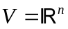 ,and 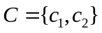then row reduction of 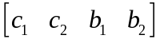 to 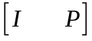
Produces a matrix P that satisfies

► 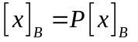for all x in V

► 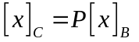for all x in V

► 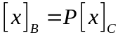for all x in V

► 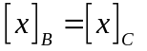for all x in V

Question No: 20 ( Marks: 1 ) - Please choose one

The Casorati matrix for the signals 1^{k}, (-2)^{k} and 3^{k} is

► 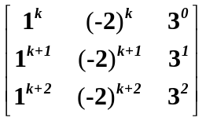

► 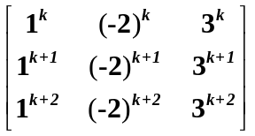

► 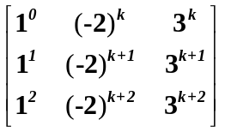

Which statement about the set S is false where S = {(1, 1, 3), (2, 3, 7),(2, 2, 6)}
(a) The set S contain an element which is solution of the equation 5x – y- z = 0
(b) The Set S is linearly independent.
(c) The set S contain two elements which are multiple of each other.
(d) The Set S is linearly dependent.

How many subspaces R2 have?
(a) only two: {0} and R2
(b) Only four: {0} x- axis and y -axis and R2
(c) Infinitely many.
(d) None of the above.

The set of vectors {(5,0,0), (7,2,-6), (9,4,-8)} is,
􀂾 a) Linearly independent
􀂾 b) Linearly dependent
􀂾 c) Basis of R³
Question No: 1 ( Marks: 1 ) - Please choose one
If A is a 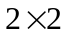 matrix, the area of the parallelogram determined by the columns of A is

► 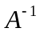
► det A

► adj A

Question No: 2 ( Marks: 1 ) - Please choose one
Cramer’s rule leads easily to a general formula for

► the inverse of an matrix A

► the adjugate of an matrix A

► the determinant of an matrix A

Question No: 3 ( Marks: 1 ) - Please choose one
The transpose of an lower triangular matrix is

► lower triangular matrix
► upper triangular matrix

► diagonal matrix

Question No: 4 ( Marks: 1 ) - Please choose one
The transpose of an upper triangular matrix is

► lower triangular matrix
► upper triangular matrix

► diagonal matrix

Question No: 5 ( Marks: 1 ) - Please choose one
Let A be a square matrix of order 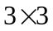 with 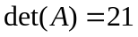, then 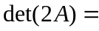

► 168
► 186
► 21
► 126

Question No: 6 ( Marks: 1 ) - Please choose one
A basis is a linearly independent set that is as large as possible.

► True
► False

Question No: 7 ( Marks: 1 ) - Please choose one
Let A be an matrix. If for each b in 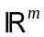 the equation Ax=b has a solution then

► A has pivot position in only one row (may be this option is true)

► Columns of A span
► Rows of A span

Question No: 8 ( Marks: 1 ) - Please choose one
Reduced echelon form of the matrix is

►
►
► 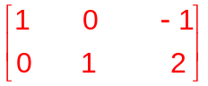
►

Question No: 22 ( Marks: 3 )
find that is invertible or not T(X₁,X₂)=T(6X₁ +8X₂ , 5X₁ -8X₂)

Question No: 23 ( Marks: 3 )
Find the volume of parallelogram of the vertices (1,2,4) (2,4,-7) and (-1,-3,20

Question No: 24 ( Marks: 2 )
Which of the following is true? If V is a vector space over the field F.(justify your answer)

(a) 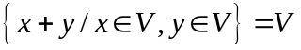
(b) 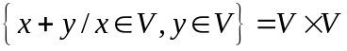
(c) 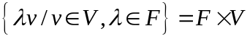

Question No: 25 ( Marks: 5 )
Let 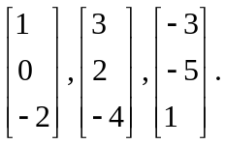 is this in R³ or not?

Question No: 26 ( Marks: 5 )
Justify that A²=I if A=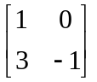, if and only M²=I. justify your answer by portioned matrix of M
M=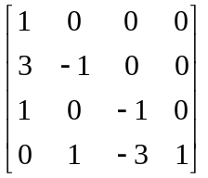
Question No: 1 ( Marks: 1 ) - Please choose one
If A is a matrix, the area of the parallelogram determined by the columns of A is

►
► det A

► adj A

Question No: 2 ( Marks: 1 ) - Please choose one
Cramer’s rule leads easily to a general formula for

► the inverse of an matrix A

► the adjugate of an matrix A

► the determinant of an matrix A

Question No: 3 ( Marks: 1 ) - Please choose one
The transpose of an upper triangular matrix is

► lower triangular matrix
► upper triangular matrix

► diagonal matrix

Question No: 4 ( Marks: 1 ) - Please choose one
Let A be a square matrix of order with , then

► 168
► 186
► 21
► 126

Question No: 5 ( Marks: 1 ) - Please choose one
A basis is a linearly independent set that is as large as possible.

► True
► False

Question No: 6 ( Marks: 1 ) - Please choose one
Col A is all of if and only if

► the equation 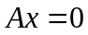has a solution for each b in

► the equation 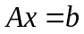has a solution for each b in
► the equation has a solution for a fixed b in .

Question No: 7 ( Marks: 1 ) - Please choose one
If 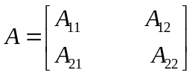and 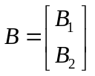, then the partitions of A and B

► are not conformable for block multiplication

► are conformable for AB block multiplication

► are not conformable for BA block multiplication

Question No: 8 ( Marks: 1 ) - Please choose one
Two vectors are linearly dependent if and only if they lie

► on a line parallel to x-axis

► on a line through origin

► on a line parallel to y-axis

Question No: 9 ( Marks: 1 ) - Please choose one
The equation x = p + t v describes a line

► through v parallel to p

► through p parallel to v
► through origin parallel to p

Question No: 10 ( Marks: 1 ) - Please choose one
Let A be an matrix. If for each b in the equation Ax=b has a solution then

► A has pivot position in only one row

► Columns of A span
► Rows of A span

Question No: 11 ( Marks: 1 ) - Please choose one
Given the system 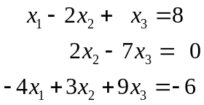 the augmented matrix for the system is

► 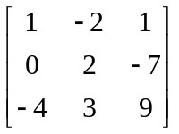
► 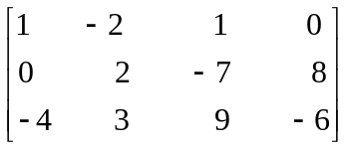
► 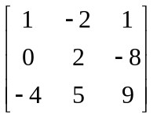
► 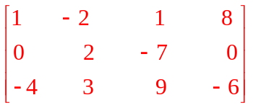

Question No: 12 ( Marks: 1 ) - Please choose one
Consider the linear transformation T such that 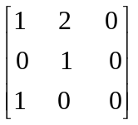is the matrix of linear transformation then T 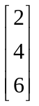 is

► 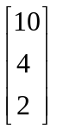
► 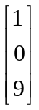
► 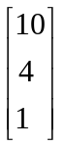
► 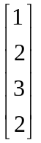

Question No: 13 ( Marks: 1 ) - Please choose one
If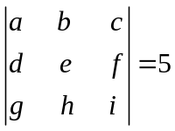then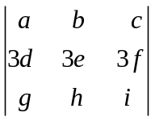will be

► 15
► 45
► 135
► 60

Question No: 14 ( Marks: 1 ) - Please choose one
For an n×n matrix (A^{t})^{t} =

► A^{t}

► A

► A⁻¹

► (A⁻¹)⁻¹

Question No: 15 ( Marks: 1 ) - Please choose one
Each Linear Transformation T from R^{n} to R^{m} is equivalent to multiplication by a matrix A of order

► m´n

► n´m

► n´n

► m´m

Question No: 16 ( Marks: 1 ) - Please choose one
Reduced echelon form of the matrix is

►
►
►
►

Question No: 17 ( Marks: 2 )
Find vector and parametric equations of the plane that passes through the origin of R³ and is parallel to the vectors v₁ = (1, 2, 5) and v₂ = (5, 0, 4).

Question No: 18 ( Marks: 2 )
Which of the following is true? If V is a vector space over the field F.(justify your answer)

(a)
(b)
(c)

Question No: 19 ( Marks: 3 )
Let 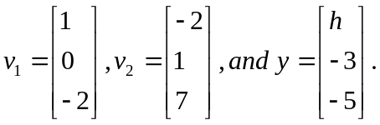 For what value(s) of h is y in the plane generated by v₁ and v₂?

Question No: 20 ( Marks: 5 )
With T defined by T(x)= Ax , find a vector x whose image under T is b, and determine whether x is unique.
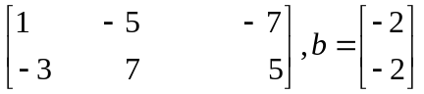

Question No: 21 ( Marks: 10 )
Given A and b , write the augmented matrix for the linear system that corresponds to the matrix equation 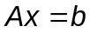 .Then solve the system and write the solution as a vector.

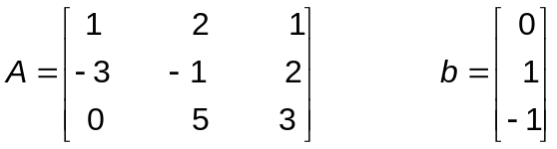

Question No: 1 ( Marks: 1 ) - Please choose one
If for a linear transformation the equation T(x)=0 has only the trivial solution then T is

► one-to-one
► onto

Question No: 2 ( Marks: 1 ) - Please choose one
Which one of the following is an elementary matrix?

► 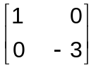
► 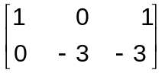
► 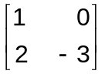
► 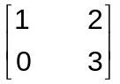

Question No: 3 ( Marks: 1 ) - Please choose one
Let 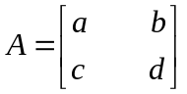and let k be a scalar .A formula that relates det kA to k and det A is

► det kA= k det A

► det kA = det (k+A)

► det k A = k² det A

► det kA = det A

Question No: 4 ( Marks: 1 ) - Please choose one
The equation x = p + t v describes a line

► through v parallel to p

► through p parallel to v
► through origin parallel to p

Question No: 5 ( Marks: 1 ) - Please choose one
Determine which of the following sets of vectors are linearly dependent.

► 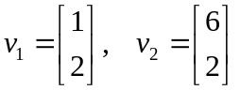
► 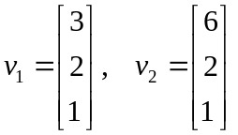
► 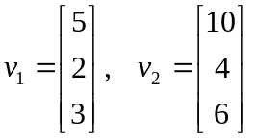

Question No: 6 ( Marks: 1 ) - Please choose one
Every linear transformation is a matrix transformation

► True
► False

Question No: 7 ( Marks: 1 ) - Please choose one
A null space is a vector space.

► True
► False

Question No: 8 ( Marks: 1 ) - Please choose one
If two row interchanges are made in succession, then the new determinant

► equals to the old determinant

► equals to -1 times the old determinant

Question No: 9 ( Marks: 1 ) - Please choose one
The determinant of A is the product of the pivots in any echelon form U of A , multiplied by (-1)^{r} , Where r is

► the number of rows of A

► the number of row interchanges made during row reduction from A to U
► the number of rows of U

► the number of row interchanges made during row reduction U to A

Question No: 10 ( Marks: 1 ) - Please choose one
If A is invertible, then det(A)det(A⁻¹)=1.

► True
► False

Question No: 11 ( Marks: 1 ) - Please choose one
A square matrix 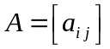 is lower triangular if and only if 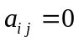 for

► 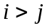
► 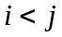
► 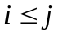
► 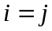

Question No: 12 ( Marks: 1 ) - Please choose one
The product of upper triangular matrices is

► lower triangular matrix

► upper triangular matrix
► diagonal matrix

Question No: 13 ( Marks: 1 ) - Please choose one
The matrix multiplication is associative
► True
► False

Question No: 14 ( Marks: 1 ) - Please choose one
We can add the matrices of ______________.
► same order
► same number of columns.
► same number of rows
► different order

Question No: 15 ( Marks: 1 ) - Please choose one
By solving system of equations with iterative method, we stop the process when the entries in two successive iterations are ________.
► repeat
► large difference
► different

Question No: 16 ( Marks: 1 ) - Please choose one
Jacobi’s Method is ____________ converges to solution than Gauss Siedal Method.
► slow
► fast
► better

Question No: 17 ( Marks: 1 ) - Please choose one
A system of linear equations is said to be homogeneous if it can be written in the form ______________.

► AX = B
► AX = 0
► AB = X
► X = A⁻¹

Question No: 18 ( Marks: 1 ) - Please choose one
The row reduction algorithm applies only to augmented matrices for a linear system.

► True
► False

Question No: 19 ( Marks: 1 ) - Please choose one
Whenever a system has no free variable, the solution set contains many solutions.

► True
► False

Question No: 20 ( Marks: 1 ) - Please choose one
Which of the following is not a linear equation?

► 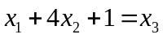
► 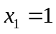
► 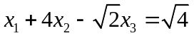
► 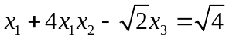

Question No: 21 ( Marks: 2 )
If a square idempotent matrix A is non singular then show that A is equal to the identity matrix I.

Question No: 22 ( Marks: 2 )
Let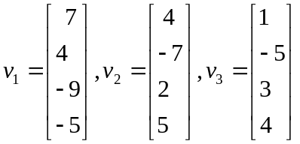, and 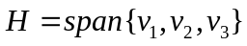.It can be verified that 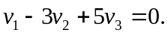Use this information to find a basis for H.

Question No: 23 ( Marks: 3 )
Find 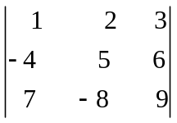

Question No: 24 ( Marks: 3 )
Determine bases for the plane 3x – 2y + 5z = 0 as a subspace of R³

Question No: 25 ( Marks: 5 )
Show that 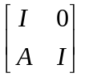 is invertible and find its inverse.

Question No: 26 ( Marks: 5 )
Find the condition for r and s such that the vectors 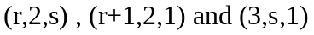 are linear dependent.

Matrix [] is an example of
► Non-Singular matrix
► Square matrix
► Column vector
► Row vector

Standard matrix for transformation T(x1, x2 ) = (−x1 + x2 , x1 − x2 )is

- None of these

Matrix is singular if

► Ad=bc
► ad ≠ bc
► ad − bc = 1
► None of these

$$ Quiz….

All the lines those passes through origin are not the subspace of a plane.
Select correct option:
 | 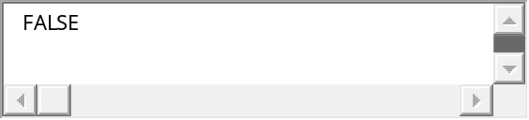 correct
 | 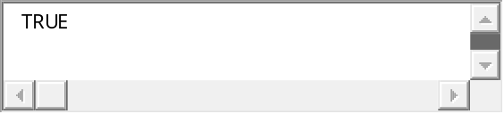





Quiz Start Time: 09:54 PM
  Time Left | 17  sec(s)

Question # 2 of 10 ( Start time: 09:55:53 PM ) | Total Marks: 1
If a system of equations is solved using the Gauss-Seidel method, then which of the following is the most appropriate answer about the matrix M that is derived from the coefficient matrix ?
Select correct option:
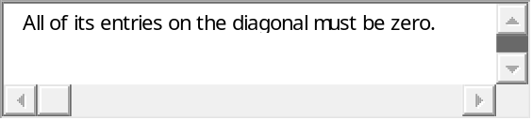
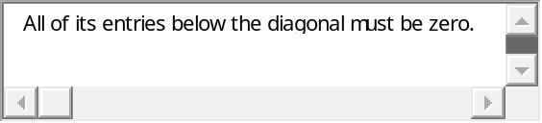
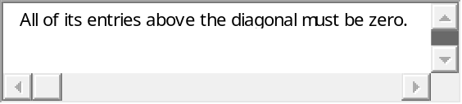 correct
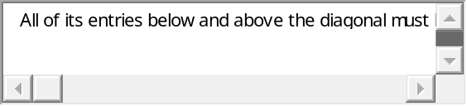

Why inverse of the matrix A= [1 2] is NOT possible?
Select correct option:



 correct

Let W = {(1, y) such that y in R}. Is W a vector subspace of plane.
Select correct option:
 | 
 | 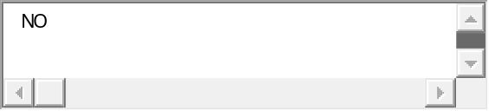 correct


Quiz Start Time: 09:54 PM
  Time Left | 7  sec(s)

Question # 5 of 10 ( Start time: 10:00:20 PM ) | Total Marks: 1
If M is a square matrix having two rows equal then which of the following about the determinant of the matrix is true?
Select correct option:
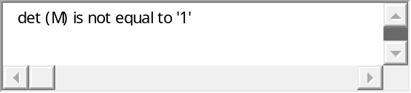
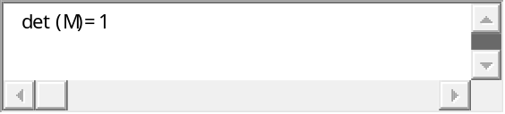
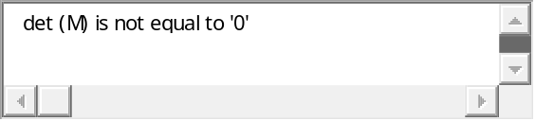
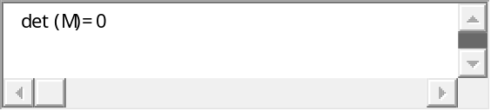 correct


Quiz Start Time: 09:54 PM
  Time Left | 12  sec(s)

Question # 6 of 10 ( Start time: 10:01:48 PM ) | Total Marks: 1
If a system of equations is solved using the Jacobi’s method , then which of the following is the most appropriate answer about the matrix M that is derived from the coefficient matrix ?
Select correct option:
correct

Which of the following is the volume of the parallelepiped determined by the columns of A where A is a 3 x 3 matrix?
Select correct option:
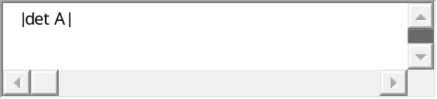 correct
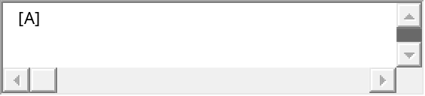
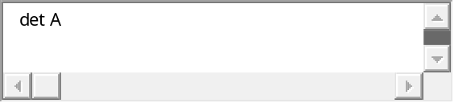
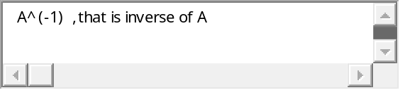

If all the entries of a row or a column of a square matrix are zero, then det (A) will be _____________.
Select correct option:
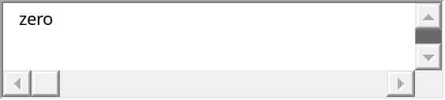 correct

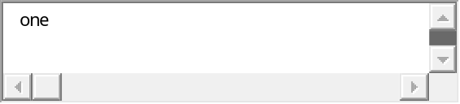
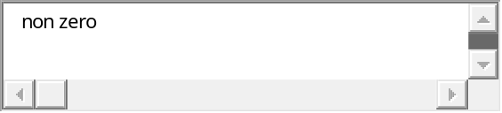

If both the Jacobi and Gauss-Seidel sequences converge for the solution of Ax=b, for any initial x(0), then which of the following is true about both the solutions?
Select correct option:

 correct
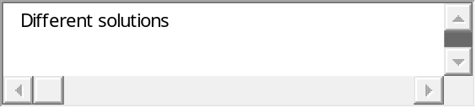


How many different permutations are there in the set of integers {1,2,3}?
Select correct option:
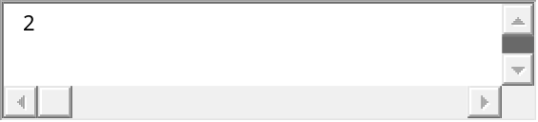
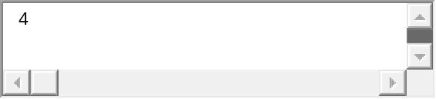
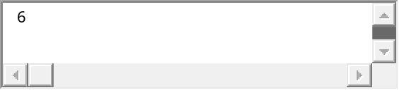
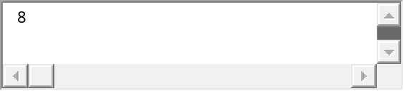 correct

LATEST 9th Dec 2011 Paper:
Q=26 Let w be the set of all vectors of the form 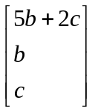,where ‘ b’ and ‘c’ are arbitrary scalars.show that w is a subspace of R³.
SOLUTION:
W is a subspace of R³ as
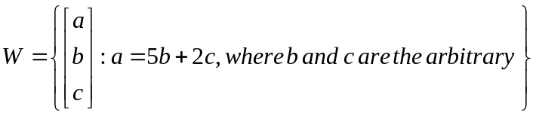
Reference to the scalars b and c “arbitrary” means that the scalars can be any real numbers.

Q=25 compute AB using block multiplication ,where 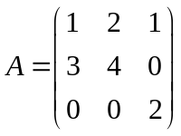 and
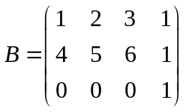
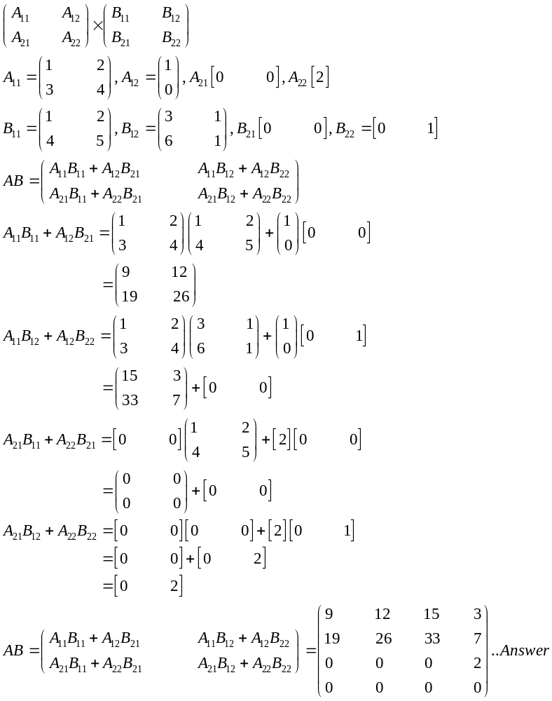

Q =24 let W be the set of all vectors of the form 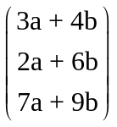 , where ‘a’ and ‘b’ are arbitrary scalars.find the vectors 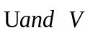such that w= span (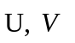) ……3 marks
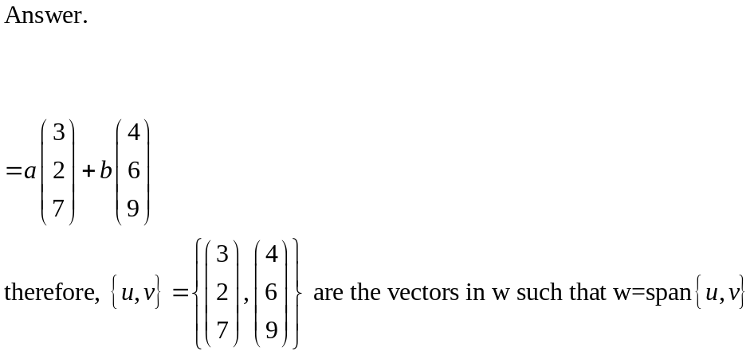

Q=23 find the increase of the matrix. 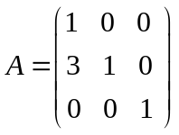 using the inversion algorithm…..3marks
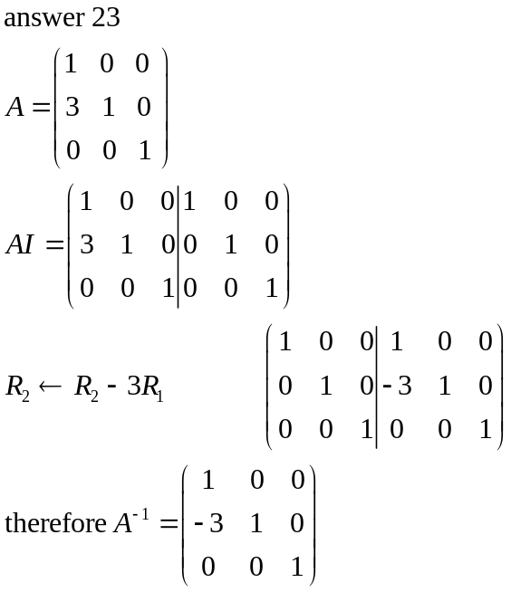

Q=22 = determine whether the set v = {(x,y,z)| x,y,z R and x,y =11} is a subspace of R³ or not….2
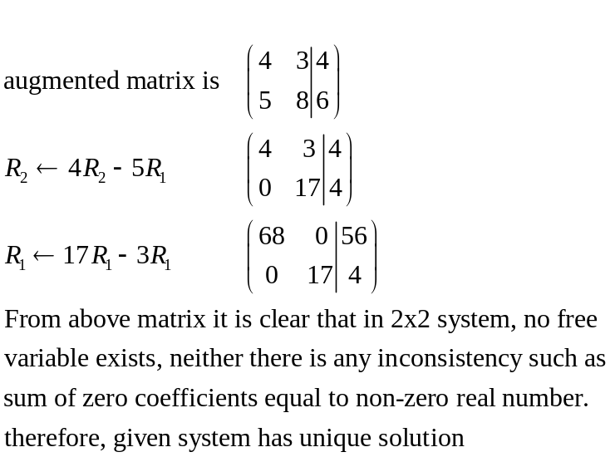

Q=21 show that the following system of linear equations has unique solutions.
4x₁ +3x₂ = 4
5x₁ +8x₂ = 6


Quiz Start Time: 11:11 PM
  Time Left | 9  sec(s)

Question # 1 of 10 ( Start time: 11:11:37 PM ) | Total Marks: 1
Let t be any m x n matrix with orthonormal columns and v be any vector then ||t . v || = _____.
Select correct option:
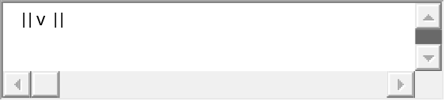
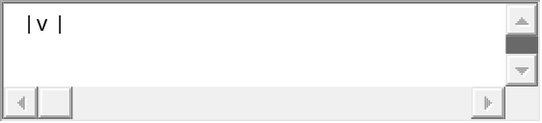 Correct
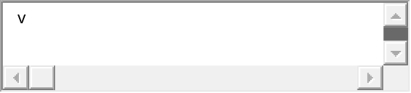
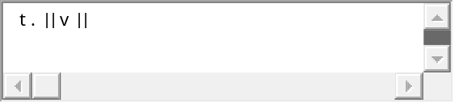




Quiz Start Time: 11:11 PM
  Time Left | 69  sec(s)

Question # 3 of 10 ( Start time: 11:14:36 PM ) | Total Marks: 1
If the augmented matrices of two linear systems are row equivalent, then the two systems have the same solution set.
Select correct option:
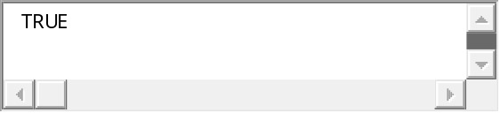 Correct
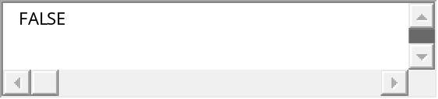


Quiz Start Time: 11:11 PM
  Time Left | 19  sec(s)

Question # 4 of 10 ( Start time: 11:15:21 PM ) | Total Marks: 1
If A^2 (A square) is the _____, then the only eigen value of A is zero.
Select correct option:
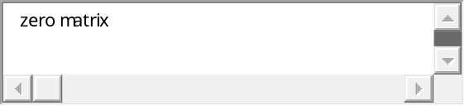 Correct
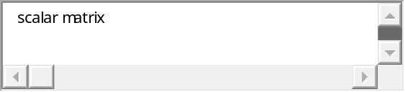
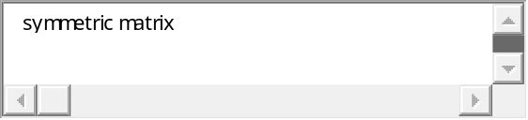


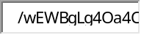
Quiz Start Time: 11:11 PM
  Time Left | 9  sec(s)

Question # 5 of 10 ( Start time: 11:16:45 PM ) | Total Marks: 1
Let t be any m x n matrix with orthonormal columns and v be any vector then ||t . v || = t . || v ||.
Select correct option:
Correct

If a square matrix has orthonormal columns, then it also has ______ rows.
Select correct option:
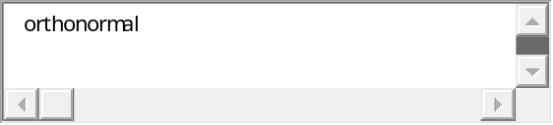 Correct
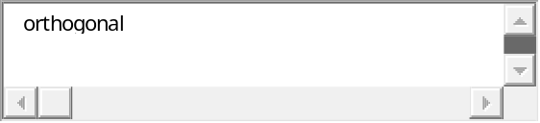

If x is _______ to both u and v, then x must be orthogonal to u – v.
Select correct option:
Correct

If a _____ matrix has orthonormal columns, then it also has orthonormal rows.
Select correct option:
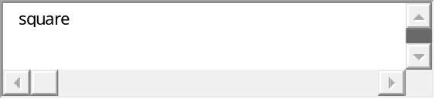 Correct
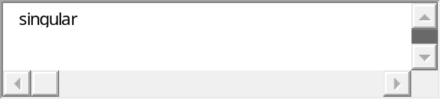
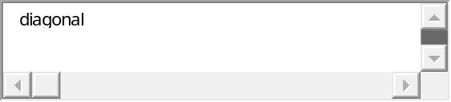
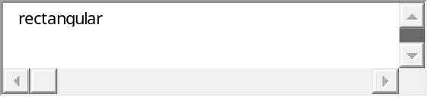

For any vectors u and v, the length of vector u – v will be || u – v ||.
Select correct option:
Correct

n x n matrix A is invertible if and only if ___________ is not an eigen value of A.
Select correct option:
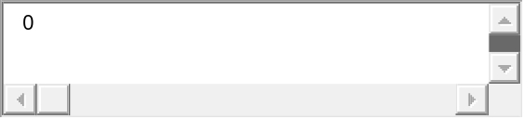Correct
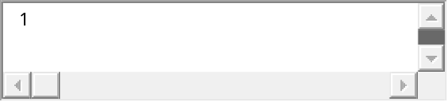
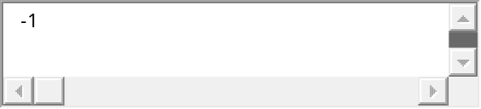
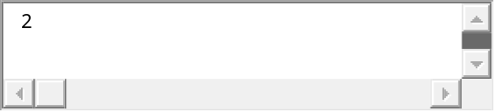

1. If w is the orthogonal projection of a vector v in R^n onto a subspace W of

R^n then w is orthogonal to v

False

========

2. Let W be a subspace of R^n and v be a vector in R^n. Among all vectors in W,

+
the vector closet to v is the orthogonal projection of v onto W

False

=========

3. The set of all vectors in R^n orthogonal to one fixed vector is a subspace

of R^n

True

================
+
4. If W is a subspace of R^n, then W and W have no vectors in common

False

=========

5. If a square matrix has orthonormal columns, then it also has orthonormal rows

True

