MTH603
Assignment#2

Question No. 1: Consider the following table of values
x | 2 | 4 | 6 | 8 | 10 | 12 | 14
F(x) | 23 | 93 | 259 | 559 | 1031 | 1713 | 2643

Use Newton’s backwards difference formula to compute f (11) with and p = 0.5

Solution
x | Y=fx | 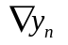 | 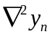 | 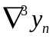 | 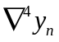 | 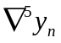 | 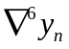
2 | 23
4 | 93 | 70
6 | 259 | 166 | 96
8 | 559 | 300 | 134 | 38
10 | 1031 | 472 | 172 | 38 | 0
12 | 1713 | 682 | 210 | 38 | 0 | 0
14 | 2643 | 930 | 248 | 38 | 0 | 0 | 0

Newton’s backwards Formula
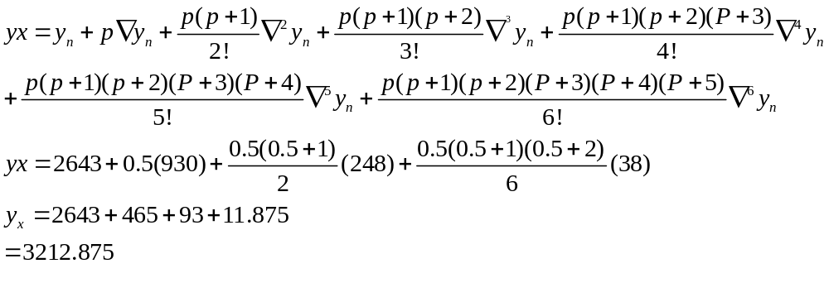

Question No. 2: Find Newton’s forward difference table from the following data.
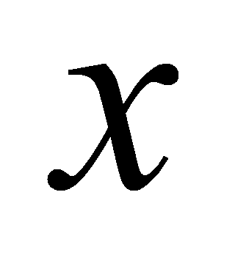 | 0.0 | 0.1 | 0.2 | 0.3 | 0.4
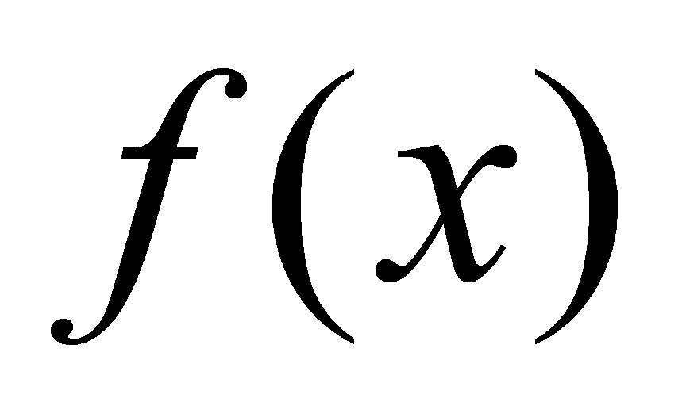 | 1 | 0.9048 | 0.8187 | 0.6408 | 0.4703

Solution:

x | Y=fx
0.0 | 1
0.1 | 0.9048 | -0.0952
0,2 | 0.8187 | -0.0861 | -0.0091
0.3 | 0.6408 | -0.1779 | -0.0918 | -0.0827
0.4 | 0.4703 | -0.1705 | -0.0074 | -0.0844 | -0.0017



