Assignment Of MTH301(Fall 2021)

Maximum Marks: 10
Due Date:13 -12-2021

DON’T MISS THESE: Important instructions before attempting the solution of this assignment:
• To solve this assignment, you should have good command over 01 - 10 lectures.
- Try to get the concepts, consolidate your concepts and ideas from these questions which you learn in the 1 to 10 lectures.
• Upload assignments properly through LMS, No Assignment will be accepted through email.
• Write your ID on the top of your solution file.
- Don’t use colorful back grounds in your solution files.
- Use Math Type or Equation Editor etc for mathematical symbols.
- You should remember that if we found the solution files of some students are same then we will reward zero marks to all those students.
- Try to make solution by yourself and protect your work from other students, otherwise you and the student who send same solution file as you will be given zero marks.
- Also remember that you are supposed to submit your assignment in Word format any other like scan images etc will not be accepted and we will give zero marks correspond to these assignments.

Question No. 1: Marks 08

Determine whether 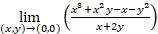 exist or not along the straight line
and the parabola .
Solution:
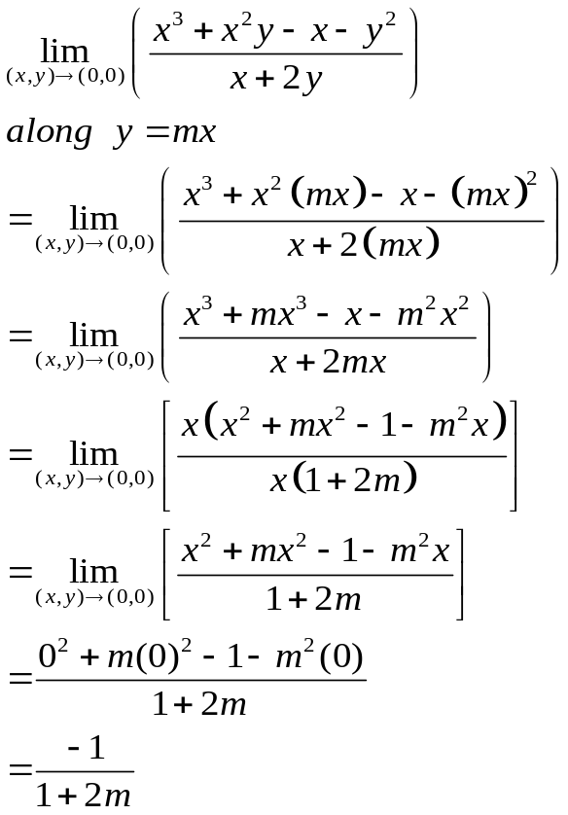
Now again
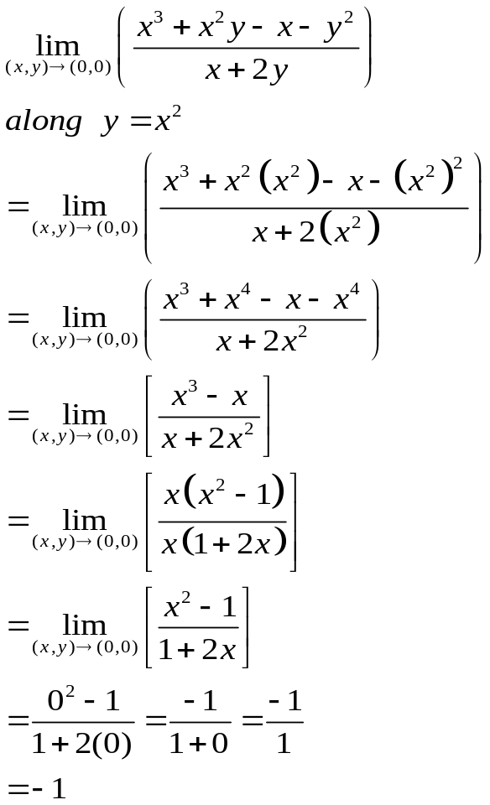
As in first case along y=mx, the value of limit depends upon the value of m. We can say that value of limit is not same along different paths so limit does not exist.

Question No. 2: Marks 02

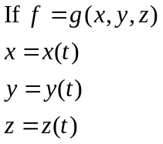
State the chain rule for derivative of f with respect to t.
Solution:


