http://vustudents.ning.com

Suppose 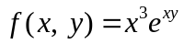. Which one of the following is correct?

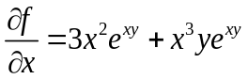
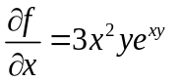
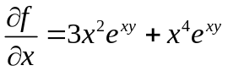
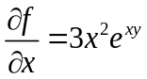

Let R be a closed region in two dimensional space. What does the double integral over R calculates?
Area of R.
Radius of inscribed circle in R.
Distance between two endpoints of R.
None of these

What is the distance between points (3, 2, 4) and (6, 10, -1)?
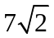
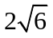
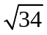
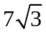

-------------------- planes intersect at right angle to form three dimensional space.
Three
4
8
12

There is one-to-one correspondence between the set of points on co-ordinate line and ------------
Set of real numbers
Set of integers
Set of natural numbers
Set of rational numbers

http://vustudents.ning.com

Let the function 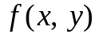 has continuous second-order partial derivatives 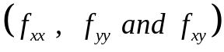 in some circle centered at a critical point 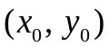and let 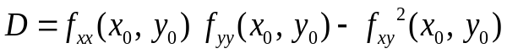

If 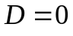 then ---------------

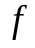 has relative maximum at

has relative minimum at
has saddle point at
No conclusion can be drawn.

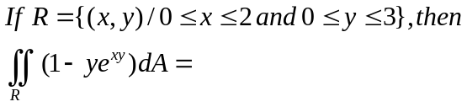

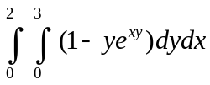
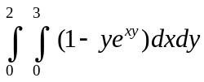
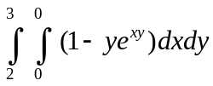
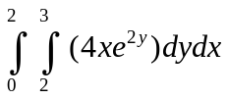

Suppose . Which one of the following is true?

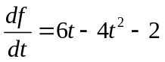
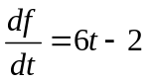
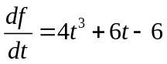
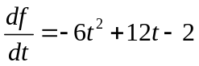
Let , and be unit vectors in the direction of x-axis, y-axis and z-axis respectively. Suppose that 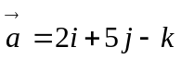. What is the magnitude of vector ?

6
30
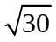
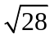

A straight line is --------------- geometric figure.
One-dimensional
Two-dimensional
Three-dimensional
Dimensionless

http://vustudents.ning.com

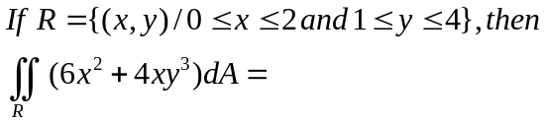

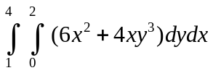
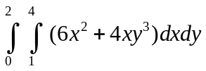
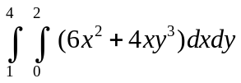
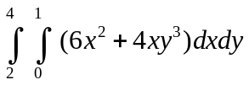

Which of the following formula can be used to find the Volume of a parallelepiped with adjacent edges formed by the vectors 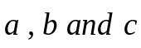?
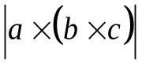
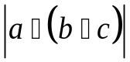
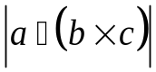
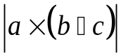

The function 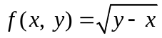 is continuous in the region --------- and discontinuous elsewhere.

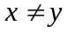
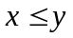
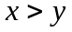

What is the relation between the direction of gradient at any point on the surface to the tangent plane at that point ?
parallel
perpendicular
opposite direction
No relation between them.

Suppose . Which one of the statements is correct?
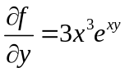

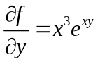
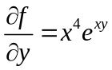
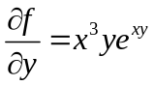

Two surfaces are said to intersect orthogonally if their normals at every point common to them are ----------
perpendicular
parallel
in opposite direction

http://vustudents.ning.com

Let the function has continuous second-order partial derivatives in some circle centered at a critical point and let

If 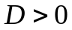 and 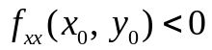 then 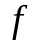 has ---------------

Relative maximum at
Relative minimum at
Saddle point at
No conclusion can be drawn.

http://vustudents.ning.com

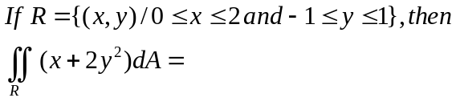
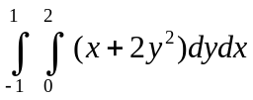

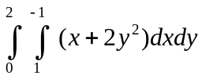
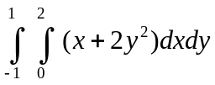
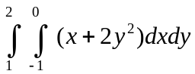

If 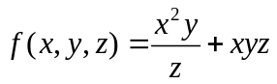
then what is the value of 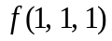?

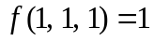
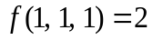
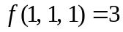
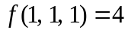

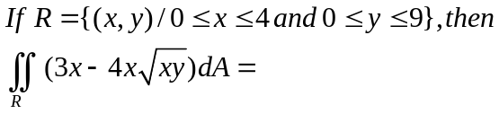

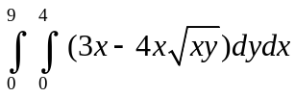
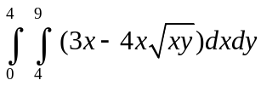
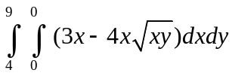
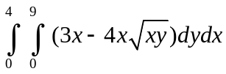

Q- 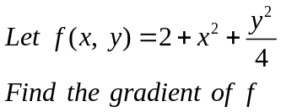
2MARKS

Q - Let the function 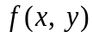is continuous in the region R, where R is a rectangle as shown below.
complete the following equation
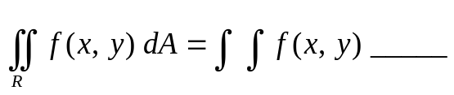
2MARKS

Q.Find all critical points of the function
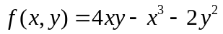

Evaluate 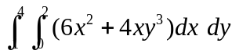

Q-Evaluate the following double integral.
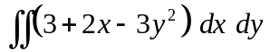
3MARKS

Q- Let 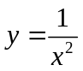. If changes from 3 to 3.3, find the approximate change in the value of y using differential dy.
3MARKS

http://vustudents.ning.com

