WWW.VUSR.NET
MIDTERM EXAMINATION
Spring 2010
MTH301- Calculus II (Session - 3)
Time: 60 min
Marks: 40
Student Info
StudentID:
Center: | OPKST
ExamDate: | 6/3/2010 12:00:00 AM

For Teacher's Use Only
Q No. | 1 | 2 | 3 | 4 | 5 | 6 | 7 | 8 | Total
Marks
Q No. | 9 | 10 | 11 | 12 | 13 | 14 | 15 | 16
Marks
Q No. | 17 | 18 | 19 | 20 | 21 | 22 | 23 | 24
Marks
Q No. | 25 | 26
Marks

Question No: 1 ( Marks: 1 ) - Please choose one
Which of the following number is associated to each point on a co-ordinate line?
► An integer
► A real number
► A rational number
► A natural number

Question No: 2 ( Marks: 1 ) - Please choose one
If 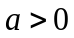, then the parabola 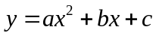opens in which of the following direction?
► Positive - direction 
► Negative - direction
► Positive - direction
► Negative - direction

Question No: 3 ( Marks: 1 ) - Please choose one
Rectangular co-ordinate of a point is 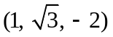. What is its spherical co-ordinate?
       ► 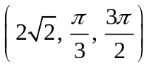
       ► 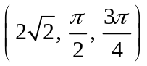
       ► 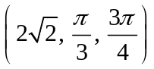
       ► 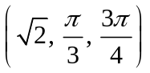

Question No: 4 ( Marks: 1 ) - Please choose one
If a function is not defined at some point, then its limit ----------- exist at that point.

       ► Always
       ► Never
       ► May

Question No: 5 ( Marks: 1 ) - Please choose one
Suppose 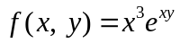. Which one of the statements is correct?

       ► 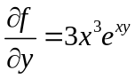
       ► 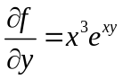
       ► 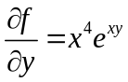
       ► 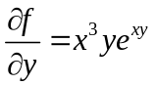

Question No: 6 ( Marks: 1 ) - Please choose one
If 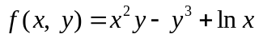
then 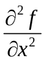=

       ► 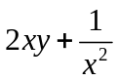
       ► 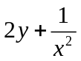
       ► 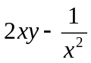
       ► 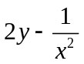

Question No: 7 ( Marks: 1 ) - Please choose one
Suppose . Which one of the following is true?

       ► 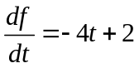
       ► 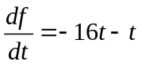
       ► 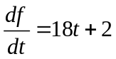
       ► 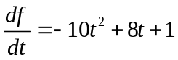

Question No: 8 ( Marks: 1 ) - Please choose one
Is the function 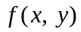 continuous at origin? If not, why?
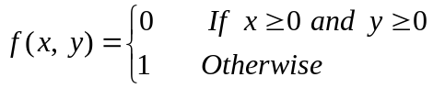
       ►  is continuous at origin
       ► 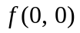 is not defined
       ►  is defined but 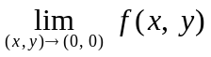 does not exist
       ►  is defined and exists but these two numbers are not equal.

Question No: 9 ( Marks: 1 ) - Please choose one
What is the relation between the direction of gradient at any point on the surface to the tangent plane at that point ?
       ► parallel
       ► perpendicular
       ► opposite direction
       ► No relation between them.

Question No: 10 ( Marks: 1 ) - Please choose one
Two surfaces are said to intersect orthogonally if their normals at every point common to them are ----------
► perpendicular
► parallel
► in opposite direction

Question No: 11 ( Marks: 1 ) - Please choose one
By Extreme Value Theorem, if a function 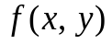 is continuous on a closed and bounded set R, then has both ---------------- on R.
► Absolute maximum and absolute minimum value
► Relative maximum and relative minimum value

Question No: 12 ( Marks: 1 ) - Please choose one
Let the function has continuous second-order partial derivatives 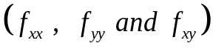 in some circle centered at a critical point 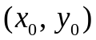and let 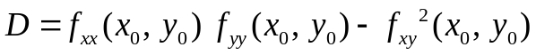

If 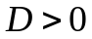 and 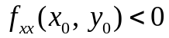 then 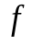 has ---------------
► Relative maximum at
► Relative minimum at
► Saddle point at
► No conclusion can be drawn.

Question No: 13 ( Marks: 1 ) - Please choose one
Let the function has continuous second-order partial derivatives in some circle centered at a critical point and let

If 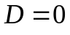 then ---------------
► 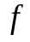 has relative maximum at
► has relative minimum at
► has saddle point at
► No conclusion can be drawn.

Question No: 14 ( Marks: 1 ) - Please choose one
The function 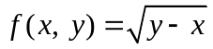 is continuous in the region --------- and discontinuous elsewhere.

► 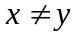
► 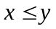
► 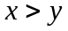

Question No: 15 ( Marks: 1 ) - Please choose one
Plane is an example of ---------------------
► Curve
► Surface
► Sphere
► Cone

Question No: 16 ( Marks: 1 ) - Please choose one
If 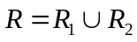 , where 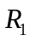 and 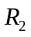 are no overlapping regions then
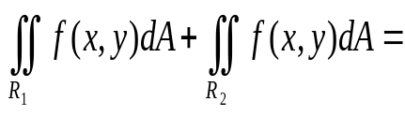

► 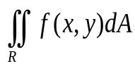
► 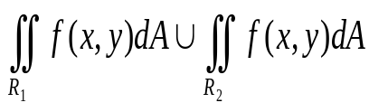
► 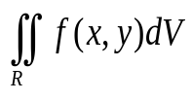
► 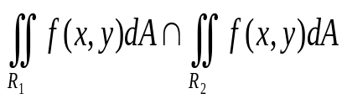

Question No: 17 ( Marks: 1 ) - Please choose one
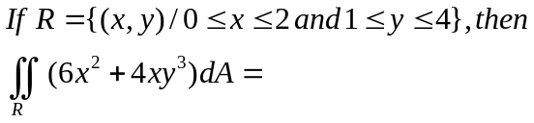

► 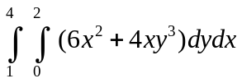
► 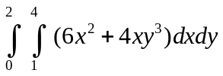
► 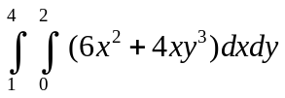
► 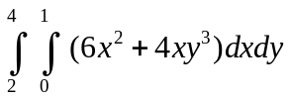

Question No: 18 ( Marks: 1 ) - Please choose one
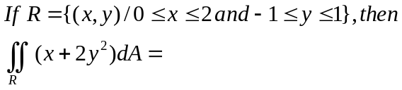

► 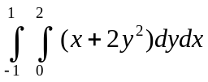
► 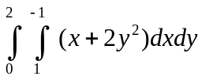
► 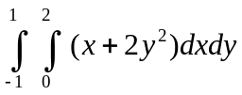
► 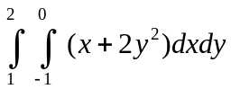

Question No: 19 ( Marks: 1 ) - Please choose one
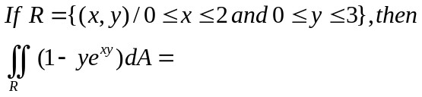

► 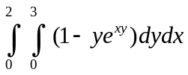
► 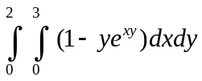
► 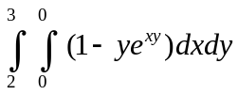
► 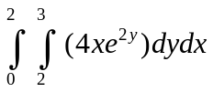

Question No: 20 ( Marks: 1 ) - Please choose one
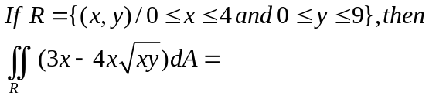

► 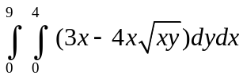
► 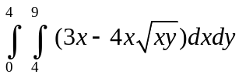
► 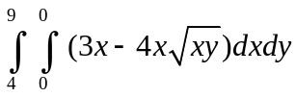
► 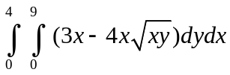

Question No: 21 ( Marks: 2 )
Evaluate the following double integral.
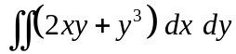

Question No: 22 ( Marks: 2 )
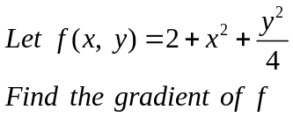

Question No: 23 ( Marks: 3 )
Evaluate the following double integral.
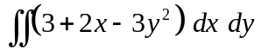

Question No: 24 ( Marks: 3 )
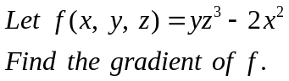

Question No: 25 ( Marks: 5 )
Find Equation of a Tangent plane to the surface 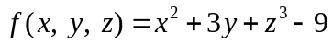 at the point 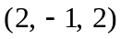

Question No: 26 ( Marks: 5 )
Evaluate the iterated integral


