**Linux Programming**

**Lab-4**

**k.bhavesh**

**17MIS1079**

Question 1:

ScreenShot:



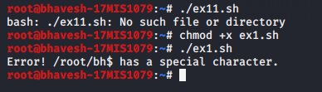

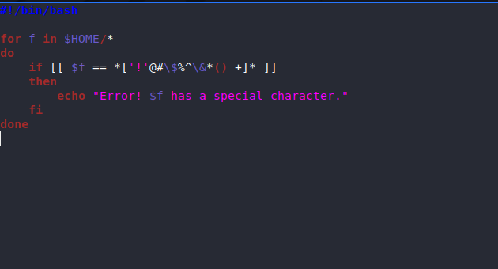

Question 2:

new.sh

echo "This is the message body" | mutt -a "email.txt" -s "subject of message" – kurellabhavesh2014@gmail.com

Screenshot:

