PashuMitra
A Ward-Level Stray Animal Grievance & Care Coordination Platform
An E-Governance Digital Service for Urban Local Bodies
Week 1 Submission — Planning & Requirements Analysis
Role: Junior Web Developer (Virtual Internship)
Prepared by: Bhoomi | B.Tech CSE, IILM University, Greater Noida

1. Project Overview
Most Indian city grievance apps treat every civic complaint the same way — a pothole, a garbage pile, and a dog bite all end up in one generic queue. Stray animal management is different: it involves a live, moving subject, a legal framework (the Animal Birth Control Rules, 2023), multiple actors who don't normally talk to each other (municipal ward staff, AWBI-recognised NGOs, veterinary teams, and residents who feed or foster the animals), and a Supreme Court-driven urgency around dog-bite and rabies incidents. This project scopes a focused e-governance platform — PashuMitra ("friend of animals") — that a municipal corporation could deploy as a dedicated module within its existing citizen-services stack.
PashuMitra sits at the intersection of two things I already care about: writing production-grade backend systems, and a long-standing idea I've had for a stray-dog rescue coordination tool. Rather than design "a generic government portal," this plan treats the ABC Rules, 2023 workflow — capture, sterilise, vaccinate, release/shelter — as the actual backbone of the system, because that is the legal process local bodies are already required to follow.

1.1 Why this problem, and why now
- India has an estimated tens of millions of stray dogs, and rabies deaths from bites remain a serious public-health concern — which is why the Central Government replaced the 2001 rules with the ABC Rules, 2023 and pushed local bodies to formalise complaint handling.
- Multiple municipal corporations (Panvel, Chandigarh, Delhi/MCD) have separately been asked to set up helplines, feeding-point registries, and shelters — but each is doing it as a one-off app or phone line, not a shared, replicable digital service.
- Residents who feed community dogs are legally protected but frequently harassed; a transparent, logged system protects both feeders and complainants.
- This is a realistic first e-governance module for a Tier-2/3 municipal corporation to pilot, because the workflow is bounded (one animal, one case, one legal process) compared to something like full property-tax digitisation.

2. Goals & Objectives
Goal | Success Measure (Year 1 target)
Cut average case-closure time for stray animal complaints | From ~10–15 days (informal helpline) to under 4 days
Give every case a transparent, trackable status | 100% of cases visible to the reporting citizen with live SLA timer
Make ABC Rules, 2023 compliance auditable | Every sterilisation/vaccination event logged with photo + vet ID
Protect registered feeders from harassment complaints | Feeding-spot registry cross-checked automatically before a harassment case is escalated
Reduce duplicate/false reports | AI + geo-tag de-duplication reduces repeat tickets by 30%
Build reusable digital infrastructure | Same case-engine reused for 2 more civic modules (e.g., garbage, streetlights) within 18 months

3. Research & Benchmarking
Before designing features, I looked at what municipal bodies are already doing, both to avoid reinventing something and to borrow what already works for citizens.
Existing initiative | What it does well | Gap PashuMitra addresses
Panvel Connect App + ABC Helpline | Dedicated helpline number and app-based complaint entry; mobile vet clinics | No public status tracking or SLA visibility for the citizen after filing
MCD ward-wise feeding points | Formal registry of feeding locations to reduce conflict | Feeding registry not linked to the complaint/harassment workflow
Chandigarh Pet & Community Dog Byelaws (draft) | Residents explicitly demanded a shelter + complaint mechanism in public consultation | Confirms citizen demand for exactly this kind of digital service
UMANG / DigiLocker (national e-gov apps) | Single sign-on, document wallet, multi-department access from one app | Pattern to reuse for auth and identity, not animal-specific workflow
MyGov citizen engagement portal | Structured public consultation and feedback loops | Pattern to reuse for policy feedback on byelaws, not case tracking
Common failure pattern across the smaller municipal tools: they are built as a single mobile app front-end with no backend workflow engine behind it, so a filed complaint disappears into a WhatsApp group or a spreadsheet. The technical plan in Section 7 is designed specifically to avoid that failure mode.

4. Stakeholder Analysis & Personas
Four personas cover the realistic range of people who would touch this system.

Persona 1 — Renu, the Resident Reporter (age 34, RWA member)
- Goal: report an injured or aggressive dog quickly and know someone is actually coming.
- Pain point: has stopped calling the ward office because complaints "go nowhere."
- Needs: one-tap photo report, visible case number, SLA countdown.

Persona 2 — Iqbal, the Community Feeder (age 52, retired, feeds 6 dogs daily)
- Goal: continue feeding without being reported or threatened by neighbours.
- Pain point: no proof he is an "authorised" feeder under local byelaws.
- Needs: a feeder registration with a digital ID/QR he can show if challenged.

Persona 3 — Dr. Meenal, Veterinary Officer, ABC Centre
- Goal: track which animals are due for sterilisation/vaccination and which cases are field emergencies.
- Pain point: paper registers, no link between the case that came in and the animal treated.
- Needs: a queue view by ward, photo-based animal ID, one-tap status update.

Persona 4 — Mr. Saxena, Ward Sanitary/Executive Officer
- Goal: close cases within his SLA and avoid escalation to the Commissioner's office.
- Pain point: juggling animal complaints alongside garbage, drainage, and streetlight complaints in the same inbox.
- Needs: auto-routing to the right NGO/vet partner, and a dashboard that separates urgent (bite/aggression) from routine (feeding dispute) cases.
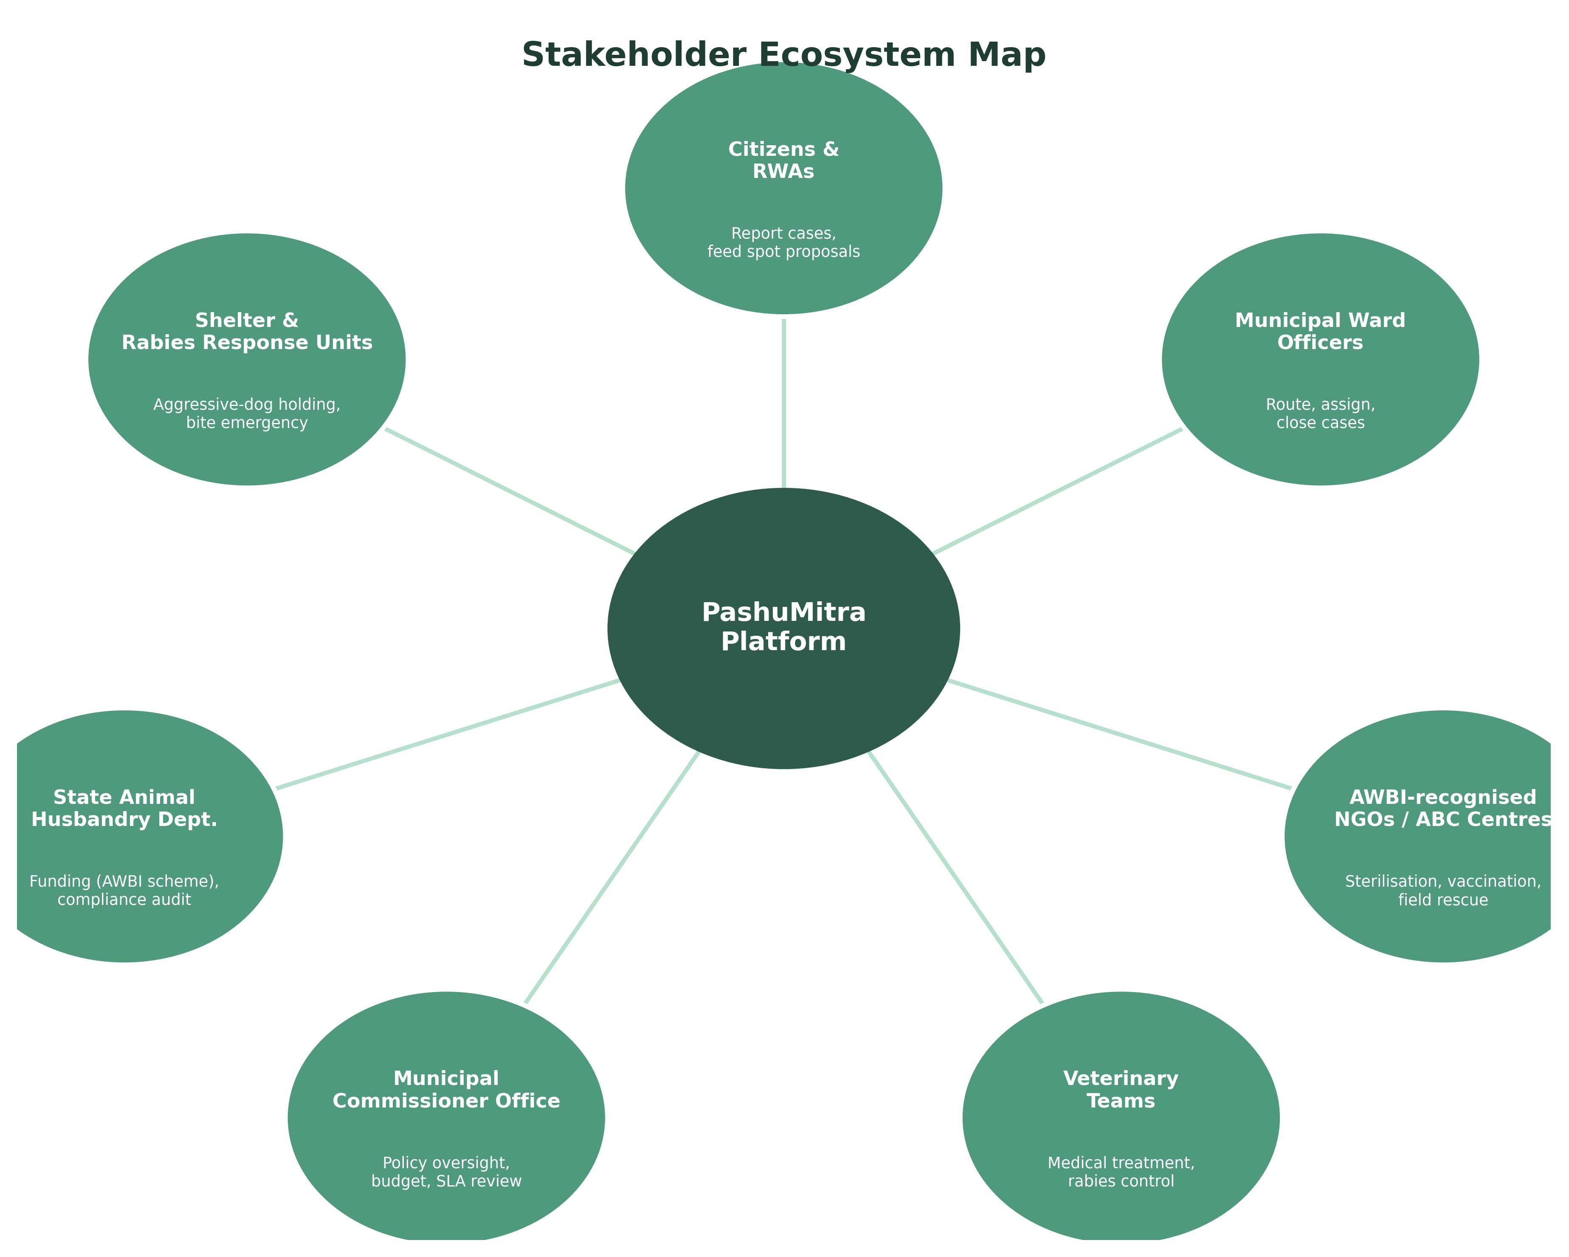
Figure 1 — Stakeholder ecosystem around the PashuMitra platform

5. Functional Requirements
ID | Requirement | Priority
FR-01 | Citizen can submit a case with photo, category, geo-tag, and optional description via app, web, or IVR helpline | Must
FR-02 | System auto-triages severity (bite/aggressive = urgent; feeding dispute/general = routine) using rule-based + basic AI classification | Must
FR-03 | Case auto-routes to the correct ward officer and nearest AWBI-recognised NGO/ABC centre based on geo-location | Must
FR-04 | Field staff/NGO can update case status (assigned → in-progress → treated → released/sheltered → closed) with photo proof | Must
FR-05 | Citizen receives SMS/app notification at each status change and can rate the resolution | Must
FR-06 | Feeder registration module: residents can register as authorised feeders with a designated spot, generating a digital ID | Should
FR-07 | Public ward-wise dashboard showing open/closed cases, average SLA, and sterilisation counts (open data, no personal info) | Should
FR-08 | Duplicate-case detection using geo-tag + time-window + photo similarity | Should
FR-09 | Admin console for the Commissioner's office to reassign cases, view NGO performance, and export AWBI compliance reports | Must
FR-10 | Multi-language interface (Hindi + English at minimum) and voice-based reporting for low-literacy users | Should
FR-11 | Escalation workflow: case auto-escalates to Commissioner's office if SLA is breached | Must
FR-12 | Integration hook for state/central AWBI reporting so sterilisation counts can feed the ₹800/dog reimbursement claim process | Could

6. Non-Functional Requirements
Category | Requirement
Availability | 99.5% uptime for the citizen-facing app; helpline IVR must degrade gracefully during outages
Performance | Case submission (with photo upload) completes in under 8 seconds on a 3G connection
Scalability | Architecture must support one municipal corporation (≈50–100 wards) at launch, scaling to a state-wide deployment
Security & Privacy | Reporter phone numbers masked from NGOs/field staff; role-based access control for admin console; data encrypted in transit and at rest
Accessibility | WCAG 2.1 AA compliance on the web portal; screen-reader support; large-touch-target mobile UI
Auditability | Every status change is immutably logged with timestamp and actor ID for RTI/audit requests
Interoperability | Exposes a documented REST API so the case engine can later plug into other civic modules or the state UMANG-style super-app
Localisation | Content and forms available in the state's official language plus Hindi and English
Offline resilience | Field staff app supports offline data capture in low-network wards, syncing when connectivity returns

7. Strategy & Technical Roadmap

7.1 Proposed technology stack
Layer | Technology | Reasoning
Frontend (citizen app + web) | React Native (mobile) + React.js (web/admin) | Single codebase logic shared between citizen mobile app and ward-officer web console
Backend / API | Node.js + Express | Lightweight REST services, matches skillset already used for the ResumeAI project
Database | PostgreSQL + PostGIS extension | Relational integrity for case records; PostGIS needed for ward/geo-fence routing
File/photo storage | Object storage (S3-compatible) | Cheap, scalable storage for case and treatment photos
Notifications | SMS gateway (for non-smartphone users) + push notifications | Reaches both smartphone and feature-phone users
Hosting | State/NIC data centre or empanelled cloud (MeitY GI Cloud "MeghRaj" panel) | Mandatory for most Indian government digital services
Auth | Aadhaar-linked OTP login for citizens; SSO-ready for staff | Consistent with DigiLocker/UMANG identity patterns

7.2 Phased delivery plan
Phase | Duration | Key outcomes
Phase 0 — Discovery (this submission) | Weeks 1–2 | Requirements, personas, wireframes, stakeholder sign-off
Phase 1 — Core case engine | Weeks 3–6 | Report → triage → route → close workflow live for one pilot ward
Phase 2 — Field & NGO tools | Weeks 7–9 | NGO/vet mobile app, offline sync, feeder registration
Phase 3 — Public dashboard & escalation | Weeks 10–11 | Open dashboard, SLA escalation, admin console
Phase 4 — Pilot rollout | Weeks 12–14 | Full deployment across all wards of one municipal corporation
Phase 5 — Scale & AWBI integration | Post week 14 | Multi-city rollout, AWBI reimbursement data hook

7.3 Grievance lifecycle
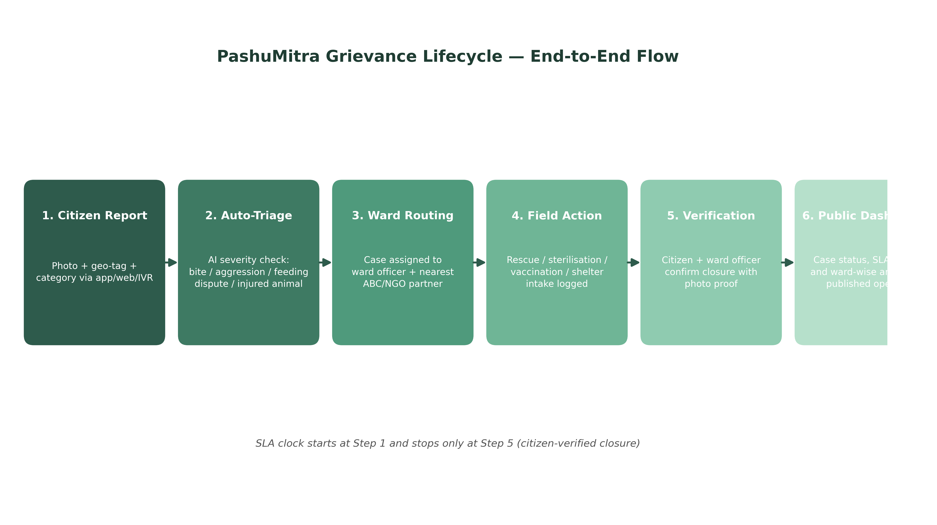
Figure 2 — End-to-end case flow from citizen report to verified closure

7.4 Illustrative wireframes
Two low-fidelity screens sketched below illustrate the core loop a citizen goes through: filing a report, and tracking it. Both prioritise a one-tap, photo-first flow because most reporters will be using this on the street, not at a desk.
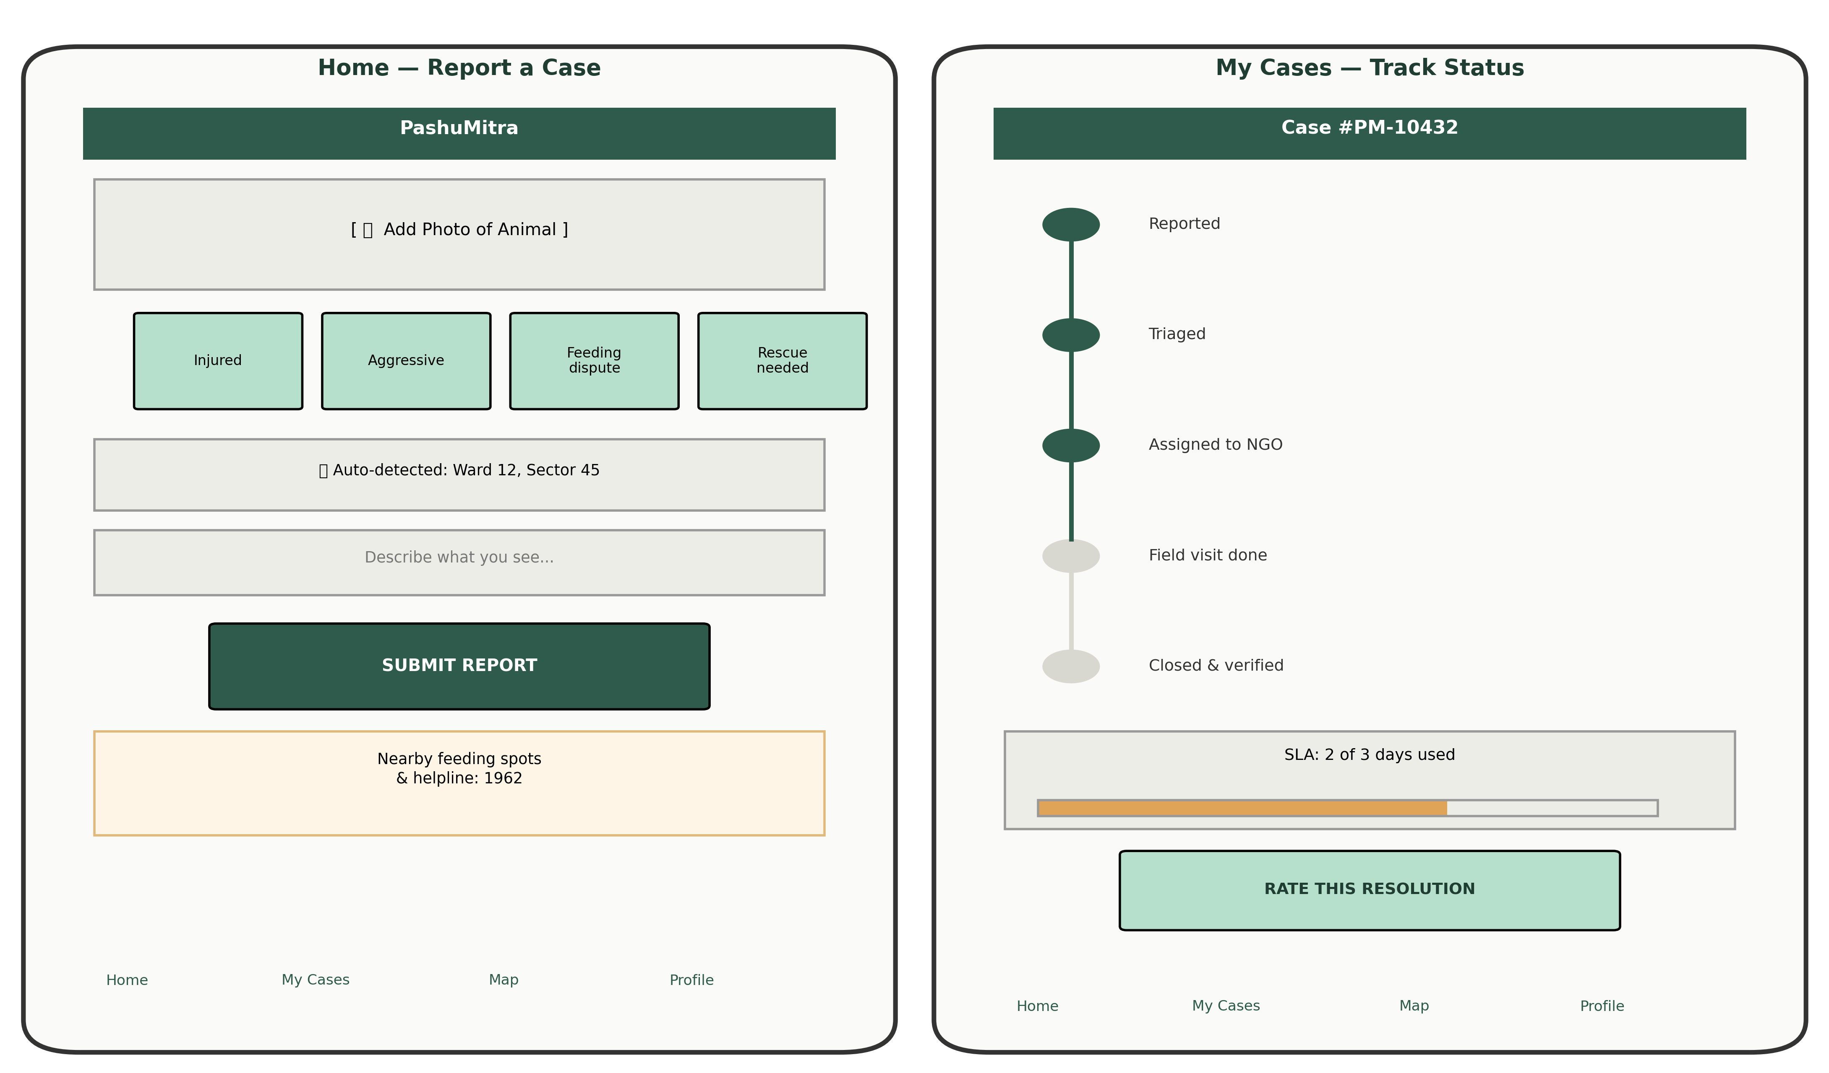
Figure 3 — Wireframes: report submission (left) and case tracker (right)

8. Risk Analysis
Risk | Likelihood | Impact | Mitigation
NGO/ABC partner capacity is lower than case volume | High | High | Phase rollout ward-by-ward; publish capacity-adjusted SLAs rather than a fixed number
Low smartphone penetration among some reporters | Medium | Medium | IVR helpline + SMS fallback kept as first-class channels, not an afterthought
False or malicious reports (e.g., against a legitimate feeder) | Medium | Medium | Feeder registry cross-check + mandatory photo/geo-tag before a case can be escalated
Data privacy concerns (citizen location, phone number) | Medium | High | Role-based access, phone masking, encryption at rest, RTI-compliant audit logs
Inter-departmental coordination failure (municipal vs. state AWBI) | High | Medium | Formal MoU + API integration hook built in from Phase 5, not bolted on later
Budget/funding delay for shelter infrastructure | Medium | High | Software rollout decoupled from physical shelter construction timeline
Public backlash if SLA targets are missed publicly | Low | Medium | Dashboard shows ward-level trend lines, not shaming individual officers

9. Conclusion & Next Steps
PashuMitra is deliberately scoped as one well-defined civic workflow rather than a sprawling "smart city" platform, because that is what actually gets piloted and approved by a municipal corporation in a realistic timeframe. The ABC Rules, 2023 already define the legal process; this plan simply gives that process a shared, transparent, and auditable digital backbone — reusing patterns from DigiLocker/UMANG for identity and MyGov for public feedback, while addressing the specific coordination gap between citizens, ward officers, and NGOs that the benchmarking in Section 3 surfaced.
Immediate next steps for Week 2 would be: validating FR-01 through FR-05 with an actual ward office, converting the wireframes in Figure 3 into a clickable prototype, and finalising the PostGIS ward-boundary data needed for auto-routing (FR-03).

