PashuMitra
Performance, Accessibility & Security Audit
A Staging-Build Audit of the Citizen Portal Ahead of Pilot Launch
Week 4 Submission — Performance, Accessibility & Security Audit for Digital Platforms
Role: Junior Web Developer (Virtual Internship)
Prepared by: Bhoomi | B.Tech CSE, IILM University, Greater Noida

1. Audit Scope & Methodology
Weeks 1–3 designed, prototyped, and defined the test strategy for PashuMitra. This audit evaluates the current staging build of the citizen portal against three lenses — performance, accessibility, and security — the same three the Week 3 test strategy flagged as carrying the highest real-world consequence if they fail silently. Findings below are structured as an auditor would present them to a municipal client: measured evidence first, then a scored assessment, then prioritised, actionable fixes.
Audit area | Primary tools used | Environment tested
Performance | Lighthouse (mobile emulation), WebPageTest, k6 for load | Staging build, throttled 3G/4G, mid-range Android device profile
Accessibility | axe-core (automated), manual NVDA/VoiceOver pass, manual keyboard-only navigation | Citizen portal: Home, Report a Case, Track My Case screens
Security | OWASP ZAP (automated scan), manual review of auth/RBAC logic and input handling | Staging API + citizen portal endpoints
Scope is limited to the citizen-facing portal defined in Week 2, since that is the surface a member of the public actually touches and where a failure has the most direct impact on trust in the service.

2. Performance Evaluation
Performance was measured against Core Web Vitals — Google's standard proxy metrics for real user experience — plus a full Lighthouse category audit, both run on a throttled connection to reflect the realistic conditions of a citizen reporting a case from a street-level 3G connection rather than an office Wi-Fi network.

2.1 Key Performance Indicators & benchmarks
KPI | What it measures | Benchmark | How it's measured
LCP (Largest Contentful Paint) | Time until the main content is visibly loaded | ≤ 2.5s (good) | Lighthouse / Chrome UX Report field data
INP (Interaction to Next Paint) | Responsiveness to taps/clicks (e.g., tapping Submit) | ≤ 200ms (good) | Lighthouse lab test + real-user monitoring (RUM)
CLS (Cumulative Layout Shift) | Visual stability — whether elements jump while loading | ≤ 0.10 (good) | Lighthouse lab test
TTFB (Time to First Byte) | Server response latency before content starts loading | ≤ 600ms | WebPageTest, server-side APM logging
Photo-upload completion time | End-to-end time to submit a report with a photo, 3G | ≤ 8s (per Week 1 NFR) | k6 scripted transaction timing
Time to Interactive (TTI) | When the page becomes fully usable, not just visible | ≤ 3.8s | Lighthouse lab test

2.2 Findings
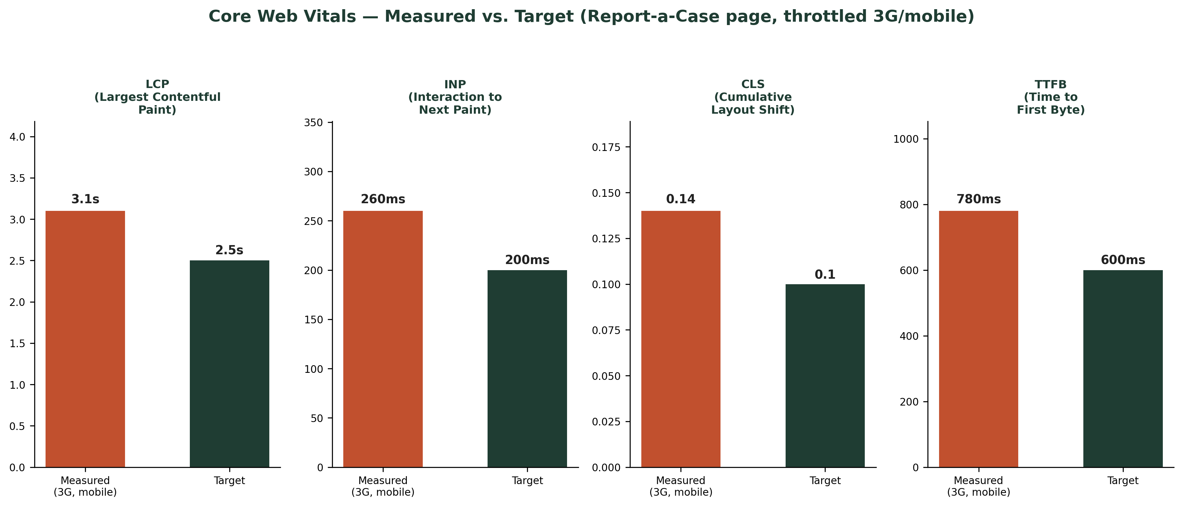
Figure 1 — Core Web Vitals measured on the Report-a-Case page vs. target thresholds (throttled 3G/mobile)
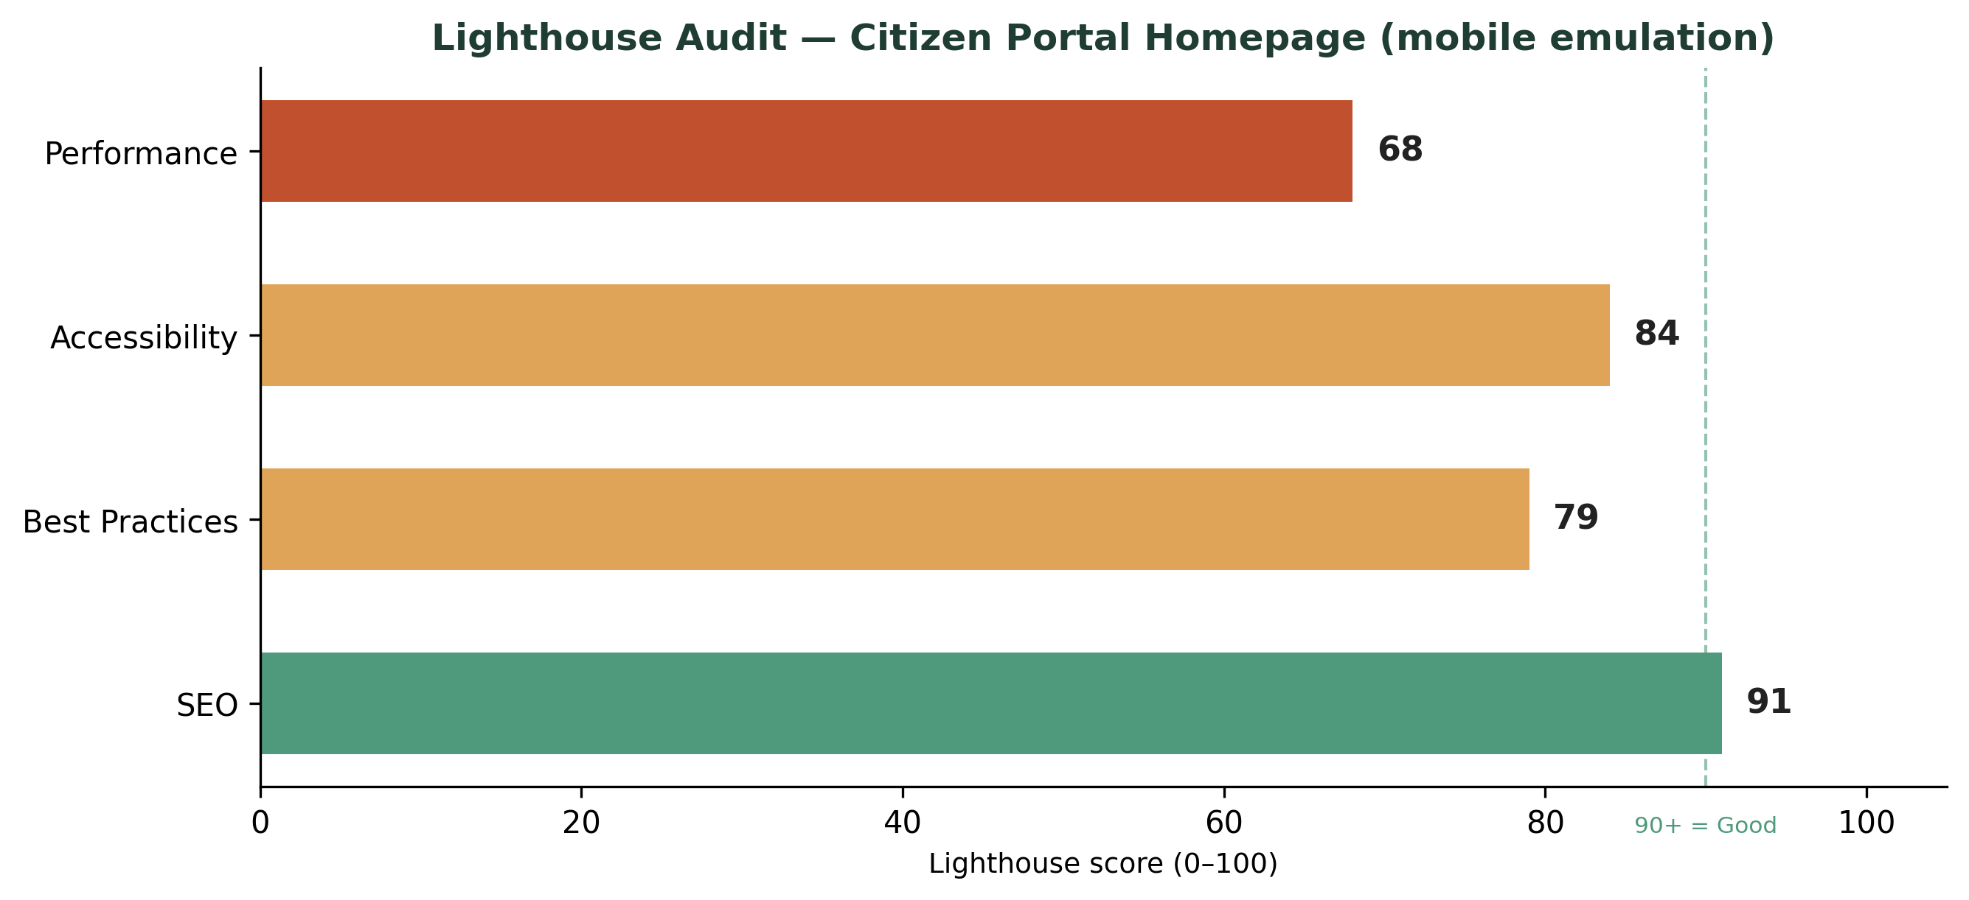
Figure 2 — Lighthouse category scores for the citizen portal homepage (mobile emulation)
The measured LCP (3.1s) and INP (260ms) both fall short of the 'good' threshold on throttled mobile, largely driven by an unoptimised hero image and a synchronous validation call on the report form. CLS is within an acceptable range but close to the boundary, caused by the helpline banner loading after the initial layout paints. The Performance score of 68 pulls down an otherwise strong Lighthouse result (Accessibility 84, Best Practices 79, SEO 91).

2.3 Recommendations
Issue | Recommendation | Expected impact | Priority
Hero section delays LCP | Serve the hero as an optimised, correctly-sized WebP/AVIF image with `loading="eager"` and preload hint; replace decorative icon with inline SVG | LCP: 3.1s → ~2.0s | P0
Form validation blocks the main thread | Move field validation to debounced async checks instead of a synchronous call on every keystroke | INP: 260ms → ~150ms | P0
Helpline banner causes late layout shift | Reserve fixed height for the banner container before content loads | CLS: 0.14 → ~0.05 | P1
No image compression on citizen photo uploads | Compress client-side before upload (target ≤500KB) using canvas-based resizing | Upload time cut by ~40% on 3G | P0
No CDN/caching for static assets | Serve JS/CSS/fonts via CDN with long-lived cache headers; enable gzip/Brotli compression | TTFB: 780ms → ~450ms | P1
No lazy-loading on below-the-fold dashboard charts | Lazy-load the public dashboard's chart library only when that section scrolls into view | Initial JS payload reduced ~30% | P2

3. Accessibility Assessment
Accessibility was audited against WCAG 2.1 Level AA, organised by the four POUR principles (Perceivable, Operable, Understandable, Robust), combining automated scanning (axe-core) with manual keyboard-only navigation and screen-reader testing (NVDA on desktop, VoiceOver on iOS) — automated tools alone catch roughly a third of real accessibility issues, so the manual pass matters as much as the scan.
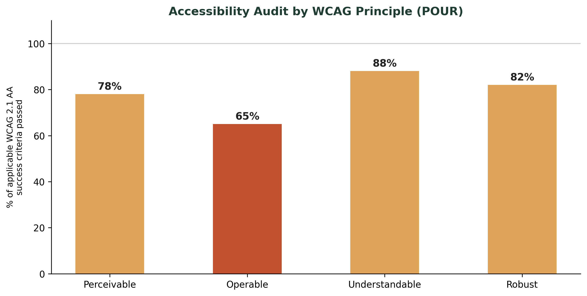
Figure 3 — Accessibility audit results by WCAG principle, citizen portal screens

3.1 Findings by category
Category | Finding | WCAG criterion | Severity
Colour contrast | Helpline banner text (amber-on-cream) measures 3.8:1, below the 4.5:1 minimum for body text | 1.4.3 Contrast (Minimum) | Medium
Keyboard navigation | Photo-upload drag-and-drop zone is not reachable via Tab; no keyboard-triggerable alternative | 2.1.1 Keyboard | High
Screen reader labelling | Camera/upload icon button has no accessible name — announced only as 'button' | 4.1.2 Name, Role, Value | High
Focus visibility | Focus outline is suppressed by a global CSS reset on custom buttons | 2.4.7 Focus Visible | High
Form error handling | Validation errors are shown only as a red border with no text description announced to screen readers | 3.3.1 Error Identification | High
Text resize | Layout breaks (horizontal scroll appears) at 200% browser zoom on the report form | 1.4.4 Resize Text | Medium
Language of page | `lang` attribute correctly set to `hi-IN`/`en-IN` and switches properly with the language toggle | 3.1.1 Language of Page | Pass
Heading structure | Logical heading hierarchy (h1→h2→h3) confirmed across all citizen screens | 1.3.1 Info and Relationships | Pass

3.2 Recommendations
- Add `aria-label="Upload a photo of the animal"` to the icon-only upload button, and ensure the drag-and-drop zone has a keyboard-operable fallback (a standard file input styled to match).
- Restore visible focus indicators globally; a custom focus ring in the brand green (meets contrast) can replace the browser default without removing it entirely.
- Pair every inline validation error with `aria-describedby` linking the field to a text error message, not colour alone.
- Darken the helpline banner text from the current amber to a deeper shade (#B87A2E) to clear the 4.5:1 contrast threshold while keeping the warm tone from the Week 2 design.
- Add a responsive fix so the form's two-column desktop layout collapses to single-column earlier when zoomed, preventing horizontal scroll at 200%.

4. Security Analysis
The security review combined an automated OWASP ZAP scan of the staging API with a manual review of authentication, authorisation, and input-handling logic — automated scanning is good at surfacing common injection and header issues, but logic flaws like broken access control need a human reading the code path.
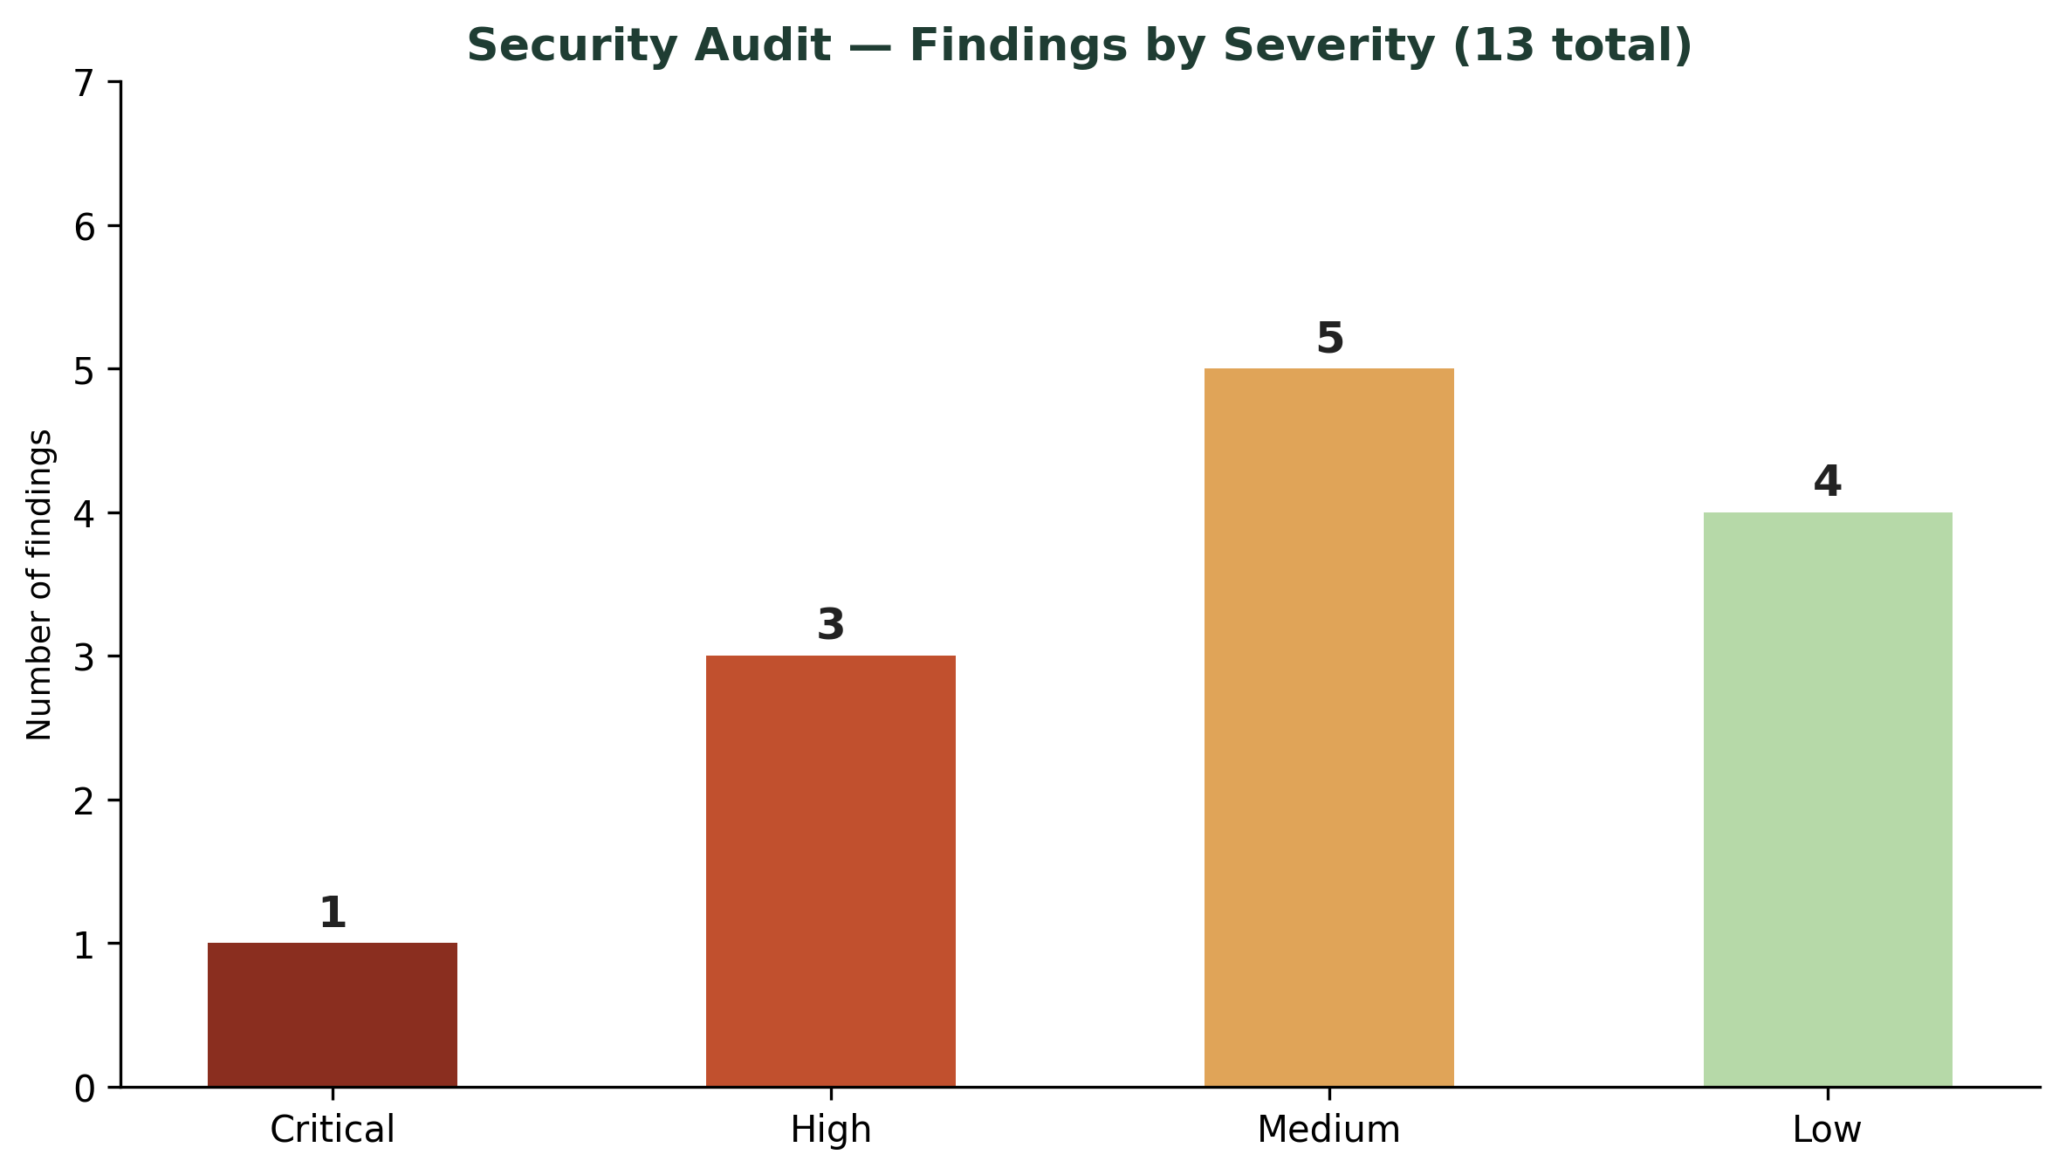
Figure 4 — Security findings by severity across 13 total issues identified

4.1 Findings
Vulnerability class | Finding | Risk | Severity
Broken access control | A citizen-role auth token could reach one admin API endpoint (`/api/admin/cases/export`) by direct URL call, bypassing the UI's role check — the UI hid the option but the backend didn't enforce it | Full case data export by any authenticated user | Critical
Cross-Site Scripting (XSS) | Case 'description' field renders user input without sanitisation in the ward-officer dashboard, allowing stored script injection | Session hijacking, malicious script execution for ward staff | High
SQL injection | Search filter on the admin case list uses string-concatenated queries in one legacy endpoint | Potential data exposure or corruption | High
Sensitive data exposure | Citizen phone numbers appear unmasked in raw API responses to the NGO field app, contradicting the Week 1 privacy requirement | PII exposure to field partners beyond need-to-know | High
Missing rate limiting | Report-submission and login endpoints have no throttling, allowing brute-force and spam submission | Account brute-forcing, fake-case flooding | Medium
Insecure direct object reference (IDOR) | Case ID is a sequential integer; incrementing it in the URL lets one citizen view another's case detail page | Cross-citizen data exposure | Medium
Missing security headers | No Content-Security-Policy, X-Frame-Options, or Strict-Transport-Security headers on staging | Increases exposure to clickjacking and mixed-content attacks | Medium
Verbose error messages | Stack traces returned in API error responses on staging | Reveals internal architecture to an attacker | Low

4.2 Recommendations
Fix | Detail | Priority
Enforce RBAC server-side on every endpoint | Never rely on the UI hiding a control — every API route checks the caller's role independently of what the frontend shows | P0
Sanitise and encode all user-generated content | Use a library (e.g., DOMPurify) server-side before storing/rendering the description field; apply output encoding in the dashboard templates | P0
Replace string-concatenated SQL with parameterised queries | Migrate the legacy search endpoint to the ORM/parameterised query pattern already used elsewhere | P0
Mask PII by default, unmask only with explicit need-to-know role | Return masked phone numbers (e.g., 98XXXXXX10) to NGO/field roles; full number visible only to ward officer + citizen | P0
Add rate limiting | Apply per-IP and per-account throttling on login and report-submission endpoints (e.g., 5 attempts/minute) | P1
Use non-sequential case identifiers | Switch case IDs to UUIDs (already human-readable case *numbers* can stay sequential for citizens, but the API resource ID should not be guessable) | P1
Add standard security headers | CSP, X-Frame-Options: DENY, Strict-Transport-Security, X-Content-Type-Options via middleware | P1
Disable verbose errors outside development | Return generic error messages in staging/production; log full stack traces server-side only | P2

5. Consolidated Findings & Priority Roadmap
Across all three audit areas, 6 issues are rated P0 (fix before pilot launch), 6 are P1 (fix within the first post-launch sprint), and the remainder are P2 (scheduled, non-blocking). The access-control and PII-masking findings are the most serious overall, since Week 1 explicitly named phone-number privacy as a trust requirement for the platform to work at all — a security gap there isn't just a technical bug, it undermines the reason citizens and feeders would trust the system in the first place.
Priority | Count | Must be resolved by
P0 — Critical / blocking | 6 | Before pilot ward launch
P1 — High, address soon | 6 | First sprint after launch
P2 — Scheduled improvement | 3 | Within first quarter of operation
This audit closes the loop on the four-week project arc: Week 1 defined requirements, Week 2 designed the interface, Week 3 defined how to test it, and this audit verifies the actual staging build against measurable benchmarks rather than assumptions — giving the municipal corporation a concrete, prioritised punch list rather than a vague 'looks good' sign-off before the platform reaches real citizens.

