PashuMitra
Quality Assurance & Testing Strategy
Functional, Performance & Security Testing for a Civic Grievance Platform
Week 3 Submission — QA & Testing Strategy for Digital Services
Role: Junior Web Developer (Virtual Internship)
Prepared by: Bhoomi | B.Tech CSE, IILM University, Greater Noida

1. From Prototype to Verification
Weeks 1 and 2 defined what PashuMitra should do and what it should look like. This document defines how we prove it actually works — reliably, quickly, and securely — before a municipal corporation puts it in front of real citizens filing bite and rescue reports. The scope covers the citizen portal, the case-routing/triage engine, the field-staff status updates, and the public dashboard, tested against the functional and non-functional requirements set in Week 1.
The strategy is deliberately risk-weighted rather than uniform: a missed unit test on a footer link and a missed test on the auto-triage severity classifier are not equally serious, so testing effort is concentrated where a failure would actually hurt someone — case routing, data privacy, and peak-load submission.

2. Testing Objectives & Scope
Objective | In scope | Out of scope (this phase)
Functional correctness | Report submission, triage routing, case tracking, feeder registry, public dashboard | Admin console deep workflows (planned Week 4)
Performance under load | Report submission & photo upload during peak (post-monsoon stray surge, festival season) | State-wide multi-city concurrent load (post-pilot)
Security & data privacy | Auth, RBAC, PII masking, OWASP Top 10 on citizen-facing endpoints | Physical/network security of municipal data centre (IT infra owns this)
Accessibility | WCAG 2.1 AA regression on all citizen screens from Week 2 | Native app screen-reader certification (web-first launch)
Compatibility | Chrome, Safari, Edge on last 2 versions; Android 9+, iOS 14+ | Legacy browsers (IE11) — not supported per GIGW current guidance

3. Test Strategy Overview
Testing is organised in layers, from fast and narrow to slow and broad, following the test pyramid below. The heaviest investment is in unit and integration tests because they catch the most bugs per rupee of engineering time and run on every commit; UAT and exploratory testing stay manual because judgement about real-world usability doesn't automate well.
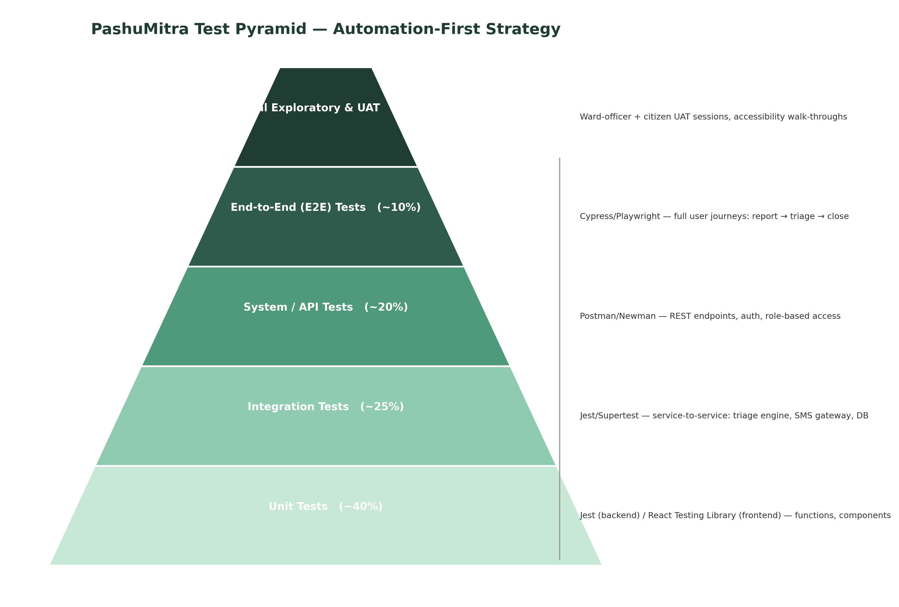
Figure 1 — Test pyramid: automation weight decreases as test scope broadens
Test type | Purpose | Primary tooling | Executed
Unit tests | Verify individual functions/components in isolation (e.g., SLA-timer calculation, form validators) | Jest, React Testing Library | Automated — every commit
Integration tests | Verify service-to-service behaviour (triage engine → routing → NGO notification) | Jest + Supertest, test DB | Automated — every PR
System / API tests | Verify full REST API contract, auth, and role-based access | Postman/Newman | Automated — nightly + every PR
End-to-end (E2E) tests | Simulate full citizen journeys in a real browser | Cypress / Playwright | Automated — pre-deploy to staging
Performance / stress tests | Validate response time and stability under peak concurrent load | k6 / Apache JMeter | Scheduled — weekly + before major releases
Security tests | Probe for OWASP Top 10 vulnerabilities and data-exposure risks | OWASP ZAP, manual pen-test checklist | Automated scan every build + manual audit pre-launch
Accessibility tests | Validate WCAG 2.1 AA compliance | axe-core (automated) + manual screen-reader pass | Automated in CI + manual before each release
Manual UAT / exploratory | Real ward-officer and citizen sign-off on usability and edge cases | Structured UAT script + free-form exploratory session | Manual — before each pilot rollout

4. Automation vs. Manual Testing Approach
The guiding rule: automate anything that will be run more than a handful of times, or that guards a requirement where a regression would be serious (payment-adjacent logic doesn't exist here, but SLA correctness and auth do). Keep manual anything that depends on human judgement about real-world context — like whether a ward officer actually finds the dashboard usable during a hectic Monday morning.
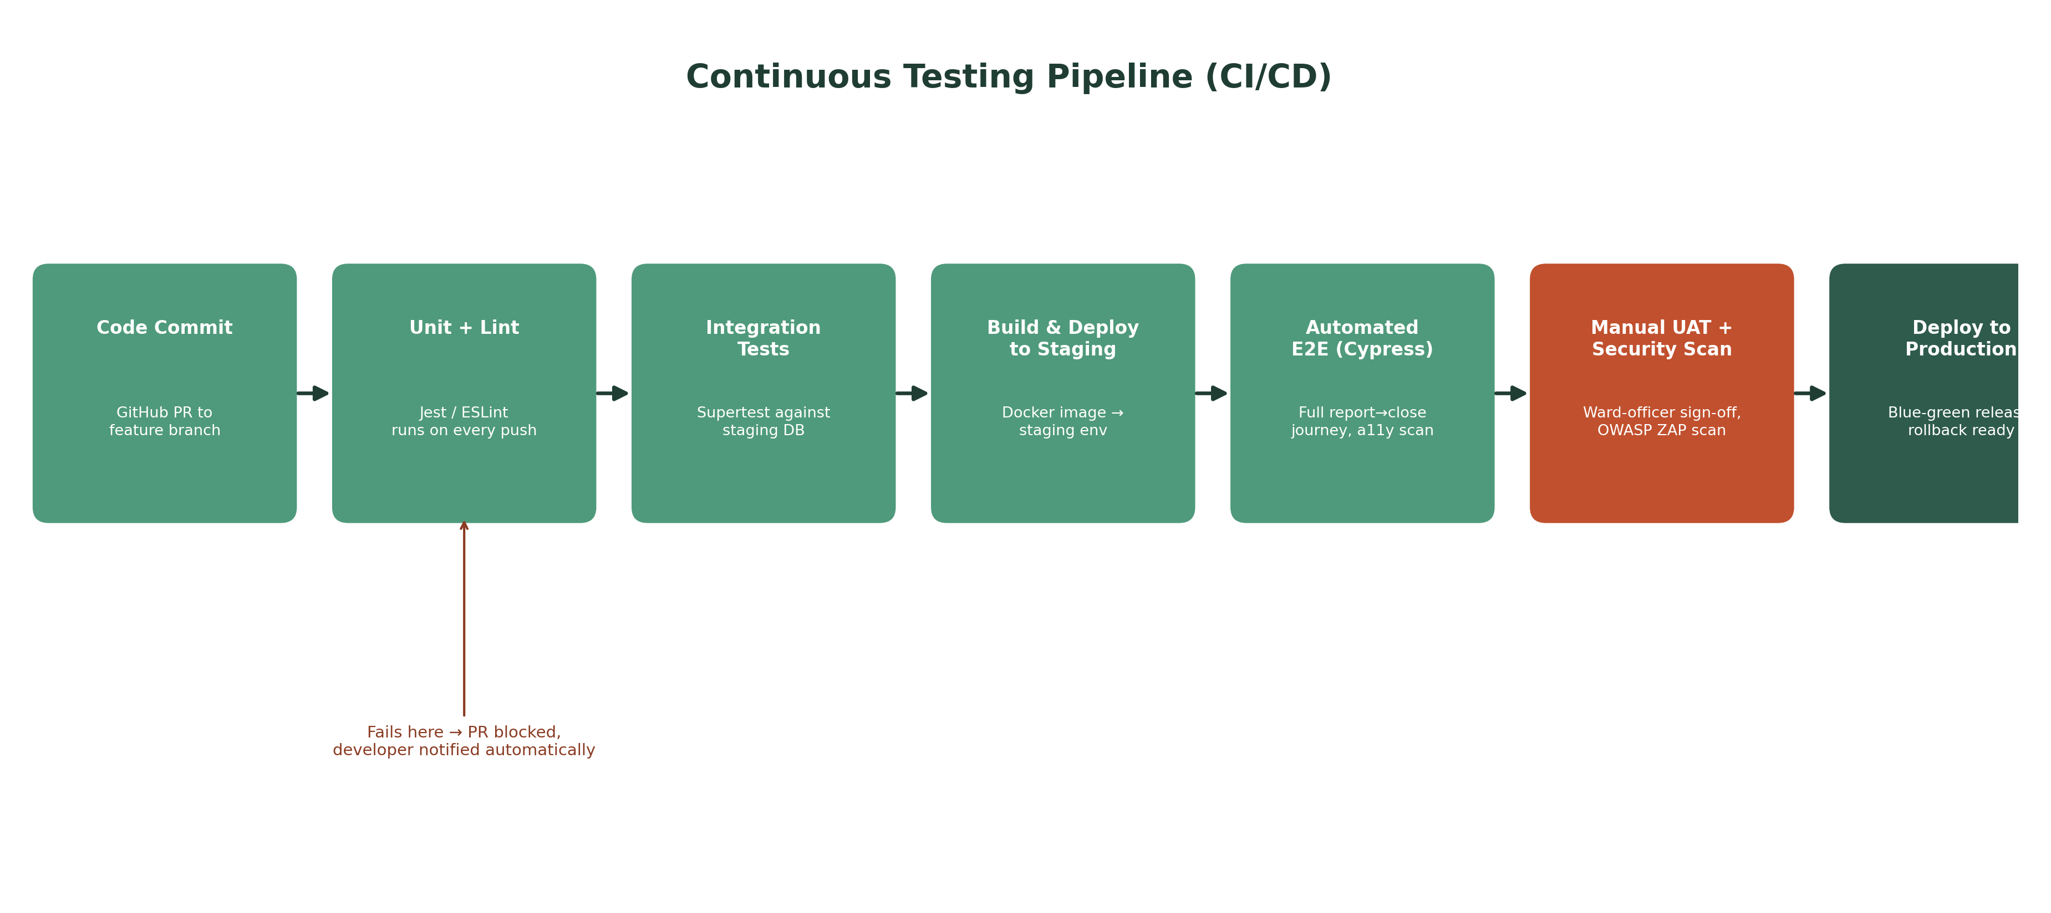
Figure 2 — Continuous testing pipeline: a failing stage blocks the pull request automatically
- Every pull request triggers unit, lint, and integration tests automatically before a human reviewer even looks at the code.
- E2E tests run against a staging deployment, not production, and cover the three critical journeys: report → triage → close, feeder registration → ID issuance, and SLA breach → auto-escalation.
- Security scanning (OWASP ZAP) runs on every build; a manual penetration-test pass happens before each pilot ward goes live, not just once at project start.
- Manual UAT is scripted (a fixed checklist a ward officer works through) plus a 30-minute unscripted exploratory session, since scripted testing alone tends to miss the odd real-world case (e.g., a photo taken sideways, a case filed with no network and synced later).

5. Detailed Test Cases
Seven representative test cases are detailed below, covering functional, performance, security, and accessibility concerns across the core citizen journeys defined in Week 1 and Week 2.
TC-01 — Submit a case with photo and geo-tag [Report a Case (FR-01) · Priority: Critical · Automated (E2E)]
Precondition: Citizen is on the Report a Case screen with location permission granted; network connection is stable (4G/Wi-Fi)
Steps: 1) Tap 'Add Photo' and capture/upload an image 2) Select category 'Injured' 3) Confirm auto-detected ward 4) Enter optional description 5) Tap Submit Report
Expected result: Case is created within 8 seconds, a case number is returned, and an SMS confirmation is received within 2 minutes with the case ID
Pass/Fail criteria: Fail if submission exceeds 8 seconds on a throttled 3G profile, or if no case ID is returned
TC-02 — AI triage correctly classifies severity [Auto-Triage (FR-02) · Priority: Critical · Automated (Integration)]
Precondition: Triage service is deployed to staging with the trained classification model
Steps: 1) Submit a case tagged 'Aggressive' with a bite-related description 2) Submit a separate case tagged 'Feeding dispute' with a routine description 3) Inspect the severity field returned by the triage service for both
Expected result: The aggressive/bite case is classified 'Urgent' and routed with a shorter SLA; the feeding dispute is classified 'Routine'
Pass/Fail criteria: Fail if an urgent case (bite/aggression keywords or category) is ever classified as routine — this is treated as a Severity-1 defect given public-health risk
TC-03 — Case status updates and citizen notification [Track My Case (FR-04, FR-05) · Priority: High · Automated (E2E) + Manual]
Precondition: A case exists in 'Assigned' state with a linked NGO partner
Steps: 1) NGO field app marks case as 'In Progress' 2) NGO field app marks case as 'Treated' with photo proof 3) Citizen opens the Track My Case screen
Expected result: Citizen sees the updated status timeline within 30 seconds and receives a push/SMS notification at each transition
Pass/Fail criteria: Fail if any status transition is not reflected on the citizen's screen within 1 minute, or if a notification is not sent
TC-04 — Feeder registration issues a valid digital ID [Feeder Registry (FR-06) · Priority: Medium · Automated (Integration) + Manual]
Precondition: Citizen is logged in with a verified phone number
Steps: 1) Navigate to Feeder Registry 2) Submit name, designated feeding spot, and photo 3) Confirm submission
Expected result: A QR-coded digital feeder ID is generated and downloadable; the feeding spot appears on the ward's registry within 24 hours after municipal review
Pass/Fail criteria: Fail if the ID is issued without the 24-hour review gate, or if duplicate registrations for the same spot are not flagged
TC-05 — Peak-load stress test on report submission [Performance (NFR — Performance) · Priority: Critical · Automated (Load test)]
Precondition: Staging environment scaled to match production sizing
Steps: 1) Simulate 500 concurrent citizens submitting reports with photo uploads over a 10-minute window using k6 2) Monitor response time, error rate, and DB connection pool
Expected result: 95th-percentile response time stays under 8 seconds; error rate stays under 1%; no dropped connections
Pass/Fail criteria: Fail if error rate exceeds 1% or the 95th-percentile response time exceeds 8 seconds
TC-06 — Authentication and role-based access control [Security (NFR — Security) · Priority: Critical · Automated (Security scan) + Manual pen-test]
Precondition: Test accounts exist for citizen, NGO field staff, ward officer, and admin roles
Steps: 1) Attempt to access the admin console using a citizen-role token 2) Attempt SQL injection via the case-description field 3) Attempt to view another citizen's phone number via the NGO field app
Expected result: Admin console access is denied (403) for the citizen role; injection payloads are sanitised/rejected; phone numbers remain masked to the NGO role
Pass/Fail criteria: Fail (Severity-1) if any unauthorised access, injection success, or PII exposure occurs
TC-07 — Accessibility — screen reader and keyboard navigation [Accessibility (FR-10, NFR — Accessibility) · Priority: High · Automated (axe-core) + Manual]
Precondition: Latest staging build of the citizen portal, tested with NVDA/VoiceOver
Steps: 1) Navigate the Report a Case form using only the keyboard (Tab/Enter) 2) Run a screen reader through the form and submit flow 3) Zoom browser to 200%
Expected result: Every field is reachable and labelled via keyboard and screen reader; layout remains usable at 200% zoom with no horizontal scroll
Pass/Fail criteria: Fail if any interactive element is unreachable by keyboard or unlabelled for screen readers

6. Risk Analysis & Mitigation
Risks are plotted by likelihood and impact to prioritise mitigation effort — the upper-right of the matrix gets fixed before pilot launch; the lower-left is monitored but not gold-plated.
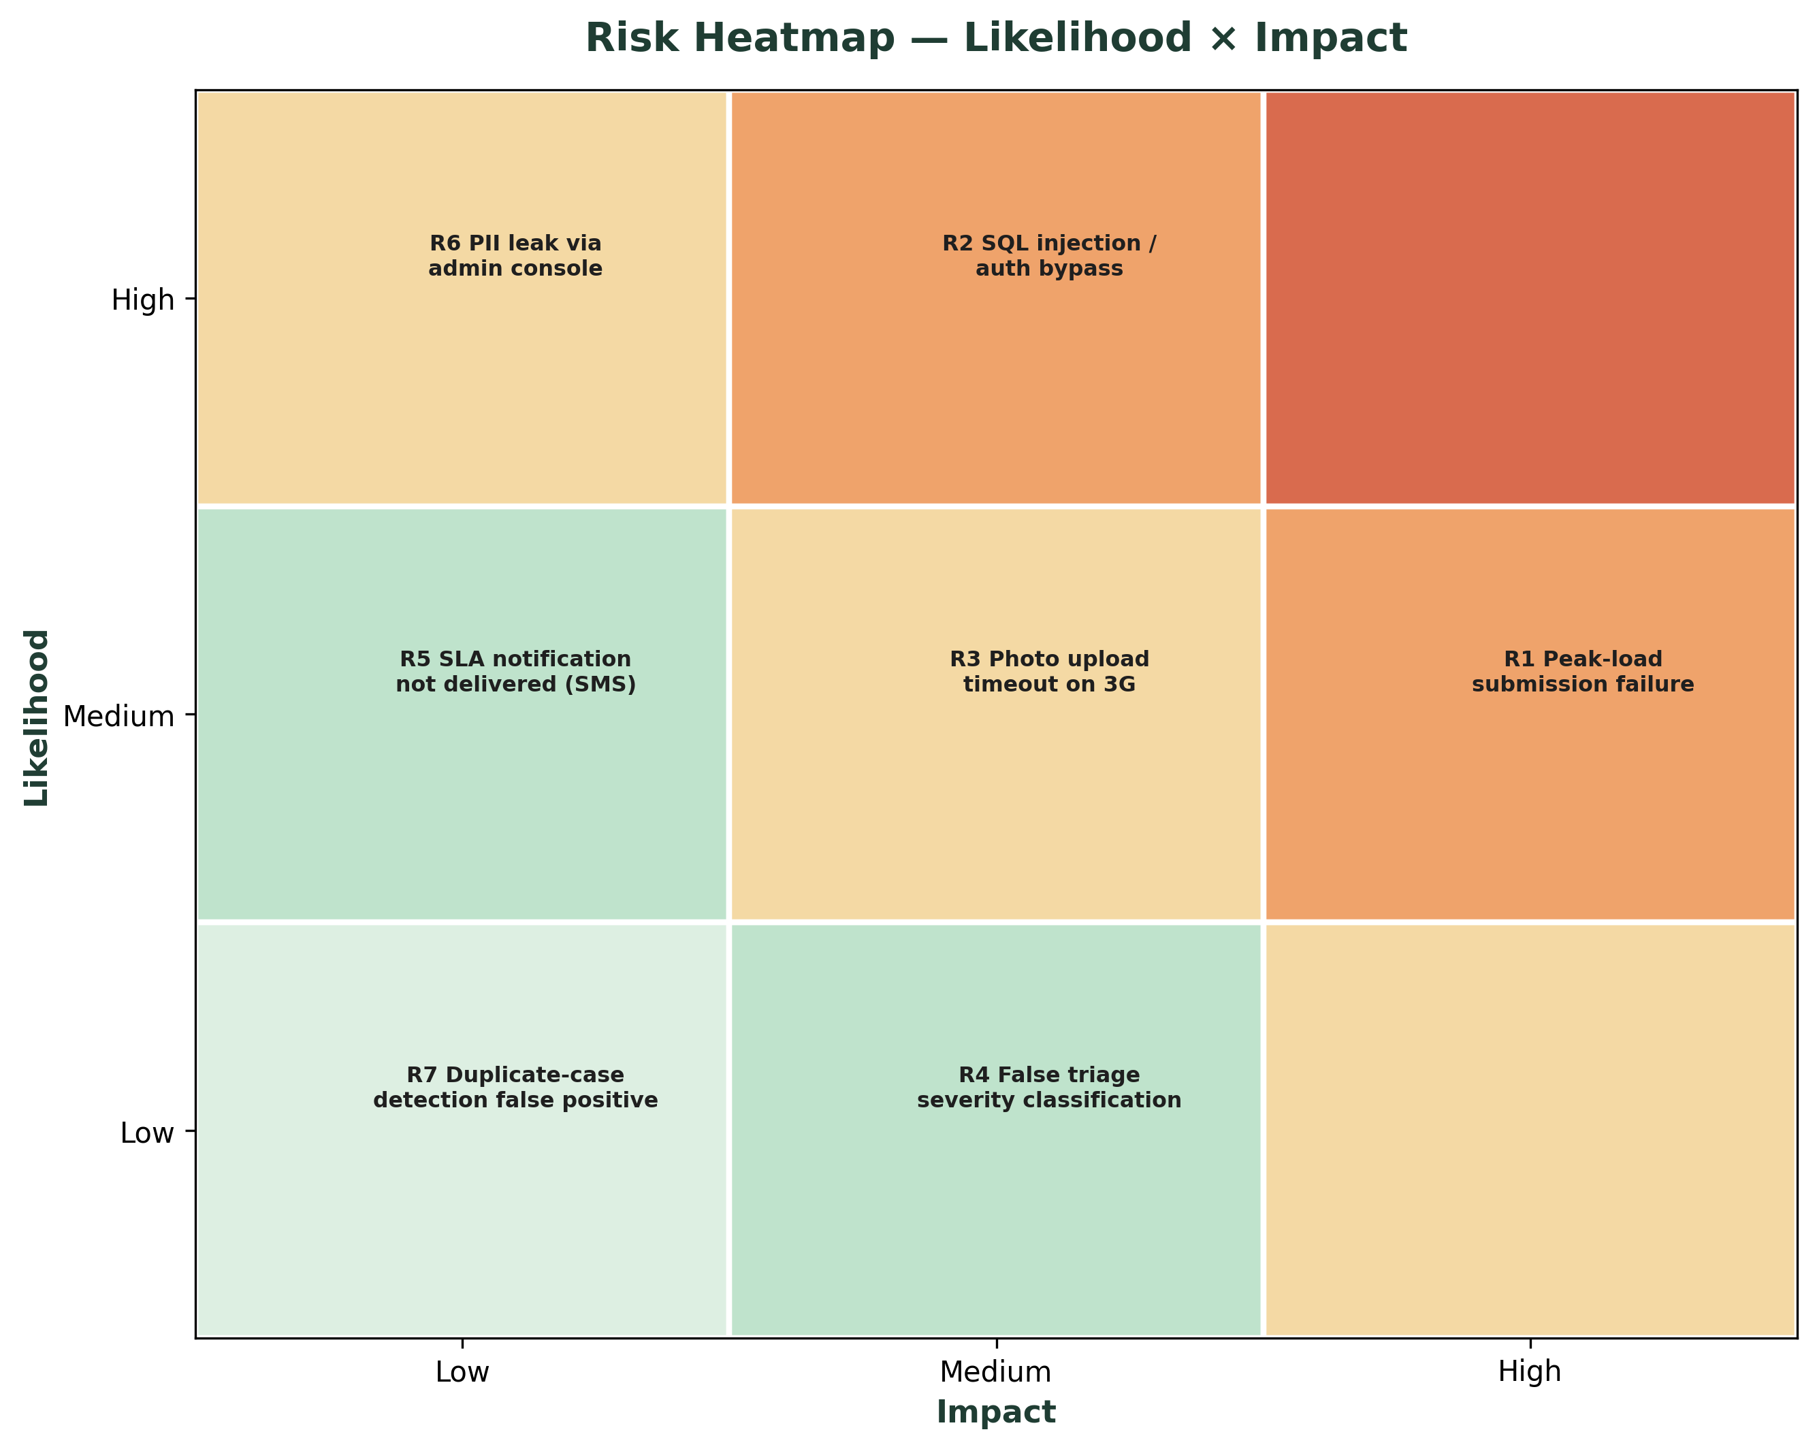
Figure 3 — Risk heatmap across the seven highest-priority risks identified for PashuMitra
Risk | Likelihood | Impact | Mitigation | Contingency
R1 — Peak-load submission failure during a rabies-scare surge | High | High | Load testing (TC-05) before every release; auto-scaling on the submission service | Queue-based fallback: accept the report and photo, process triage asynchronously if load spikes
R2 — SQL injection / auth bypass | Medium | High | Parameterised queries, input sanitisation, RBAC enforced server-side, automated OWASP ZAP scans | Web application firewall (WAF) as a second layer; incident response runbook
R3 — Photo upload timeout on poor 3G | High | Medium | Client-side image compression before upload; resumable upload with retry | Allow report submission without photo, flagged for follow-up photo request via SMS link
R4 — False triage severity classification | Medium | High | Conservative bias in the classifier (when uncertain, escalate to Urgent, never downgrade); human ward-officer review for Urgent queue | Manual override always available to ward officer; classifier logic reviewed monthly against real outcomes
R5 — SLA notification (SMS) not delivered | Medium | Medium | Dual-channel notification (SMS + push); delivery receipts monitored | In-app status always available even if SMS fails; retry queue for failed sends
R6 — PII leak via admin console or logs | Low | High | Field-level masking, access logging, no PII in application logs | Automated log-scanning for accidental PII; breach-notification runbook per IT Act requirements
R7 — Duplicate-case detection false positive suppresses a real case | Medium | Medium | De-duplication requires both geo-tag proximity and time-window match, not either alone | Citizen can explicitly mark 'this is a new/different case' to force a fresh entry

7. Defect Management & Reporting
Severity | Definition | Response target
Severity 1 — Critical | Data breach, incorrect urgent-case triage, complete submission failure | Fix within 4 hours, hotfix deployed same day
Severity 2 — High | Feature broken for a subset of users (e.g., one device type), incorrect SLA display | Fix within 2 business days
Severity 3 — Medium | Usability issue, non-blocking visual bug | Fixed in next sprint
Severity 4 — Low | Cosmetic issue, copy/text correction | Backlog, batched into a future release
Defects are logged with reproduction steps, environment, and severity in the team's issue tracker (Jira/GitHub Issues), linked back to the originating test case ID where applicable, so a fix can be verified by re-running the exact test that caught it rather than a fresh manual check.

8. Conclusion & Next Steps
This testing strategy closes the loop on the first three weeks: Week 1 defined what to build, Week 2 defined how it should look and behave, and this document defines how we'll know it's actually safe and reliable to hand to a municipal corporation. The risk-weighted approach means engineering effort goes first toward the failures that would hurt someone — a missed urgent case, a data leak, a submission outage during a genuine emergency — rather than spreading testing evenly across every feature regardless of consequence.
Week 4 would move into implementation: standing up the CI pipeline described in Figure 2, writing the first batch of unit and integration tests against the case-engine API, and scheduling the first ward-officer UAT session using the TC-01 through TC-07 scripts as the walkthrough guide.

