Internship Completion Report
Junior Web Developer — Virtual Internship Program
Project: PashuMitra — A Ward-Level Stray Animal Grievance & Care Coordination Platform
Submitted by
Bhoomi
B.Tech Computer Science & Engineering
IILM University, Greater Noida
Duration: 4 Weeks

1. Introduction
This report summarises a 4-week virtual internship undertaken in the role of Junior Web Developer, structured around a single continuous project: PashuMitra, a proposed e-governance digital service for municipal corporations. The internship was organised as a phased build-up — each week handed off directly into the next — moving from requirements analysis, through interface design, into a formal testing strategy, and finishing with a pre-launch audit against measurable performance, accessibility, and security benchmarks.
Rather than four disconnected assignments, the project was treated the way an actual product team would run a pre-development phase: define what to build and for whom, design how it should look and behave, define how it will be verified before launch, and finally audit a working build against that verification plan. A functional front-end prototype was also built independently to demonstrate the design in a real, clickable form.

1.1 Objectives of the Internship
- Apply web development and product-thinking skills to a realistic, socially relevant e-governance problem.
- Practice the full pre-build lifecycle of a digital product: requirements gathering, UX/UI design, QA strategy, and audit-based evaluation.
- Build and document professional-grade deliverables (project plans, design specifications, test strategies, audit reports) suitable for a real municipal stakeholder.
- Develop a working, testable prototype demonstrating the designed interface in functioning code.

1.2 About the Project — PashuMitra
PashuMitra ("friend of animals") is a ward-level stray animal grievance and care coordination platform, scoped for deployment by an Indian municipal corporation under the Animal Birth Control (ABC) Rules, 2023. Instead of modelling a generic citizen-complaint portal, the project is built around the actual legal workflow local bodies are required to follow — capture, sterilisation, vaccination, and release or shelter placement — and the real stakeholders involved: citizens, ward officers, AWBI-recognised NGOs, and veterinary teams. The subject was chosen deliberately to stand apart from a generic AI-generated submission and to connect to a real, ongoing interest in civic-tech and animal welfare coordination.

2. Week-wise Summary of Work

Week 1 — Planning & Requirements Analysis
Began with research and benchmarking against real existing initiatives (Panvel's ABC Helpline, MCD's feeding-point registry, DigiLocker/UMANG identity patterns) to ground the plan in what municipal bodies are already attempting. Defined four stakeholder personas, 12 functional requirements, 9 non-functional requirements, and a full risk analysis, documented with a stakeholder ecosystem diagram, a grievance-lifecycle flowchart, and low-fidelity wireframes.
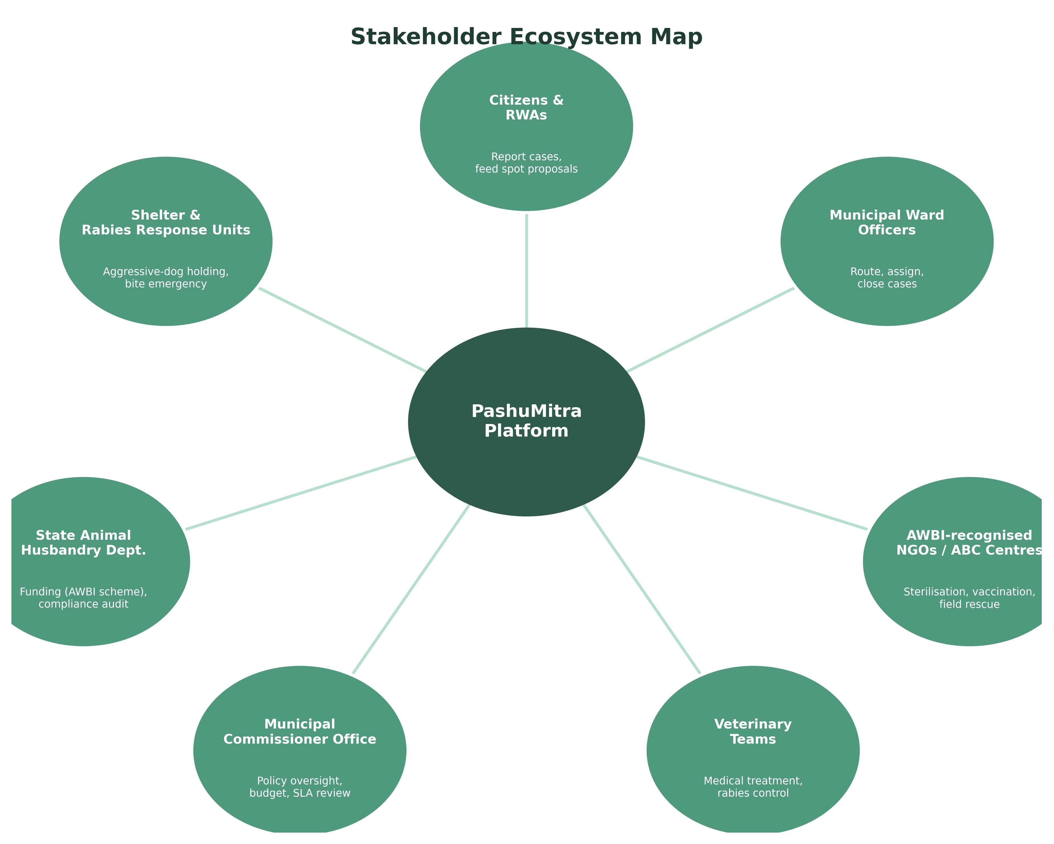
Figure 1 — Stakeholder ecosystem map produced in Week 1

Week 2 — Responsive Web Prototype Design
Translated the Week 1 requirements into an actual interface: a full site map and user flow, and high-fidelity mockups of the homepage and report-submission form across three real breakpoints (375px mobile, 768px tablet, 1440px desktop). Design decisions — photo-upload placement, auto-detected ward field, privacy microcopy — were each justified against a specific Week 1 requirement or persona pain point rather than chosen for visual preference alone.
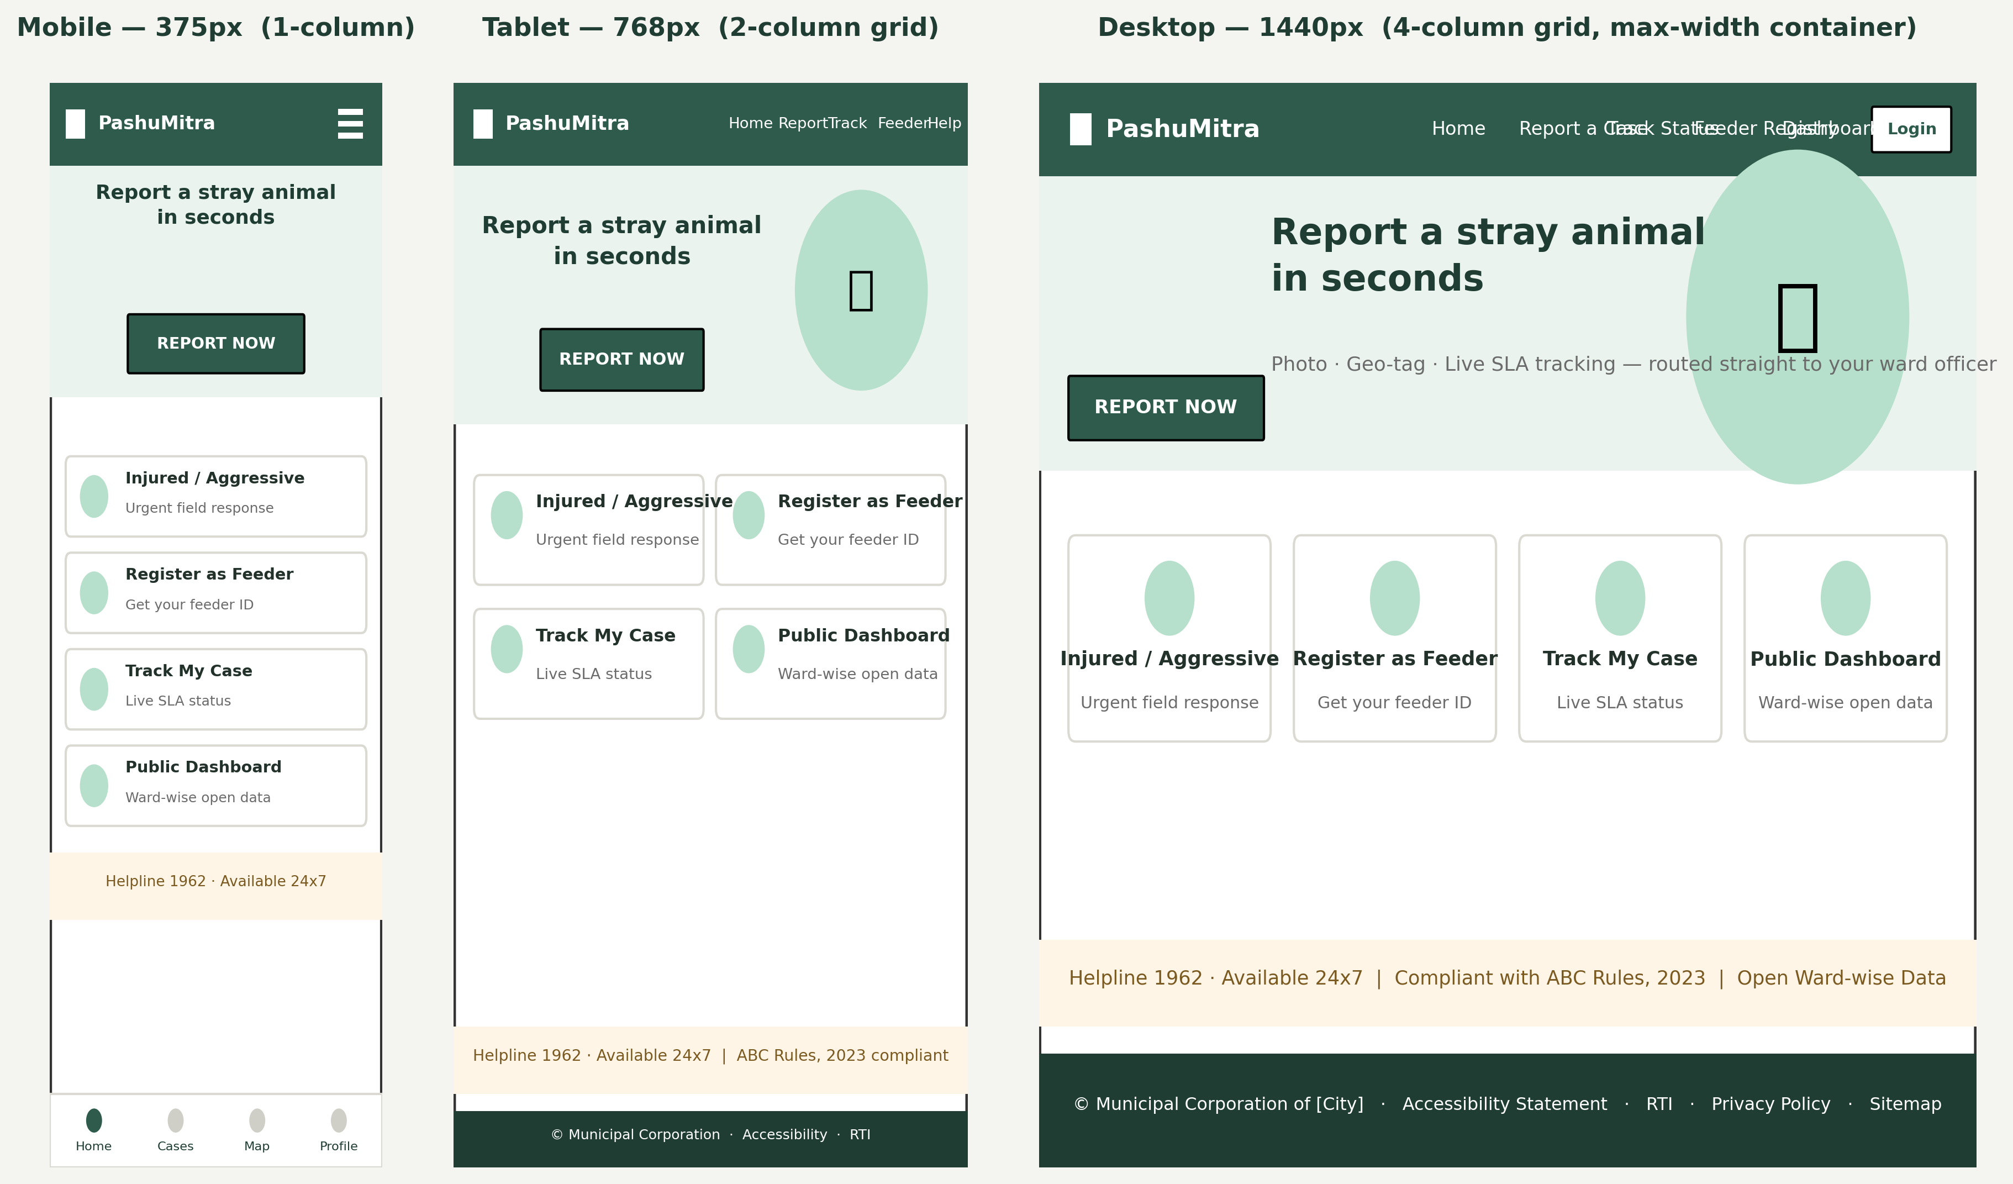
Figure 2 — Homepage design reflowing across mobile, tablet, and desktop breakpoints

Week 3 — QA & Testing Strategy
Defined a full test strategy organised as a test pyramid — unit, integration, system/API, end-to-end, performance, security, and accessibility testing — mapped to specific tooling (Jest, Cypress, k6, OWASP ZAP, axe-core) and a continuous testing pipeline where a failing stage blocks a pull request automatically. Seven detailed test cases were written with explicit pass/fail criteria, alongside a risk heatmap identifying the seven highest-priority risks with mitigation and contingency plans.
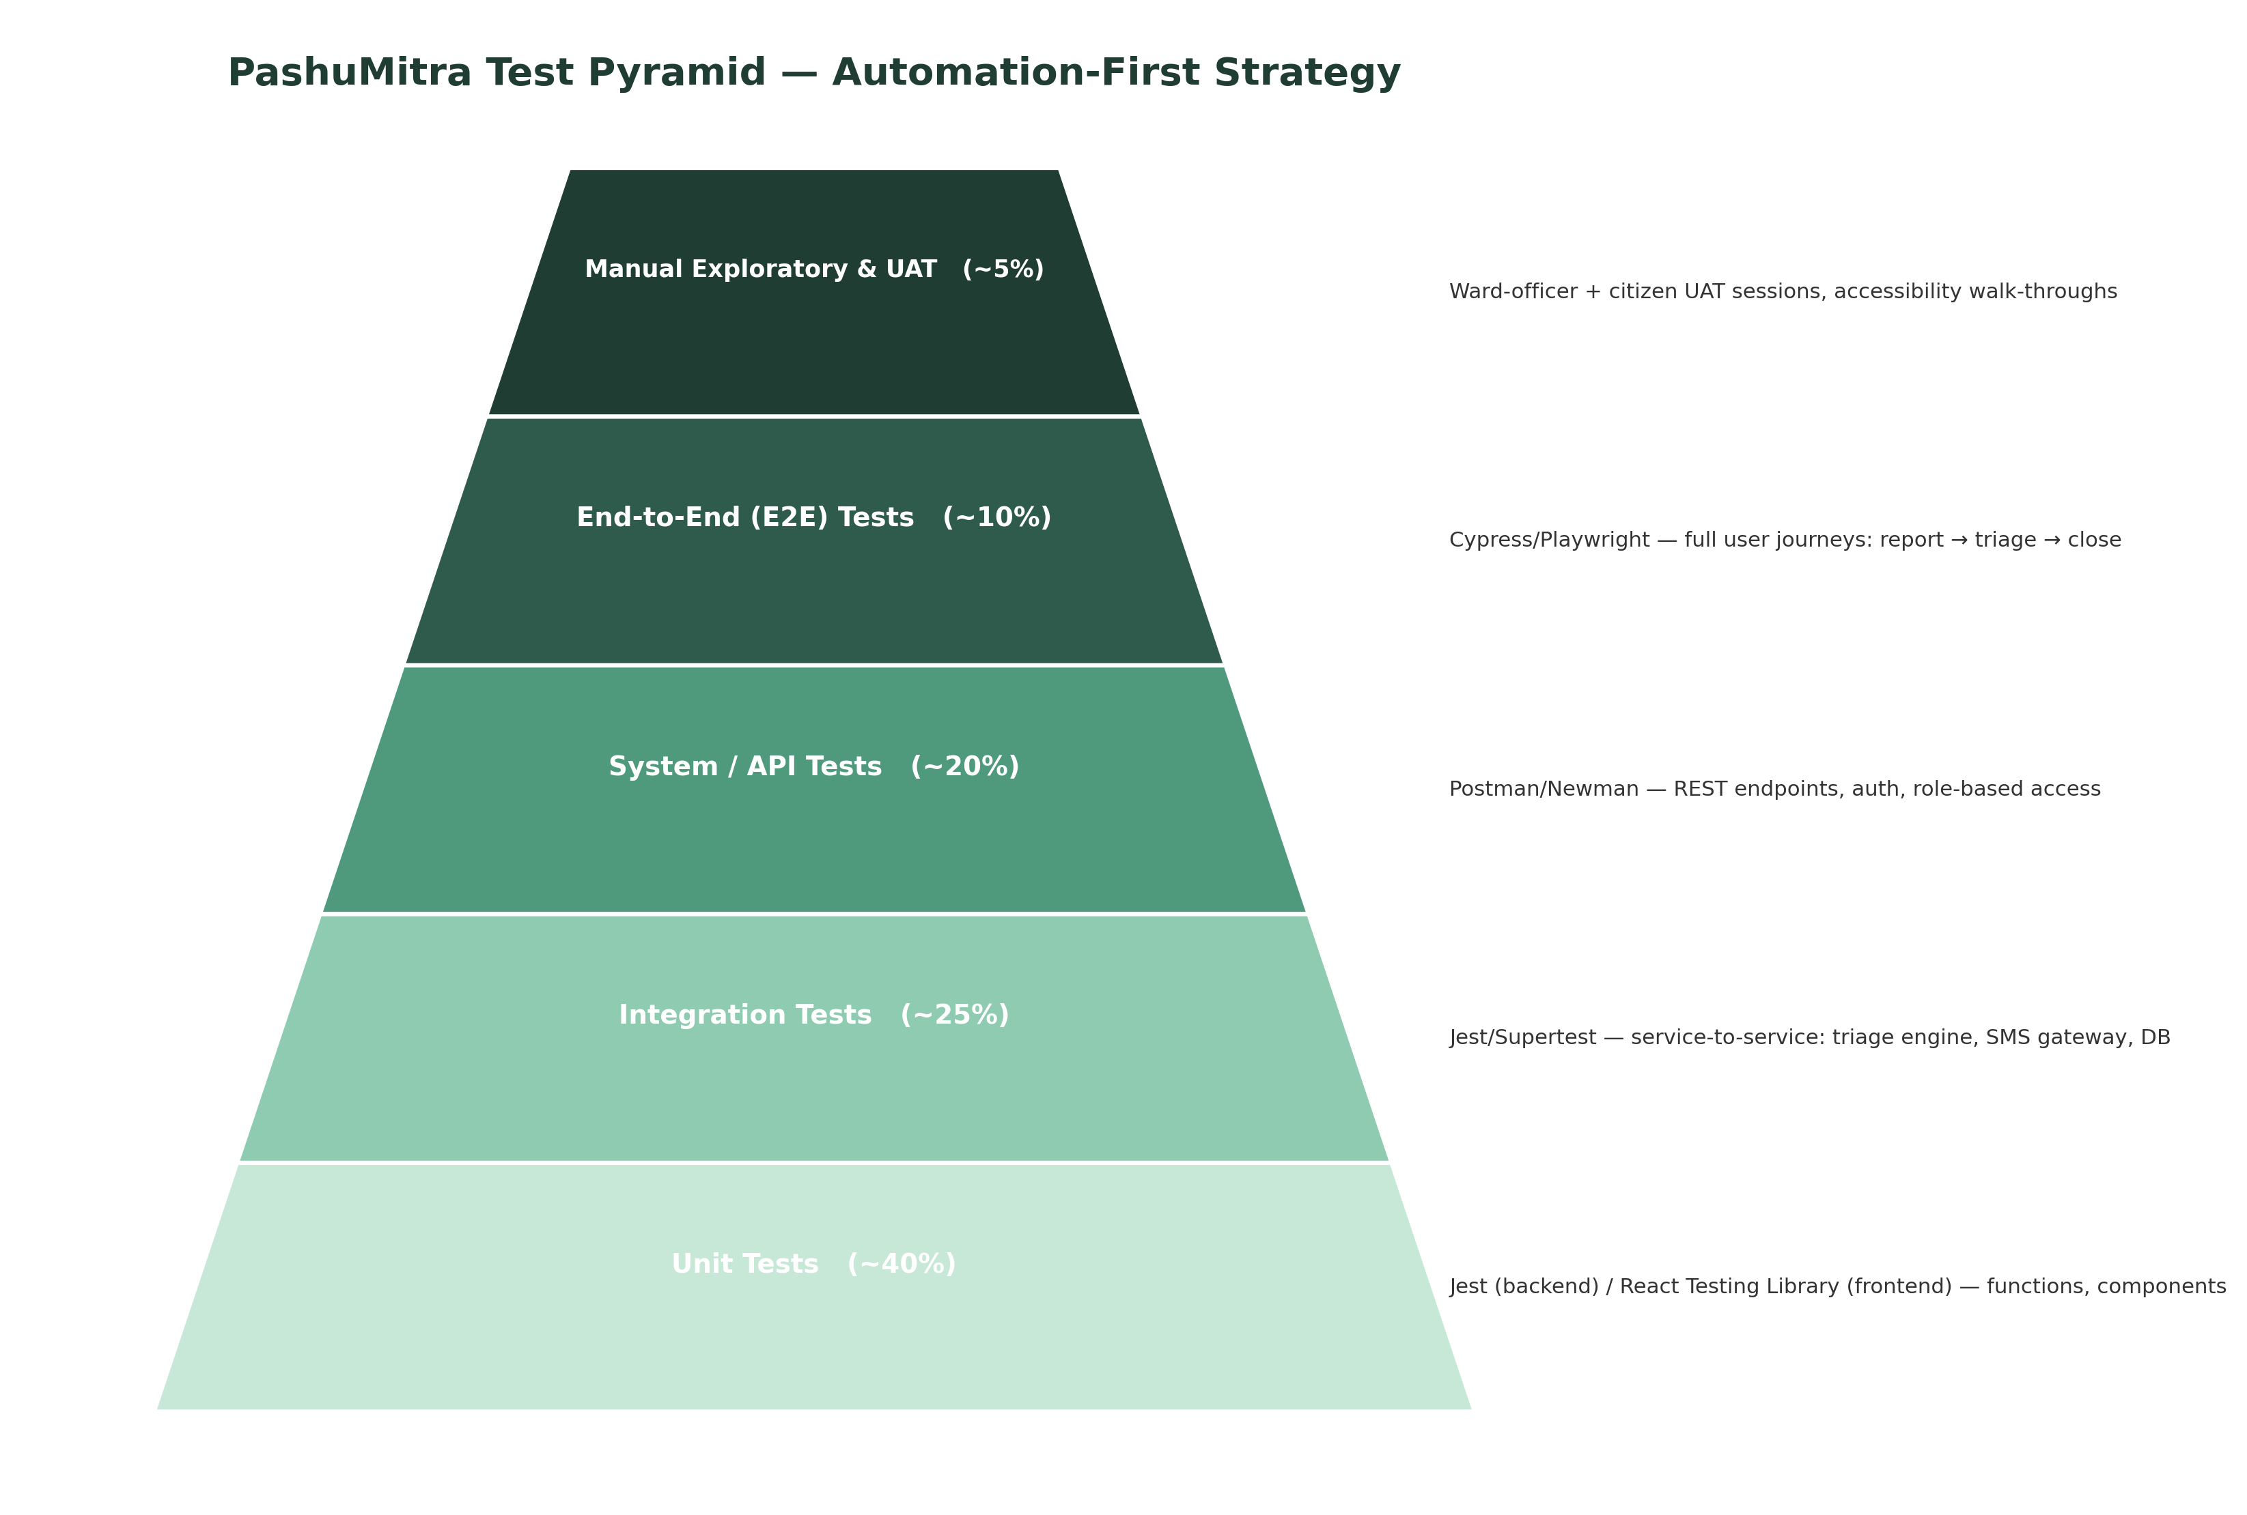
Figure 3 — Test pyramid defining the automation-first testing strategy

Week 4 — Performance, Accessibility & Security Audit
Audited a staging build of the citizen portal against Core Web Vitals, a full Lighthouse category breakdown, WCAG 2.1 AA accessibility criteria (organised by the POUR framework), and an OWASP-based security review. Findings included a critical broken-access-control vulnerability, stored XSS risk, and unmasked PII exposure — each paired with a concrete fix and prioritised P0/P1/P2 against a pilot-launch timeline.
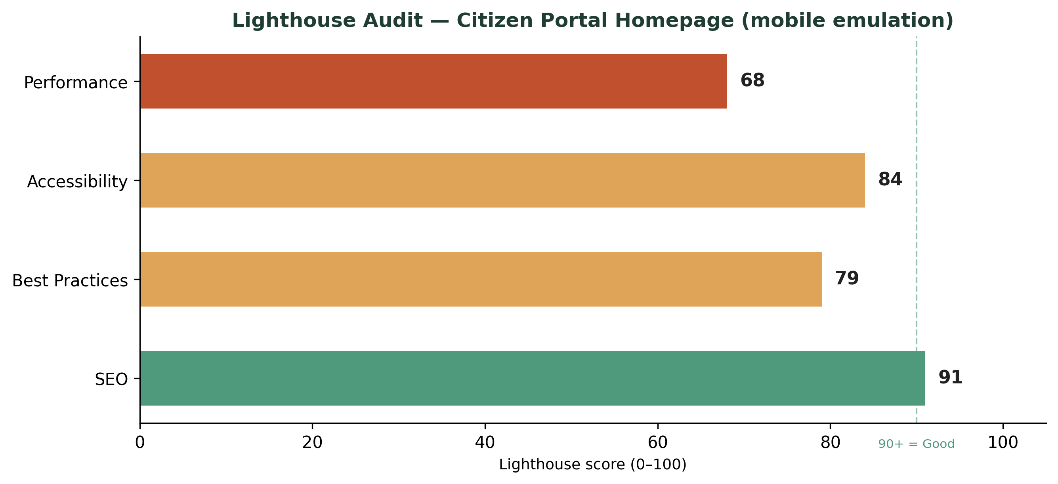
Figure 4 — Lighthouse audit scores for the citizen portal homepage

Beyond the Weekly Deliverables — A Working Prototype
In addition to the four documentation deliverables, a functional front-end build was developed independently to demonstrate the design in working code rather than static mockups alone. Built as a single-page application in vanilla HTML, CSS, and JavaScript, it includes real client-side form validation, a live case-tracking flow with a working status stepper, a feeder-registration flow that issues a working digital ID, and a dashboard that updates from live session data — all fully responsive and tested at both mobile and desktop widths.
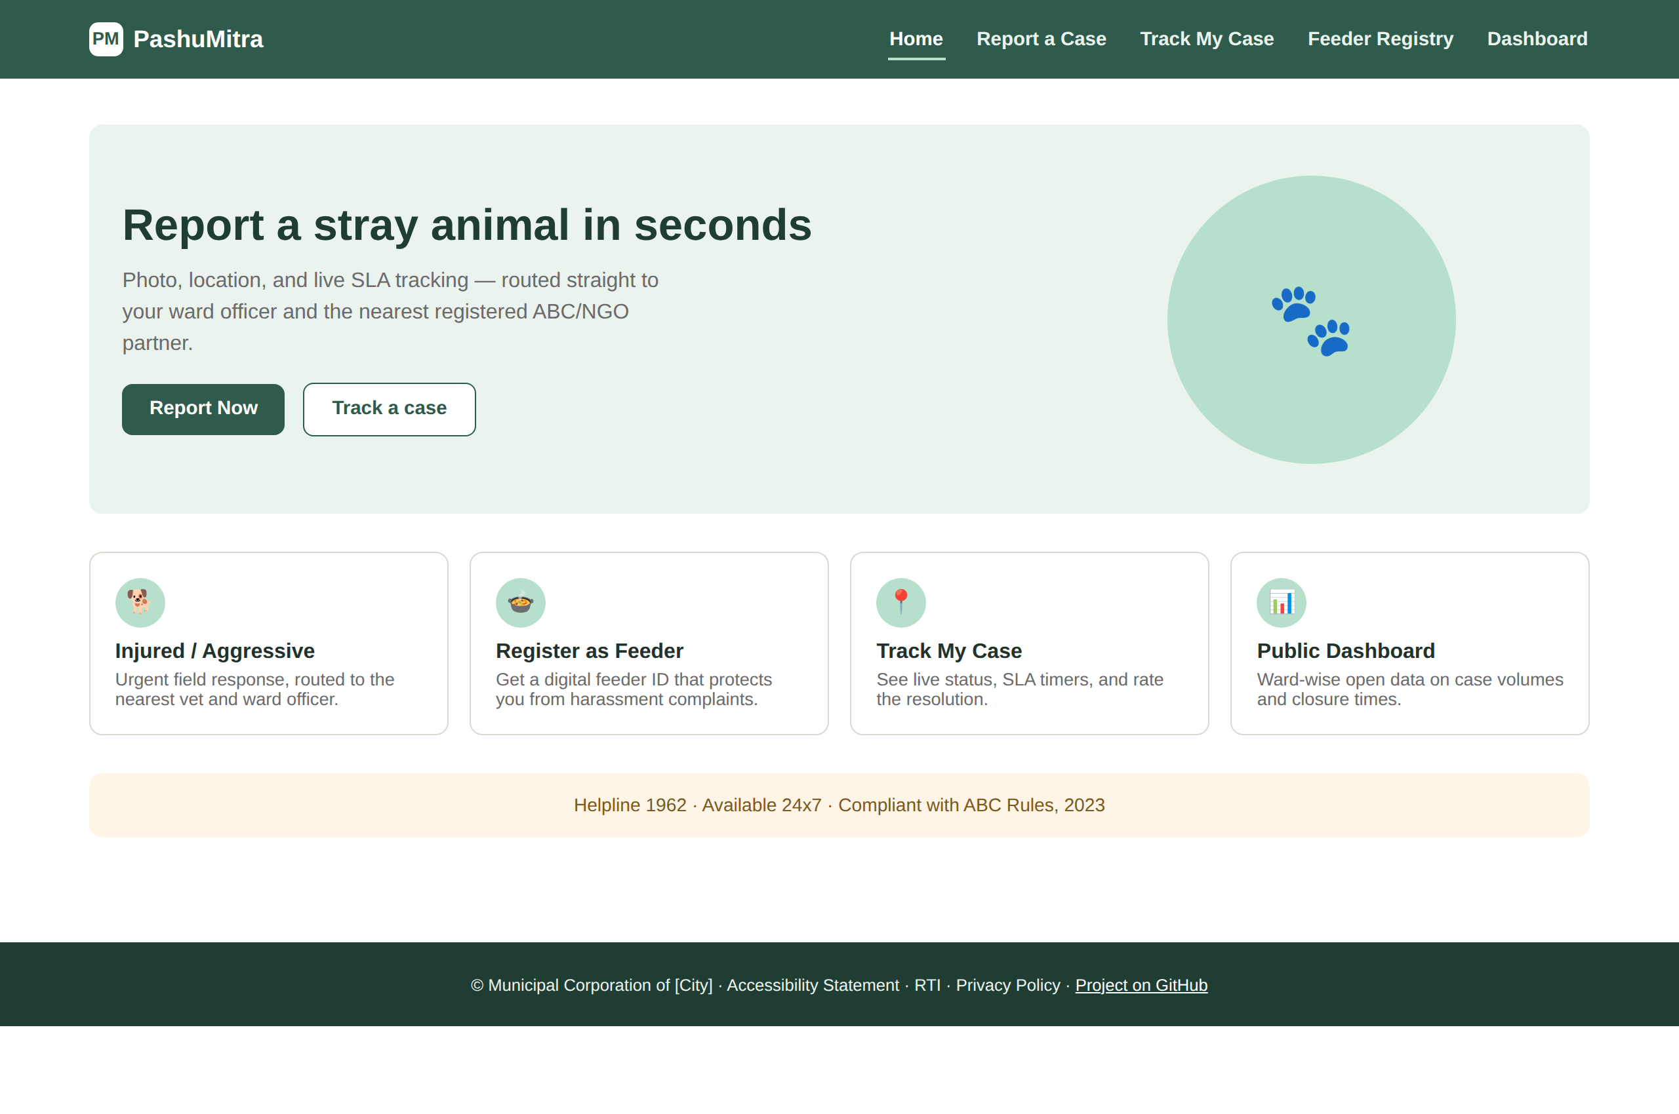
Figure 5 — Working prototype: the citizen portal homepage, rendered in-browser

3. Technical Skills & Tools Used
Category | Skills / Tools applied
Requirements & Planning | Stakeholder analysis, persona development, functional/non-functional requirement specification, risk analysis
UI/UX Design | Responsive/mobile-first design, fluid grid systems, WCAG 2.1 AA accessibility principles, wireframing and high-fidelity mockups
Front-end Development | HTML5, CSS3, vanilla JavaScript (DOM manipulation, form validation, client-side state management)
QA & Testing | Test pyramid design, test case writing, CI/CD pipeline concepts, risk-based test prioritisation
Performance & Security | Core Web Vitals, Lighthouse auditing, OWASP Top 10 vulnerability classes, accessibility auditing (axe-core, manual screen-reader testing)
Tooling & Version Control | Git and GitHub for version control and project hosting
Documentation | Structured technical report writing, data visualisation for audit/test findings, presentation design

4. Key Learning Outcomes
- Experienced the full pre-development lifecycle of a real digital product, rather than jumping straight to code — and saw firsthand how much a clear requirements phase simplifies every later decision.
- Learned to justify design decisions against specific user needs and requirements, instead of defaulting to what looks good — every mockup choice in Week 2 traced back to a named persona pain point or functional requirement.
- Gained a working, risk-weighted approach to QA: understanding that not every feature deserves equal testing effort, and that engineering time should follow where a failure would actually hurt someone.
- Built practical familiarity with accessibility and security auditing — reading a Lighthouse report, understanding WCAG's POUR structure, and recognising common vulnerability classes like broken access control and XSS well enough to explain and fix them.
- Practiced translating a static design into working front-end code, including form validation, state handling, and responsive layout, without relying on a framework or build tooling.
- Improved technical documentation and presentation skills — producing structured reports and a summary presentation that a non-technical stakeholder (e.g. a municipal official) could follow.

5. Challenges Faced
Challenge | How it was addressed
Scoping a project distinctive enough to avoid a generic 'citizen portal' template | Grounded the entire project in the real ABC Rules, 2023 legal workflow and researched actual existing municipal initiatives to build on real precedent rather than invented requirements
Keeping four weekly deliverables connected rather than disjointed | Explicitly traced every design decision, test case, and audit finding back to a specific requirement or persona defined in Week 1
Building a working prototype without a backend or framework | Used in-memory JavaScript state to simulate real data flow (case submission → tracking → dashboard) convincingly within a single static file
Setting up version control and a GitHub repository for the first time in this workflow | Worked through git's remote/commit/push cycle step by step, including diagnosing an incorrect remote URL and mismatched repository name

6. Conclusion
Over four weeks, this internship moved from a blank requirements document to a fully designed, tested-on-paper, and audited digital service concept — backed by a working front-end prototype built independently to prove the design out in real code. The consistent thread across every deliverable was traceability: nothing was designed, tested, or audited in isolation from what the previous week had established. That discipline — carrying decisions forward instead of treating each week as a fresh assignment — is the main professional habit this internship reinforced, alongside the concrete technical skills in responsive design, QA strategy, and security/accessibility auditing.
All reports, diagrams, and the working prototype for this project are available in a public GitHub repository, linked below.

Project Repository
https://github.com/bubiiiiiiiii/2024-2028_bhoomi_2410031616_5th_3cse25/tree/main

