**REPORT-I**

**gesture control robot arm**

Submitted towards the professional course

**15Z610 – EMBEDDED SYSTEMS LABORATORY**

Rahul .R(17z340)

Madhubala . R (18z468)

Vishnu .P.S(18z476)



**06 February 2020**

***Department of Computer Science and Engineering***

***PSG College of Technology,***

***Coimbatore - 641 004.***

**INTRODUCTION:**

Robots are increasingly being integrated into industries to replace humans especially

to perform the hazardous tasks. A robot is an electro-mechanical machine capable of

carrying out a complex series of actions automatically or under human supervision. These

are used in various fields such as industries, military, healthcare and research.

It might be dangerous for humans to perform some specific tasks like working with

explosive chemicals, defusing bombs and other hazardous works. Therefore, humans can be

replaced by robotic arm to perform the operations. A robotic arm is a robot manipulator,

usually programmable, with similar functions to a human arm. The robot arms can be

autonomous or controlled manually and can be used to perform a variety of tasks with great

accuracy.

Robots are increasingly being integrated into industries to replace humans especially

to perform the hazardous tasks. A robot is an electro-mechanical machine capable of

carrying out a complex series of actions automatically or under human supervision. These

are used in various fields such as industries, military, healthcare and research.

It might be dangerous for humans to perform some specific tasks like working with

explosive chemicals, defusing bombs and other hazardous works. Therefore, humans can be

replaced by robotic arm to perform the operations. A robotic arm is a robot manipulator,

usually programmable, with similar functions to a human arm. The robot arms can be

autonomous or controlled manually and can be used to perform a variety of tasks with great

accuracy.

Robots are increasingly being integrated into industries to replace humans especially

to perform the hazardous tasks. A robot is an electro-mechanical machine capable of

carrying out a complex series of actions automatically or under human supervision. These

are used in various fields such as industries, military, healthcare and research.

It might be dangerous for humans to perform some specific tasks like working with

explosive chemicals, defusing bombs and other hazardous works. Therefore, humans can be

replaced by robotic arm to perform the operations. A robotic arm is a robot manipulator,

usually programmable, with similar functions to a human arm. The robot arms can be

autonomous or controlled manually and can be used to perform a variety of tasks with great

accuracy.

Robots are increasingly being integrated into industries to replace humans especially

to perform the hazardous tasks. A robot is an electro-mechanical machine capable of

carrying out a complex series of actions automatically or under human supervision. These

are used in various fields such as industries, military, healthcare and research.

It might be dangerous for humans to perform some specific tasks like working with

explosive chemicals, defusing bombs and other hazardous works. Therefore, humans can be

replaced by robotic arm to perform the operations. A robotic arm is a robot manipulator,

usually programmable, with similar functions to a human arm. The robot arms can be

autonomous or controlled manually and can be used to perform a variety of tasks with great

accuracy.

Robots are increasingly being integrated into industries to replace humans specially to perform the hazardous tasks. A robot is an electro-mechanical machine capable of carrying out a complex series of actions automatically or under human supervision. These are used in various fields such as industries, military, healthcare and research.

It might be dangerous for humans to perform some specific tasks like working with explosive chemicals, defusing bombs and other hazardous works. Therefore, humans can be replaced by robotic arm to perform the operations. A robotic arm [2] is a robot manipulator, usually programmable, with similar functions to a human arm. The robot arms can be autonomous or controlled manually and can be used to perform a variety of tasks with great accuracy.

**PROBLEM STATEMENT:**

The gesture-controlled Robot arm [2][3] will function by a wearable hand glove from which the movements of the hand can be used as the input for the movement of the robot. The basic idea of our project is to develop a system (Robot) which can recognize the Human Interaction with it to accomplish the certain tasks assigned to it. In our project we will design a wearable Hand Glove which will contain the sensors (flex sensor) [1] mounted on it to capture the movement of the hand and convert the raw mechanical data into electrical form. This data will be further processed and converted into an understandable format for the Arduino Uno mounted on the Glove. Arduino UNO will deduce the commands and accordingly it will actuate the motor drivers to control the Motors [4] for various tasks on the robot.

**COMPONENTS REQUIRED:**

* Arduino UNO
* Handmade Flex Sensor
* 10k Resistor
* Glove
* Bread board
* Glue gun
* Glue stick
* Jumper wires
* DGServo 9g
* Strings
* Foam
* Bell pin

**SCHEMATIC DIAGRAM:**

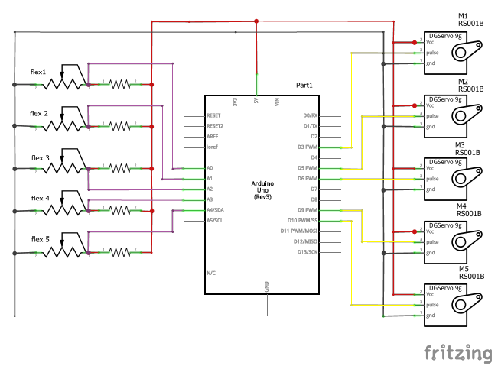

**CODE:**

#include<Servo.h>

Servo m1;

Servo m2;

Servo m3;

Servo m4;

Servo m5;

const int f1=A0;

const int f2=A1;

const int f3=A2;

const int f4=A3;

const int f5=A4;

void setup() {

// put your setup code here, to run once:

m1.attach(3);

m2.attach(5);

m3.attach(6);

m4.attach(9);

m5.attach(10);

Serial.begin(9600);

}

void loop() {

// put your main code here, to run repeatedly:

int fs1;

int fs2;

int fs3;

nt fs4;

int fs5;

int sp1;

int sp2;

int sp3;

int sp4;

int sp5;

Serial.println(analogRead(A0)); //thumb finger

fs1= analogRead(f1); //reads the input from the port A0

sp1=map(fs1,1015,1020,0,180); //just map the values of flux variation with servo motor rotation

sp1=constrain(sp1,0,180); //to maintain the constant values

m1.write(sp1); // fixes the values in the servo motor

//fore finger

fs2= analogRead(f2); //reads the input from the port A1

sp2=map(fs2,0,50,0,180); //just map the values of flux variation with servo motor rotation

sp2=constrain(sp2,0,180); //to maintain the constant values

m2.write(sp2); // fixes the values in the servo motor

//middle finger

fs3= analogRead(f3); //reads the input from the port A2

sp3=map(fs1,1020,1022,0,180); //just map the values of flux variation with servo motor rotation

sp3=constrain(sp3,0,180); //to maintain the constant values

m3.write(sp3); // fixes the values in the servo motor

//ring finger

fs4= analogRead(f4); //reads the input from the port A3

sp4=map(fs4,1005,1008,0,180); //just map the values of flux variation with servo motor rotation

sp4=constrain(sp4,0,180); //to maintain the constant values

m4.write(sp4); // fixes the values in the servo motor

//index finger //reads the input from the port A4

fs5= analogRead(f5);

sp5=map(fs5,1000,1006,0,180); //just map the values of flux variation with servo motor rotation

sp5=constrain(sp5,0,180); //to maintain the constant values

m5.write(sp5); // fixes the values in the servo motor

}

**CHELLENGES FACED:**

* Making a flex sensor.
* Making a robot arm.

**CONTRIBUTION OF TEAM MEMBERS:**

* Rahul- to making flex sensor.
* Madhubala- to making flex sensor.
* Vishnu- to making flex sensor and robot arm, coding .

**REFERENCES:**

[1]<https://www.hackster.io/SHAHIR_nasar/simple-homemade-flex-sensor-ff54f0>

[2]<https://en.wikipedia.org/wiki/Robotic_arm>

[3]<https://www.researchgate.net/publication/272023064_A_Simple_Solution_for_Programming_of_a_Robotic_Arm>

[4]<https://www.allaboutcircuits.com/projects/servo-motor-control-with-an-arduino/>

**SNAP SHOT OF PROJECT:**

