Raspberry Pi based Interactive Home Automation
Iskandar Askarov Navya Kollapally Martin Sonale Palliparangattu Mullepattu

New Jersey Institute of Technology, Newark , New Jersey
ia253@njit.edu,nk495@njit.edu,sp2486@njit.edu

Abstract— A home automation system is a technological solution that enables automating bulk of electronic, electrical and technology-based tasks within a home. In this report, we are presenting a prototype of home automation with Raspberry Pi. To design this system, we are using a Raspberry pi 3b+ model, pi camera module, Passive Infrared sensors and buzzers. In the proposed system, we can control electronic devices connected through a web-based application, email and REST API’s. LEDs are used to indicate the switching action. Raspberry pi controls motion sensors and video camera for sensing and surveillance. The designed system detects intruder’s presence, captures their identity and alerts the user with a video of the activity through SMS and Email. The system also activates devices when user enters his house. We also evaluate the performance of the designed system using various techniques.
Keywords—Raspberry Pi, E-mail, SMS, Home Automation, Python, Profiling
I. INTRODUCTION
Home automation is expanding to greater horizons with the potential to make home a service rich environment. We still face many challenges with respect to the overheads while designing a smart home system. Till now the various automation techniques were implemented using micro controllers and computers. Using Microcontrollers, it is difficult to control both the appliance and surveillance at the same time; which in-turn makes simultaneous execution of multiple functions complex. Using computers for implementation provides ease with complex functions, but at the same time increase the overall cost. The prototype we build is a solution to this using Raspberry pi, a system that functions like a computer with very small setup .It contains GPIO pins and USB ports for various external hardware/device connections. These ports not only provide a user-friendly interface for camera surveillance but also helps to control the electronic devices using sensors. The presented system is interactive and flexible. The devices can
be controlled either through email or web interface and can be enabled to perform automatically.

II. GOALS
The main aim of this project was to develop a cost effective and energy efficient home automation system using Raspberry Pi. The project can be quantified as three phases and was developed by achieving the following milestones.

A. Physical deployment and setup.
The main external modules used in this project are Passive Infrared Sensors(PIR), Pi camera and GPIO extension cables. The testing of individual components, setup and integration of these devices with Raspberry pi were done in this phase of project. PIR sensor has 3 pins : Input , Output and Ground. The pins of PIR sensor was connected to the corresponding GPIO pins of raspberry pi through GPIO extension cable and tested to ensure that on detection of motion, the LED’s connected to GPIO pins of pi were turned on. Pi camera module has a cable strip which is inserted to the cable slot between the HDMI port and ethernet port on raspberry pi. After updating the Raspberry Pi camera configuration, Pi camera captured an image when necessary python commands were given in the terminal.
B. Design and develop controller and notification.
In this phase of project, the system was able to be controlled using the commands specified in email, web user interface, REST API’s. The web interface developed in this phase of project enables the user to view the status of various devices like PIR sensors, Lights, Fans and change the device status. i.e., to switch ON or OFF devices. When sensors are turned on either through email or web interface , it will enable automate the surveillance and control of devices in the room
When the PIR sensor near the door detects an intruder, a real time image and a short video was sent to the user’s mobile number. Twilio messaging gateway was used to send SMS and this process was done as long as user disable the notification. Motion activated devices were implemented using PIR sensors and LED’s and when motion is detected in a room, the lights and Fan were switched on. The status of these devices was updated in the MySQL database.
C. Testing and Performance evaluation of the system.
In this phase, we tested the working of the overall system and evaluated the performance using various profiling techniques. SQL profiling, Python profiling and Web server benchmarking was performed. We also compare the performance of the various interfaces we are using to control the devices.
III. IMPLEMENTATION AND INSTALLATION
Raspberry Pi 3b+ model is used as the device controller because of its cost effectiveness and ease in connecting with external modules. As this model of raspberry pi has built-in Wi-Fi, no additional Wi-Fi dongles were required to connect to the network. The programming language used in developing the system is Python 2.7. The system is developed such that the end user gets the current status (i.e., ON or OFF) of each devices and also get images and video captured by Pi camera as SMS notification when intruder is detected. The python program reads the status of the device and stores the status and history of device activity in MySQL database version 5.7 which is accessible to the web application. Apache 2.4 web server is used to host the system. The basic block diagram of the proposed system is given in Figure 1.
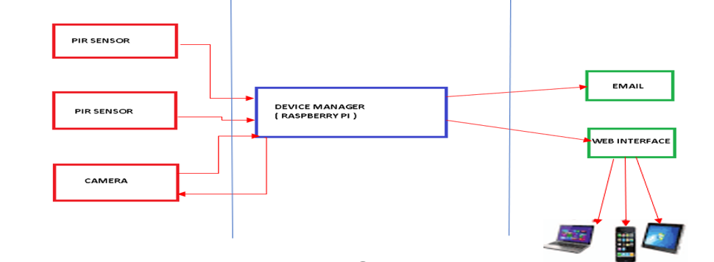
Figure 1. Basic block diagram
Raspbian operating system is installed in Raspberry pi. Raspbian is a Linux based OS which supports Python, C, C++.Python 2.7 language is used to communicate with the General purpose input output devices and MySQL database. The GPIO pin diagram of raspberry pi 3b+ is given in Figure 2.
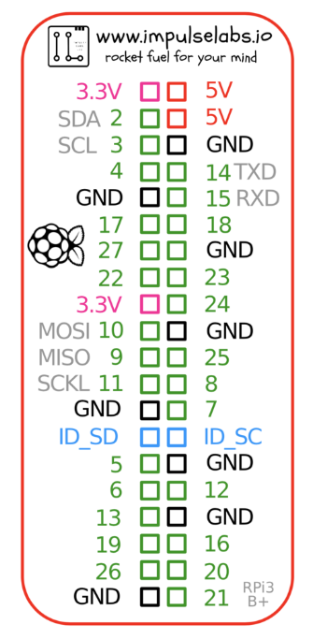

Figure 2. GPIO pinout diagram of Raspberry Pi 3b+
GPIO pin 7 is used for getting output from PIR sensor attached to the camera and pin 11 reads the output from PIR sensor in the room which controls the devices.
Any new or missing packages were installed in Raspberry Pi and Pi camera module was installed using the below code.
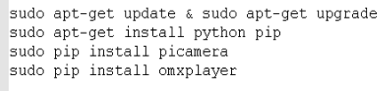
MySQL database server, client and connectors were installed using the below code.
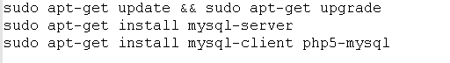
To complete the stack below packages will need to be installed using apt package manager.
sudo apt-get install apache2
sudo apt-get install libapache2-mod-wsgi
source tarball contains requirments.txt file which lists all necessary python modules for application deployment. These can be installed via command listed below.
pip install -r requirements.txt
IV.SYSTEM DESIGN
Our project tries to provide management of devices through various interfaces. The devices and sensors can be switched ON and OFF through web interface, email and REST API’s. If the sensors are turned on, it will automate the process of switching ON and OFF of the devices. If the sensors are turned OFF, devices can be switched remotely from the web user interface and email. A considerable amount of energy can be saved this way.
The logical flow diagram of the system is shown in the Figure 3 given below. High power usage can be recognized from the device activity log.
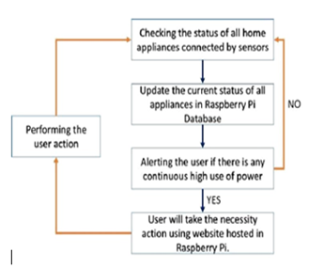
Figure 3. Flow chart of the system

A. Database Design
The system stores the status of each devices and also maintain the device activity in a database. The database used for this prototype is MySQL 5.7 and consists of mainly 4 tables to stores device details and one table for user authentication details. The schema diagram is shown in Figure 4 given below.
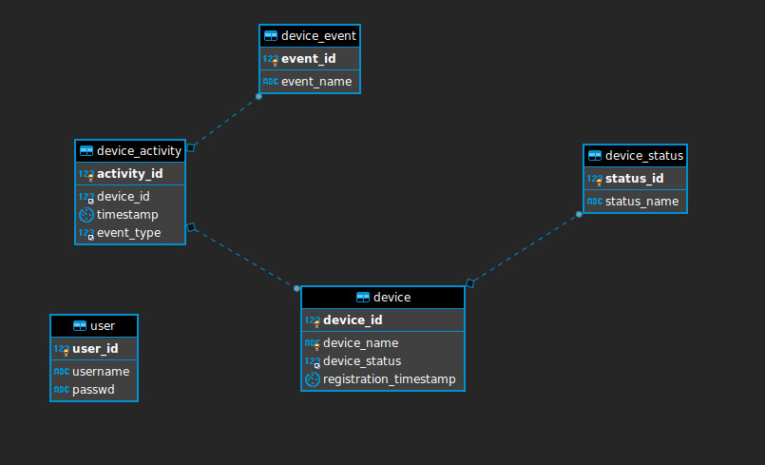
Figure 4. Schema diagram
B. Front End Design and Email parsing:
We used light weight Flask web framework to design REST API. Web service listens on http://{FQDN}/action for POST requests in JSON format. Listing below gives payload sample for device FAN_1 to be turned off.
{‘device_id’: 2, ‘action’: 0}
When above payload is received, device object is retrieved from application context and signal(False) is called on “FAN_1” object resulting a 0x0 to be sent to GPIO PIN where “FAN_1” is connected.
For Web UI we used Twitter Bootstrap framework that allowed us build web forms swiftly. Web UI performs a web call to REST web service listed above to control connected devices using a function written in JavaScript and bind to HTML button object.
C. Notification :
When the PIR sensor for the surveillance system detects any intruder, it sends an SMS through Twilio messaging gateway. The 10 second video taken by the pi camera is stored in imgur which is an online image and video sharing community and image host. Twilio gateway picks up the image and video from this server and sends it to the user through SMS .
V.RESULT AND ANALYSIS
The prototype we build is a cost-effective alternative of Smart homes. The system allows control of devices through three interfaces : Email, Web user interface and through Rest API’s. When sensors are turned ON, it allows automatic control of surveillance system and motion activated electronic devices.
The web interface for viewing the status and controlling the devices is shown in figure 5 and figure 6.
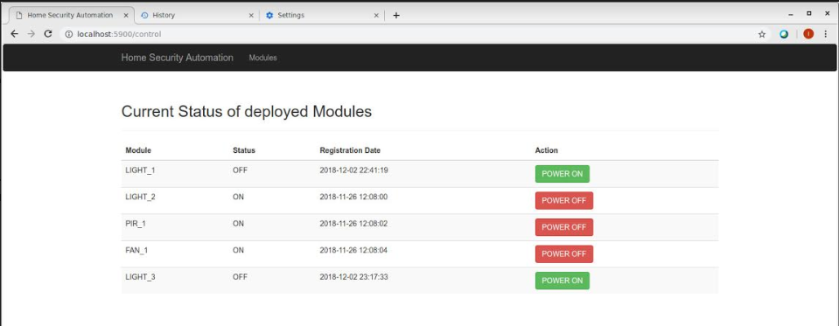
Figure 5. Webpage showing device status
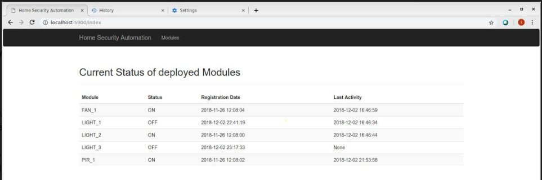
Figure 6. Webpage showing device activity.
The email control of devices is implemented using Python code. A sample email received by raspberry pi Gmail account is shown figure 7 below. The devices respond to the instruction in the email.
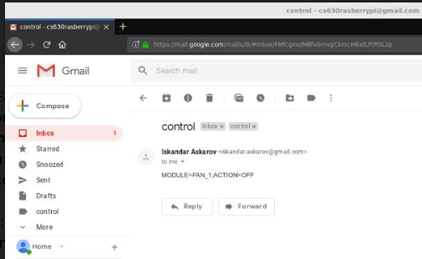
Figure 7. Payload example
The user is able successfully receive SMS when intruder is detected by the PIR sensor. A sample SMS is given in Figure 8.
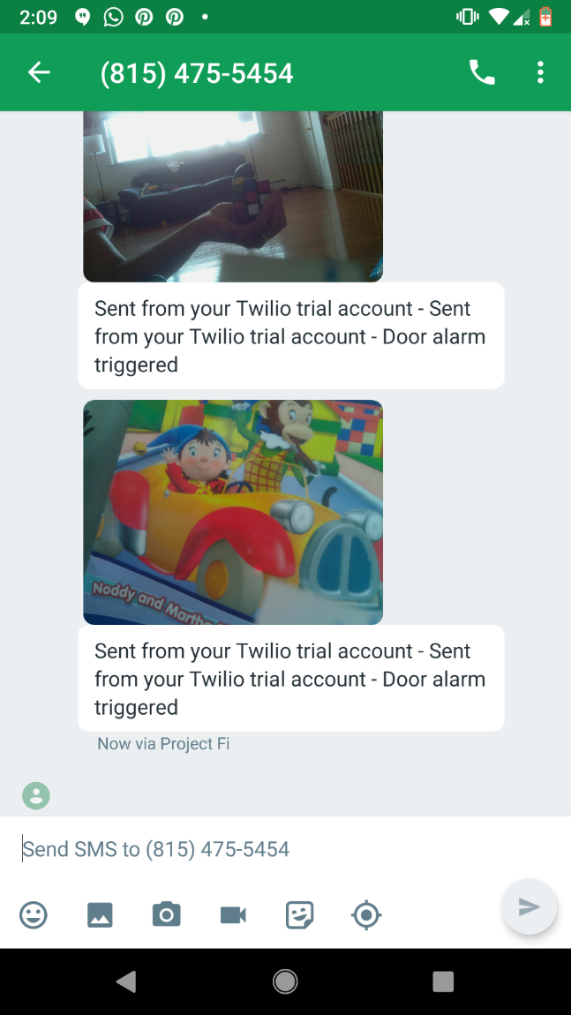
Figure 8 : SMS alert when intruder is detected.
Our analysis included profiling of python and SQL code to identify bottlenecks. Fortunately, due to simplicity of the application no bottlenecks were identified.
SQL Profiling:
SQL query that produces largest results set ran in 0.00270350 seconds. Profile_results.txt provided in source tarball lists SQL profiler table.
Python profiling:
We used cProfile module to analysis our code. No bottlenecks were identified during our analysis. Source Tarball contains autohome.prof file that contains profiler information about our sample run.
One can run pyprof2calltree -k -i autohome.prof to view profiling information.
Web server benchmarking:
Total of 2000 requests were created to benchmark our web server. Mean value of TpR was 9.766ms for all concurrent connections. We used ab tool for load testing. Tarball contains http_ab.txt with results of our load testing.
Interface testing and comparisons:
We ran singular tests on each of the interfaces (Web UI, REST and Email). File named control-test.txt lists the results of our testing. Results of our tests are listed below.
a)Email: Testing of control via email includes retrieval of email message, parsing of a payload in a message and performing a web call to API endpoint. All these steps were consolidated in a single python script “email_parser.py”. Hence, we used standard “time” utility provided in Linux to measure total execution time of a script. Control of one device was completed in 19.774 seconds.
b)Web UI: We used standard JavaScript console.time() and console.timeEnd() functions to measure execution of a function action_device(int, int). Function was successfully returned in 11.117ms.
c)REST API: A web call to webservice endpoint was wrapped in standard python function time() in email_parser.py script. Webcall() function was returned in 15.6 seconds.
The reason for python calls to under-perform is because there were executed directly on Raspberry Pi system. Whereas JavaScript files are part of Web UI and are loaded along with the rest of HTML objects into the browsers cache. Hence, on opening of a “control” page, JavaScript calls are executed on client’s machine.
VI. LESSONS LEARNED AND RELATED WORKS
Raspberry Pi is very convenience to use in educational purposes such as to prototype or to provide a proof of a concept. However, considering the resource constraints, it is not recommended to use in production environment.
VII. CONCLUSION
The developed system using raspberry pi 3 B+ is an affordable alternative to micro controllers. Any other devices like temperature, humidity sensors, gas detectors can be connected to the developed system. The model is effective in reducing energy consumption.

IX. ACKNOWLEDGEMENT

We would like to extend our gratitude to our Professor.
Jing Li for providing valuable guidance throughout this project.

X. REFERENCES

- 1M.P.Sathish, 2Dr. S.A.K.Jilani, 3Mr.D.Girish kumar ,”Home Automation through E-Mail using Raspberry Pi “,International Journal of Advanced Research in Electronics and Communication Engineering (IJARECE) Volume 4, Issue 9, September 2015
- Vamsikrishna, Patchava; Sonti Dinesh Kumar; Shaik Riyaz Hussain; RamaNaidu,K., "Raspberry PI controlled SMS-Update-Notification (Sun)system,"Proceeding of IEEE International Conference on Electrical,Computer and Communication Technologies (ICECCT 2015), pp.1-4, 5-7 March 2015
- Soundhar Ganesh S, Venkatash S, Vidhyasagar P, Maragatharaj S,” Raspberry Pi Based Interactive Home Automation System through Internet of Things”

