- Create Database

mysql> use database Online_Shopping;
mysql> use Online_Shopping;

- Design Schema

create table Customer ( user_id varchar(20) not null unique, firstName varchar(255) not null, secondName varchar(255) not null, email varchar(255) not null unique,adress varchar(255), primary key(user_id));

- Create tables

create table Sales (sales_id bigint(20) not null unique, firstName varchar(255) not null, secondName varchar(255) not null, email varchar(255) not null unique,adress varchar(255), primary key(sales_id));

create table Orders ( order_id bigint(20), order_name varchar(255), user_id , sales_id, foreign key(user_id) references Customer(user_id), foreign key(sales_id) references Customer(sales_id));

- Insert sample data

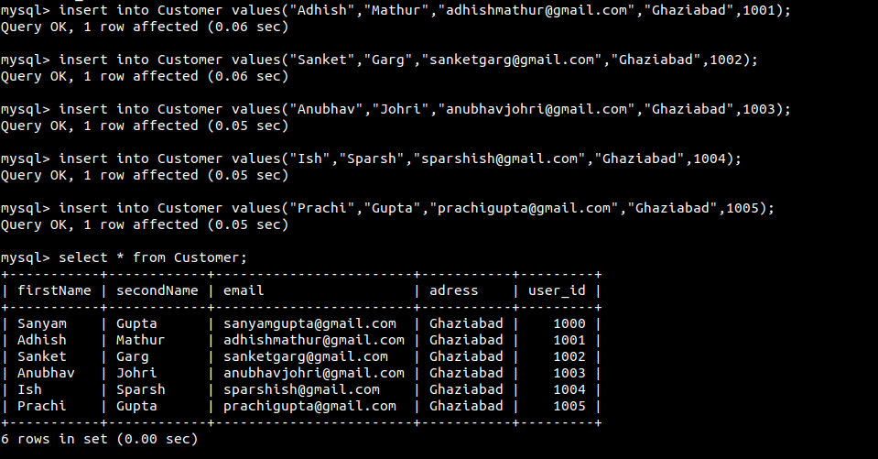
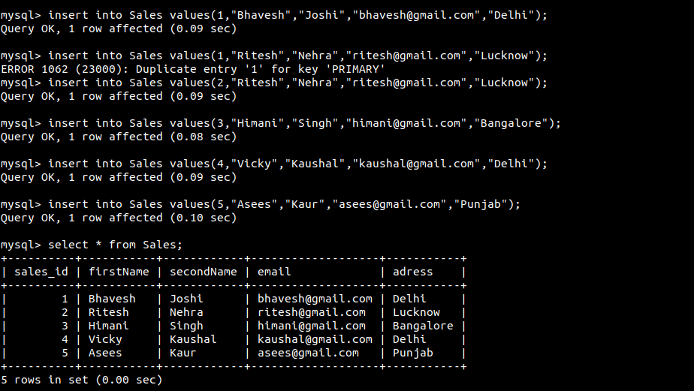
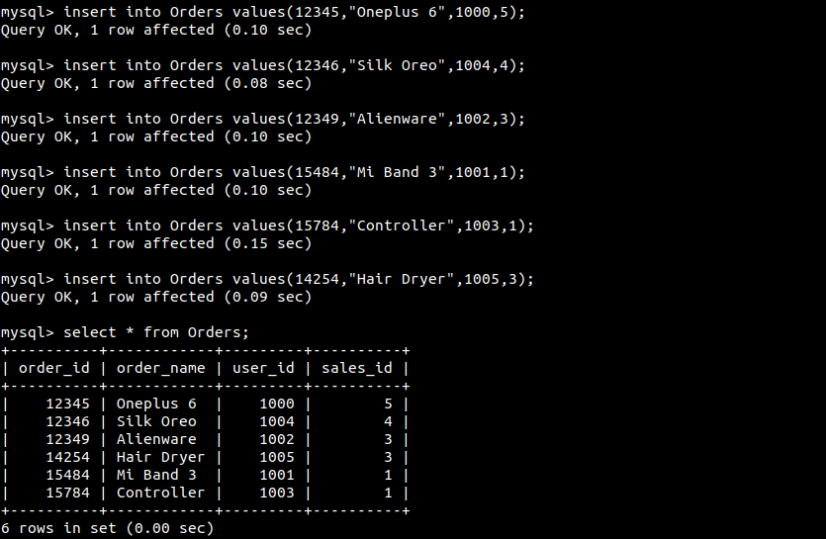

- Find the sales person have multiple orders.

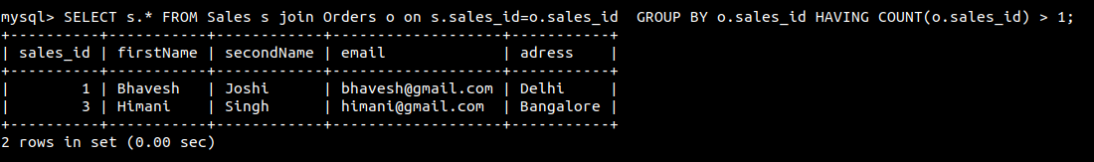

- Find the all sales person details along with order details .

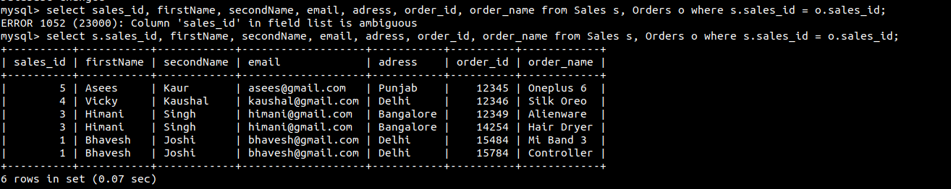
- Create index



- How to show index on a table

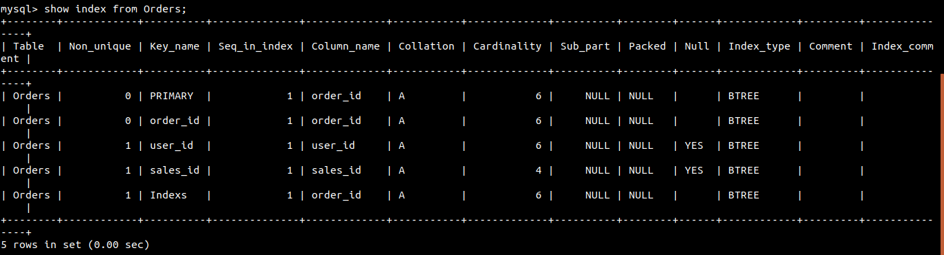

- Find the order number, sale person name, along with the customer to whom that order belongs to

