1. Git Setup https://confluence.atlassian.com/bitbucket/set-up-git-744723531.html
ttn@bucc:~$ sudo apt-get install git
2. Initialize a Git Repository
ttn@bucc:~/Desktop/$ mkdir test
ttn@bucc:~/Desktop/$ cd test
ttn@bucc:~/Desktop/test$ git init
3. Add files to the repository
ttn@bucc:~/Desktop/test$ touch readme
ttn@bucc:~/Desktop/test$ git add readme
4.Unstage 1 file
ttn@bucc:~/Desktop/test$ git reset readme
5.Commit the file
ttn@bucc:~/Desktop/test$ git commit readme
6. Add a remote
ttn@bucc:~/Desktop/test$ git remote add origin git@github.com:bucc- sanyam/Version-Control.git
7.Undo changes to a particular file
ttn@bucc:~/Desktop/test$ git checkout readme
8.Push changes to Github
ttn@bucc:~/Desktop/test$ git push origin master
9.Clone the repository
ttn@bucc:~/Desktop/test$ git clone git@github.com:bucc-sanyam/Version-Control.git
10.Add changes to one of the copies and pull the changes in the other.
ttn@bucc:~/Desktop/test$ vim readme
ttn@bucc:~/Desktop/test$ git commit sanyam
ttn@bucc:~/Desktop/test$ git push
ttn@bucc:~/Desktop$ git clone https://github.com/bucc-sanyam/Version-Control.git
ttn@bucc:~/Desktop$ cd Version-Control
ttn@bucc:~/Desktop$ git pull

11.Check differences between a file and its staged version
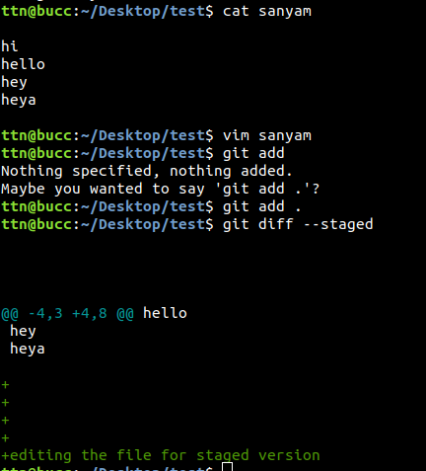

12.Ignore a few files to be checked in
ttn@bucc:~/Desktop/test$ vim .gitignore --> debug
ttn@bucc:~/Desktop/test$ git commit
13.Create a new branch.
ttn@bucc:~/Desktop/test$ git branch test
14.Diverge them with commits
ttn@bucc:~/Desktop/test$ git branch newBranch
ttn@bucc:~/Desktop/test$ git checkout newBranch
ttn@bucc:~/Desktop/test$ vim sanyam
ttn@bucc:~/Desktop/test$ git add .
ttn@bucc:~/Desktop/test$ git commit sanyam -m "Different Branch"
ttn@bucc:~/Desktop/test$ git push origin newBranch
15.Edit the same file at the same line on both branches and commit
ttn@bucc:~/Desktop/test$ vim sanyam
ttn@bucc:~/Desktop/test$ git commit .
ttn@bucc:~/Desktop/test$ git push origin test
ttn@bucc:~/Desktop/test$ git checkout master
ttn@bucc:~/Desktop/test$ vim sanyam
ttn@bucc:~/Desktop/test$ git commit .
ttn@bucc:~/Desktop/test$ git push origin master
16.Try merging and resolve merge conflicts
ttn@bucc:~/Desktop/test$ git merge test
Remove the conflict in the files and commit.
17.Stash the changes and pop them
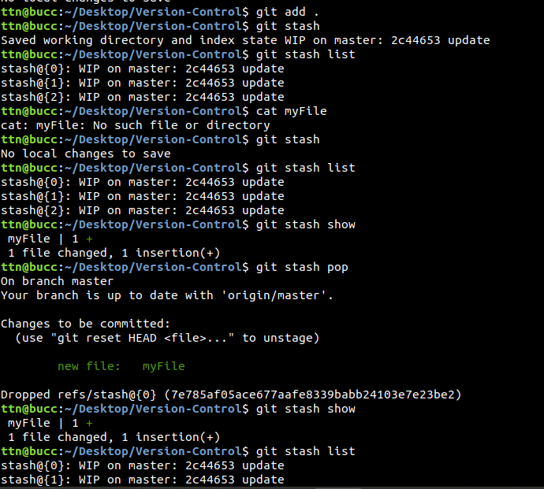

18.Add the following code to your .bashrc file : color_prompt="yes"
parse_git_branch() {
git branch 2> /dev/null | sed -e '/^[^*]/d' -e 's/* \(.*\)/(\1)/'
}
if [ "$color_prompt" = yes ]; then
PS1='\u@\h\[\033[00m\]:\[\033[01;34m\]\W\[\033[01;31m\] $(parse_git_branch)\[\033[00m\]\$ '
else
PS1='\u@\h:\W $(parse_git_branch)\$ '
fi
unset color_prompt force_color_prompt
