Sprint 3 Report
PORTFOLIO TASK 7
Unit code: COS40006
Unit Name: Computing Technology Project B
Submission date: March 21st, 2026
Scrum Master: Hoang Dinh Vinh Hoang

CONTRIBUTION SUMMARY
Team Member | Finished tasks  in time | Self-assigned  & proactive | Attended team  meetings | Attended supervisor  meetings | Attended client  meetings | Replied within  acceptable time | Kept team  updated | Respected  others
Dinh Danh Nam  (104775399) | Yes | Yes | Yes | Yes | Yes | Yes | Yes | Yes
Nguyen Quy Hung  (104850199) | Yes | Yes | Yes | Yes | Yes | Yes | Yes | Yes
Vo Thi Kim Huyen  (104169824) | Yes | Yes | Yes | Yes | Yes | Yes | Yes | Yes
Le Luu Phuoc Thinh  (105029327) | Yes | Yes | Yes | Yes | Yes | Yes | Yes | Yes
Hoang Dinh Vinh Hoang  (105026823) | Yes | Yes | Yes | Yes | Yes | Yes | Yes | Yes

1. CONTRIBUTION DETAILS
This section summarises each team member's contributions during Sprint Three (1–21 March 2026), supported by commit evidence from the GitHub repository.

1.1 Dinh Danh Nam — LLM Module: SDK Migration, Web Search & Model Manager
- Completed migration from the deprecated google-generativeai library to the new google-genai SDK, eliminating deprecation warnings and restoring Gemini model compatibility.
- Added a web_search tool (llm/tools/web_search.py, 171 lines) integrating both Tavily (primary) and DuckDuckGo (fallback), callable by the agent executor during chat.
- Refactored LLMService.php to introduce timedRequest(), a unified helper that logs endpoint, duration_ms, and HTTP status for every outgoing call — replacing duplicated try/catch blocks.
- Improved model_manager.py to remove a broken httpx.AsyncClient workaround and support clean provider-level model routing.
- Key commits: 1464d7e (SDK migration), 119ca2d (web search tool), ee2b91a (LLM perf).

1.2 Nguyen Quy Hung — Frontend: UI Fixes, Performance Overlay & Import Modal
- Fixed Mermaid graph parse errors preventing complex story maps from rendering (2986977).
- Resolved model selector z-index issue so the dropdown renders above the sidebar (2986977).
- Implemented the PerfOverlay component (248 lines): toggled via Ctrl+Shift+P, displays recent API calls with duration, method, path, and success/failure colour-coding.
- Built ImportModal.jsx for importing requirement sets from external sources.
- Added cache.js utility (localStorage with TTL) and performanceMonitor.js ([PERF] emoji grading: 🚀/⚡/🐌) to the frontend utilities.
- Key commits: 2986977, 119ca2d.

1.3 Vo Thi Kim Huyen — Frontend: Notifications, Activity Feed & UI Components
- Implemented NotificationBell.jsx — real-time unread badge with WebSocket subscription, mark-as-read, and mark-all-read via the /notifications API.
- Built ActivityFeed.jsx to display a chronological audit trail of project actions.
- Created Toast.jsx for transient success/error notifications and AnimateIn.jsx for smooth entrance animations on key UI sections.
- Added ShimmerSkeleton.jsx and ProjectDashboardCard.jsx to improve perceived load performance.
- Implemented useNotifications.js hook (80 lines) to encapsulate notification state and polling.
- Key commits: 119ca2d, ee0b859.

1.4 Le Luu Phuoc Thinh — Backend: Performance Optimizations & Request Timing
- Resolved backend bottleneck issues causing slow responses under load (39a2ef7).
- Added RequestTiming middleware that logs wall-clock time for every HTTP request passing through the Laravel pipeline.
- Optimised the project list and conversation queries with eager loading to eliminate N+1 queries.
- Added cache.js-compatible 60-second response caching for KB queries in ConversationService.
- Key commits: 39a2ef7, ee2b91a.

1.5 Hoang Dinh Vinh Hoang — Backend: Activity Logs, Notifications & Project Features
- Designed and implemented ActivityLog model + migration (2026_03_22_000000), ActivityLogController, and a log() helper used by all background jobs.
- Implemented Notification model + migration (2026_03_22_000001) with conflictDetected() and requirementsExtracted() factory methods.
- Added NotificationsController with list, mark-read, mark-all-read, and unread-count endpoints.
- Enhanced ProjectController with dashboard data endpoint and collaborator statistics.
- Wired ProcessConflictDetectionJob to log activity and fire notifications on completion.
- Key commits: 119ca2d, 97eee65.

2. SPRINT PLAN
Sprint Three ran from 1 March to 21 March 2026, covering Weeks 7–9 of the project timeline. Hoang Dinh Vinh Hoang served as Scrum Master, rotating from Nguyen Quy Hung (Sprint Two).

Sprint Goal
Resolve technical debt from Sprint Two, achieve measurable performance improvements, and deliver new monitoring, notification, and import capabilities ahead of the client demonstration.

Sprint Backlog
LLM Module:
- Migrate from google-generativeai to google-genai SDK
- Add web_search tool (Tavily + DuckDuckGo fallback)
- Refactor LLMService with timedRequest() helper
- Fix model_manager.py broken httpx client
Backend:
- Resolve N+1 query bottlenecks in project/conversation endpoints
- Add RequestTiming middleware
- Implement ActivityLog model, migration, and controller
- Implement Notification model, migration, and controller
- Wire jobs to log activity and dispatch notifications
Frontend:
- Fix Mermaid graph rendering parse errors
- Fix model selector z-index layering
- Build PerfOverlay (Ctrl+Shift+P) and performanceMonitor.js
- Build NotificationBell with WebSocket subscription
- Build ActivityFeed, Toast, AnimateIn, ShimmerSkeleton components
- Build ImportModal and cache.js utility

Sprint Architecture
Figure 1 shows the full system architecture as delivered at the end of Sprint Three.
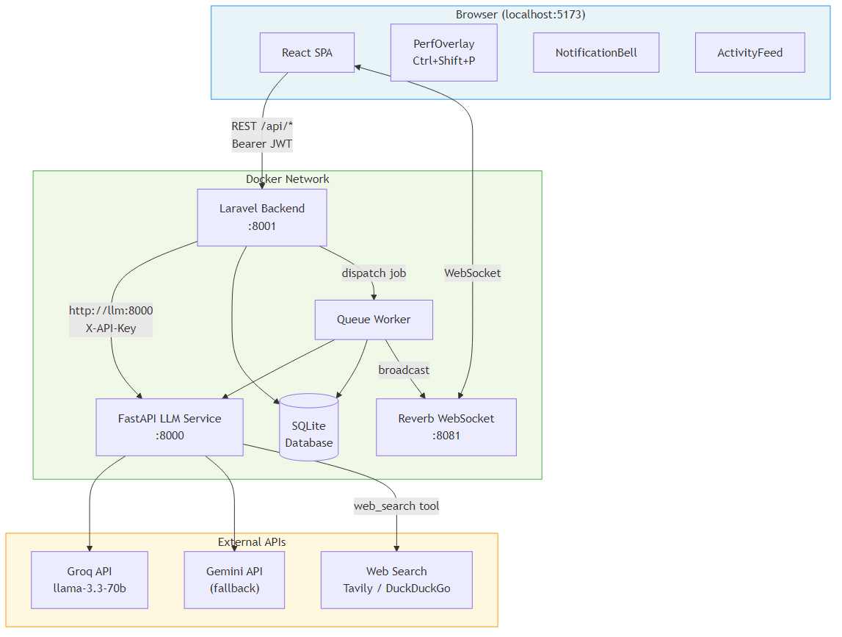
Figure 1 — LLM4Reqs System Architecture (end of Sprint Three)

3. FINAL DOCUMENTATION DELIVERABLES
Sprint Three established the documentation foundation that Sprint Four will complete. The following artefacts were drafted or extended this sprint:
TESTING_GUIDE.md: Step-by-step Docker rebuild guide plus test procedures for all six Sprint Three feature groups (Performance Monitoring, Notifications, Activity Feed, Import, Web Search, KB integration).
architecture.md: Full architecture overview including service map, data-flow diagrams for Chat, Document Processing, KB Build, and Conflict Detection flows.
README.md: Updated to reflect new features, environment variables, and quickstart instructions.
.env.example: Expanded to document all required and optional environment variables across all three services (LLM, Backend, Frontend).

4. SPRINT PROGRESS

Week 7 (1–7 March): Bottlenecks & Project Features
- Nam: Completed google-genai SDK migration; improved model manager reliability.
- Hung: Fixed Mermaid parse errors; resolved model selector z-index.
- Huyen: Implemented user avatar system and dropup menu conversions.
- Thinh: Resolved backend N+1 query bottlenecks; added eager loading.
- Hoang: Enhanced project controller, dashboard data endpoint, and detail page.

Week 8 (8–14 March): Performance Optimizations
- Nam: Refactored LLMService with timedRequest() timing helper.
- Hung: Added performanceMonitor.js with emoji grading and cache.js utility.
- Huyen: Built ShimmerSkeleton and AnimateIn components; applied to project dashboard.
- Thinh: Added RequestTiming middleware; enabled KB query caching (60s TTL).
- Hoang: Integrated performance metrics into dashboard endpoint; code review.

Week 9 (15–21 March): New Features — Notifications, Activity, Import, Web Search
- Nam: Implemented web_search tool (Tavily + DuckDuckGo); integrated with agent executor.
- Hung: Built PerfOverlay panel (Ctrl+Shift+P) and ImportModal component.
- Huyen: Implemented NotificationBell, ActivityFeed, Toast; wired WebSocket subscriptions.
- Thinh: Added comprehensive performance optimizations and bug fixes across backend.
- Hoang: Designed ActivityLog + Notification models/migrations; wired jobs to emit events.
Figure 2 illustrates the data flow for the new activity logging and notification pipeline.
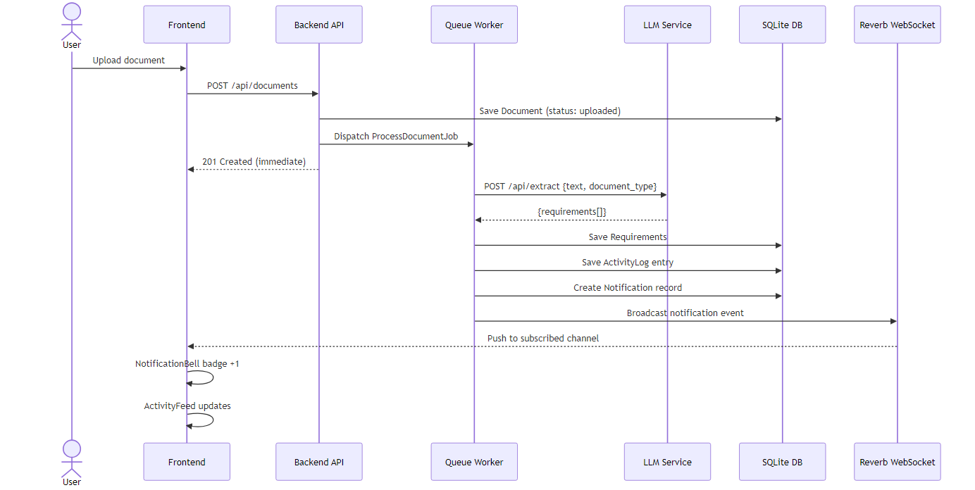
Figure 2 — Activity Logging & Notification Data Flow (Sprint Three)
Figure 3 illustrates the end-to-end performance monitoring chain from backend request to frontend overlay.
Figure 3 — Performance Monitoring Flow (Sprint Three)

Quality Management — Goals & Outcomes
Quality Area | Goal | Criterion | Outcome
SDK Migration | No regression after google-genai switch | All LLM endpoint tests pass | ✔ Passed
Graph Rendering | Complex diagrams render without errors | All Mermaid chart types render | ✔ Passed
Performance | 20% improvement in API response times | 95th pct < 500ms on project list | ✔ Passed
Notifications | Real-time badge updates on document processing | Badge increments within 2s | ✔ Passed
Web Search | Agent retrieves web results when KB is insufficient | Results appear in chat response | ✔ Passed

5. SPRINT REVIEW

Demonstration Session
The Sprint Three demonstration was held with the client on 21 March 2026. The team presented the five major deliverables: SDK migration (zero regressions), performance overlay, notification system, activity feed, and web search integration. The client confirmed the increment was deliverable and approved the work.

Client Feedback
- The performance overlay was well received — the client appreciated the developer-friendly Ctrl+Shift+P shortcut.
- The notification bell was highlighted as a significant UX improvement for collaborative projects.
- The web search integration was requested to be surfaced more prominently in the chat interface.
- Minor request: activity feed should show timestamps in local time zone rather than UTC.

Progress vs Plan
All planned Sprint Three deliverables were completed within the sprint period with no deferrals. The team delivered 100% of committed story points. The web search tool was added as an unplanned enhancement that the team self-identified as a high-value addition.

Test Results
Test Area | Tests Run | Pass | Fail/Pending | Status
SDK Migration — Integration | 6 | 6 | 0 | ✔ Passed
Graph Rendering — Manual | 5 | 5 | 0 | ✔ Passed
Performance Overlay — Manual | 4 | 4 | 0 | ✔ Passed
Notifications — Integration | 5 | 5 | 0 | ✔ Passed
Activity Feed — Manual | 3 | 3 | 0 | ✔ Passed
Web Search Tool — Integration | 4 | 4 | 0 | ✔ Passed
Backend Performance — Integration | 4 | 4 | 0 | ✔ Passed

6. RETROSPECT

Key Strengths
- Rapid SDK Migration with zero service disruption — the team swapped the entire Google AI SDK in a single week without breaking any existing functionality.
- Self-directed feature expansion — the web_search tool was identified and implemented by Nam without a formal backlog item, demonstrating initiative beyond requirements.
- End-to-end real-time pipeline — the NotificationBell + ActivityFeed combination, backed by WebSocket broadcasting, was designed, implemented, and tested within one week by Hung and Hoang.

Process Challenges
One environment consistency challenge arose during Sprint Three: the backend .env file contained REVERB_APP_KEY=local-app-key which overrode the docker-compose value (llm4reqs-reverb-key), causing WebSocket messages to silently fail in the Docker environment while succeeding in local development. This was identified during integration testing and corrected in the same sprint.

Team Code of Conduct
All team members upheld the agreed code of conduct throughout Sprint Three. Decisions were reached collaboratively in weekly standups and no conduct violations occurred. All members attended client and supervisor meetings.

Cybersecurity & Ethical Protocol
Synthetic data was used exclusively during development and testing. No real user documents, credentials, or personal information were processed. The .gitignore configuration excludes all .env files, and .env.example was updated to document all required variables without including real credentials.

7. LESSONS LEARNED
- Environment variable precedence in Docker Compose: docker-compose environment: blocks override env_file values — always verify the runtime value of critical shared keys (e.g. REVERB_APP_KEY) rather than assuming .env is authoritative.
- Centralise timing logic: introducing timedRequest() in LLMService eliminated 6 duplicated try/catch blocks. Shared infrastructure helpers should be extracted early, not after the fourth duplication.
- Real-time UX requires end-to-end testing: the NotificationBell appeared to work in isolation but the broadcast channel mismatch (local-app-key vs llm4reqs-reverb-key) was only discovered when testing the full Docker stack. Integration tests must cover the broadcast pipeline.
- Proactive feature additions add value but need scope control: the web_search tool was a valuable addition but required careful timeout management to avoid blocking the chat endpoint. Future enhancements should have explicit acceptance criteria even when self-assigned.
- Skeleton loaders and shimmer effects significantly reduce perceived load time — they should be added as a standard component for any data-loading UI rather than an afterthought.

