**The Project entitled**

**MATCH PREDICTION TOOL(MPT)**

Submitted in partial fulfillment of academic requirements for the award of the degree of

Bachelor of Engineering (Computer Science and Engineering)

**By**

**B Anirudh 2451-12-733-167**

**M.L.N.Shashank Raj 2451-12-733-166**

**Yash Thakur 2451-12-733-163**



**Department of Computer Science and Engineering**

**M.V.S.R.ENGINEERING COLLEGE**

**(Affiliated to Osmania University& Recognized by AICTE)**

**Nadergul, Saroor Nagar Mandal, Hyderabad – 501 510**

**2014-15**

**ACKNOWLEDGMENT**

I take this opportunity to express my profound and sincere gratitude to all those who helped us in carrying out this project successfully.

At the very outset, I am thankful to our principal Sri **Dr.P.A.Sastri** and Sri **J.Prasanna Kumar**, Professor and Head, Department of Computer Science and Engineering, MVSR Engineering College, Hyderabad for their consent to do the project work as a part of our B.E Degree (CSE). We thank them for their valuable suggestions and advice throughout our stay at the college, during our project work.

I would like to thank our Internal Project Guide Mrs.**M**.**Anupama**, Associate Professor and Mr.**T**.**Sujanavan**, Assistant Professor, Department of Computer Science and Engineering, MVSR Engineering College for his/her useful suggestions, guidance and encouragement.

We thank the teaching and non-teaching staff of CSE for extending their support.

Finally we are thankful to our parents for their cooperation and support throughout all endeavours in our life.

**B.Anirudh 2451-12-733-167**

**M.L.N.Shashank Raj 2451-12-733-166**

**Yash Thakur 2451-12-733-163**

INDEX:

|  |  |  |
| --- | --- | --- |
| **S.No** | **Contents** | **Page No.** |
| **1.0** | **Introduction** | **04** |
| **1.1** | **Problem Statement** | **05** |
| **1.2** | **Scope of the Project** | **05** |
| **1.3** | **Objectives** | **05** |
| **1.4** | **Motivation** | **06** |
|  |  |  |
| **2.0** | **System Architecture or Design** | **07** |
| **2.1** | **Architecture diagram** |  |
| **2.2** | **Usecase diagram** |  |
|  |  |  |
| **3.0** | **System Development or Procedure** | **07** |
| **3.1** | **Modules(parts)** | **07** |
| **3.1.2** | **Flow chart for finding Private key** |  |
| **3.1.3** | **Flow chart for finding plain text** |  |
| **3.2** | **Screen shots of outputs** | **13** |
| **3.3** | **Conclusion** | **19** |
| **3.4** | **References** | **20** |
| **3.5** | **Appendix : Source Code** | **20** |
|  |  |  |
|  |  |  |
|  |  |  |
|  |  |  |

Introduction - Predicting something as indecisive as the outcome of a football match seems like a herculean task.The lack of technical expertise of a layman with respect to football adds to this uncertainty.The MPT fills this void by providing a simple solution which involves linking various decisive factors relevant to the game.The factors would be the versus record,formations,number of goals scored and conceded along with the position of the team in the league table.The versus record would probably be one of the most decisive factors in determining the outcome of a particular match.A dynamic database record,limited to 5 teams is created which contains the number of wins,losses and draws against each team.After which the other decisive factors follow like formations,no of goals scored and conceded and postion in the league table.The formation of the first selected team is to be entered.The tool contains limited number of formations so the formation closest to the team's style of play is to be chosen.Following which the number of goals the said team scored and conceded in the last five matches is to be entered.Finally the postion of the team in the league table is entered.Points are assigned to various factors based on relative decisiveness.The data of the 2nd team is to be entered similarly.The win percentage calculating algorithm compares various factors of the two teams by binding them together in cohesion.This win percentage calculating algorithm finally displays the win percentage of the 1st team against the 2nd team.

SYSTEM ARCHITECTURE-

Main workflow through various modules

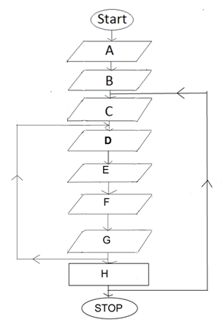

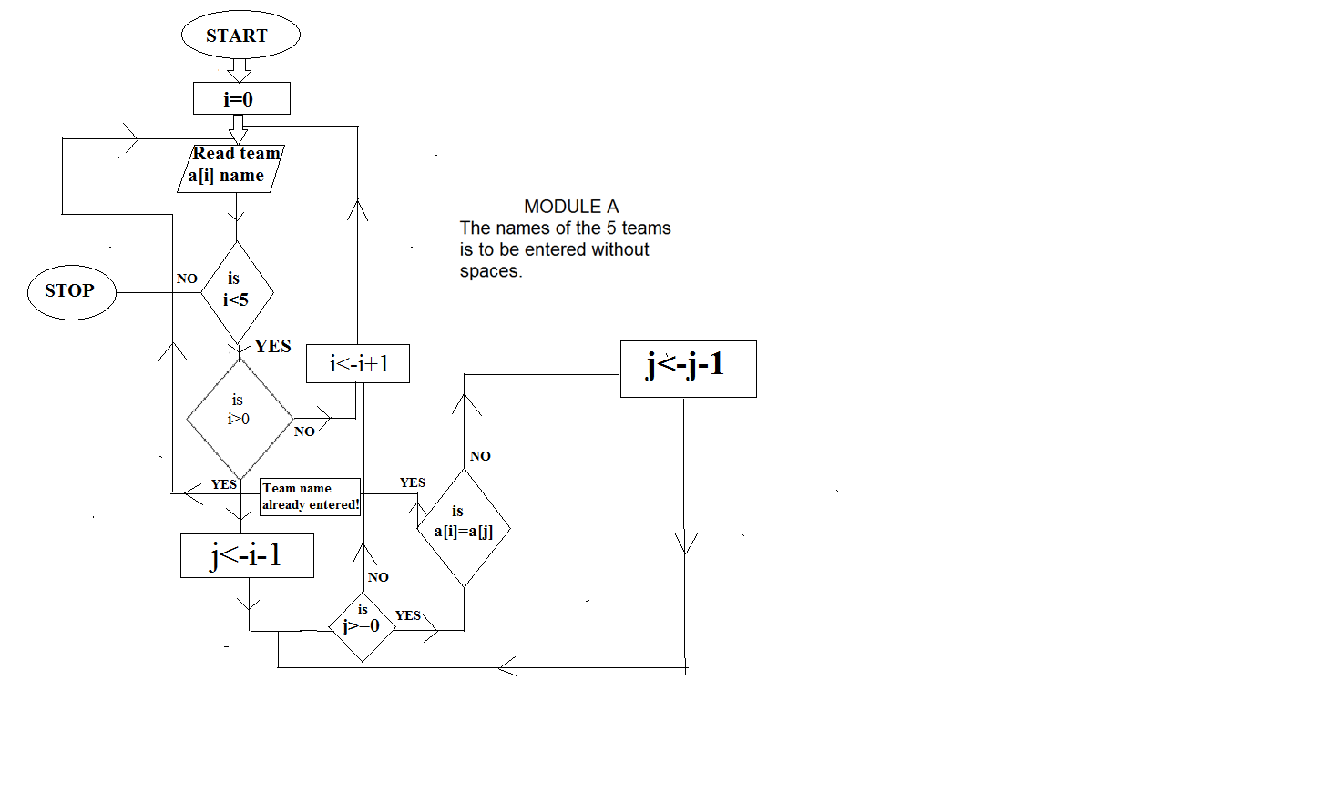

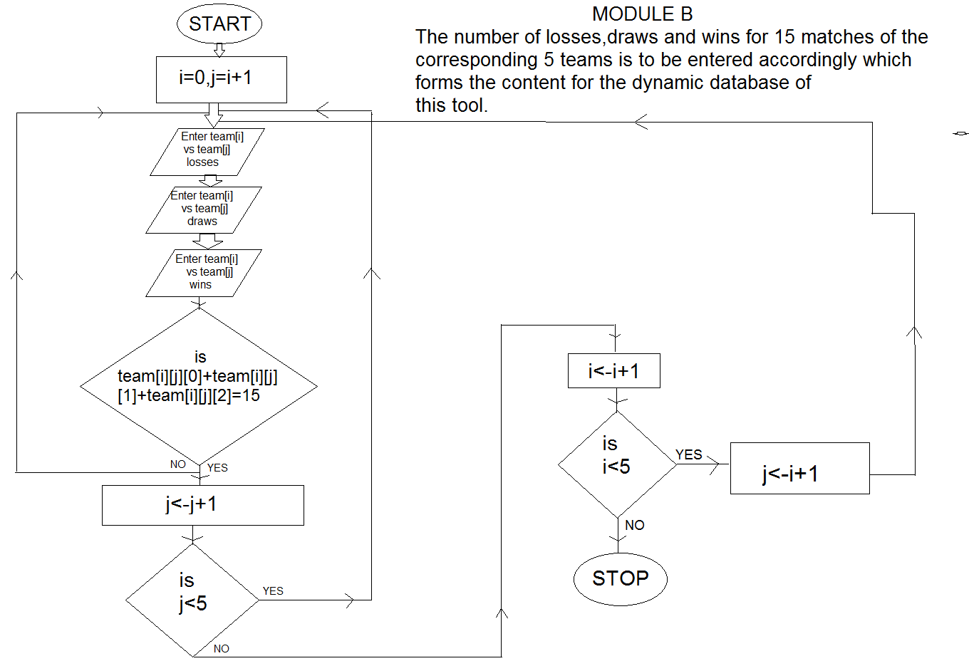

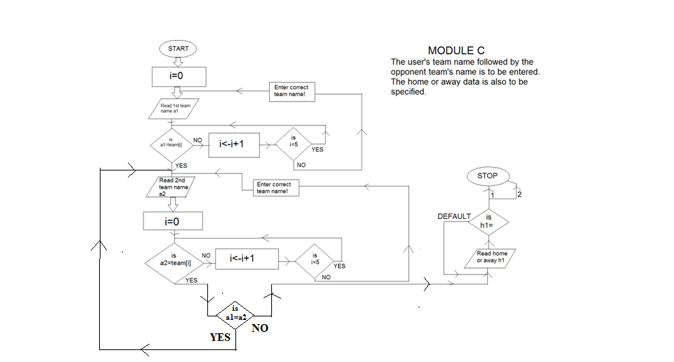

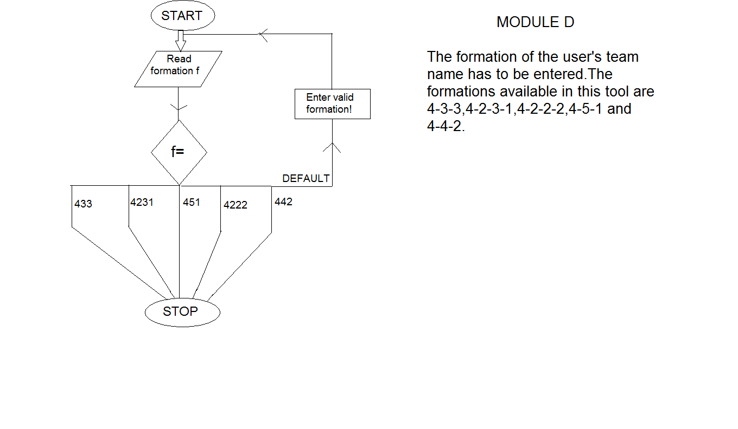

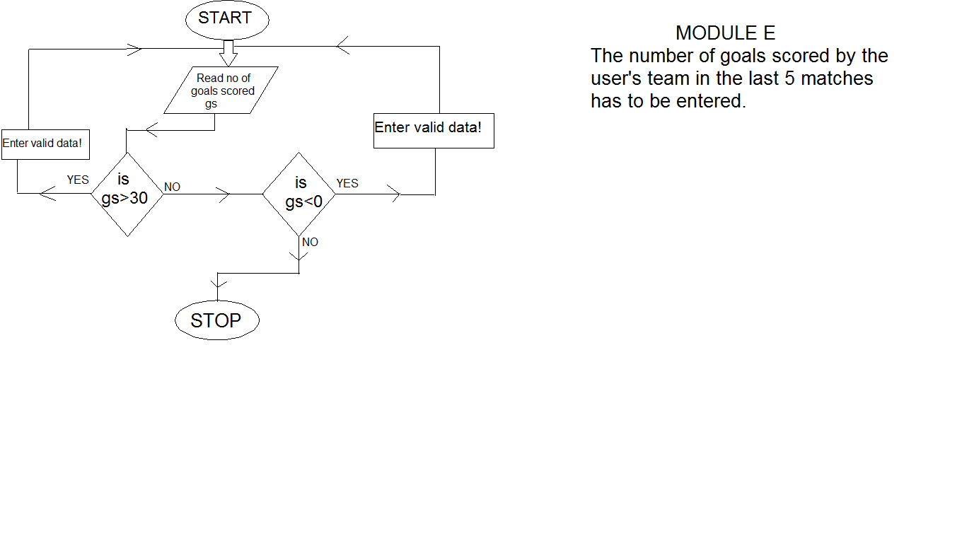

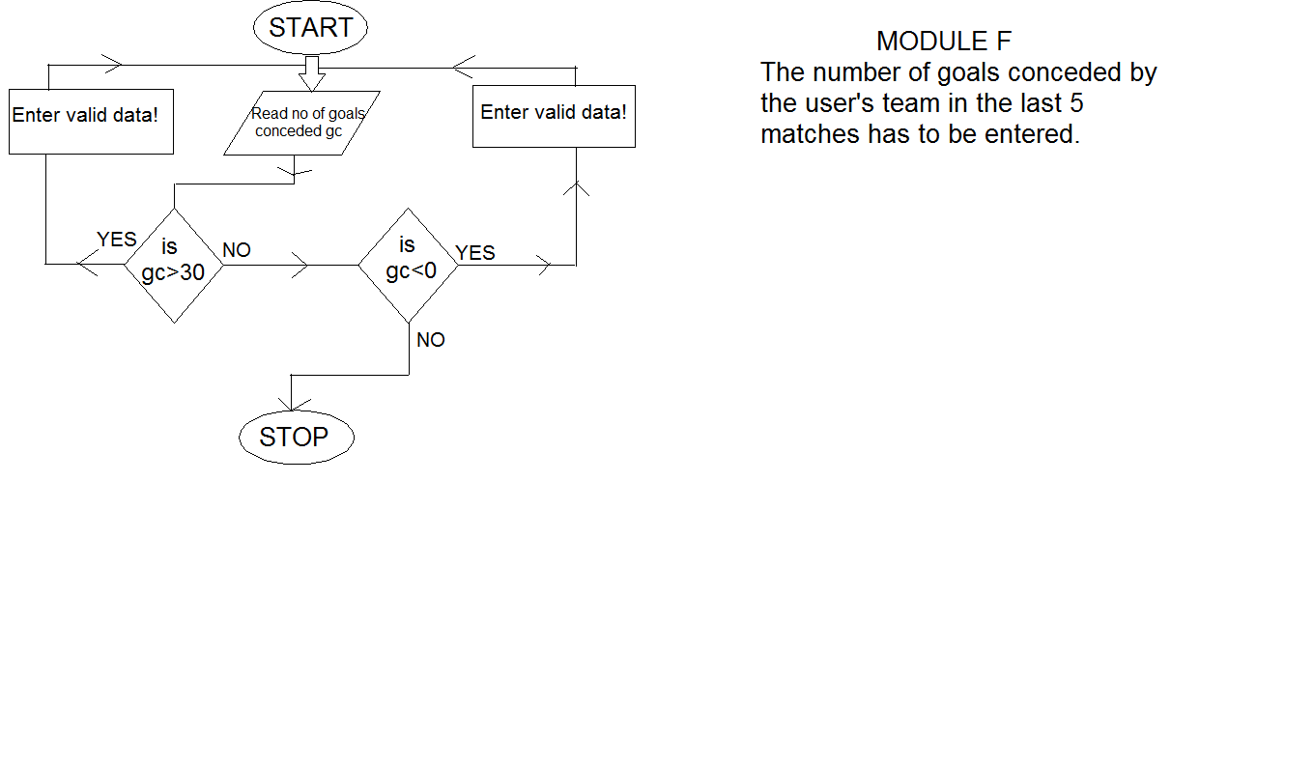

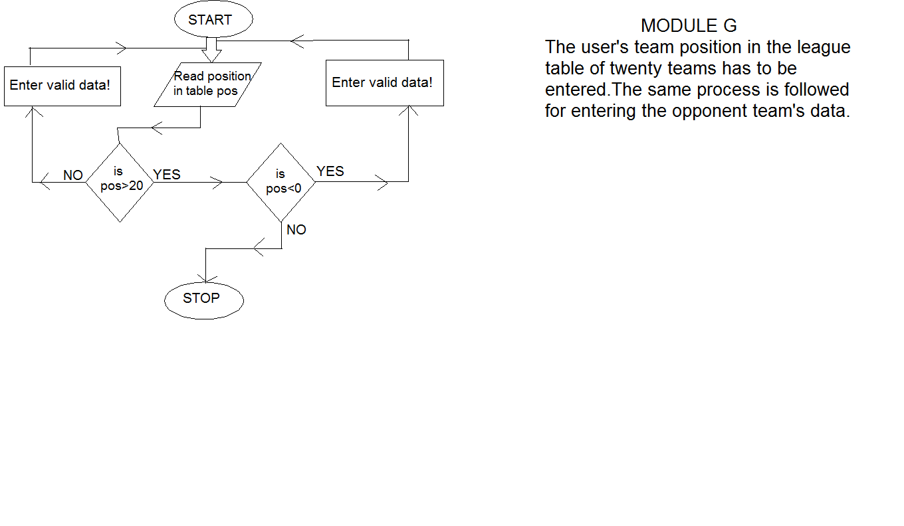

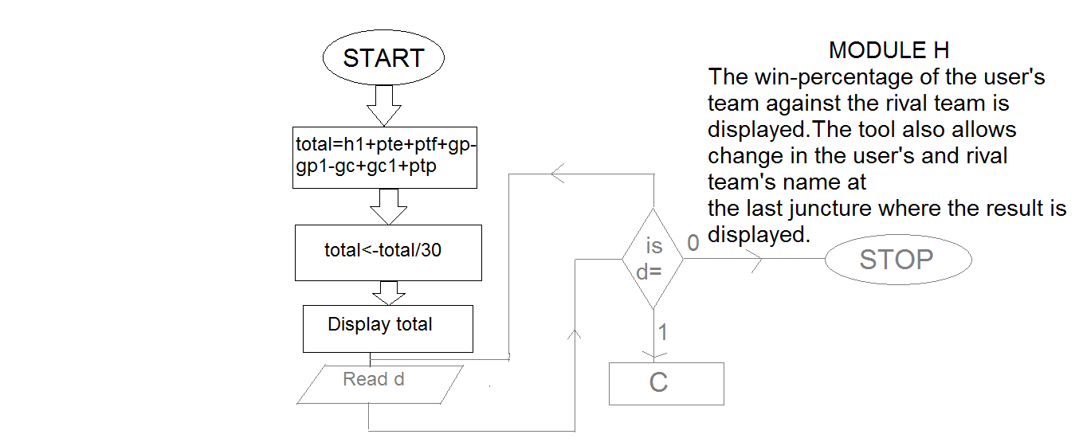

MODULE A

The names of the 5 teams is to be entered without spaces.

MODULE B

The number of losses,draws and wins for 15 matches of the corresponding 5 teams is to be entered accordingly which forms the content for the dynamic database of this tool.

MODULE C

The user's team name followed by the opponent team's name is to be entered.

MODULE D

The formation of the user's team name has to be entered.The formations available in this tool are 4-3-3,4-2-3-1,4-2-2-2,4-5-1 and 4-4-2.

MODULE E

The number of goals scored by the user's team in the last 5 matches has to be entered.

MODULE F

The number of goals conceded by the user's team in the last 5 matches has to be entered.

MODULE G

The user's team position in the league table of twenty teams has to be entered.The same process is followed for entering the opponent team's position.

MODULE H

The win-percentage of the user's team against the rival team is displayed.The tool also allows change in the user's and rival team's name at the last juncture where the result is displayed.

TESTING-

  
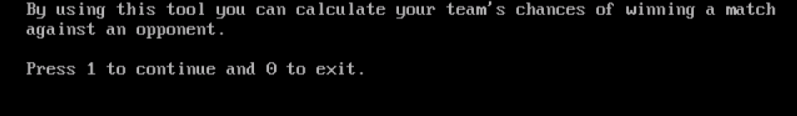

To start using the tool we first press 1.

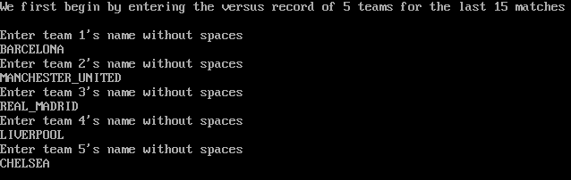

The names of the five teams is to be entered.

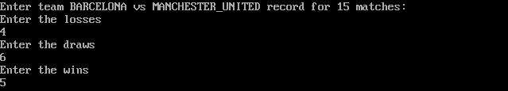

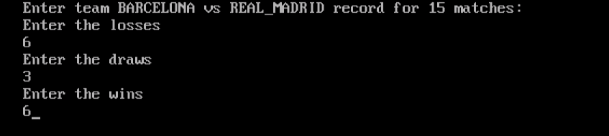

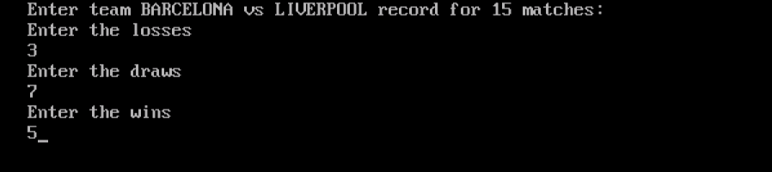

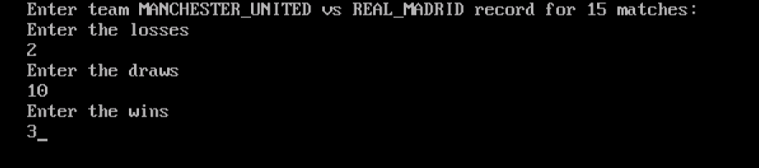

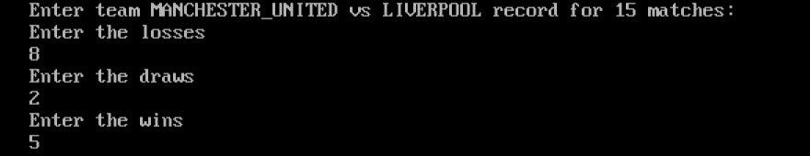

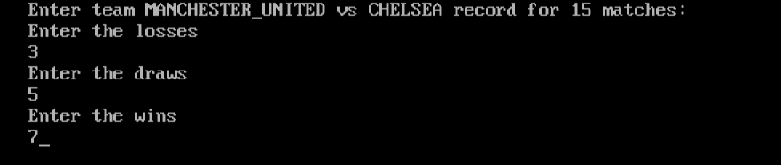

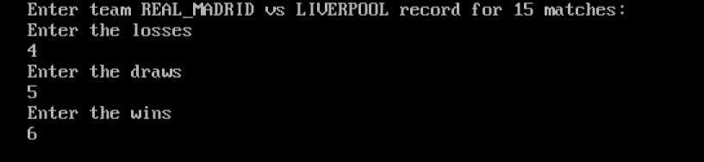

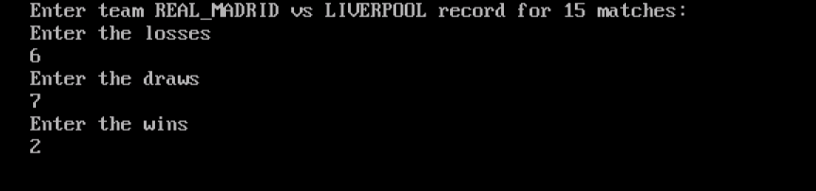

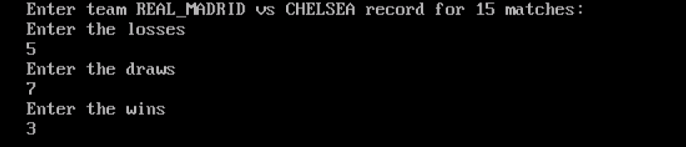

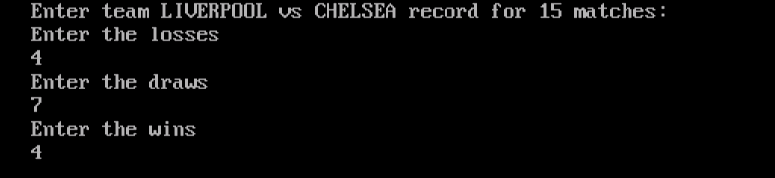

The versus record of the five teams is entered.



The user’s team followed by the opponent team’s name is to be entered.



Is the user’s team playing at its home ground or away has to be specified.

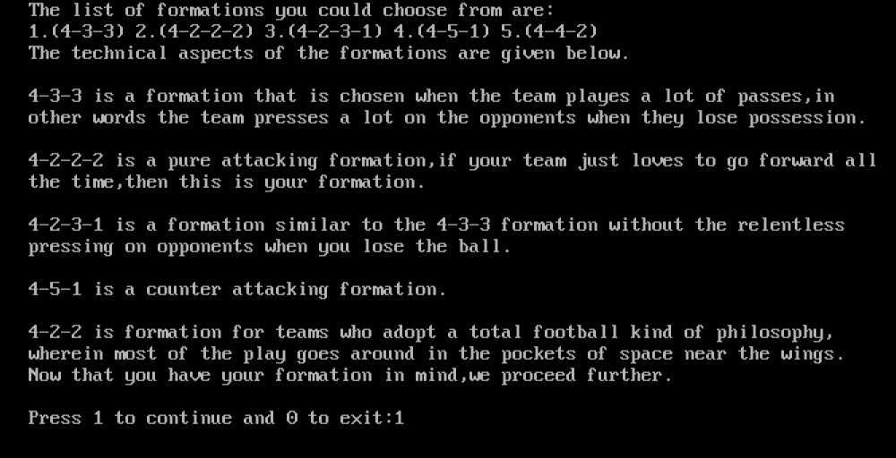

The technical details of various formations is to be entered.

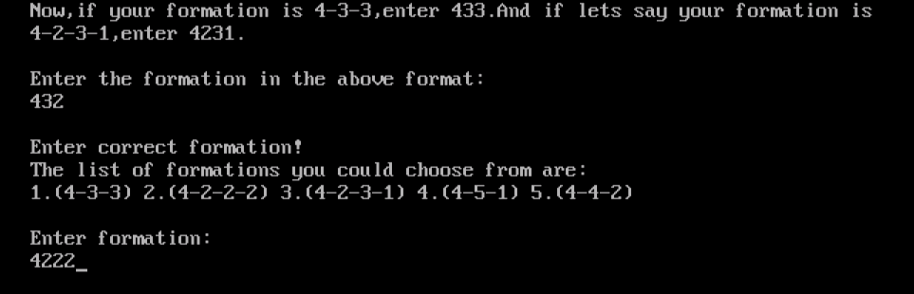

The user’s team formation is to be entered.

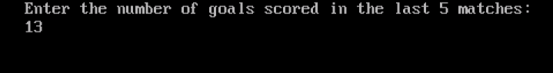



The number of goals scored and conceded by the user’s team in the last 5 matches has to be entered.

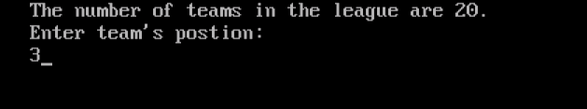

The position of the team in the league table has to be entered.

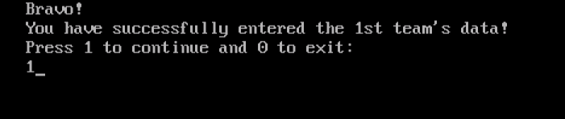

The opponent team’s data has to be entered in the same way.

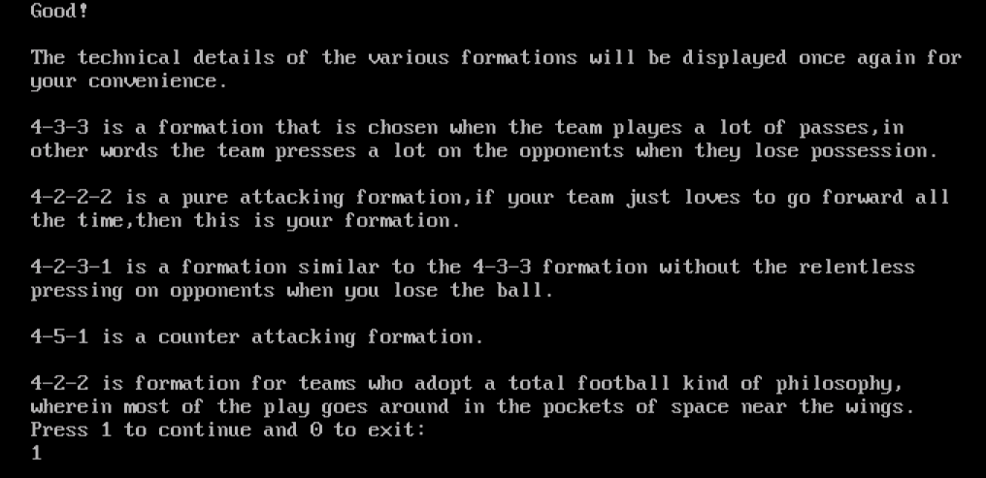

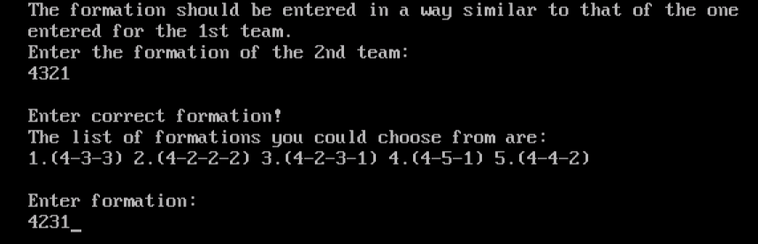

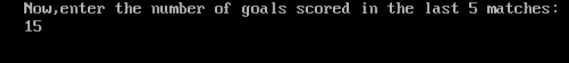



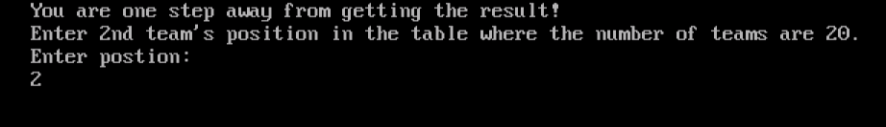

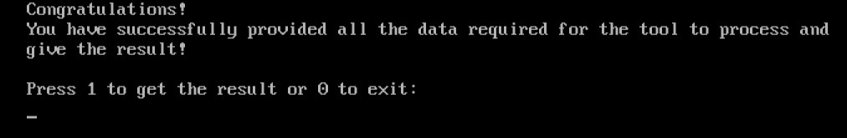

The result is obtained on entering 1.

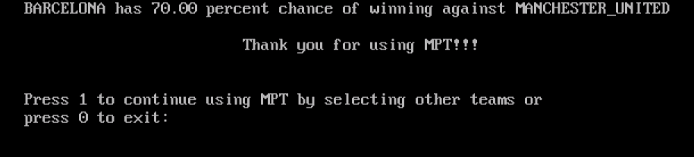

The result is displayed.To use the tool again,we press 1.