CPE301 – SPRING 2019

Design Assignment 1A

Student Name: Andrew Buchanan

Student #:5003154346

Student Email: buchaa2@unlv.nevada.edu

Primary Github address: https://github.com/buchaa2/103EPC

Directory:

Submit the following for all Labs:

1. In the document, for each task submit the modified or included code (only) with highlights and justifications of the modifications. Also, include the comments.
2. Use the previously create a Github repository with a random name (no CPE/301, Lastname, Firstname). Place all labs under the root folder ESD301/DA, sub-folder named LABXX, with one document and one video link file for each lab, place modified asm/c files named as LabXX-TYY.asm/c.
3. If multiple asm/c files or other libraries are used, create a folder LabXX-TYY and place these files inside the folder.
4. The folder should have a) Word document (see template), b) source code file(s) and other include files, c) text file with youtube video links (see template).

1. **COMPONENTS LIST AND CONNECTION BLOCK DIAGRAM w/ PINS**

Atmel studio

1. **INITIAL/MODIFIED/DEVELOPED CODE OF TASK 1/A**

N/A

1. **DEVELOPED MODIFIED CODE OF TASK 2/A from TASK 1/A**

.org 0 ;starts at 0

ldi R22, 0xff ;load lower 8 bits of multiplier

ldi R23, 0xff ;load upper 8 bits of multiplier

ldi R24, 0xff ;load lower 8 bits of multiplicand

ldi R25, 0xff ;load upper 8 bits of multiplicand

ldi R17, 0 ;set value as 0

ldi R18, 0 ;set value as 0

ldi R19, 0 ;set value as 0

ldi R20, 0 ;set value as 0

ldi R21, 0 ;set value as 0

BLAH1:

cpi R23, 0

breq BLAH2

add R17, R24 ;add lower 8 bits into R17

adc R18, R25 ;add upper 9 bits into R18 with carry

adc R19, R20 ;add carry R20 into R19

subi R23,1 ;decrement counter of upper 8 bits of multiplier

cpi R23, 0

breq BLAH2 ;loops while counter is greater than zero

jmp BLAH1

BLAH2:

cpi R22, 0

breq END

add R18, R24 ;add lower 8 bits

adc R19, R25 ;add upper 9 bits

adc R20, R21 ;add carry

subi R22,1 ;decrements

cpi R22, 0

breq END ;loops while counter is greater than zero

jmp BLAH2

//answer is R20-R17

END:

jmp END

1. **SCHEMATICS**

N/A

1. **SCREENSHOTS OF EACH TASK OUTPUT (ATMEL STUDIO OUTPUT)**

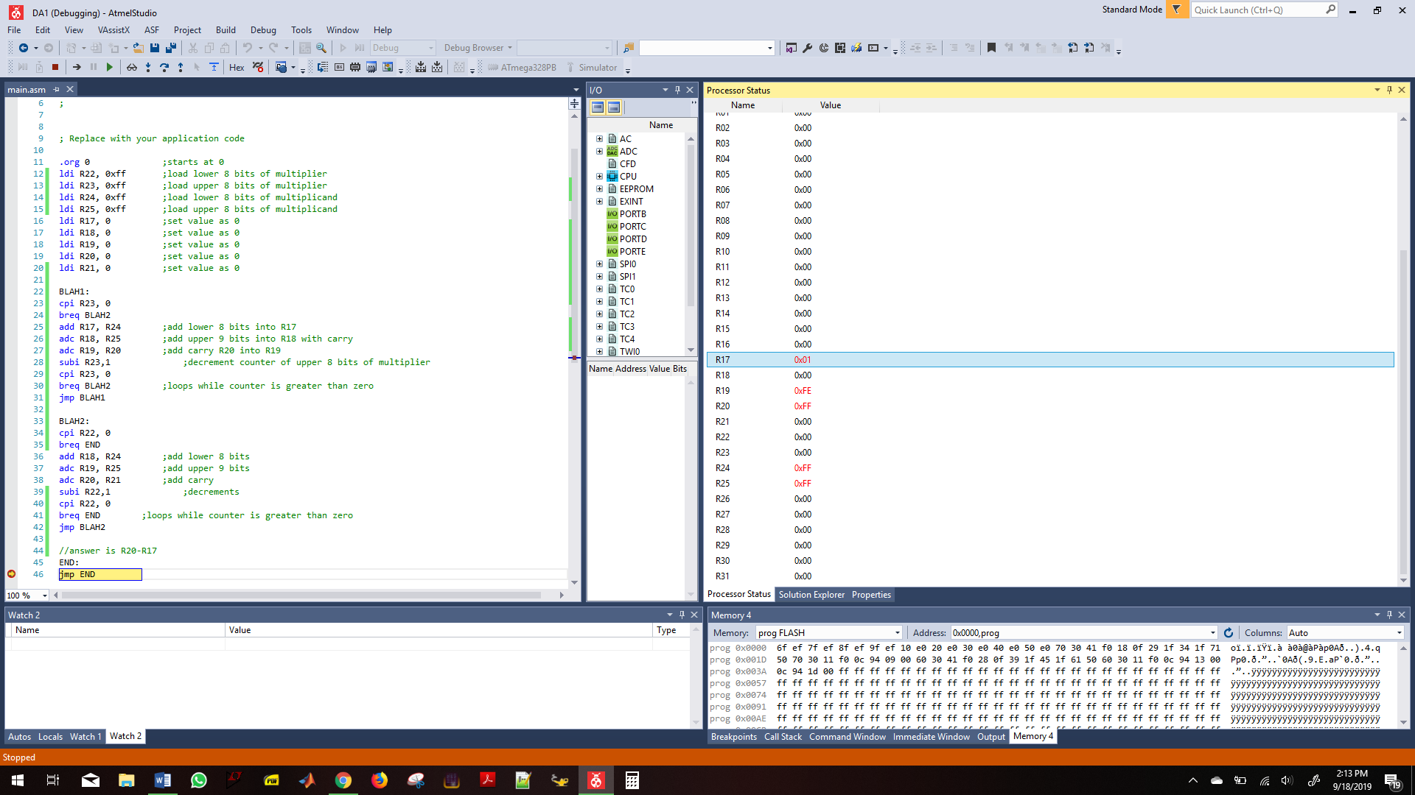

1. **SCREENSHOT OF EACH DEMO (BOARD SETUP)**

N/A

1. **VIDEO LINKS OF EACH DEMO**

[**https://youtu.be/uRlrAzNvo-o**](https://youtu.be/uRlrAzNvo-o)

1. **GITHUB LINK OF THIS DA**

**Student Academic Misconduct Policy**

<http://studentconduct.unlv.edu/misconduct/policy.html>

“This assignment submission is my own, original work”.

Andrew Buchanan