CPE301 – FALL 2019

Design Assignment 1B

Student Name: ANDREW BUCHANAN

Student #: 5003154346

Student Email: buchaa2@unlv.nevada.edu

Primary Github address: <https://github.com/buchaa2/103EPC>

Directory:

Submit the following for all Labs:

1. In the document, for each task submit the modified or included code (only) with highlights and justifications of the modifications. Also, include the comments.
2. Use the previously create a Github repository with a random name (no CPE/301, Lastname, Firstname). Place all labs under the root folder ESD301/DA, sub-folder named LABXX, with one document and one video link file for each lab, place modified asm/c files named as LabXX-TYY.asm/c.
3. If multiple asm/c files or other libraries are used, create a folder LabXX-TYY and place these files inside the folder.
4. The folder should have a) Word document (see template), b) source code file(s) and other include files, c) text file with youtube video links (see template).

1. **COMPONENTS LIST AND CONNECTION BLOCK DIAGRAM w/ PINS**
2. **INITIAL/MODIFIED/DEVELOPED CODE OF TASK 1/A**

;

; DA1B.asm

;

; Created: 9/20/2019 10:18:10 PM

; Author : ANDREW BUCHANAN

.equ STARTADDS = 0x0200 ; STARTADDS

.equ FIVESTART = 0x0300 ; 5 DIVIDES GO INTO 0X0300

.equ NONFIVESTART = 0x0500 ; EVERYTHINGELSE GOES TO 0X0500

ldi ZL, LOW(STARTADDS) ;

ldi ZH, HIGH(STARTADDS) ; Z EQUALS 0X200

ldi R20, 0x5 ; START AT 5

ldi R21, 0xFA ; COUNT 250 VALUES

; FIRST THE PROGRAM FILLS THE VALUES TO BE TESTED

FILL: ; FILL THE 0X0200'S WITH 250 VALUES

st Z+, R20 ; R20 INTO Z AND INCREMENT Z

inc R20 ; INCREMENT R20 BY 1

dec R21 ; DECREMENT R21

brne FILL ; IF R21 DOES NOT EQUAL 0 LOOP TO FILL

;LOAD THE POINTERS TO THE RIGHT VALUES

ldi ZL, LOW(STARTADDS) ;

ldi ZH, HIGH(STARTADDS) ; Z EQUALS 0X200

ldi YL, LOW(FIVESTART) ;

ldi YH, HIGH(FIVESTART) ; Y EQUALS 0X0300

ldi XL, LOW(NONFIVESTART) ;

ldi XH, HIGH(NONFIVESTART) ; X EQUALS 0X0500

;LOAD 0 INTO THE FINAL SUM REGISTERS

ldi R16, 0 ; MAKE SUM REGISTER EQUAL ZERO

ldi R17, 0 ; MAKE SUM REGISTER EQUAL ZERO

ldi R18, 0 ; MAKE SUM REGISTER EQUAL ZERO

ldi R19, 0 ; MAKE SUM REGISTER EQUAL ZERO

ldi R20, 249 ; MAKE R20 249 BECAUSE WE START THE COUNT AT 0

ldi R23, 0 ; MAKE CARRY REGISTER EQUAL ZERO

;START THE LOOP TO SPLIT THE VALUES INTO THE TWO REGISTER LOCATIONS

SPLIT_LOOP: ;THIS LOOP CHECKS THE VALUE AND DECIDES WHICH MEMORY GROUP TO SEND THE VALUE

ld R21, Z+ ; LOADS THE VALUE IN THE 0X0200'S SPOT INTO R21

mov R22, R21 ; MAKES R22 EQUAL TO R21 FOR TESTING THE DIVISION WITHOUT CHANGING THE ORIGINAL NUMBER

FIVES_SEPERATE: ;THIS LOOP CHECKS IF THE NUMBER IS DIVISABLE BY 5

subi R21, 0x05 ; SUBTRACT 5 FROM THE TEST NUMBER

breq DIVI ; IF THE NUMBER EQUALS 0 THEN IT IS DIVISABLE BY 5 GOT TO DIVI

brsh FIVES_SEPERATE ; IF THE NUMBER SUBTRACTED EQUALS 5 OR LARGER SUBTRACT AGAIN

;IF THE LOOP BREAKS THEN THE NUMBER IS NOT DIVISABLE BY 5

st X+, R22 ; STORE VALUE IN THE NON-FIVES SECTION OF REGISTERS

add R18, R22 ; ADD NEW VALUE TO STACK OF NON-FIVES SUMMED VALUES

adc R19, R23 ; ADD THE CARRY TO THE STACK OF CARRIES

;AFTER ADDING TO THE SUM, THE LOOP THEN SKIPS THE PART WHERE THE DIVISIBLE BY 5 NUMBERS ARE LOADED

rjmp IHOP ; JUMP DOWN TO IHOP TO CONTINUE SEPERATING ANOTHER NUMBER

; IF THE FIVES_SEPERATE LOOP BRANCHES TO DIVI THEN IT IS DIVISABLE BY FIVE

DIVI: ;DIVI STORES THE VALUE AND ADDS THE VALUE TO THE THE SUM FOR THE DIVISABLE BY FIVE NUMBERS

st Y+, R22 ; STORE VALUE IN THE FIVES SECTION OF REGISTERS

add R16, R22 ; ADD NEW VALUE TO STACK OF FIVES SUMED VALUES

adc R17, R23 ; ADD THE CARRY TO THE STACK OF CARRIES

IHOP:

dec R20 ; DECREMENT FROM 249 TO GO THROUGH ALL 250 NUMBERS

brne SPLIT_LOOP ; WHEN R20 EQUALS 0 BREAK LOOP

END: jmp END ; JUMP TO END

1. **DEVELOPED MODIFIED CODE OF TASK 2/A from TASK 1/A**
2. **SCHEMATICS**
3. **SCREENSHOTS OF EACH TASK OUTPUT (ATMEL STUDIO OUTPUT)**

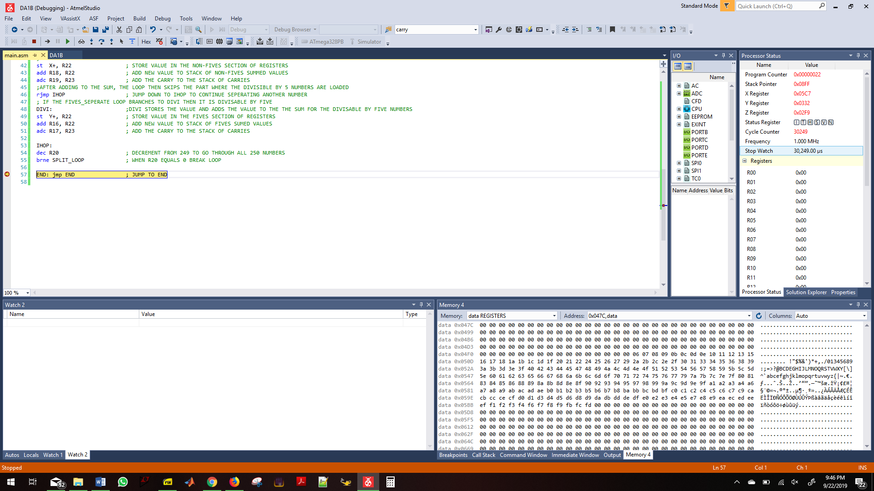

1. **SCREENSHOT OF EACH DEMO (BOARD SETUP)**
2. **VIDEO LINKS OF EACH DEMO**

<https://www.youtube.com/watch?v=Ds4WMjRfEoM&t=4s>

1. **GITHUB LINK OF THIS DA**

https://github.com/johnsb18/ClassRepository/tree/master/DesignAssignments/DA1B

**Student Academic Misconduct Policy**

<http://studentconduct.unlv.edu/misconduct/policy.html>

“This assignment submission is my own, original work”.

ANDREW BUCHANAN