CPE301 – FALL 2019

Design Assignment 2B

Student Name: Andrew Buchanan

Student #:5003154346

Student Email: buchaa2@unlv.nevada.edu

Primary Github address: <https://github.com/buchaa2/103EPC>

Directory:

Submit the following for all Labs:

1. In the document, for each task submit the modified or included code (only) with highlights and justifications of the modifications. Also, include the comments.
2. Use the previously create a Github repository with a random name (no CPE/301, Lastname, Firstname). Place all labs under the root folder ESD301/DA, sub-folder named LABXX, with one document and one video link file for each lab, place modified asm/c files named as LabXX-TYY.asm/c.
3. If multiple asm/c files or other libraries are used, create a folder LabXX-TYY and place these files inside the folder.
4. The folder should have a) Word document (see template), b) source code file(s) and other include files, c) text file with youtube video links (see template).

1. **COMPONENTS LIST AND CONNECTION BLOCK DIAGRAM w/ PINS**
2. **INITIAL/MODIFIED/DEVELOPED CODE OF TASK 1/A**

;

1. ; DA2B.asm
2. ;
3. ; Created: 10/5/2019 9:15:12 PM
4. ; Author : bugul
5. ;
6. .org 0 ; location of the reset
7. jmp MAIN ; start the main program
8. .org 0x02 ; location for external interrupt INT0
9. jmp EXT_INT ; start the external interrupt
10. MAIN:
11. ldi R20, HIGH(RAMEND) ; initialize stack
12. out SPH, R20
13. ldi R20, LOW(RAMEND)
14. out SPL, R20
15. ldi R20, 2 ; make INT0 falling edge triggered
16. sts EICRA, R20
17. sbi DDRB, 3 ; set PORTB.2 as output
18. sbi PORTB, 3 ; start the PORTB.3 LED off
19. sbi PORTD, 3 ; turn on PORTD.3
20. ldi R20, 1<<INT0 ; enable INT0
21. out EIMSK, R20
22. sei ; set the interupt
23. WHILE:
24. sei ; set the interupt again
25. ; generate waveform with 40% DC and .625 sec period
26. cbi PORTB, 3 ; set LED on
27. ; Delay 4 000 000 cycles
28. ; 250ms at 16 MHz
29. ldi r18, 21
30. ldi r19, 75
31. ldi r20, 191
32. L1: dec r20
33. brne L1
34. dec r19
35. brne L1
36. dec r18
37. brne L1
38. nop
39. cbi PORTD, 3 ; turn on pull-up
40. sbi PORTB, 3 ; set LED off
41. ; Delay 6 000 000 cycles
42. ; 375ms at 16 MHz
43. ldi r18, 31
44. ldi r19, 113
45. ldi r20, 31
46. L2: dec r20
47. brne L2
48. dec r19
49. brne L2
50. dec r18
51. brne L2
52. nop
53. jmp WHILE ; wait for interrupt
54. EXT_INT:
55. cbi PORTB, 3
56. ; Delay 17 328 000 cycles
57. ; 1s 83ms at 16 MHz
58. ldi r18, 88
59. ldi r19, 232
60. ldi r20, 170
61. L3: dec r20
62. brne L3
63. dec r19
64. brne L3
65. dec r18
66. brne L3
67. jmp WHILE ; reti was taking a really long time to return to the while loop so i just
68. ; made the interupt jump back up to the while loop then set the inerupt again
69. **DEVELOPED MODIFIED CODE OF TASK 2/A from TASK 1/A**
70. **SCHEMATICS**
71. **SCREENSHOTS OF EACH TASK OUTPUT (ATMEL STUDIO OUTPUT)**

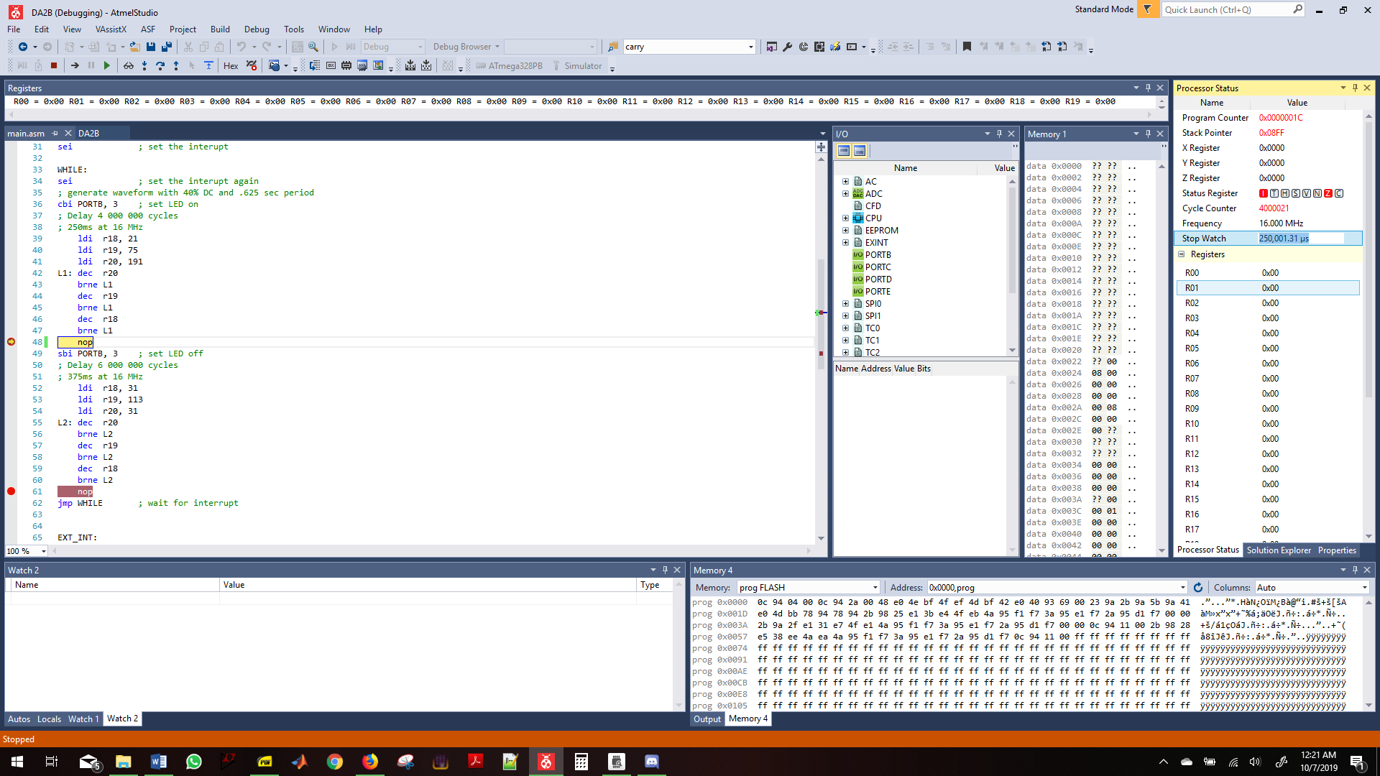

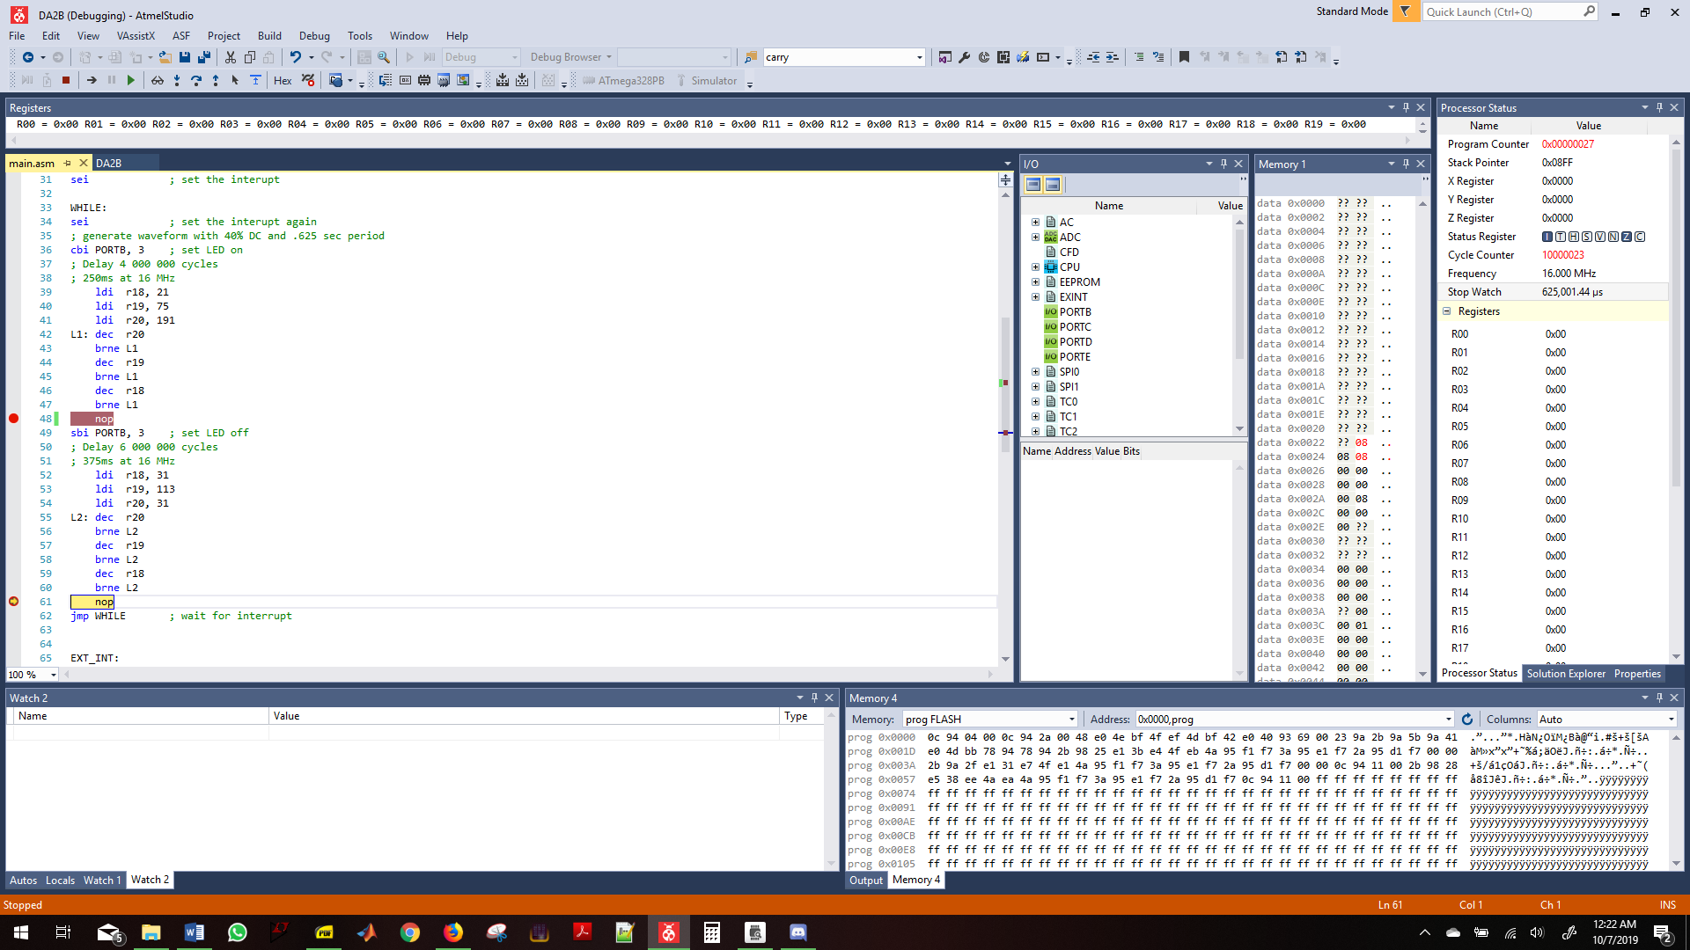

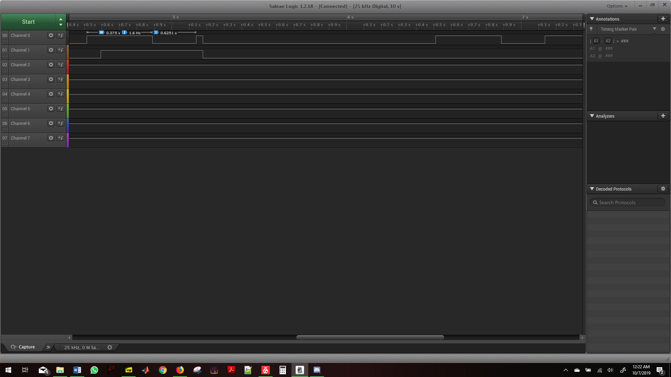

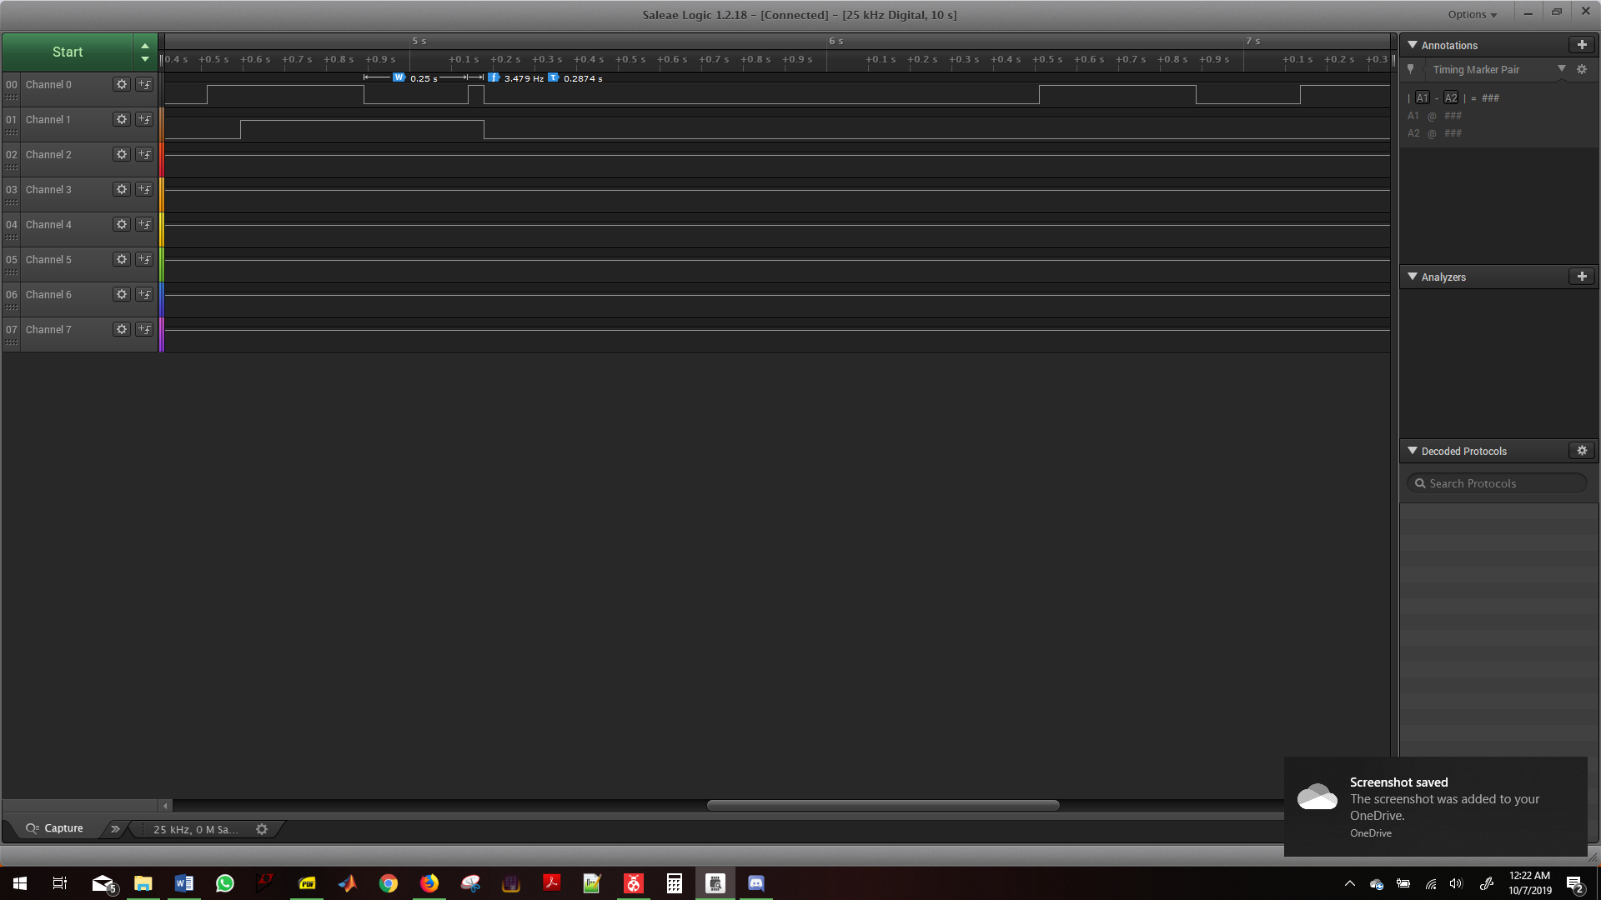

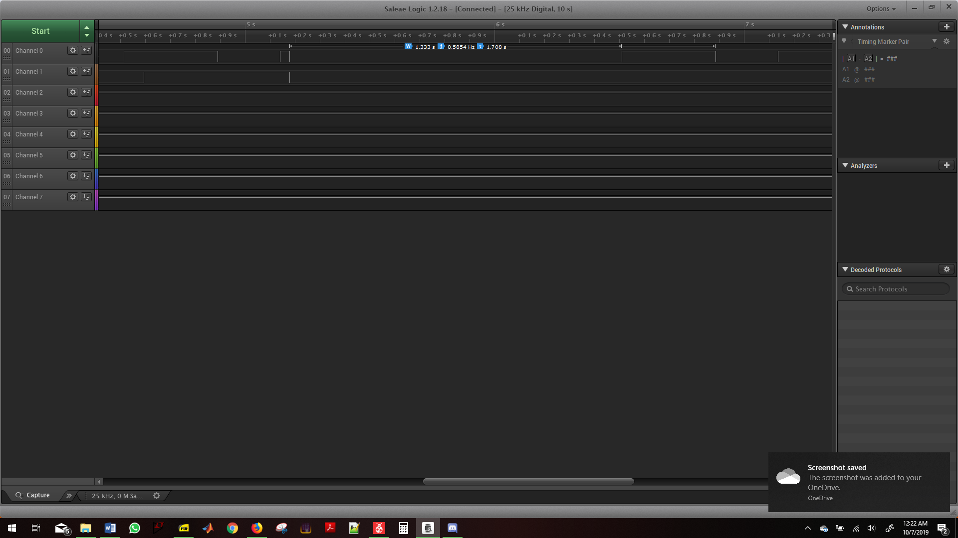

1. **SCREENSHOT OF EACH DEMO (BOARD SETUP)**

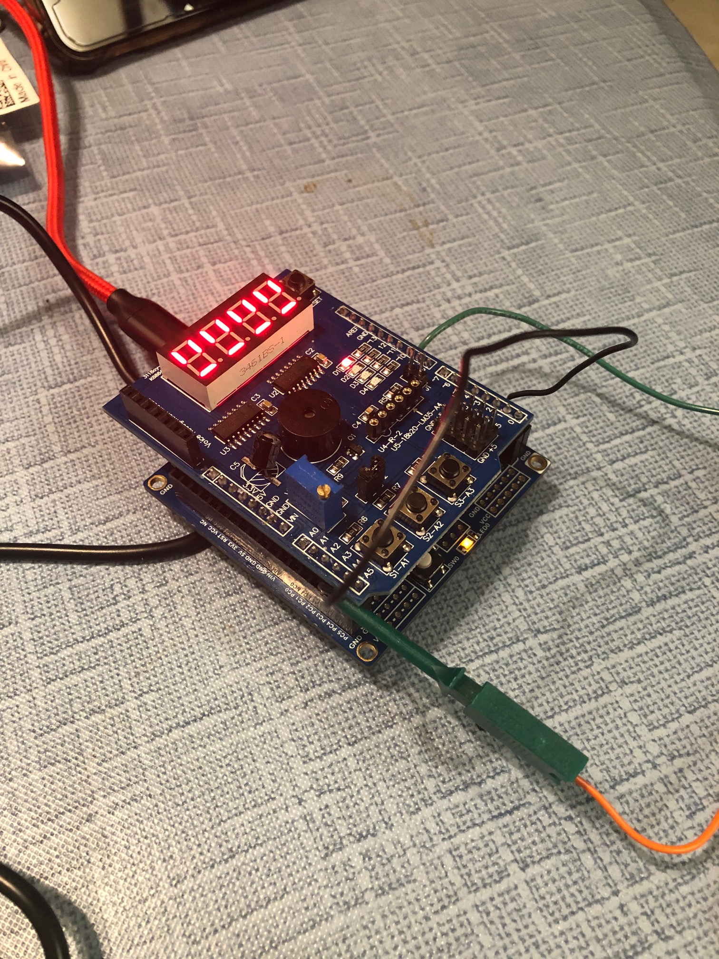

1. **VIDEO LINKS OF EACH DEMO**

<https://www.youtube.com/watch?v=Xu2gUbivu08>

1. **GITHUB LINK OF THIS DA**

**Student Academic Misconduct Policy**

<http://studentconduct.unlv.edu/misconduct/policy.html>

“This assignment submission is my own, original work”.

Andrew Buchanan