CPE301 – SPRING 2019

Design Assignment 1A

Student Name: Andrew Buchanan

Student #:5003154346

Student Email: buchaa2@unlv.nevada.edu

Primary Github address: <https://github.com/buchaa2/103EPC>

Directory:

Submit the following for all Labs:

1. In the document, for each task submit the modified or included code (only) with highlights and justifications of the modifications. Also, include the comments.
2. Use the previously create a Github repository with a random name (no CPE/301, Lastname, Firstname). Place all labs under the root folder ESD301/DA, sub-folder named LABXX, with one document and one video link file for each lab, place modified asm/c files named as LabXX-TYY.asm/c.
3. If multiple asm/c files or other libraries are used, create a folder LabXX-TYY and place these files inside the folder.
4. The folder should have a) Word document (see template), b) source code file(s) and other include files, c) text file with youtube video links (see template).

1. **COMPONENTS LIST AND CONNECTION BLOCK DIAGRAM w/ PINS**

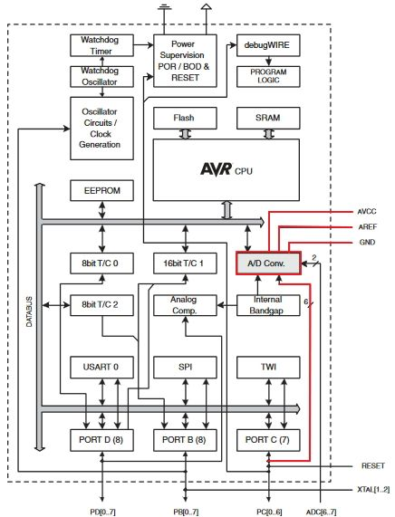

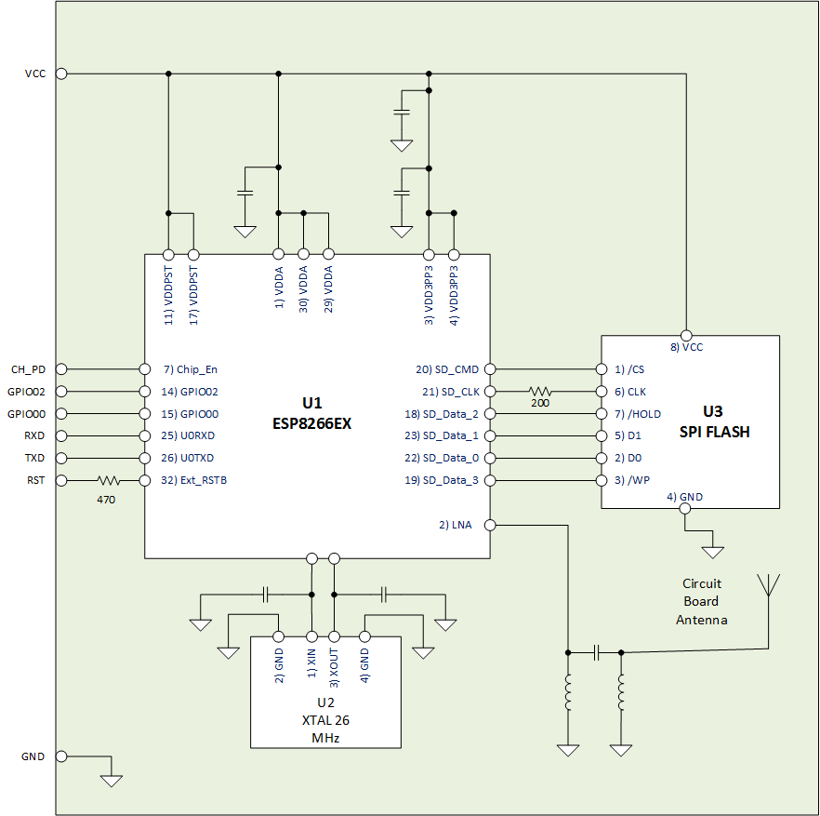

1. **INITIAL/MODIFIED/DEVELOPED CODE OF TASK 1/A**

N/A

1. **DEVELOPED MODIFIED CODE OF TASK 2/A from TASK 1/A**

#ifndef F_CPU

#define F_CPU 16000000UL

#endif

#include <avr/io.h>

#include <stdio.h>

#include <avr/interrupt.h>

#include <util/delay.h>

#include <stdlib.h>

#include <stdint.h>

#include "APDS9960_def.h"

#include "i2c_master.h"

#define F_CPU 16000000UL

#define BAUD 115200

#define FOSC 16000000

#define UBRREQ FOSC/8/BAUD -1

#define APDS9960_WRITE 0x72

#define APDS9960_READ 0x73

void UART_init (void);

void APDS_init (void);

int UART_putchar( char c, *FILE* *stream);

*FILE* str_uart = *FDEV_SETUP_STREAM*(UART_putchar, *NULL* , *_FDEV_SETUP_WRITE*);

void startreading(void);

*uint16_t* red;

*uint16_t* green;

*uint16_t* blue;

int main( void )

{

UART_init(); // This initializes UART values

APDS_init(); // This initializes APDS9960

i2c_init(); // This initializes I2C

*stdout* = &str_uart;

red = 0;

green = 0;

blue = 0;

//

*_delay_ms*(2000);

*printf*("AT\r\n");

// Set AP’s info connected by ESP8266. (AP + Station Mode)

*_delay_ms*(5000);

*printf*("AT+CWMODE=3\r\n");

// Internet Connection

*_delay_ms*(5000);

*printf*("AT+CWJAP=\"ASUS\",\"abulator\"\r\n"); // Wifi password and SSID

while(1) // This constantly sends values to the cloud

{

// Enables Single Connection

*_delay_ms*(5000);

*printf*("AT+CIPMUX=0\r\n");

// Start the connection to cloud

*_delay_ms*(5000);

*printf*("AT+CIPSTART=\"TCP\",\"184.106.153.149\",80\r\n");

// Send values red, green, blue to field 1, field 2, and field 3

*_delay_ms*(5000);

startreading();

*printf*("AT+CIPSEND=104\r\n");

*printf*("GET /update?key=ZDG1BP942G9NVEWD&field1=", red, green, blue);

*_delay_ms*(3000);

//

}

}

void startreading(){

*uint8_t* redH, redL;

*uint8_t* greenH, greenL;

*uint8_t* blueH, blueL;

// RED

i2c_readReg(APDS9960_WRITE, APDS9960_RDATAH, &redH, 1);

i2c_readReg(APDS9960_WRITE, APDS9960_RDATAL, &redL, 1);

// GREEN

i2c_readReg(APDS9960_WRITE, APDS9960_GDATAH, &greenH, 1);

i2c_readReg(APDS9960_WRITE, APDS9960_GDATAL, &greenL, 1);

// BLUE

i2c_readReg(APDS9960_WRITE, APDS9960_BDATAH, &blueH, 1);

i2c_readReg(APDS9960_WRITE, APDS9960_BDATAL, &blueL, 1);

red = (redH << 8) | redL;

green = (greenH << 8) | greenL;

blue = (blueH << 8) | blueL;

// The Threshold limit

if (red > 255)

red = 255;

if (green > 255)

green = 255;

if (blue > 255)

blue = 255;

}

void APDS_init(void){

*uint8_t* setup;

i2c_readReg(APDS9960_WRITE, APDS9960_ID, &setup,1);

if(setup != APDS9960_ID_1) while(1);

setup = 1 << 1 | 1<<0 | 1<<3 | 1<<4;

i2c_writeReg(APDS9960_WRITE, APDS9960_ENABLE, &setup, 1);

setup = DEFAULT_ATIME;

i2c_writeReg(APDS9960_WRITE, APDS9960_ATIME, &setup, 1);

setup = DEFAULT_WTIME;

i2c_writeReg(APDS9960_WRITE, APDS9960_WTIME, &setup, 1);

setup = DEFAULT_PROX_PPULSE;

i2c_writeReg(APDS9960_WRITE, APDS9960_PPULSE, &setup, 1);

setup = DEFAULT_POFFSET_UR;

i2c_writeReg(APDS9960_WRITE, APDS9960_POFFSET_UR, &setup, 1);

setup = DEFAULT_POFFSET_DL;

i2c_writeReg(APDS9960_WRITE, APDS9960_POFFSET_DL, &setup, 1);

setup = DEFAULT_CONFIG1;

i2c_writeReg(APDS9960_WRITE, APDS9960_CONFIG1, &setup, 1);

setup = DEFAULT_PERS;

i2c_writeReg(APDS9960_WRITE, APDS9960_PERS, &setup, 1);

setup = DEFAULT_CONFIG2;

i2c_writeReg(APDS9960_WRITE, APDS9960_CONFIG2, &setup, 1);

setup = DEFAULT_CONFIG3;

i2c_writeReg(APDS9960_WRITE, APDS9960_CONFIG3, &setup, 1);

}

void USART_putstring(char *StringPtr)

{

while ((*StringPtr != '\0')){ // Keep looping until the end of the line

while (!(UCSR0A & (1 << UDRE0))); // Keep looping until UDRE0 goes high

UDR0 = *StringPtr;

StringPtr++;

}

}

void UART_init(void)

{

//Sets the baud rate

*uint16_t* baud_rate = UBRREQ;

UBRR0H = baud_rate >> 8;

UBRR0L = baud_rate & 0xFF;

//This enable receiver and the transmitter

UCSR0B = ( 1 <<RXEN0)|( 1 <<TXEN0);

// Set frame format: 8data, 1stop bit

UCSR0C = (3 <<UCSZ00);

}

int UART_putchar(char c, *FILE* *stream)

{

//waits until buffer is empty

while ( !( UCSR0A & ( 1 <<UDRE0)) );

//Put data into the buffer

UDR0 = c;

return 0;

}

1. **SCREENSHOTS OF EACH TASK OUTPUT (ATMEL STUDIO OUTPUT)**

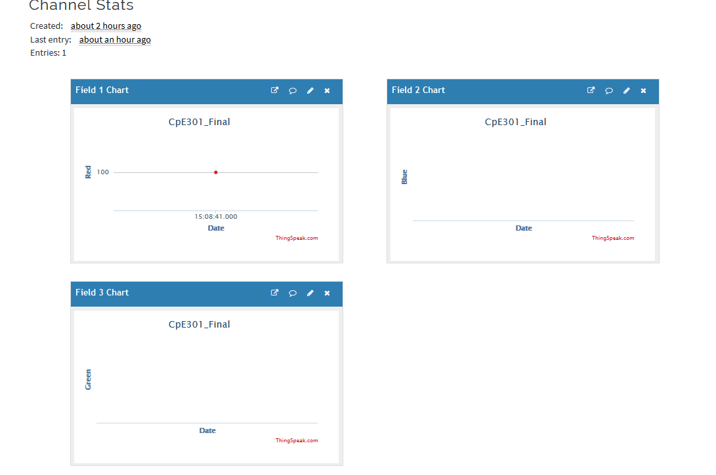

1. **SCREENSHOT OF EACH DEMO (BOARD SETUP)**

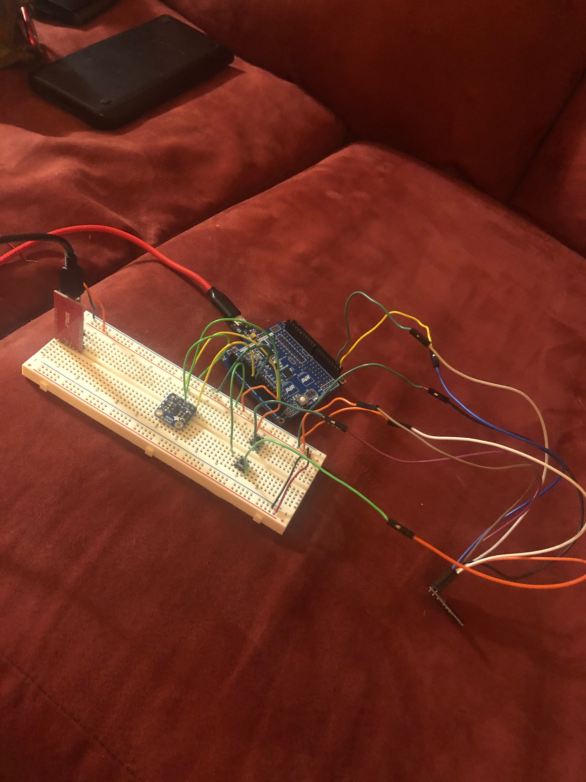

1. **VIDEO LINKS OF EACH DEMO**

<https://www.youtube.com/watch?v=Yb1kDIrHqGA>

1. **GITHUB LINK OF THIS DA**

**Student Academic Misconduct Policy**

<http://studentconduct.unlv.edu/misconduct/policy.html>

“This assignment submission is my own, original work”.

Andrew Buchanan