CPE301 – FALL 2019

Midterm_1

Student Name: Andrew Buchanan

Student #:5003154346

Student Email: buchaa2@unlv.nevada.edu

Primary Github address: <https://github.com/buchaa2/103EPC>

Directory: <https://github.com/buchaa2/103EPC/tree/master/Midterm_1>

Submit the following for all Labs:

1. In the document, for each task submit the modified or included code (only) with highlights and justifications of the modifications. Also, include the comments.
2. Use the previously create a Github repository with a random name (no CPE/301, Lastname, Firstname). Place all labs under the root folder ESD301/DA, sub-folder named LABXX, with one document and one video link file for each lab, place modified asm/c files named as LabXX-TYY.asm/c.
3. If multiple asm/c files or other libraries are used, create a folder LabXX-TYY and place these files inside the folder.
4. The folder should have a) Word document (see template), b) source code file(s) and other include files, c) text file with youtube video links (see template).

1. **COMPONENTS LIST AND CONNECTION BLOCK DIAGRAM w/ PINS**

AtMini xplained:

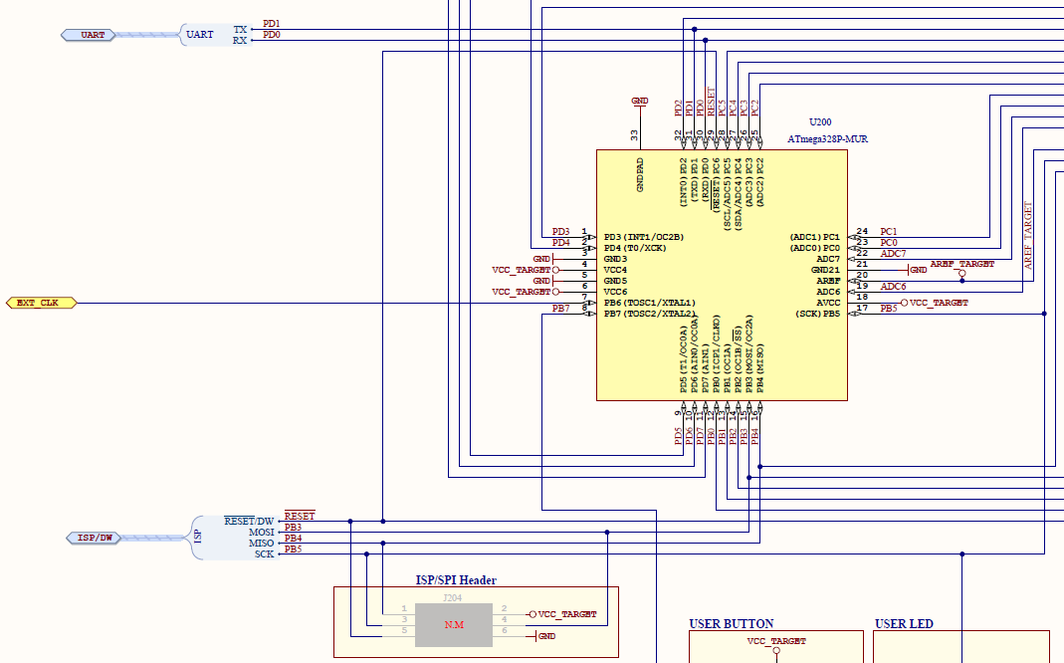

ESP8266:

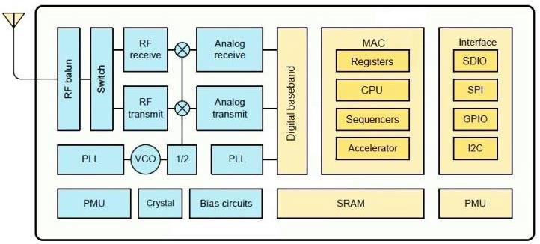

LM35 temperature sensor:

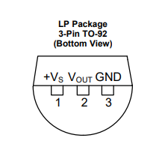

1. **INITIAL/MODIFIED/DEVELOPED CODE OF TASK 1/A**

#define *F_CPU* 16000000UL

#include <avr/io.h>

#include <stdlib.h>

#include <math.h>

#include <avr/interrupt.h>

#include <stdio.h>

#include <util/delay.h>

#include <math.h>

#define BAUDRATE 115200

#define BAUD_PRESCALLER (int)*round*(((((double)*F_CPU* / ((double)BAUDRATE * 8.0))) - 1.0))

*uint8_t* OVFLOWCOUNT = 0; //initialize the overflow count for interrupt

*uint8_t* OVFLOWLIMIT = 250; //set the over flow limit for 1 sec delay

void USART_init(void); //initialize USART

void USART_transmit(unsigned char data); //send through USART

void USART_putstring(char* StringPtr); //scan through string

void ADC_init (void); //function to initialize ADC

int main(void)

{

USART_init(); //initialize USART

ADC_init (); //initialize ADC

USART_putstring("AT+CWMODE=1\r\n");//set esp01 to station 1 mode

*_delay_ms*(20);//string needs time to process before sending another command

USART_putstring("AT+CWJAP=\"ASUS\",\"abulator\"\r\n");// Enable connection

*_delay_ms*(20);//string needs time to process before sending another command

USART_putstring("AT+CIPMUX=0\r\n");

*_delay_ms*(20);//string needs time to process before sending another command

USART_putstring("AT+CIPMUX=0\r\n");

TCCR0A = 0x00; //set normal operation

TCCR0B |= (1 << CS02); //set prescalar to 256

TCNT0 = 6;

TIMSK0 |= (1 << TOIE0);

sei(); //set interrupt

while (1)

{ //sit here waiting for interrupt

}

}

void USART_init(void)

{

UCSR0A = (1 << U2X0);

UBRR0H = (*uint8_t*)(BAUD_PRESCALLER >> 8);

UBRR0L = (*uint8_t*)(BAUD_PRESCALLER);

UCSR0B = (1 << RXEN0) | (1 << TXEN0);

UCSR0C = (3 << UCSZ00);

}

void USART_transmit(unsigned char data)

{

while(!(UCSR0A & (1 << UDRE0)));

UDR0 = data;

}

void USART_putstring(char* StringPtr)

{

while(*StringPtr != 0x00)

{

USART_transmit(*StringPtr);

StringPtr++;

}

}

void ADC_init (void)

{

ADMUX = (0<<REFS1)|

(1<<REFS0)|

(0<<ADLAR)|

(1<<MUX2)|

(0<<MUX1)| // ADC5 PC4

(0<<MUX0);

ADCSRA = (1<<ADEN)|

(0<<ADSC)|

(0<<ADATE)|

(0<<ADIF)|

(0<<ADIE)|

(0<<ADPS2)| // ADC Prescaler

(1<<ADPS1)|

(1<<ADPS0);

}

ISR (TIMER0_OVF_vect)

{

OVFLOWCOUNT++;

if (OVFLOWCOUNT == OVFLOWLIMIT)

{

ADCSRA|=(1<<ADSC);

while((ADCSRA&(1<<ADIF))==0);

ADCSRA |= (1<<ADIF);

//take value from ADC and transmit it

int var = ADCL;

var = var | (ADCH<<8);

var = (var/1024.0) * 5000/10;

var = (var*2)+32;

var = var % 100;

USART_putstring("AT+CIPSTART=\"TCP\",\"api.thingspeak.com\",80\r\n"); //connect to thingspeak

*_delay_ms*(20);

USART_putstring("AT+CIPSEND=51\r\n"); //start sending data in transparent transmission mode

*_delay_ms*(20);

USART_putstring("GET /update?key=QWQ7N2VIHJPFQR3F&field1="); //prepare to send data using "Write" API Key

*_delay_ms*(20);

USART_transmit((var/10)+'0');

*_delay_ms*(20);

var = var % 10;

USART_transmit((var)+'0');

*_delay_ms*(20);

USART_putstring(" ");

*_delay_ms*(20);

USART_putstring("\r\n");

*_delay_ms*(20);

OVFLOWCOUNT=0;

}

TCNT0 = 6;

}

1. **SCHEMATICS**

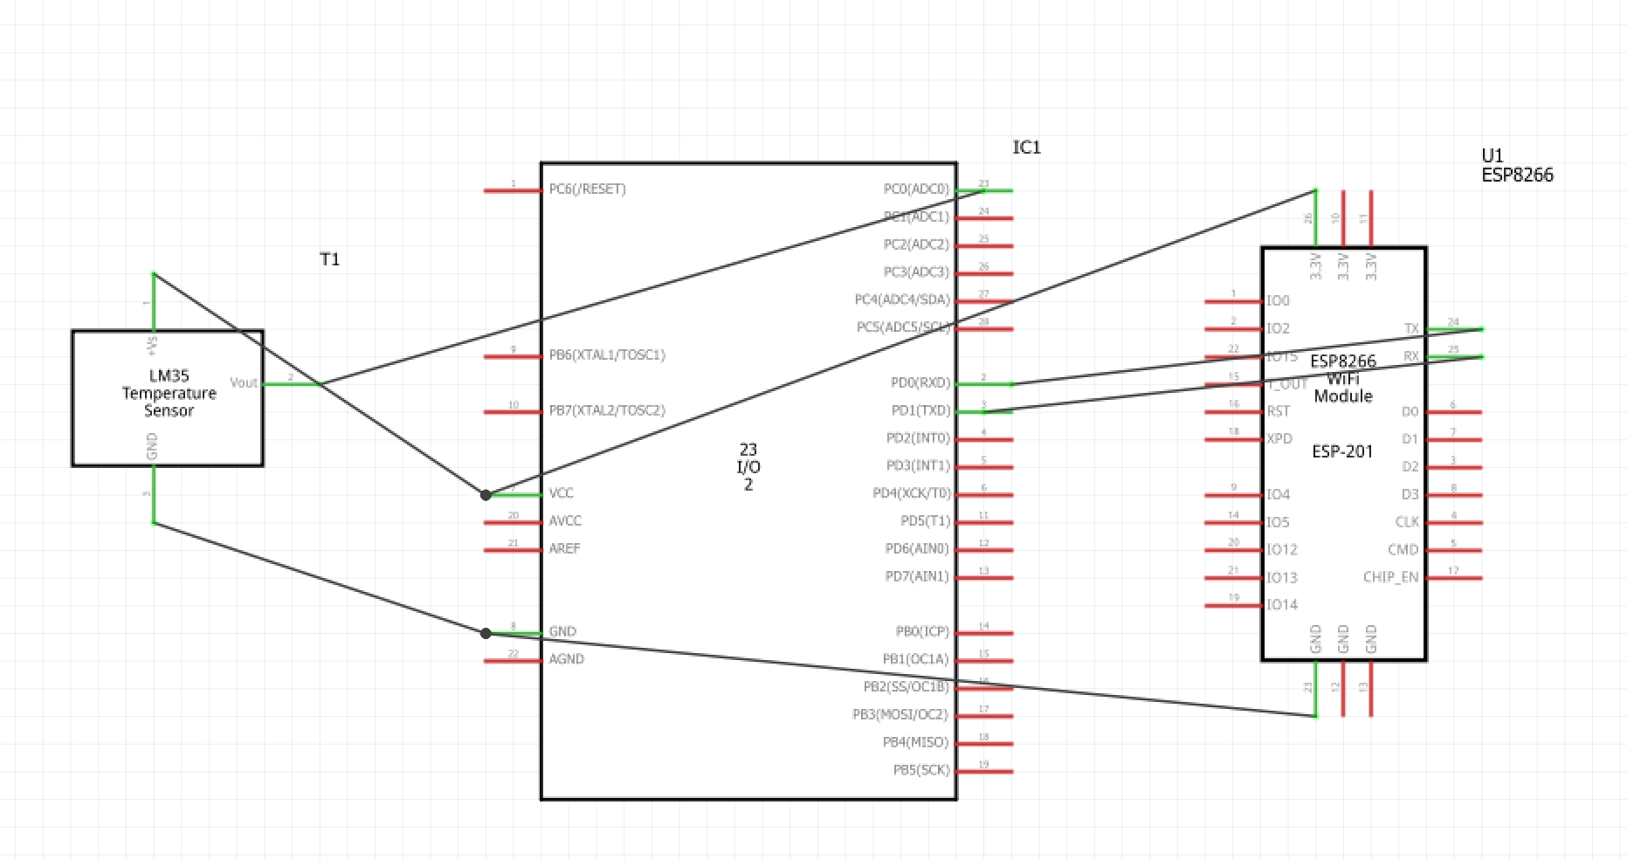

1. **SCREENSHOTS OF EACH TASK OUTPUT (ATMEL STUDIO OUTPUT)**

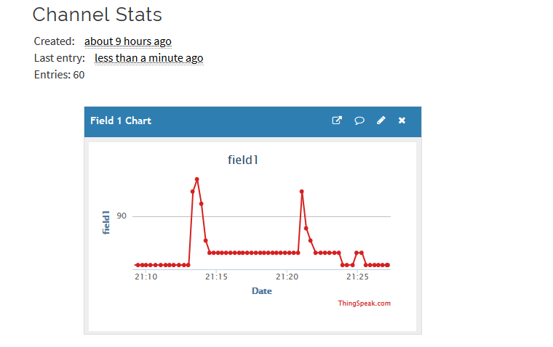

1. **SCREENSHOT OF EACH DEMO (BOARD SETUP)**
2. **VIDEO LINKS OF EACH DEMO**

<https://www.youtube.com/watch?v=O0ewytnI_bg>

1. **GITHUB LINK OF THIS DA**

<https://github.com/buchaa2/103EPC/tree/master/Midterm_1>

**Student Academic Misconduct Policy**

<http://studentconduct.unlv.edu/misconduct/policy.html>

“This assignment submission is my own, original work”.

Andrew Buchanan