**Human Centered Design Techniques and Tools**

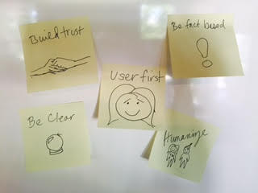

We believe in putting our users first and creating applications that are inherently easy for the user to learn and understand, rather than going on our own biased perspectives and forcing the users to learn.

A few of the techniques that we utilized in this project include:

* Define our audience
  + We defined our audience for the challenge and made an effort to understand who they are and their backgrounds by creating persona models and being mindful of how these personas would interact with our application.
* Using Design principles
  + As shown in the sticky notes above, our design principles include:
    - Build trust
    - Humanize
    - Present the Facts
    - Be simple and approachable
    - Be clear
* Build from user stories
  + In order to understand who we are building our applications for, we built from user stories so that there was a clear objective and problem to be solved for each user.
* Usability testing
  + We understand the importance of testing with real-world users. While we could not select testing candidates from a large pool of prospective users due to time constraints, we did create screening documents and testing scripts, and took videos of actual, real-world users trying out our application to get feedback.
* Rapid prototyping
  + Rapid prototyping helped us to more quickly understand what we want and if our ideas will work. We sketched out some ideas and also used “Invision” to prototype.