

**Disentangling age-related trends of reproductive success in a wild population of collared flycatchers (*Ficedula albicollis*)**

James Buchanan

Supervisor: Dr Pierre Bize

BI4016 Research Project Thesis 2020/2021 School of Biological Sciences

Work completed in partial fulfilment of the requirements for the degree

Integrated Master in Science Biological Sciences

Word count (excluding references and figure legends): 7620

**Abstract**

Trends in reproductive success with age are often reported in wild populations. Competency improvements and increasing parental investment tend to produce early-age increases, whilst late-age declines typically result from ageing. However, individual changes are seldom the sole cause of this trajectory. Population trends may result from shifting reproductive successes of age-cohorts as individuals of varying reproductive capability appear and disappear. Such ‘demographic effects’ may mask or emulate individual changes when observed at the population-level. Separating these within- and between-individual effects is essential to accurately describing individual reproductive success within populations. I analysed age-related patterns of reproductive success in a population of short-lived collared flycatchers (*Ficedula albicollis*) on the island of Gotland, Sweden, where many individuals are of known age. Fledging success increased in early-age and decreased in late-age, however separating variation failed to indicate the source of this pattern. Chick body condition increased in early-age females and decreased in late-ages of both sexes; likely caused by demographic factors. While provisioning rate did not change with age and did not explain variation in chick body condition, it did explain variation in fledging success. Indeed, provisioning rates positively correlated with fledging success. Interpretations of these findings are discussed. Partial support for the classic early-age improvements and late-age declines in reproductive success was found, as predicted by life-history theory. The influence of demographic variation highlighted the importance of decomposing population trends so that erroneous conclusions are avoided. Multifactorial measures of parental and effort proficiency may be crucial in reliably identifying age-related change.

**Introduction**

Increasing reproductive success with age is a commonly observed in the early reproductive years of birds (Møller & Lope 2002; Wooler *et al*. 1990) and several life-history processes are hypothesised to account for this trajectory in wild populations. Hypotheses explaining early-age increases are often generalised into three main groups: improvements in competency, optimisation of reproductive effort, and appearance and disappearance of varying quality phenotypes. These hypotheses are not mutually exclusive and likely act in combination. Early-age increases are typically followed by plateaus in middle-age and are sometimes concluded by declines in late-age (Włodarczyk & Minias 2020; Balbontín & Møller 2015; Forslund & Pärt 1995). Several physiological and behavioural characteristics are known to deteriorate with age, and this effect known as senescence, produces reproductive degradation. Senescence is a maladaptive trade-off which typically occurs as resources are shifted from self-maintenance to reproduction as individuals near their demise (Kirkwood 1977). Several of these forces shape the life-history trajectories observed in wild animal populations, and the sources of these patterns are of interest to an array of ecological fields (Stearns 2000). Reported patterns can be separated into sources of individual and demographic variation; however, these effects commonly confound one-another when analysed cross-sectionally (Rebke *et al*. 2010; Catry *et al*. 2006) and are a major challenge in studying age-dependent reproduction (Forslund & Pärt 1995). Indeed, one of the main obstacles that has prevented reliable isolation of the causes of within-individual change has been the reliance on cross-sectional analyses (Nussey *et al*. 2008) wherein data are periodically collected as instants in time without identifying specific individuals by which to track lifetime change. Many studies concerned with evolutionary questions of individual reproductive change report age-related correlations at the population-level. However, such correlations are seldom representative of individual change as cross-sectional analyses cannot account for changes in the phenotypic structure of populations as cohorts age. For this reason, studies of individual change within populations often encounter difficulty when attempting to explain trends at the population level, as demographic variation may emulate or obstruct within-individual change (Vaupel & Yashin 1985).

One contributing factor to early-age improvements in reproductive success are increases in experience and resultant improvements in competency in young adults (Pyle *et al*. 1991; Wunderle 1991). This hypothesis suggests that as individuals age and are repeatedly exposed to situations which test their proficiency, they should iteratively improve in skills which positively affect their reproductive success. As such, reproductive efforts should become more efficient with age if greater experience allows individuals to exploit greater success for the same unit of investment. Many behaviours may be subject to competency improvements with experience, but perhaps the most commonly considered is foraging proficiency. Generally, improvements in searching time, handling time, and speed of identification are responsible for increases in foraging competency (Forslund & Pärt 1995; Wunderle 1991). Inexperienced individuals may forage in nonoptimal habitats, may be less capable of discerning quality or edibility of prey, and may be less skilful at capturing prey (Wunderle 1991). Changes in competency are therefore commonly studied influences of reproductive success.

An additional group of hypotheses postulate that organisms become more proficient reproducers as they age because their optimal reproductive efforts, which describe the total proportion of available resources optimally invested in current reproduction, should increase. Two primary factors may explain this trend. Firstly, Individuals should commit more resources to reproduction as investments provide increasingly great returns with age, owing to rising competency (Schaffer 1974). Optimal reproductive effort should increase for as long as competency Is accrued and should cease when improvements plateau (Forslund & Larsson 1992). Secondly, reproductive effort may increase as the number of reproductive opportunities decreases, and as mortality risk increases with age. Investment in current reproduction should therefore increase as individuals age, as saving resources for future reproduction becomes less profitable; this is known as the terminal investment hypothesis (Clutton-Brock 1984). Parental investment increases the likelihood of current offspring survival at the cost of investment in further reproduction (Trivers 1972). Investment strategies ultimately aim to maximise reproduction wherein costs are measured in losses of potential future offspring (Dawkins & Carlisle 1976). Increasing effort is typically achieved by reducing self-maintenance in favour of increased reproductive investment (Kirkwood 1977). Birds typically express rising investment through nutritional delivery to chicks, and so increasing provisioning rates have often been utilised as signifiers of increasing effort (Schaffer *et al*. 2003; Tolonen and Korpimaèki 1994). For this reason, patterns of effort are often examined in relation to reproductive change.

Physiological condition has long been known to worsen with age (Medawar 1952). Age-related deterioration was previously thought to be an artifact of laboratory models or otherwise domestic organisms where environmental conditions are conducive to longevity (Medawar 1952; Comfort 1956). However, since the formation of long-term datasets and the ability arose to identify unique individuals across their lifespans, evidence for ageing in wild populations has steadily mounted (see Nussey *et al*. 2013 for review). Ageing is recognised as one of the most important factors influencing age-structured populations (Stearns 2000) and must be accounted for in long-term studies of population change (Nussey *et al*. 2013). Senescence is commonly identified through declines in reproductive success (Spagopoulou *et al*. 2020; Wiggins *et al*. 1994). Specifically known as reproductive ageing, this process describes the reducing capacity of individuals to successfully produce and rear offspring with age (Velde & Pearson 2002). Although decreased egg production, clutch size, and fledging success commonly diagnose reproductive ageing in birds (Holmes *et al*. 2003), senescence has also been observed to manifest as deterioration of body condition. Age-related reductions in activity levels (Sallis 2000) and visual acuity (Schmolesky *et al*. 2000) have been reported across species. Flight capabilities may also be subject to deterioration in birds (Navarro & González-Solís 2007), negatively affecting foraging proficiency, provisioning rates, and other mobility-dependent tasks. Senescence is therefore of critical interest to the study of reproductive-dynamics in wild populations.

While equal parental labour is sometimes noted (Greenberg & Gradwohl 1983), duties are often divided unequally in the >80% of bird species known to exhibit biparental care (Olson *et al*. 2008; Cockburn 2006). Theories of investment suggest that parents must balance their contributions to shared offspring (Maynard Smith 1977) as either parent may benefit from reducing their input and relying on their partner’s increased investment (Kokko & Jennions 2008). Alternation of provisioning and foraging duties typically facilitate this balance (Bebbington *et al*. 2015). Nest roles may produce different life-histories as tasks are completed at different rates or durations between sexes (Guigueno & Sealy 2012; Chazarreta *et al*. 2011). Different Incubation and provisioning duties may also produce different patterns of effort between sexes (Siikamäki *et al*. 1998). Parents typically occupy complementary nest roles, dividing provisioning, incubation (Rytkönen *et al*. 1996; Kuitunen *et al*. 1995; Greenberg & Gradwohl 1983), defence, and sanitation duties (Guigueno & Sealy 2012; Burger 1980). Tasks may be completed at different rates or durations (Guigueno & Sealy 2012; Chazarreta *et al*. 2011; Bartlett *et al*. 2005). Additionally, different sexes of pied flycatchers (*Ficedula hypoleuca*) have been observed to forage in different areas and capture different prey species (Mänd *et al*. 2013). Separating patterns by sex therefore allows greater precision when investigating reproductive patterns.

Within-individual effects are rarely the sole contributors to population variation as correlations may result from progressive changes in the phenotypic compositions as cohorts age (van de Pol & Verhulst 2006). Such variation between individuals occurs naturally in all populations and may cause certain parents to reproduce more successfully than others: this is known as the individual quality hypothesis (Wilson & Nussey 2009). Additionally, when phenotypes differ in their survival probabilities or reproductive success, appearance and disappearance of individuals will occur in the population; this is known as the selection hypothesis (Nol & Smith 1987). For example, if good reproducers have greater survival likelihoods than poor reproducers, progressive appearance of high-performers will result in older cohorts featuring the greatest reproductive success of the population (Włodarczyk & Minias 2020). Moreover, if individuals who begin to breed at a later ages are superior reproducers to those who breed younger, the proportion of highly successful reproducers will increase as cohorts age; this is known as a delayed breeding hypothesis (Hamann & Cooke 1987). Empirical support for such demographic effects is mixed, however differential survival with age is frequently observed (Pärt *et al*. 1991; Nol & Smith 1987). While the low annual mortality of long-lived birds means differential-mortality alone is unlikely to produce age-related variation, the converse may be true of short-lived species with relatively greater mortality (Forslund & Pärt 1995). Repeated measures are crucial for compartmentalising age-related trends into sources of between- and within-individual variation (Rebke *et al*. 2010; van de Pol & Verhulst 2006). Unlike cross-sectional data, longitudinal data record individuals throughout their lifespans via repeated measurements, and this allows individual variation to be effectively isolated from demographic trends and for the sources of observed patterns to be precisely attributed (Catry *et al*. 2006). This is often achieved using random effects models which allow sources of variation to be partitioned into multiple levels of aggregation (van de Pol & Verhulst 2006; Snijders & Bosker 1999). Longitudinal analyses are therefore commonly argued to be the only reliable method by which to study age-effects in populations (Nussey *et al*. 2008; Forslund & Pärt 1995). Controlling for demographic variation is imperative to reliably measuring individual change within populations as failure to do so may cause erroneous conclusions (van de Pol & Verhulst 2006; Catry *et al*. 2006).

My study analysed changes of individual reproductive success in a wild population of short-lived collared flycatchers (*Ficedula albicollis*) by analysing age-related patterns of fledging success, chick body condition, and provisioning rate. Exact ages were known for many individuals due to capture as nestlings and as yearlings then marking with unique identification rings (Récapet *et al*. 2017). Plumage characteristics are age-dependent and so yearlings could be reliably distinguished (Svensson 1992). These factors allowed the presence and absence of unique individuals to be monitored over time and consequently within-individual changes in behavioural traits to be temporally quantified. The changes in these traits were partitioned into sources of variation arising from between- and within-individual levels of aggregation, and in doing so their relative contributions were compared. I expected Individual reproductive success to increase in early-age (*a*) until a plateau in middle-age (*b*) whereafter reproductive success would decline in late-age (*c*). I expected provisioning rates to follow a similar quadratic trajectory (*d*), and to explain patterns of reproductive success (*e*). Lastly, I expected patterns of reproductive success to differ between sexes (*f*).

**Materials and Methods**

*Study population*

Collared flycatchers (*Ficedula albicollis*) are insectivorous, migratory passerines, which typically breed in deciduous or mixed woodland in central to eastern Europe as monogamous pairs (Merilä & Hemborg 2003) and which migrate to southern and central Africa for overwintering. They typically breed in cavities, but readily adopt nest boxes when available, making them a convenient study species for remote video observation and capture. A distinct sexual dimorphism in plumage allows for easy identification, as males are characterised by a distinctive head patch and sharp contrast in colouration, whilst females are plainer in appearance (*see figs. 1 & 2*). This study was conducted on an isolated population of collared flycatchers present on the southern end of the island of Gotland, Sweden (57°07’N, 18°20’E) in the Baltic sea (see Pärt & Gustafsson 1989 for details). Long term data collection of the Gotland population was organised by B. Dolgiez and L. Gustafsson (see Récapet *et al*. 2017 for details). Nest boxes were attached to trees in 8 patches of spatially discrete woodland and were regularly spaced at an average of approximately 37-48m; between 24 and 77 nest boxes were contained in each woodland patch (see Récapet *et al*. 2017 for details). Furthermore, dispersal is restricted in this population (Pärt & Gustafsson 1989), therefore survival and reproduction can be reliably studied in individuals throughout their lifespans through longitudinal analyses. These factors allowed the presence and absence of unique individuals in the study population to be monitored over time and consequently within-individual changes in behavioural traits to be measured with age.

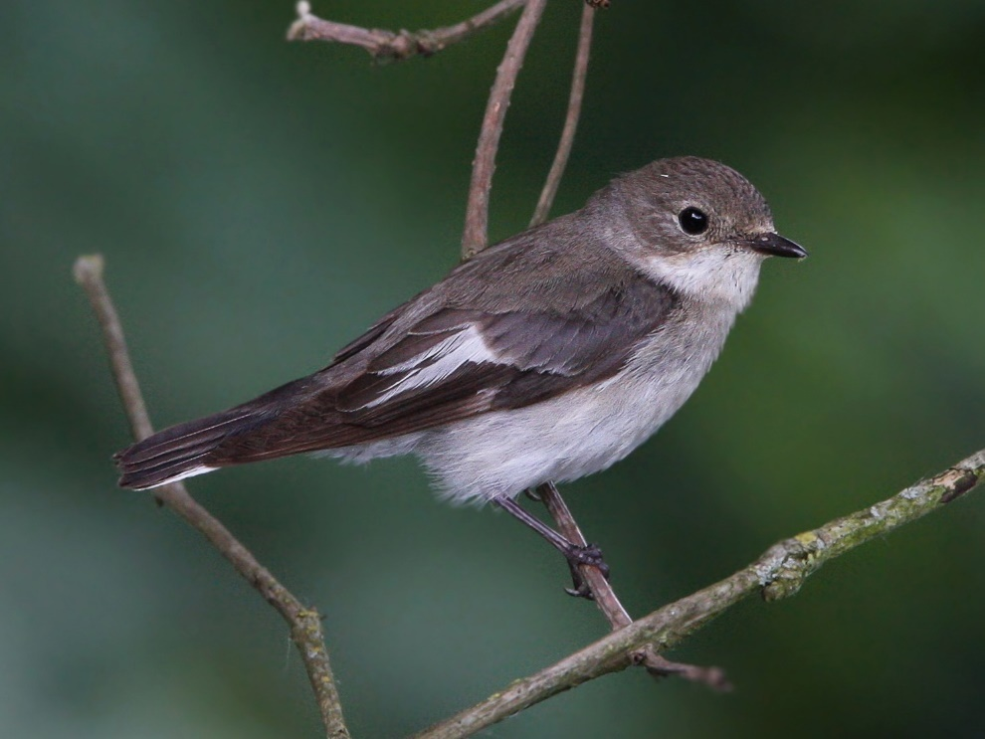

**Figure 1:** Female adult collared flycatcher (Ficedula albicollis) (Moning 2009). Note lack of plumage contrast and absence of head patch.

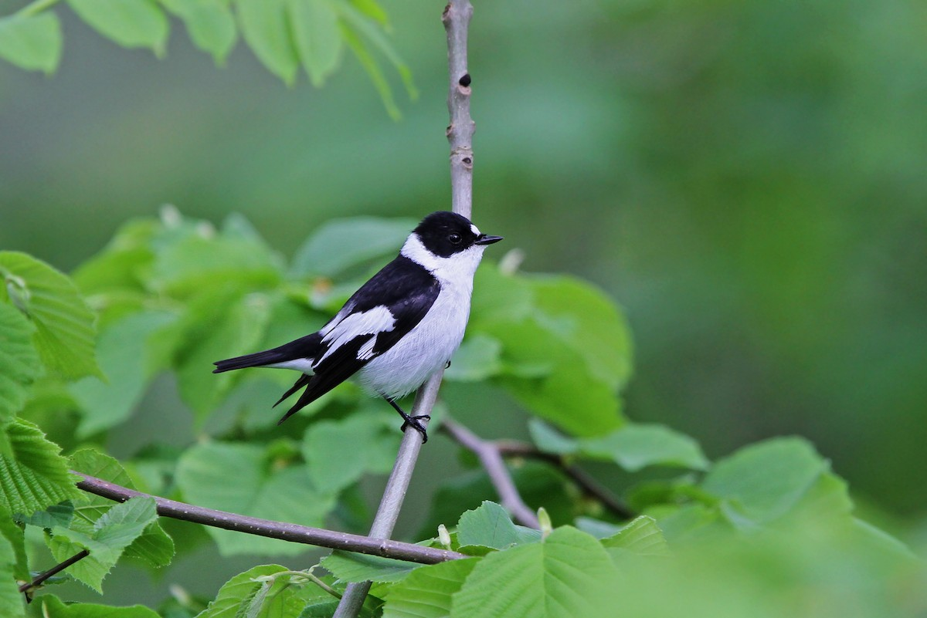

**Figure 2:** Male adult collared flycatcher (Ficedula albicollis) (Moning 2010). Note contrasting plumage and distinct head patch.

*Measures of reproductive success*

All nest boxes were visited at regular 2-day intervals beginning on the 27th of April so that measurements of fledging success could be estimated (see Récapet *et al*. 2017 for details). Chick body condition was estimated by collecting measurements of both tarsus length (to the nearest 0.1mm) as an estimate of body size and body weight (to the nearest 0.1g). Body condition was represented as body weight over tarsus length, which provided an index of resource intake relative to body size. Additionally, most breeding females were captured during incubation whilst males were primarily trapped whilst provisioning their offspring in nest boxes (see Pärt & Gustafsson 1989 for details). Together, chick body condition and fledging success provided measures of reproductive success.

*Measures of provisioning rate*

A dataset of parental provisioning behaviour in collared flycatchers was collected near-annually from 2006 to 2015 using film recordings of nest activity. Hidden cameras captured feeding behaviour within regularly distanced nest boxes placed in discrete patches of woodland of varying size (see Récapet *et al*. 2017 for details). These recordings were converted into ethograms using the Behavioural Observational Research Interactive Software (BORIS) package (Friard & Gamba 2016) and videos were analysed until either the recording ended, or 90 minutes passed, past which all behavioural observation ended. Most nest box entries were recorded and presumed to represent provisioning events, however, entries which occurred less than approximately 30 seconds after a previous exit were discounted and marked as visitations. Likewise, individuals whose behaviour appeared unlike that of the regularly visiting parents were marked as prospectors and were discounted from the provisioning study. Moreover, in instances where chicks repeatedly alarmed in response to a disturbance, approximately 20 minutes of footage was analysed after which the analysis ended if no nest box entrances were observed. I analysed 128 videos. Provisioning rates were then calculated as a measure of visitations per hour, beginning when individuals first seen feeding until end of recording. Provisioning rates were assumed to represent reproductive effort and foraging competency of parents. 1384 observations, of which 233 (16.8%) were repeat measurements, were recorded for 1250 individuals. This allowed for limited separation of individual-level effects from the observed population patterns.

*Statistics overview*

Two models were assembled for each trait wherein the first analysed age-related change at the population-level and the second decomposed population-level change into sources of between- and within-individual variation. All statistical analyses were conducted in the R programming language (version 3.6.1) (R Core Team 2020) using the RStudio integrated development environment (version 1.3.1093) (RStudio team 2020). All models were constructed using the lme4 package (version 1.1-26) (Bates *et al*. 2015). Gaussian model fit assumptions were tested by analysing the normality of residuals using the fitdistrplus package (version 1.1-3) (Delignette-Muller & Dutang 2015). All graphical outputs were produced by the ggplot2 package (3.3.2) (Wickham 2016). Satterthwaite’s method was used to calculate degrees of freedom for linear mixed models. REML vs ML

*Population-level models*

Continuous data were assumed to be drawn from gaussian distributions and were run as either linear regressions or linear mixed models; however, count data were ran as generalised linear mixed models with a poisson function. Age was included as a continuous variable in all models, rather than as a factor, so as to maintain high degrees of freedom. Interactions were then sequentially removed in order of decreasing number of parameters and by decreasing non-significance. Furthermore, as early-age increases and late-age decreases were anticipated, a quadratic age effect was initially included in all population-level models so as to quantify the non-linearity of the trends. Moreover, (age x sex) and (age2 x sex) interactions were included initially in all models so that the age-related trends could be compared between the sexes. Individual identity and year of recording were included as random effects initially in all models to control for heterogeneity between individuals and between study years.

*Individual-level models*

In order to disentangle within- from between-individual effects, additional parameters were included in the models which allowed for multilevel variation. Decomposition was achieved using an adapted within-group centering approach (van de Pol & Verhulst 2006) where between-individual variation was represented by the maximum observed age of each individual, and the within-individual variation was represented by the difference between each individual’s observed age and their respective maximum age. This method allowed the changes in traits as cohorts aged to be measured at the population level, whilst the change of traits at the individual level was measured as individuals approached their maximum observed age. Additionally, provisioning rate was included as a fixed effect in the chick body condition and fledging success models so as to estimate the influences of effort and foraging proficiency on reproductive success. Significant provisioning rate terms were included in final models but were removed if non-significant. Furthermore, interactions between fixed effects of provisioning rate, chick body condition, fledging size, and sex were initially included in all decomposed-effects models and were sequentially removed if non-significant, re-running models each time, and starting with the largest order of interaction. Significant interactions between the between- and within-individual terms indicated that individual change differed between cohorts, while interactions with sex signified that terms were sex-dependent.

**Results**

*Changes in fledging success with adult age*

Fledging success at the population level was significantly explained by age (*P* = 0.007, *see table 1*) and age2 (*P* = 0.008, *see table 1*) wherein fledging success increased with age until about 3 years of age whereafter it decreased (*see fig. 3*). Additionally, the effect of sex was found to be significant (*P* = 0.011, *see table 1*) as males were observed to fledge marginally more offspring than females (*see fig. 4*).

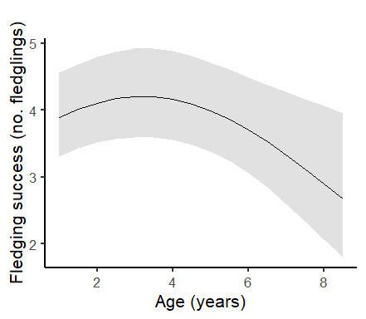

**Figure 3:** Relationship between fledging success and age at the population level, as predicted by model 3 (see table 1). Shaded regions represent 95% confidence intervals.

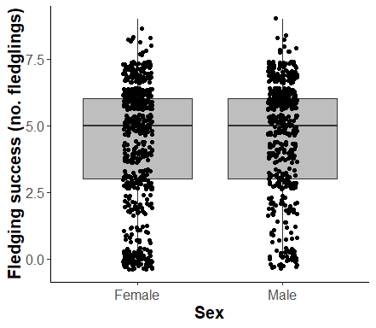

**Figure 4:** Raw data of fledging success compared between males and females. Shaded region represents interquartile range.

When decomposing population variation, no significant between-individual (P = 0.264, see table 2) or within-individual (P = 0.353, see table 2) effects were observed. However, provisioning rates were observed to significantly explain variation in fledging success (P <.005, see table 2) and were positively correlated with the number of offspring fledged (see fig. 5).

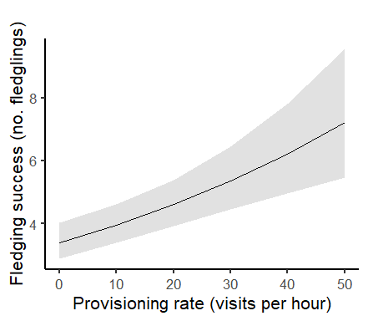

**Figure 5:** Relationship between fledging success and provisioning rate, as predicted by model 6 (*see table 2*). Shaded regions represent 95% confidence intervals.

*Changes in chick body condition with adult age*

The random effects of individual identity and year of recording were found not to explain a large degree of variation in chick body condition, and because of their causing convergence issues were removed from both models. Chick body condition at the population level was found to be significantly explained by age (*P* = 0.029, *see table 1*) and age2 (*P* = 0.035, *see table 1*), suggesting a quadratic trajectory (*see fig. 6*). Additionally, chick body condition differed by parent sex (*P* = 0.016, *see table 1*) and patterns of age related change differed between parent sexes (*P* = 0.016, see table 1). Female chick body condition increased until 3 years of age while no increase was observed in males. Declines of chick body condition with age occurred in both sexes, with males falling further and more rapidly (*see fig. 6*). Decomposition of the population-level variation suggested between-individual factors to drive differences in patterns between sexes (*P* = 0.006, *see table 2*). Additionally, provisioning rate was found to not significantly explain variation in chick body condition, and so was not included in the final model.

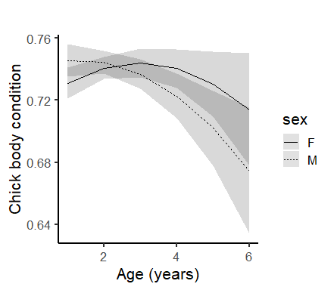

**Figure 6:** Relationships between chick body condition and age between sex at the population level, as predicted by model 2 (*see table 1*). Shaded regions represent 95% confidence intervals. M = male, F= female.

*Changes in provisioning rate with adult age*

No significant change in provisioning rate with age was observed at the population level. Furthermore, no significant age-related patterns could be evidenced when decomposing variation. However, both models found provisioning rates to differ between sexes (*P* = <.005, *see tables 1 & 2*), wherein males provisioned their offspring at greater rates than females (*see fig. 7*).

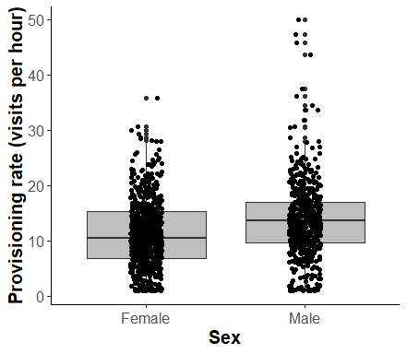

**Figure 7:** Raw data of feeding frequencies compared between males and females. Shaded region represents interquartile range.

**Table 1:** Final population-level models with estimated regression parameters, standard errors, test statistics, and P-values. Asterisks represent significant findings (*α* = 0.05). lm = linear model, lmm = linear mixed model, and glmm = generalised linear mixed model.

|  |  |  |  |  |
| --- | --- | --- | --- | --- |
| **(Model) Effects** | **Estimate ± SE** | **t or z value** | **P value** | **DF** |
| **(1) Fledging Success (glmm) (*N*obs = 1114)** | | | | |
| *Fixed* | | | | |
| Age | 0.105 ± 0.039 | 2.70 | 0.007 | 1108 |
| Age2 | -0.016 ± 0.006 | -2.66 | 0.008 | 1108 |
| Sex | 0.072 ± 0.028 | 2.55 | 0.011 | 1108 |
| *Random* | *SD* | *Var* | *N* |  |
| Individual ID | <.001 | <.001 | 952 |  |
| Year of recording | 0.222 | 0.049 | 9 |  |
| **(2) Chick body condition (lm) (*N*obs= 425)** | | | | |
| *Fixed* | | | | |
| Age | 0.020 ± 0.009 | 2.20 | 0.029 | 420 |
| Age2 | -0.003 ± 0.002 | -2.12 | 0.035 | 420 |
| Sex | 0.025 ± 0.010 | 2.42 | 0.016 | 420 |
| Age × sex | -0.011 ± 0.004 | -2.43 | 0.016 | 420 |
| **(3) Provisioning rate (lmm) (*N*obs = 1233)** | | | | |
| *Fixed* | | | | |
| Age | 0.215 ± 0.150 | 1.44 | 0.151 | 1196 |
| Sex | 2.508 ± 0.381 | 6.59 | <.005* | 920 |
| *Random* | *SD* | *Var* | *N* |  |
| Individual ID | 2.441 | 5.956 | 1019 |  |
| Year of recording | 1.372 | 1.883 | 9 |  |

**Table 2:** Final decomposed models with estimated regression parameters, standard errors, test statistics, and P-values. Asterisks represent significant findings (α = 0.05). lm = linear model, lmm = linear mixed model, and glmm = generalised linear mixed model.

|  |  |  |  |  |
| --- | --- | --- | --- | --- |
| **(Model) Effects** | **Estimate ± SE** | **t or z value** | **P value** | **DF** |
| **(4) Fledging Success (glmm) (*N*obs = 1009)** | | | | |
| *Fixed* | | | | |
| Between-ind. age effect | 0.013 ± 0.012 | 1.12 | 0.264 | 1001 |
| Within-ind. age effect | -0.025 ± 0.027 | -0.93 | 0.353 | 1001 |
| Sex | 0.213 ± 0.066 | 3.25 | <.005* | 1001 |
| Provisioning rate | 0.015 ± 0.003 | 4.72 | <.005* | 1001 |
| Sex × prov. rate | -0.012 ± 0.004 | -2.72 | 0.007* | 1001 |
| *Random* | *SD* | *Var* | *N* |  |
| Individual I.D. | 5.31e-5 | 2.82e-09 | 870 |  |
| Year of recording | 0.214 | 4.56e-02 | 9 |  |
| **(5) Chick body condition (lm) (*N*obs= 384)** | | | | |
| *Fixed* | | | | |
| Between-ind. age effect | 0.002 ± 0.003 | 0.677 | 0.499 | 420 |
| Within-ind. age effect | 0.003 ± 0.004 | 0.621 | 0.535 | 420 |
| Btw.-ind. × sex | -0.011 ± 0.004 | -2.740 | 0.006 | 420 |
| Sex | 0.029 ± 0.011 | 2.701 | 0.007 | 420 |
| **(6) Provisioning rate (lmm) (*N*obs = 1233)** | | | | |
| *Fixed* | | | | |
| Between-ind. age effect | 0.227 ± 0.152 | 1.50 | 0.135 | 1055 |
| Within-ind. age effect | 0.142 ± 0.328 | 0.43 | 0.666 | 957 |
| Sex | 2.507 ± 0.380 | 6.59 | <.005* | 918 |
| *Random* | **SD** | **Var** | **N** |  |
| Individual ID | 2.414 | 5.827 | 1019 |  |
| Year of recording | 1.177 | 1.385 | 9 |  |

**Discussion**

Patterns of reproductive success are important when considering age-structured population dynamics and the sources of these changes have long remained elusive. My study attempted to extract patterns of individual reproductive success in a wild population of collared flycatchers (*Ficedula albicollis*). Fledging success followed a quadratic trajectory at the population level, but I could not isolate the sources of variation. Chick body condition increased in early-age females and declined from a peak further in male parents; between-individual effects likely drove these patterns. Provisioning rates did not significantly change with age and did not explain variation in chick body condition. However, fledging success was explained by and positively correlated with provisioning rate.

*Increasing reproductive success in early age*

Previous breeding experience has been observed to be predictive of future reproductive success and birds are often observed to improve with repeated breeding attempts (Huhta *et al*. 2008; Hatch & Westneat 2007). As such, reproductive success was expected to increase with age in young birds. Observed early-age increases in fledging success were expected, often being reported in the literature. For example, greater fledging success has been observed in older individuals than in yearlings in both pied flycatchers (*Ficedula hypoleuca*) (Huhta *et al*. 2008), and in house sparrows (*Passer domesticus*) (Hatch & Westneat 2007). Similarly, older collared flycatchers (*Ficedula albicollis)* have been observed to more capably rear large broods than younger individuals (Sendecka *et al*. 2007). These observations may result from competency improvements wherein individuals become increasingly proficient with age and exploit greater success from the same unit of effort as experience increases (Wunderle 1991). Several behaviours may be subject to competency improvements, such as foraging proficiency and nest site choice. For example, greater fledging success and selection of more secluded nest-sites at lesser risk of predation have been observed with age in northern wheatears (*Oenanthe oenanthe*) (Pärt 2001). However, breeding experience alone is unlikely to produce competency improvements and it has been suggested that adjacent skills, such as foraging proficiency and nest selection are more likely to produce increases of reproductive success (Pärt 1995). Increasing breeding experience with age may partially explain the increasing fledging success I observed in early-age. However, because decomposition failed to indicate the source of this variation, the contribution of demographic variation to this pattern could not be quantified.

Additionally, I observed early age increases in chick body condition at the population level, but only in females. While this increase was likely to be similarly influenced by competency gains as aforementioned, decomposition revealed demographic variation to be significantly influential. This pattern may result ‘good reproducers‘ who began producing at earlier ages than their conspecifics, resulting in selective appearance in younger cohorts. Several factors may cause this, such as ‘silver spoon’ natal environments (Spagopoulou *et al*. 2020). Individuals raised in higher quality environments may reproductively outperform conspecifics of comparatively poor upbringing conditions (Ratikainena & Kokko 2009; Basolo 1998). As ages of first reproduction were not recorded in this study, such demographic effects could not be investigated. However, while females were captured during incubation in early-reproduction, males were caught during nest-box visitations later in brooding. As such, fathers of failed broods were not recorded, resulting in male underrepresentation. Therefore, that no increases were observed in males is likely due to lower sample sizes of fathers, preventing individual change from being detected. Queuing for high-quality nesting sites may produce a similar pattern of selective appearance, as individuals reproduce later and more successfully than their conspecifics (Ens *et al*. 1995). In addition, quality differences may influence individual ‘willingness’ to accept low-quality nesting sites and to queue (van de Pol *et al*. 2007). It may be that higher-quality individuals are more ‘willing’ to risk waiting for high-quality sites and therefore more frequently breed later. This too would result in a delayed appearance of highly-successful breeders. However, the influence of such effects remains speculative, as competition levels and dates of first reproductions were unknown. Investigation of the relationships between nesting competition, ages of first reproduction, and relative reproductive success could be achieved by modulating nest-box availability on Gotland.

That no individual increases in chick body condition were observed was unexpected as competency gains are widely reported (e.g., Forslund & Pärt 1995; Pyle *et al*. 1991). For example, experimental destruction of the nests of first-time breeding female collared flycatchers (*Ficedula albicollis*) yielded fledglings that were significantly smaller and lighter than those of parents with a previous year of breeding experience (Cichoñ 2003). My lack of observed individual change is again likely to have resulted from my sample size of repeated measures being too low to reliably isolate the sources of the variation. It may be the case that chick body condition poorly represented parental investment in this system, as parents may have invested in factors other than offspring quality, such as self-maintenance. Improving fledging success with age may result from parents investing in quantity of offspring rather than increasing quality past a satisfactory degree of chick physiological condition.

*Changes in foraging proficiency with age*

One of the most studied mechanisms of competency increases in foraging performance with age is the increasing proficiency resulting from acquired skill through experience. This generally results in improvements in efficiency of searching, capturing, and handling prey (e.g., Wunderle 1991; Enoksson 1988). As such, I expected provisioning rates to be highly susceptible to improvements in competency as individuals aged, however I found no age-related change in the Gotland population. Parental care is one of the most crucial aspects of brooding and provisioning rates are therefore commonly used as indications of parental investment (Lagassé & Ryder 2016; Mitrus *et al*. 2010). That no change in provisioning rate with individual age was evidenced was an unexpected result as the current literature consistently reports foraging proficiency to improve with age in the early reproductive period in birds (see Lescroël *et al*. 2019; Daunt *et al*. 2007; Caldow *et al*. 2002) and many studies have found support for the notion that juvenile birds are less proficient and skillful foragers than their experienced adult counterparts (see Zimmer *et al*. 2011; Catry et al. 2006; Shearer & Burger 1995). For example, significant increases in foraging success of European blackbirds (*Turdus merula*) between yearlings and with age in adults have been observed via repeated measures (Desrochers 1992). Additionally, experienced snow buntings (*Plectrophenax nivalis*) have been observed to provision at greater rates and to make greater improvements in relative feeding rates than inexperienced individuals suggesting improvement effects (Smith & Metcalfe 1994). However, early-life improvements may occur due to changes in the skeletal and muscular structure of young birds as they develop, allowing for greater foraging capabilities as individuals mature (Marchetti & Price 1989). A likely explanation for my inability to observe within-individual change is that provisioning rate may have been a poor indicator of foraging proficiency in this system, and so present changes may not have been readily detected. For example, increased foraging proficiency may be reflected in increased loads and several studies have shown that foraging load size and composition vary with brood size of parent birds (e.g., Wanless *et al*. 1993; Lifjeld 1988). However, my study neglected to address that the composition of forage may vary with skill without necessarily invoking changes in feeding rates. Hence, improving knowledge of prey items with experience may translate into more specialised capture or items of relative higher qualities in as birds increase in age (Wunderle 1991). Moreover, food intake may change as parents mature, resulting in a differential composition of prey as their nutritional requirements shift (GarcÍa-Navas *et al*. 2012; Clutton-Brock *et al*. 1985). Similarly, parents may alter the composition of their forage in response to changing nutritional requirements of chicks as they age (Mitrus *et al*. 2010). Increasing foraging experience with age may also allow knowledgeable birds to become less exploratory and locate favourable foraging sites more efficiently (Voiter *et al*. 2017) or differentially exploit various habitat types with age (Caldow *et al*. 2002). Another explanation for the lack of an observed trend may be that the sample size of repeatedly measured individuals were simply too low to detect any age-related improvements, and It is likely the case that greater sample sizes would have revealed competency- and optimisation-driven increases in early ages. However, several other possible explanations may account for my inability to observe changes. It may alternatively be the case that no individual improvements in were occurring in this population, although this is highly unlikely due to the abundance of studies observing increasing foraging proficiency with age (e.g., Zimmer *et al*. 2011; Catry *et al*. 2006; Desrochers 1992). Therefore, while no change in provisioning rate with age was observed at the individual level, changes in foraging competency and parental effort were likely reflected in other dimensions, such as in load size and in load composition.

*Changes in parental effort with age*

Provisioning rates were assumed to be indicative of parental effort, and as such Individuals who invested more resources in their offspring were expected to reproduce more successfully. I expected increasing effort to contribute to within-individual reproductive improvement, however I found no support for increased effort with age when using provisioning rate as an indicator. It may have been that no increase in effort was occurring as parents may have invested fixed effort in chicks. This strategy tends to occur in species where survival likelihoods are great enough that consistently investing in future reproduction is a viable strategy. However, in short-lived species, optimal reproductive effort is likely to be variable due to high mortality (Botkin & Miller 1974) and so terminal investments are more likely (Forslund & Pärt 1995). Many studies have noted evidence of terminal investments in passerines. For example, in collared flycatchers (*Ficedula albicollis*) females have been observed to increase their reproductive effort as they approach the end of their lives (Pärt *et al*. 1991). Old females were also observed to provision at greater rates and lose more weight than their younger counterparts, suggesting diversion of resources from somatic maintenance to reproduction. Similarly, age-related mass loss has been observed in pied flycatchers (*Ficedula hypoleuca*) and may also be an adaptation for more efficient foraging due to lower body weight (Tilgar *et al*. 2010). Furthermore, reproductive effort should increase as mortality risk rises, particularly as individuals senesce (Kirkwood 1977; Williams 1957). Older individuals increase their reproductive efforts when challenged with diseases, suggesting that terminal investments are a function of mortality risk and not merely age (Bonneaud *et al*. 2007; Velando *et al*. 2006). Indeed, age-related brood sizes and fledging success has been observed to correlate with mortality (Boonekamp *et al*. 2014; Pugesek 1987). However, while terminal investments were likely influencing reproductive success in the Gotland population, I found no direct evidence of changing effort. A likely explanation for the lack of change is that provisioning rates were an inappropriate indication of reproductive effort as they did not account for other measures of investment such as prey quality and prey size. While provisioning frequency can be indicative of effort (Schaffer *et al*. 2003; Tolonen and Korpimaèki 1994), increasing foraging loads may also be an expression of rising reproductive effort (Wanless *et al*. 1993).

*Reproductive success explained by provisioning rate*

I observed fledging success to be significantly explained by provisioning rate. Parents of larger broods are often observed to provision their offspring at greater rates (Čech & Čech 2017; Bortolotti *et al*. 2011; Moreno *et al*. 1999), and experimental brood enlargements have yielded analogous results (Magrath *et al*. 2007; Moreno *et al*. 1995). Additionally, since larger broods have been shown to fledge more offspring (Thys *et al*. 2020), the positive correlation between provisioning rate and fledging success may simply result from larger broods, which provision more frequently, fledging more successfully. However, the exact reasons for the increases in provisioning rate with brood size remain unclear ,and explanations in the literature are often ambiguous. One explanation may be that as broods increase in size, parents respond by increasing provisioning effort to meet the consequent increases in energy demand (Wanless *et al*. 1993; Lifjeld 1988). This is likely achieved by increasing foraging input, and both larger loads and more frequent delivery may achieve this (Schaffer *et al*. 2003; Tolonen & Korpimaèki 1994). Conversely, larger brood sizes may be the product of greater foraging competency in parents, allowing larger broods to be successfully provisioned (Wunderle 1991). As variation occurs in all populations, those which are of greater quality may naturally produce more offspring, this is known as a selection hypothesis (Wilson & Nussey 2009). Furthermore, since parents tend to improve in both foraging proficiency and fledging success as they gain reproductive experience, my observed correlation need not necessarily be causative.

Furthermore, reduced provisioning rates have been noted in parents of large broods (Schadd & Richardson 1998) and may occur due to lower thermoregulatory costs as more individuals are present, resulting in lower energy expenditure in maintaining thermostasis. Reduced provisioning rate per chick resulting from this scenario is known as the Royama effect (Royama 1966). As such, improvements in provisioning and foraging competency may be greater in the population than reflected by fledging success.

Since parents govern much of the early developmental environment of their chicks, particularly nutrition, chick body condition was expected to closely mirror reproductive effort. However, I found provisioning rates not to significantly explain chick body condition. While it may again be that provisioning rate was an inadequate indicator of parent effort in this system, this may alternatively suggest that parents raised chicks to a satisfactory condition and thereafter invested in greater brood sizes. However, these hypotheses remain inconclusive as parental effort could not be accurately measured. Future studies of reproductive effort should implement multi-factorial measures of investment, including load sizes and relative quality, so that patterns of reproductive success can be adequately explained.

Additionally, I observed males to reproduce more successfully and this may result from their greater provisioning rates. While both similar and different provisioning rates have been noted between male and female passerines (Bańbura *et al*. 2001; Wright & Cuthill 1989; Breitwisch *et al*. 1986), fathers have often been observed to feed their young more frequently (Carr *et al*. 2019; Eldegard & Sonerud 2012) and my results are consistent with these findings. However, chick body condition did not differ between sexes, and was not explained by provisioning rates. This may again result from low sample sizes of males due to under-capturing, providing an unreliable estimation of sex differences.

*Decreasing reproductive success in late age*

Antagonistic pleiotropy theory predicts that genes which confer early-life fitness benefits do so at the expense of late-life fitness and that the greater the early-age investment, the sooner the onset of senescence (Williams 1957). This is hypothesised to result from optimal allocation of finite resources namely between somatic maintenance and reproduction (Kirkwood 1977). The point of optimal allocation should occur before the longevity cost of reduced somatic maintenance exceeds benefits accrued by favouring reproduction (Kirkwood & Rose 1991). Disposable soma theory predicts that individuals should decrease self-maintenance in favour of reproductive investment as they approach their final reproductive event (Kirkwood 1977). My observed declines in fledging success are likely diagnostic of reducing self-maintenance with age, however due to my inability to isolate the sources of this population variation, that within-individual change is driving this pattern remains speculative. It is again likely that a greater sample size of repeated measures is necessary to reveal the relative contributions of this pattern. A growing body of evidence suggests wild populations undergo ageing (see Nussey *et al*. 2013 for review) and my study corroborates this. The observed individual reductions in reproductive success were likely influenced by various senescent degradations that act to reduce reproductive capabilities. For example, foraging proficiency may suffer with ageing due to weakening flight performance, and experimental reductions of wing surface area have been observed to incur greater foraging effort and longer trips (Navarro & González-Solís 2007). Additionally, weakened immune function may result from reducing self-maintenance and is widely reported to correlate with reduced reproductive success (Hansen *et al*. 2005; Moreno *et al*. 1999; Nordling *et al*. 1998). For example, increasing frequency of ectoparasitism has been noted with age and has been associated with reduced reproductive success and increased mortality (Møller & Lope 2002). Additionally, pied flycatchers (*Ficedula hypoleuca*) have been observed to fledge lower-quality offspring and in fewer numbers when immune systems were experimentally challenged (Ilmonen *et al*. 2000). As such, reduced ability of older individuals to tolerate parasitism may contribute to late-age fitness declines alongside failing foraging proficiency. However, the relative contributions of between- and within-individual effects to my observed decline could not be measured. Caution should be taken when interpreting late-age declines in reproduction as they may result from optimal life histories rather than senescence (Blarer *et al*. 1995).

Decomposition revealed between-individual effects to be the likely drivers of decreasing chick body condition in late age. Ages of first reproduction have been observed to differ between individuals and to strongly influence the life-history trajectories of individuals (Spagopoulou *et al*. 2020; Péron *et al*. 2010; Møller 2006). One reason for my observed pattern may be that Individuals with initial environmental advantages suffer detriments to future reproduction in exchange for an early-life advantages if they overinvest resources by reproducing early (Spagopoulou *et al*. 2020). Such individuals may be less capable of raising high-quality chicks than their conspecifics in later ages due to earlier and more severe senescence resulting from greater initial effort (Boonekamp *et al*. 2014; Moreno *et al*. 1999; Nordling *et al*. 1998). Selective appearance of deteriorated ‘live fast, die young’ strategists into older age classes may therefore produce a demographic decline in chick body condition. Alternatively, as earlier reproduction results in earlier deterioration (Péron *et al*. 2010) good reproducers which exert greater sustained effort into old age may selectively disappear, lowering reproductive success in older cohorts. Furthermore, the earlier and more rapid declines in paternal chick body condition may be diagnostic of greater early-age investment in males and greater provisioning and fledging success suggest this hypothesis. However, as ages of first and last reproductions were unrecorded, differences in parental effort between sexes may be of interest to future investigations. Analysing the effects of varying habitat quality on ages of first and last reproduction would also allow the effects of ‘silver spoon’ effects on life-history trajectories to be determined.

Similarly, provisioning rates were expected to decrease into old age as physiological deterioration reduced foraging competency; however, no change was observed. This lack of decline may again result from provisioning rate being insensitive to competency changes in this population, as individuals may deteriorate in factors such as prey choice or load size. Alternatively, the lack of age-related change may again result from insufficient sample sizes. However, it may be that no foraging senescence was occurring in the population as individuals may not have survived long enough to experience deterioration; several studies have failed to observe worsening foraging proficiency with age (e.g., Froy *et al*. 2015; Pelletier *et al*. 2014). Despite this, the conclusion that senescence was absent in the Gotland population is unlikely due to the overwhelming evidence of age-related declines reported across wild populations (see Nussey *et al*. 2013 for review).

*Limitations and future directions*

I found no evidence of individual change in reproductive success with age, however that no individual change was occurring was unlikely. It may be that increasing the proportion of repeat measures would have revealed individual effects, but these remain speculative. Only breeding individuals were studied, so many breeding events may have occurred unrecorded. The true extent of ageing and competency changes would likely be more pronounced when including non-breeders. Similarly, parents in nest boxes likely exploited greater reproductive success than natural cavity breeders (Griffith *et al*. 2008) and due to the abundance of nest boxes, nesting competition was likely low. Therefore, age-related trends may be more pronounced in natural cavity-breeding populations. Additionally, provisioning rate may not have accurately indicated effort nor competency in this system as it did not change with age and did not explain variation in chick body condition. A coefficient that accounts for delivery frequency, load size, and relative forage quality may more accurately detect changes in proficiency and effort which may otherwise be overlooked. This method would also allow fixed-effort and prey switching to be more reliably detected. Sole reliance on one-dimensional measures of effort may allow certain aspects of changes in proficiency and optimisation to be overlooked. Furthermore, between-individual variation was observed to drive patterns of chick body condition; however, these demographic effects could not be investigated as ages of first and last reproductions were unrecorded. These factors may allow future studies to analyse how life-history trajectories change with onset of breeding as well as elucidating the extent of terminal investments. RFID tagging of individuals upon capture and mapping occupancy of nest boxes with receivers would allow appearance and disappearance to be precisely observed, as well as increasing sample sizes by ensuring less reproductive events are overlooked. Sex differences were likely partially produced by male under-capturing. As males were only recorded during nest visitations, males which failed to brood successfully were not recorded. The majority of females however were recorded much earlier in the reproductive cycle during incubation and were included even if broods later failed. Male underrepresentation may be partly responsible for the observed sex differences. Additionally, a multifactorial measure of effort would allow differences in investment to be compared between sexes, which may explain differences in fledging and provisioning.

*Conclusion*

Partial evidence was found for the classic life-history trajectory of early-age improvements and late-age declines. Improvements in foraging competency and optimisations of reproductive effort likely influenced the early-age improvements in fledging success in my study. Additionally, senescent declines were likely partially responsible for the decreases in late-age fledging success. However, I was unable to pinpoint the exact source of this population trend. Demographic age-effects in chick body condition highlighted the essentiality in disentangling sources of population variation, as no individual change was evidenced, despite a clear population trend. Furthermore, while provisioning rates were found to positively correlate with fledging success, they did not significantly explain variation in chick body condition. This may have been due to provisioning rate poorly indicating parental effort. Future studies should ensure that appropriate measures of effort are used when studying age-related change in natural systems. Studies may seek to implement multi-factorial measures of foraging proficiency so as to ensure that underlying changes of parental effort are not overlooked.

**Acknowledgements**

I thank Prof. Lars Gustafsson and Dr. Blandine Dolgiez for providing me with access to the flycatcher data, and the land managers on the island of Gotland who permitted it’s collection. I further thank all individuals who were involved in gathering, extracting, and organising the study data. I also thank Dr. Pierre Bize for his continued guidance, particularly in assembling the various models of this study, and for his advice in utilising R for the statistical analyses. Lastly I’m grateful to Prof. Christoph Moning for allowing me to include his photographs.

**References**

Balbontín & Møller (2015), Environmental conditions during early life accelerate the rate of senescence in a short‐lived passerine bird, *Ecology* **96**:948-59

Bańbura *et al*. (2001), Sex differences in parental care in a Corsican blue tit *Parus caeruleus* population, *ARDEA.* **89**:517-26

Bartlett *et al*. (2005), Division of labor: Incubation and biparental care in house sparrows (*Passer domesticus*), *Auk* **122**:835-42

Basolo (1998), Shift in investment between sexually selected traits: Tarnishing of the silver spoon, *Anim. Behav.* **55**:665-71

Bates *et al*. (2015), Fitting linear mixed-effects models using lme4, *J. Stat. Softw*. **67**:1-48

Bebbington *et al*. (2015), Coordinated parental provisioning is related to feeding rate and reproductive success in a songbird, *Behav. Ecol.* **27**:652-9

Blarer *et al*. (1995), Diagnosing senescence: Inferring evolutionary causes from phenotypic patterns can be misleading, *Proc. Royal Soc.* *B* **1365**:305-12

Bonneaud *et al*. (2007), Terminal investment induced by immune challenge and fitness traits associated with major histocompatibility complex in the house sparrow, *Evolution* **58**:2823-30

Boonekamp *et al*. (2014), Reproductive effort accelerates actuarial senescence in wild birds: An experimental study, *Ecol. Lett.* **17**:599-605

Bortolotti *et al*. (2011), Can changes in provisioning by parent birds account for seasonally declining patterns of offspring recruitment?, *Can. J. Zool.* **89**:921-8

Botkin & Miller (1974), Mortality rates and survival of birds, *Am. Nat.* **108**:181-92

Breitwisch *et al*. (1986), Parental investment by the northern mockingbird: Male and female roles in feeding nestlings, *Auk* **103**:152-9

Burger (1980), Sexual differences in parental activities of breeding black skimmers, *Am. Nat.* **117**:975-84

Caldow *et al*. (2002), Individual variation in the competitive ability of interference‐prone foragers: The relative importance of foraging efficiency and susceptibility to interference, *J. Anim. Ecol.* **68**:869-78

Carr *et al*. (2019), Patterns of provisioning in known-aged *Spizella pusilla* (field sparrow): A multi-year study, *Northeast. Nat.* **26**:484-98

Catry *et al*. (2006), Senescence effects in an extremely long-lived bird: The grey-headed albatross *Thalassarche chrysostoma, Proc. Royal Soc. B*. **273**:1625-30

Čech & Čech (2017), Effect of brood size on food provisioning rate in common kingfishers *Alcedo atthis*, *Ardea* **105**:5-17

Chazarreta *et al*. (2011), Division of labour in parental care in the magellanic woodpecker *Campephilus magellanicus, J*. *Ornithol*. **152**:231-42

Cichoñ (2003), Does prior breeding experience improve reproductive success in collared flycatcher females?, *Oecologia* **134**:78-81

Clutton-Brock (1984), Reproductive effort and terminal investment in iteroparous animals, *Am. Nat.* **123**:212-29

Clutton-Brock *et al*. (1985), Parental investment and sex differences in juvenile mortality in birds and mammals, *Nature* **313**:131-3

Cockburn (2006), Prevalence of different modes of parental care in birds, *Proc. Royal Soc. B* **273**:1375-83

Comfort (1956), The Biology of Senescence, *Routledge & Kegan Paul*, London

Daunt *et al*. (2007), From cradle to early grave: Juvenile mortality in European shags *Phalacrocorax aristotelis* results from inadequate development of foraging proficiency, *Proc. Royal Soc. B* **3**:371-4

Dawkins & Carlisle (1976), Parental investment, mate desertion and a fallacy, *Nature* **262**:131-3

Delignette-Muller & Dutang (2015), fitdistrplus: An R package for fitting distributions, *J. Stat. Softw.* **64**:1-34.

Desrochers (1992), Age and foraging success in European blackbirds: Variation between and within individuals, *Anim. Behav.***43**:885-94

Eldegard & Sonerud (2012), Sex roles during post-fledging care in birds: Female Tengmalm’s owls contribute little to food provisioning, *J. Ornithol.* **153**:385-98

Enoksson (1988), Age- and sex-related differences in dominance and foraging behaviour of nuthatches *Sitta europaea, Anim. Behav.* **36**:231-8

Ens *et al*. (1995), The despotic distribution and deferred maturity - 2 sides of the same coin, *Am. Nat.* **146**:625-50

Forslund & Larsson (1992), Age-related reproductive success in the barnacle goose, *Anim. Ecol.* **61**:195-204

Forslund & Pärt (1995), Age and reproduction in birds — hypotheses and tests, *Trends Ecol. Evol.* **10**:374-78

Friard & Gamba (2016), BORIS: A free, versatile open‐source event‐logging software for video/audio coding and live observations, *Ecol. Evol.* **7**:1325-30

Froy *et al*. (2015), Age-related variation in foraging behaviour in the wandering albatross at South Georgia: No evidence for senescence, *PLoS One* **10**

GarcÍa-Navas *et al*. (2012), Prey selectivity and parental feeding rates of blue tits *Cyanistes caeruleus* in relation to nestling age, *Bird Study* **59**:236-42

Greenberg & Gradwohl (1983), Sexual roles in the dot-winged antwren (*Microrhopias quixensis*), a tropical forest passerine, *Auk* **100**:920-5

Griffith *et al*. (2008), Use of nest-boxes by the Zebra Finch (*T*a*eniopygia guttata*): Implications for reproductive success and research, *Emu* **108**:311-9

Guigueno & Sealy (2012), Nest sanitation in passerine birds: implications for egg rejection in hosts of brood parasites, *J. Ornithol.* **153**:35-52

Hamann & Cooke (1987), Age effects on clutch size and laying dates of individual female Lesser Snow Geese *Anser caerulescens*, *IBIS*. **129**:527-32

Hansen *et al*. (2005), Cost of reproduction in a long-lived bird: incubation effort reduces immune function and future reproduction, *Proc. Royal Soc. B* **272**:1039-46

Hatch & Westneat (2007), Age‐related patterns of reproductive success in house sparrows *Passer domesticus*, *J. Avian Biol.* **38**:603-11

Holmes *et al*. (2003), Reproductive aging in female birds. *Exp. Gerontol.* 38:751-56

Huhta *et al*. (2008), Distribution and reproductive success of the Pied Flycatcher *Ficedula hypoleuca* in relation to forest patch size and vegetation characteristics: The effect of scale, *IBIS.* **140**:214-22

Ilmonen *et al*. (2000), Experimentally activated immune defence in female pied flycatchers results in reduced breeding success, *Proc. Royal Soc. B* **267**:665-70

Kirkwood & Rose (1991), Evolution of senescence: Late survival sacrificed for reproduction. *Proc. Royal Soc. B* **332**:15-24

Kirkwood (1977), Evolution of ageing, *Nature* **270**:301-4

Kokko & Jennions (2008), Parental investment, sexual selection and sex ratios, *J. Evol. Biol.* **21**:919-48

Kuitunen *et al*. (1995), Food availability and the male's role in parental care in double‐brooded treecreepers *Certhia familiaris*, *IBIS.* **138**:638-43

Lagassé & Ryder (2016), Sex and age-specific variation in provisioning by a long distance neotropical migrant, the wood thrush (*Hylocichla mustelina*), *Wilson J. Ornithol.* **128**:821-9

Lescroël *et al*. (2019), Evidence of age-related improvement in the foraging efficiency of Adélie penguins, *Sci. Rep.* **9**:3375

Lifjeld (1988), Prey choice and nestling hunger: An experiment with pied flycatchers *Ficedula hypoleuca*, *Anim. Behav.* **36**:134-9

Magrath *et al*. (2007), Provisioning adjustments by male and female fairy martins to short-term manipulations of brood size, *Behaviour* **144**:1119-32

Mänd *et al*. (2013), When a male changes his ways: Sex differences in feeding behavior in the pied flycatcher, *Behav. Ecol.* **24**:8538

[Marchetti](https://onlinelibrary.wiley.com/action/doSearch?ContribAuthorStored=MARCHETTI%2C+KAREN) [& Price](https://onlinelibrary.wiley.com/action/doSearch?ContribAuthorStored=PRICE%2C+TREVOR) (1989), Differences in the foraging of juvenile and adult birds: The importance of developmental constraints, *Biol. Rev.* **64**:51-70

Maynard Smith (1977), Parental investment: A prospective analysis, *Anim. Behav.* **25**:1-9

Medawar (1952), An unsolved problem of biology, *Lewis*, *London*

Merilä & Hemborg (2003), Fitness and feather wear in the Collared Flycatcher (*Ficedula albicollis*), *J. Avian Biol.* **31**:504-10

Mitrus *et al*. (2010), Changes in nestling diet composition of the red-breasted flycatcher *Ficedula parva* in relation to chick age and parental sex, *Anim. Biol.* **60**:319-28

Møller & Lope (2002), Senescence in a short‐lived migratory bird: Age‐dependent morphology, migration, reproduction, and parasitism, *J. Anim. Ecol.* **68**:163-71

Møller (2006), Sociality, age at first reproduction and senescence: Comparative analyses of birds, *J. Evol. Biol.* **18**:682-9

Moning (2009), Collared flycatcher (*Ficedula albicollis*), Macaulay Library: ML63596721, available at URL: https://macaulaylibrary.org/asset/63596721#_ga=2.212078804.1517110356.1610537388-550640003.1610537388

Moning (2010), Collared flycatcher (*Ficedula albicollis*), Macaulay Library: ML63455131, available at URL: https://macaulaylibrary.org/asset/63455131#_ga=2.220421208.1517110356.1610537388-550640003.1610537388

Moreno *et al*. (1995), Differential response by males and females to brood manipulations in the pied flycatcher: Energy expenditure and nestling diet, *Anim. Ecol.* **64**:721-32

Moreno *et al*. (1999), Reproductive effort and T-lymphocyte cell-mediated immunocompetence in female pied flycatchers *Ficedula hypoleuca*, *Proc. Royal Soc. B* **266**:1105

Navarro & González-Solís (2007), Experimental increase of flying costs in a pelagic seabird: Effects on foraging strategies, nutritional state, and chick condition, *Oecologia* **151**:150-60

[Nol & Smith (1987)](https://www.jstor.org/stable/4816?seq=1), Effects of age and breeding experience on seasonal reproductive success in the song sparrow, *J. Anim. Ecol.* **56**:301-13

Nordling *et al*. (1998), Reproductive effort reduces specific immune response and parasite resistance, *Proc. Royal Soc. B* **265**:1291-8

Nussey *et al*. (2008), Measuring senescence in wild animal populations: towards a longitudinal approach*, Funct. Ecol*. **22**:393-06

Nussey *et al*. (2013), Senescence in natural populations of animals: Widespread evidence and its implications for bio-gerontology, *Ageing Res. Rev.* **12**:214-25

Olson *et al*. (2008), Parental conflict in birds: comparative analyses of offspring development, ecology and mating opportunities, *Proc. Royal Soc. B* **275**:301-7

Pärt & Gustafsson (1989), Breeding dispersal in the collared flycatcher (*Ficedula albicollis*): Possible causes and reproductive consequences, *J. Anim. Ecol.* **58**:305-20

Pärt (1995), Does breeding experience explain increased reproductive success with age? An experiment, *Proc. Royal Soc. B* **260**:113-7

Pärt (2001), The effects of territory quality on age-dependent reproductive performance in the northern wheatear, *Oenanthe oenanthe, Anim. Behav.* **62**:379-88

Pärt *et al*. (1991), "Terminal investment" and a sexual conflict in the collared flycatcher (*Ficedula albicollis*), *Am. Nat.* **140**:868-82

Pelletier *et al*. (2014), Fine-scale spatial age segregation in the limited foraging area of an inshore seabird species, the little penguin, *Oecologia* **176**:399-408

Péron *et al*. (2010), Age at the onset of senescence in birds and mammals is predicted by early-life performance, *Proc. Royal Soc. B* **277**:2849-56

Pugesek (1987), Age-specific survivorship in relation to clutch size and fledging success in California gulls, *Behav. Ecol. Sociobiol.* **21**:217-21

Pyle *et al*. (1991), The effects of experience and age on the breeding performance of western gulls, *Auk* **108**:25-33

R Core Team (2020), R: A language and environment for statistical computing. R foundation for statistical computing, *Vienna, Austria,* URL: http://www.R-project.org

Ratikainen & Kokko (2009), Differential allocation and compensation: Who deserves the silver spoon?, *Behav. Ecol.* **21**:195-200

Rebke *et al*. (2010), Reproductive improvement and senescence in a long-lived bird, *PNAS*. **107**:7841-46

Récapet *et al*. (2012), Food availability modulates differences in parental effort between dispersing and philopatric birds, *Behav. Ecol.* **28**:688-97

Royama (1966), Factors governing feeding rate, food requirement and brood size of nestling great tits *Parus major*, *IBIS.* **108**:313-47

RStudio Team (2020), RStudio: integrated development for R. RStudio, *PBC, Boston, MA,* URL: http://www.rstudio.com/

Rytkönen *et al*. (1996), Patterns of per-brood and per-offspring provisioning efforts in the willow tit *Parus montanus*, *J. Avian Biol.* **27**:21-30

Sallis (2000), Age-related decline in physical activity: A synthesis of human and animal studies, *Med. Sci. Sports Exerc.* **32**:1598-600

Schadd & Richardson (1998), Provisioning of nestlings by male and female, yellow-breasted chats, *Wilson Bull.* **110**:398-402

Schaffer (1974), Selection for optimal life histories: The effects of age structure, *Ecology* **55**:291-303

Schaffer *et al*. (2003), Foraging effort in relation to the constraints of reproduction in free-ranging albatrosses, *Funct. Ecol.* **17**:66-74

Schmolesky *et al*. (2000), Degradation of stimulus selectivity of visual cortical cells in senescent rhesus monkeys, *Nat. Neurosci.* **3**:384-90

Sendecka *et al*. (2007), Age‐dependent reproductive costs and the role of breeding skills in the Collared flycatcher, *Acta Zool.* **88**:95-100

Shearer & Burger (1995), Comparative foraging success between adult and one-year-old roseate and sandwich terns, *Col. Waterbirds* **18**:93-9

Siikamäki *et al*. (1998), Properties of food loads delivered to nestlings in the pied flycatcher: Effects of clutch size manipulation, year, and sex, *Oceologica* **115**:579-85

Smith & Metcalfe (1994), Age, sex and prior site experience have independent effects on the foraging success of wintering snow buntings, *Behaviour* **129**:99-111

Snijders and Bosker (1999), Multilevel Analysis: An introduction to basic and advanced multilevel modelling, London, Sage

Spagopoulou *et al*. (2020), Silver-spoon upbringing improves early-life ﬁtness but promotes reproductive ageing in a wild bird, *Ecol. Lett.* **23**:994-1002

Stearns (2000), Life history evolution: Successes, limitations, and prospects, *Sci. Nat.* **87**:476–86

Svensson (1992), Identification guide to european passerines, *London: British trust for ornithology*

Thys *et al*. (2020), Pathways linking female personality with reproductive success are trait- and year-specific, *Behav. Ecol.* 1-10

Tilgar *et al*. (2010), Predator-induced stress changes parental feeding behavior in pied flycatchers, *Behav. Ecol.* **22**:23-8

Tolonen & Korpimaèki (1994), Determinants of parental effort: a behavioural study in the Eurasian kestrel *Falco tinnunculus*, *Behav. Ecol. Sociobiol.* **35**:355-62

[Trivers (1972)](https://www.researchgate.net/publication/288653750_Parental_Investment_and_Sexual_Selection), Parental investment and sexual selection (53-95), Sexual selection and the descent of man, Aldine, Chicago

Van de Pol & Verhulst (2006), Age‐dependent traits: A new statistical model to separate within‐ and between‐individual effects, *Am. Nat.* **167**:766-73

Van de Pol *et al*. (2007), Variation in habitat choice and delayed reproduction: Adaptive queuing strategies or individual quality differences? *Am. Nat.* **170**:530-41

Vaupel & Yashin (1985), Heterogeneity's ruses: Some surprising effects of selection on population dynamics, *Am. Stat*. **39**:176-85

Velando *et al*. (2006), Senescent birds redouble reproductive effort when ill: Confirmation of the terminal investment hypothesis, *Proc. Royal Soc. B* **273**:1443-8

Velde & Pearson (2002), The variability of female reproductive ageing. *Hum. Reprod. Update* **8**:141-54

Voiter *et al*. (2017), Effects of age and reproductive status on individual foraging site fidelity in a long-lived marine predator, *Proc. Royal Soc. B* **284**:20171068

Wanless *et al*. (1993), Factors influencing food‐load sizes brought in by Shags *Phalacrocorax aristotelis* during chick rearing, *IBIS.* **135**:19-24

Wickham (2016), ggplot2: Elegant graphics for data analysis, *Springer-Verlag New York*. ISBN 978-3-319-24277-4

Wiggins *et al*. (1994), Seasonal decline in collared flycatcher *Ficedula albicollis* reproductive success: An experimental approach, *Oikos* **7**:359-64

Williams (1957), Pleiotropy, natural selection, and the evolution of senescence, *Evolution* **11**:398-11

Wilson & Nussey (2009), What is individual quality? An evolutionary perspective, *Trends Ecol. Evol.* **25**:207-14

Włodarczyk & Minias (2020), Age-related differences in reproductive success support the selection hypothesis in a mute swan population, *J. Ornithol.* **161**:1185-93

Wooler *et al*. (1990), Reproductive success of short-tailed shearwaters *Puffinus tenuirostris* in relation to their age and breeding experience, *Anim. Ecol.* **59**:161-70

Wright & Cuthill (1989), Manipulation of sex differences in parental care, *Behav. Ecol. Sociobiol.* **25**:171-81

Wunderle (1991), Age-specific foraging proficiency in birds, *Current Ornithol.* **8**:273-324

Zimmer *et al*. (2011), Does foraging performance change with age in female little penguins (*Eudyptula minor*)?, *PLoS One* **6**