Crystal Settling in Silicate Melts

Quantitative Analysis using xtal-sttl

Buchanan Kerswell[1]

Matthew Kohn[2]

08 January 2021

Crystals may sink (or float) out of suspension as silicate melts (magma) intrude the crust and cool. This process chemically differentiates magma and may form sheet-like layers of accumulated crystals, called “cumulate” rocks, which can have high economic value. To better understand this process, we will use the app xtal-sttl to calculate a crystal’s settling velocity under a range of physical conditions. We will quantitatively explore how temperature, pressure, and melt composition affect the settling velocity of crystals.

Table of Contents

# Introduction

Cooling intrusions chemically differentiate in two ways:

1. More Fe- and Mg-rich (mafic) minerals crystallize first, driving the residual melt composition to lower FeO and MgO, and higher SiO $​_{2}$ (more felsic; Bowen, 1956)
2. Crystals may sink (or float) out of suspension, physically separating higher density (mafic) minerals from lower density (felsic) minerals (Figures 1 & 2)

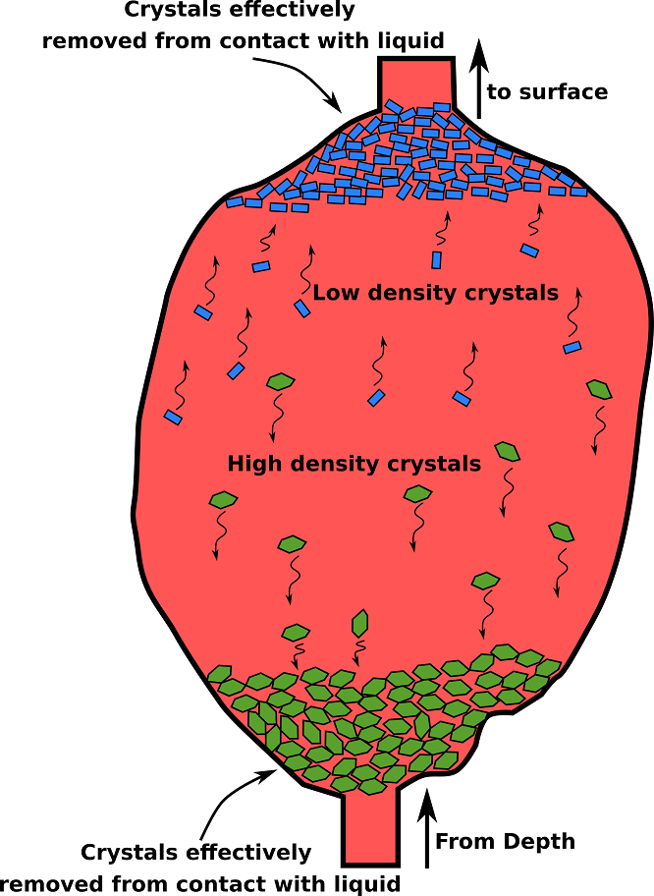

Figure 1. A cartoon illustrating the formation of cumulate rocks by settling of crystals out of suspension in a vertical intrusive body. From Alex Strekeisen: <http://www.alexstrekeisen.it/english/pluto/cumulate.php>.

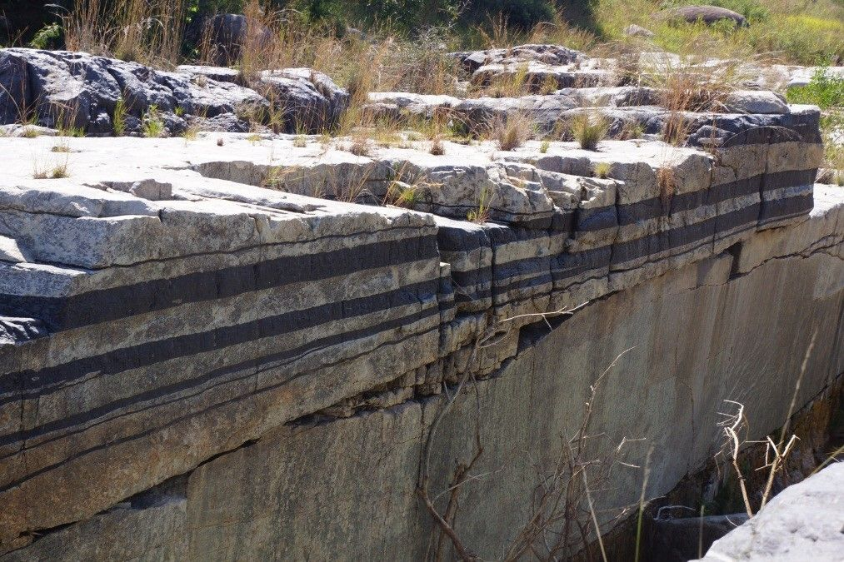

Figure 2. These rocks appear to be sedimentary, but are actually alternating layers of dark and light minerals that settled out of suspension in a horizontal intrusive body (sill). These rocks form the famous economic deposits of platinum-group elements in Bushveld, South Africa. Photo by Jackie Guantlett.

## Stokes’ Equation

Cumulate rock formation can be modelled using a simple solution of Stokes’ Equation:

$$v=\frac{2 g r_{crystal}^{2}(ρ_{crystal}−ρ_{melt})}{9η}$$

where $v$ is terminal settling velocity, $g$ is gravitational acceleration, $r$ is radius, $ρ$ is density, and $η$ is viscosity.

# Exercise

The xtal-sttl app will run in your web browser. You can use this [link](https://kerswell.shinyapps.io/xtal-sttl), or navigate to kerswell.shinyapps.io/xtal-sttl. A short [users’ guide](https://github.com/buchanankerswell/xtal-sttl) can be found at github.com/buchanankerswell/xtal-sttl.

## Assumptions

Lets consider a 300-meter-thick sill that is cooling and forming spherical olivine crystals with densities of 3450 kgm $​^{−3}$, and radii of 0.5 mm. The composition of the melt is given in Table 1, and intruded the crust at 1180 $​^{∘}$ C at a depth of 4 km below the surface (~ 1000 bars).

Table 1. Melt composition

ID

SiO2

TiO2

Al2O3

FeO

MnO

MgO

CaO

Na2O

K2O

H2O

cheesemelt

47.96

1.69

16.88

11.65

0.18

7.98

10.44

2.59

0.39

0.24

## Questions

Given this information, use the app xtal-sttl to answer the following questions:

### Olivine crystals

1. Would olivine crystals sink or float in this magma?
2. What is the Stokes velocity of olivine crystals in m/s?
3. Convert the velocity into units that make more sense, which are not extremely large or small
4. How long would it take an olivine crystal to traverse the entire thickness of the sill?

### Plagioclase crystals

Do the same calculation assuming plagioclase is crystallizing in suspension. Assume the plagioclase crystals have radii of 0.5 mm and densities of 2730 kgm $​^{−3}$.

1. Would plagioclase crystals sink or float in this magma?
2. What is the Stokes velocity of plagioclase crystals (in appropriate units)?
3. How long would these plagioclase crystals take to traverse the entire thickness of the sill?

### Discussion question

Copy and paste a handful (5-10) of samples from the [dataset](https://github.com/buchanankerswell/xtal-sttl/blame/main/app/data/test-data-hydr.tsv) found at github.com/buchanankerswell/xtal-sttl/blame/main/app/data/test-data-hydr.tsv. Select whichever samples you want, but I suggest selecting a variation of compositions.

In your own words (3-5 sentences), describe how temperature, pressure, and melt composition (especially SiO2 and H2O) affect the density, viscosity, and settling velocity of crystals in silicate melts.

# References

Bowen, N. L. (1956). *The evolution of the igneous rocks*. Dover Publications.

1. Boise State University, [buchanankerswell@u.boisestate.edu](mailto:buchanankerswell@u.boisestate.edu)
2. Boise State University, [mattkohn@boisestate.edu](mailto:mattkohn@boisestate.edu)