**18CSC302J- Computer Networks**

**University Practical Examination**

Registration Number:

**SRM Institute of Science & Engineering- Kattankulathur Campus**

**School of Computing**

**B.Tech- 3rd Year**

Date:1st Dec 2020

**Question:**Alice has prepared a document for a building construction from system 1 in LAN 2. She wants to share the document to the site engineer, who is in system 32 in LAN 4. The communication should be a reliable data deliver. Write a code to help Alice for sharing the file over a reliable communication.

**Aim: IMPLEMENTATION OF FILE TRANSFER PROTOCOL**

**Procedure:**

1. ***Server:***
2. Include the necessary header files
3. Create a socket using socket function with family AF_INET, type as SOCK_STREAM.
4. Initialize server address to 0 using the bzero function.
5. Assign the sin_family to AF_INET, sin_addr to INADDR_ANY, sin_port to dynamically assigned port number.
6. Bind the local host address to socket using the bind function.
7. Listen on the socket for connection request from the client.
8. Accept connection request from the Client using accept function. Within an infinite loop, receive the file name from the Client.

Open the file, read the file contents to a buffer and send the buffer to the Client.

1. ***Client:***
2. Include the necessary header files.
3. Create a socket using socket function with family AF_INET, type as SOCK_STREAM.
4. Initialize server address to 0 using the bzero function
5. Assign the sin_family to AF_INET.
6. Get the server IP address and the Port number from the console
7. Using gethostbyname function assign it to a hostent structure, and assign it to sin_addr of the server address structure
8. Within an infinite loop, send the name of the file to be viewed to the Server
9. Receive the file contents, store it in a file and print it on the console.

**Program Code:**

**Client:** import socket

import sys

s = socket.socket()

PORT = 9898

s.connect(('127.0.0.1', PORT))

filename = str(input("Enter filename :: "))

file = open(filename, "rb")

SendData = file.read(1024)

while SendData:

print("\nAcknowledgement from Server\n ",

s.recv(1024).decode("utf-8"))

s.send(SendData)

SendData = file.read(1024)

s.close()

**Server:**

import socket

s = socket.socket()

PORT = 9898

print("Server up and ready at :", PORT, "\n")

s.bind(('127.0.0.1', PORT))

s.listen(10)

file = open("recv.txt", "ab+")

while True:

conn, addr = s.accept()

msg = "---|\n Hi Client[IP address: " + addr[0] + "],|------|\n \n\n"

conn.send(msg.encode())

RecvData = conn.recv(1024)

while RecvData:

file.write(b"\n")

file.write(RecvData)

RecvData = conn.recv(1024)

file.close()

print("File has been copied successfully.\n")

conn.close()

print("Server closed the connection!\n")

print("The content of the file is:-\n")

f = open("recv.txt", "r")

print(f.read())

break

**Output Screenshots:**

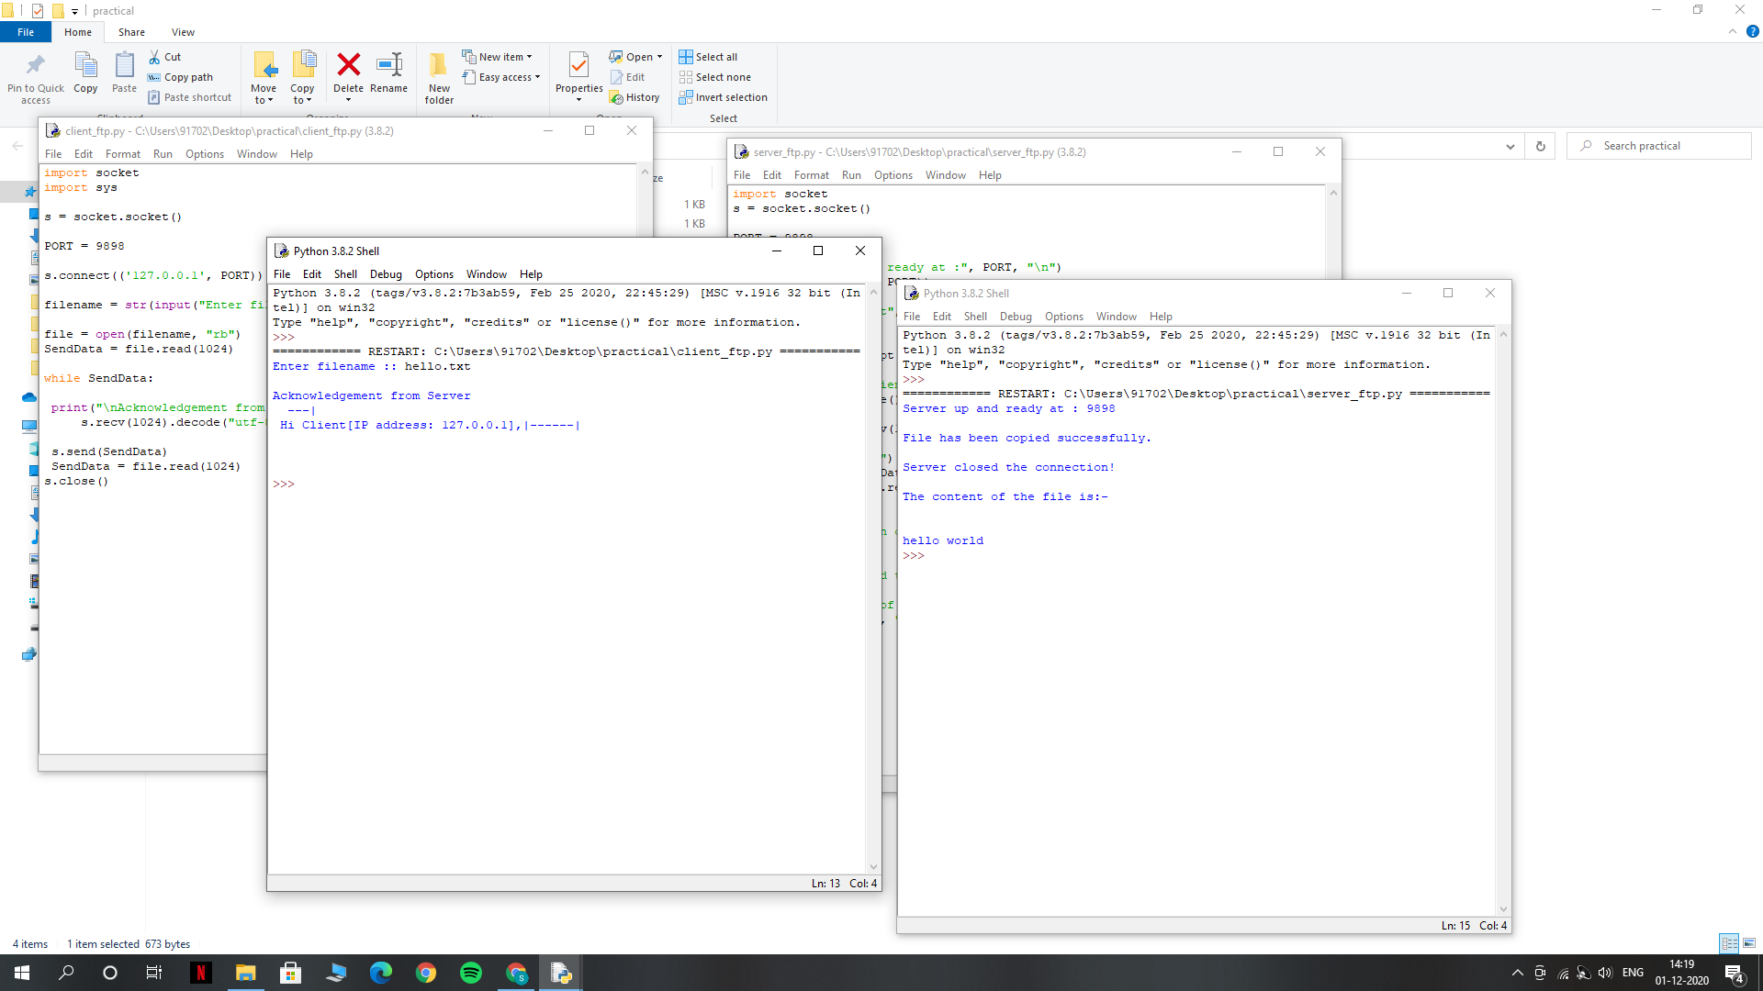

**Result: Thus the FTP client-server communication is established and data(file)is transferred between the client and server machines.**